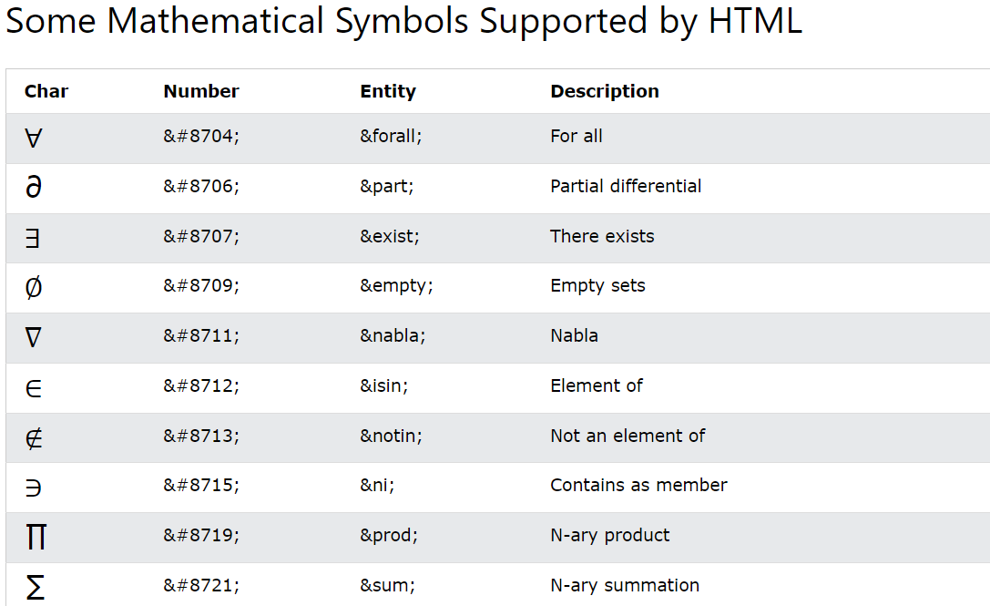

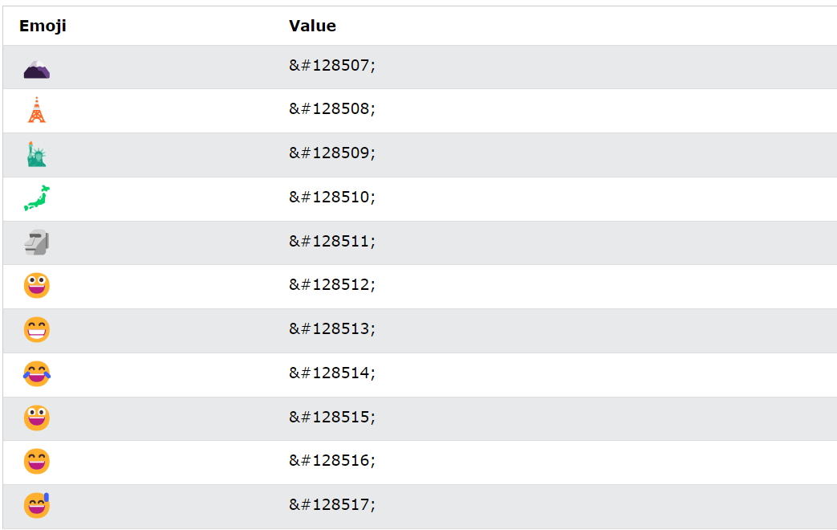

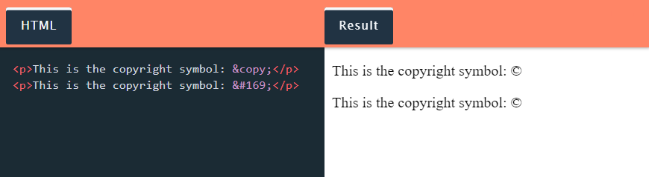

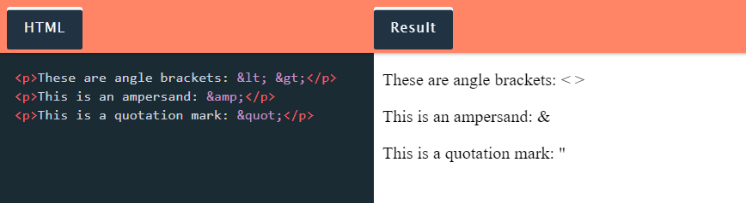

**HTML Symbols List**

Sometimes, you can remember an HTML entity from its name. Other times, you’ll have to look it up. To help you out, here’s a list of common symbols along with their HTML entities in name and number formats:

Punctuation and Grammatical Symbols

|  |  |  |  |
| --- | --- | --- | --- |
| **SYMBOL** | **ENTITY NAME** | **ENTITY NUMBER** | **KNOWN AS** |
|  | &NBSP; | &#160; | NON-BREAKING SPACE |
| & | &amp; | &#38; | ampersand |
| ' | &apos; | &#39; | apostrophe/single quotation mark |
| " | &quot; | &#34; | double quotation mark |
| “ | &ldquo; | &#147; | left double quotation mark |
| ” | &rdquo; | &#148; | right double quotation mark |
| ‘ | &lsquo; | &#145; | left single quotation mark |
| ’ | ;&lsquo; | &#146; | right single quotation mark |
| – | &ndash; | &#150; | en dash |
| — | &mdash; | &#151; | em dash |
| ~ | &tilde; | &#126; | tilde |
| ¿ | &iquest; | &#191; | inverted question mark |
| ¡ | &iexcl; | &#161; | inverted exclamation mark |

Currency Symbols

|  |  |  |  |
| --- | --- | --- | --- |
| **SYMBOL** | **ENTITY NAME** | **ENTITY NUMBER** | **KNOWN AS** |
| € | &EURO; | &#128; | EURO |
| £ | &pound; | &#163; | pund sterling (British pound) |
| ¥ | &yen; | &#165; | yen |
| ¢ | &cent; | &#162; | cent |
| ₤ |  | &#8356; | lira |
| ₣ |  | &#8355; | franc |

Mathematical Symbols

|  |  |  |  |
| --- | --- | --- | --- |
| **SYMBOL** | **ENTITY NAME** | **ENTITY NUMBER** | **KNOWN AS** |
| × | &TIMES; | &#215; | MULTIPLICATION |
| ÷ | &divide; | &#247; | division |
| ± | &plusmn; | &#177; | plus or minus |
| < | &lt; | &#60; | less than |
| > | &gt; | &#62; | greater than |
| ≤ | &le; | &#8804; | less than or equal to |
| ≥ | &ge; | &#8805; | greater than or equal to |
| √ | &radic; | &#8730; | square root |
| ∑ | &sum; | &#8721; | sum |
| ∞ | &infin; | &#8734; | infinity |
| ƒ | &fnof; | &#131; | function |
| ∫ | &int; | &#8747; | integral |
| ∆ |  | &#8710; | increment |
| ∂ | &part; | &#8706; | partial differential |
| ∏ | &prod; | &#8719; | n-ary product |
| ∙ |  | &#8729; | bullet operator |
| ∀ | &forall; | &#8704; | for all |
| ∃ | &exist; | &#8707; | there exists |
| ∈ | &isin; | &#8712; | is an element of the set |
| ∉ | &notin; | &#8713; | is not an element of the set |
| ∅ | &empty; | &#8709; | empty set |
| ∋ | &ni; | &#8715; | under the condition that |

Other Common Symbols

| **SYMBOL** | **ENTITY NAME** | **ENTITY NUMBER** | **KNOWN AS** |
| --- | --- | --- | --- |
| ® | &REG; | &#174; | REGISTERED TRADEMARK |
| © | &copy; | &#169; | copyright |
| ™ | &trade; | &#153; | trademark |
| † | &dagger; | &#8224; | dagger |
| ‡ | &Dagger; | &#8225; | double dagger |
| ← |  | &#8592; | left arrow |
| → |  | &#8594; | right arrow |
| ↑ |  | &#8593; | up arrow |
| ↓ |  | &#8595; | down arrow |
| ★ |  | &#9733; | black star |
| ☆ |  | &#9734; | white star |
| ⚑ |  | &#9873; | black flag |
| ⚐ |  | &#9872; | white flag |
| ♠ | &spades; | &#9824; | black spade |
| ♣ | &clubs; | &#9827; | black club |
| ♥ | &hearts; | &#9829; | black heart |
| ♦ | &diams; | &#9830; | black diamond |
| ♧ |  | &#9831; | white club |
| ♤ |  | &#9828; | white spade |
| ♡ |  | &#9825; | white heart |
| ♢ |  | &#9825; | white diamond |
| ☐ |  | &#9744; | empty ballot box |
| ☑ |  | &#9745; | ballot box with a checkmark |
| ☒ |  | &#9746; | ballot box with an X |
| ☻ |  | &#9787; | black smiling face |
| ☺ |  | &#9786; | white smiling face |
| ☹ |  | &#9785; | frowning face |
| ☮ |  | &#9774; | peace symbol |
| ♲ |  | &#9842; | recycling symbol |