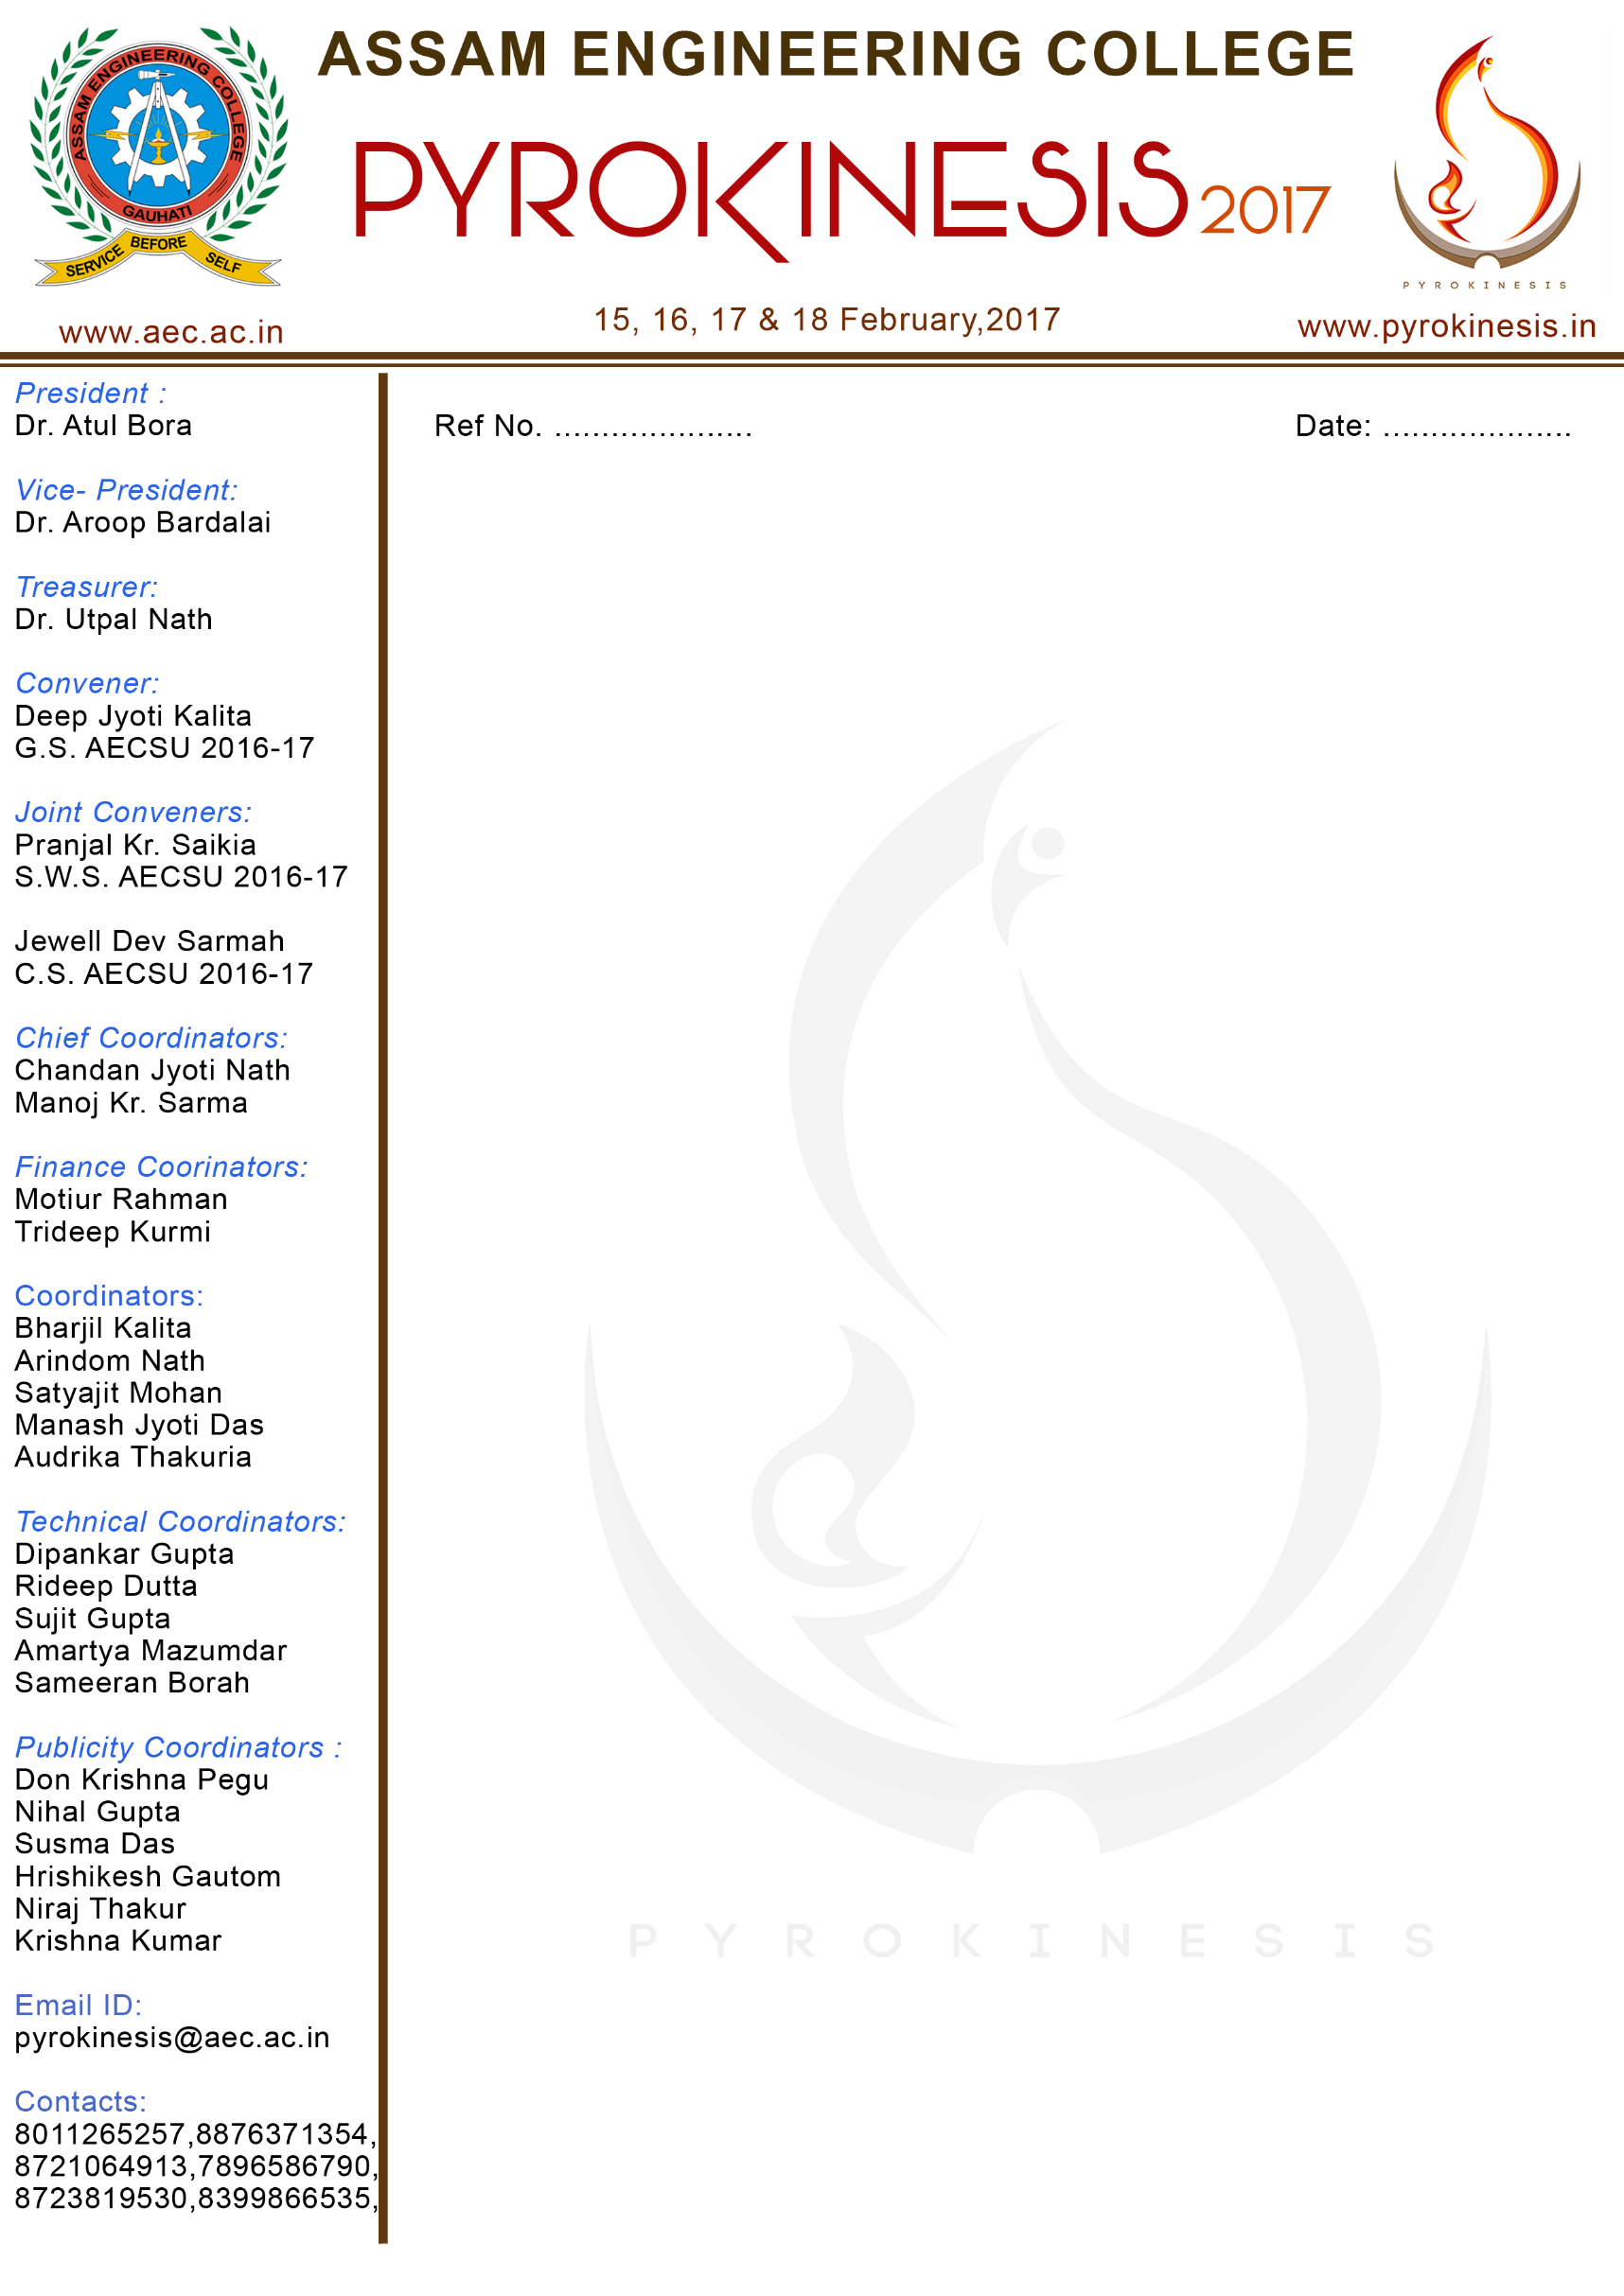

**Date**: 10th February, 2017

Sir,

Subject: Invitation to attend Code War 2017.

Code War 2017, on behalf of Udbhavanam and Pyrokinesis, extends the invitation to 24 Tech Soft to witness our event along with the other events to be held under Pyrokinesis and Udbhavanam on 15th February, 2017.

The event Code War 2017 would be held at the Electronics and Telecommunication and Computer Science Department at Assam Engineering College, Jalukbari, Guwahati-13. As one of esteemed sponsors, it would be our honour to have your presence on this auspicious occasion. It would also be an opportunity to thank you for your support in organising the event.

I do hope that you will be able to confirm your attendance to this invitation; we look forward to your presence at the event.

Yours Sincerely,

Code War 2017.