Q1. Write a Sql query that will fetch all upcoming courses.
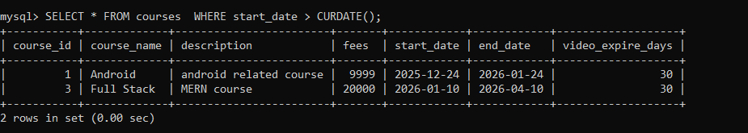

Q2. Write a Sql query that will fetch all the registered students along with course name
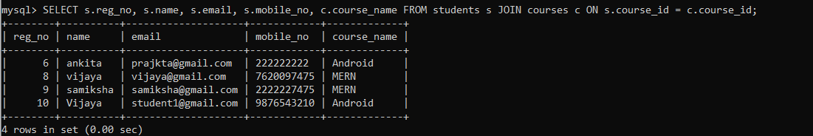

Q3. Write an SQL query to fetch the complete details of a student (based on their email) along with the details of the course they are enrolled in.

Q4. Write an SQL query to retrieve the course details and the list of non-expired videos for a specific student using their email address. A video is considered active (not expired) if its added_at date plus the course’s video_expire_days has not yet passed compared to the current date. Example: A video added on 2025-01-01 with 30 video_expire_days remains active until 2025-01-31

