#### ***PROJECT REPORT***

## 

#### ***AUTOMATED LIBRARY MANAGEMENT SYSTEM***



#### **NAME - BAIBHAB SWAIN GUIDED BY**

**REGD NO - 1641012206 Assist Profressor**

**SEC - F BISHNUPRIYA PANDA**

**BRANCH - CSE**

#### ***ABSTRACT***

#### Library management system is a project which aims in developing a computerized system to maintain all the daily work of library .This project has many features which are generally not availiable in normal library management systems like facility of user login and a facility of teachers login .It also has a facility of admin login through which the admin can monitor the whole system .It also has facility of an online notice board where teachers can student can put up information about workshops or seminars being held in our colleges or nearby colleges and librarian after proper verification from the concerned institution organizing the seminar can add it to the notice board . It has also a facility where student after logging in their accounts can see list of books issued and its issue date and return date and also the students can request the librarian to add new books by filling the book request form.The librarian after logging into his account ie admin account can generate various reports such as student report , issue report, teacher report and book report Overall this project of ours is being developed to help the students as well as staff of library to maintain the library in the best way possible and also reduce the human efforts.

## *****Modules*****

#### Basically there are two main modules,they are

#### 1.Admin

#### 2.Users

## *****Admin Module*****

#### The Admin module  stores the details of staff working in the library, the details of students, the details of books,updates the status of books ,adds newly purchased book details to the database ,issues the books,collects fine etc.

## ****User Module****

#### User Module  is  further classified into  two because in an institution for example an engineering college  the user may be a staff or a student.

#### The users have the functionalities like accessing the books ,search for a book etc.

#### The Library Management System provides exact information about the  number of books that are taken by the users, the number of books that are left,date of issue etc   and it even  calculates the fine automatically, thereby reducing the risk present in the manual management of libraries.

# struct (C programming language)

#### A **struct** in the [C programming language](https://en.wikipedia.org/wiki/C_programming_language) (and many derivatives) is a [composite data type](https://en.wikipedia.org/wiki/Composite_data_type) (or [record](https://en.wikipedia.org/wiki/Record_(computer_science))) declaration that defines a physically grouped list of variables to be placed under one name in a block of memory, allowing the different variables to be accessed via a single [pointer](https://en.wikipedia.org/wiki/Pointer_(computer_programming)), or the struct declared name which returns the same address. The struct can contain many other complex and simple data types in an association, so is a natural organizing type for records like the mixed data types in lists of directory entries reading a hard drive (file length, name, extension, physical (cylinder, disk, head indexes) address, etc.), or other mixed record type (patient names, address, telephone... insurance codes, balance, etc.).

#### The C struct directly references a *contiguous block* of physical memory, usually delimited (sized) by word-length boundaries. It corresponds to the similarly named feature available in some [assemblers](https://en.wikipedia.org/wiki/Assembly_language) for Intel processors. Language implementations that could utilize half-word or byte boundaries (giving denser packing, using less memory) were considered advanced in the mid-eighties. Being a block of contiguous memory, each field within a struct located at a certain fixed offset from the start. As an illustration, many BASIC interpreters once fielded a string data struct organization with one value recording string length, one indexing (cursor value of) the previous line, one pointing to the string data.

#### Because the contents of a struct are stored in contiguous memory, the [sizeof](https://en.wikipedia.org/wiki/Sizeof" \o "Sizeof) operator must be used to get the number of bytes needed to store a particular type of struct, just as it can be used for [primitives](https://en.wikipedia.org/wiki/Primitive_data_type). The alignment of particular fields in the struct (with respect to [word](https://en.wikipedia.org/wiki/Word_(computer_architecture)) boundaries) is implementation-specific and may include padding, although modern compilers typically support the #pragma pack directive, which changes the size in bytes used for alignment

#### ***DATA FLOW DIAGRAM***

#### A data flow diagram, also known as “bubble chart” has the purpose of clarifying

#### system requirements and identifying major transformation that will become

#### programs in system design. It is a graphic representation of a system or portion of

#### system. A DFD consists of a series of bubbles joined by lines. It consists of data

#### flows, processes, sources, destinations and stores all described through the use of

#### easily understood symbols. An entire system can be described from the viewpoint

#### of the data it processes with only four symbols. The DFD is also powerful enough

#### to show parallel activities.

#### ***TYPES OF DATA FLOW DIAGRAM***

#### • Physical data flow diagram: -Physical data flow diagram is

#### implementation dependent. They show the actual devices, department,

#### people etc. involved in the current system.

#### • Logical data flow diagram: -It describes the system independently of how

#### it is actually implemented, that is , they show what takes place, rather than

#### how an activity is accomplished.

#### ***COMPONENTS OF DATA FLOW DIAGRAM***

#### a) Source or Destination: -The source or destination is graphically represented

#### as a rectangle. Source or destination external entities with which the system

#### communicates. A source or destination is a person or a group of persons that are

#### outside the control of the system being modeled.

#### b) Data Flow: -The flow is represented graphically by an arrow into or out of a

#### process. The flow is used to describe the movement of chunks or packet of

#### information from one part of the system to another part. The flow represents data

#### in motion.

#### c) Process: -The process shows a part of the system that transforms input into

#### output. The process is represented graphically as a circle or bubble.

#### d) Data Store: -The data store is used to model a collection of data packet at rest.

#### The notation of a data store is two parallel lines. Data stores are typically

#### implemented as files or databases in computerized system. Data stores are

#### connected by flow to processes.

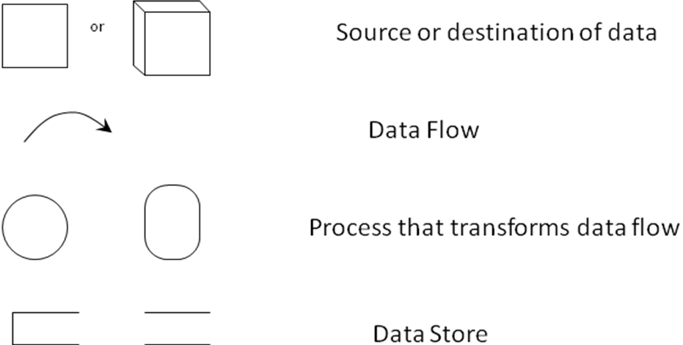

**LEVEL 0 DFD DIAGRAM:**

In Level 0 DFD diagram, it will display the menus of the project that is what are all we can do in the project. From that we can select the option what we are going to do. Based upon the condition it display the next screen for the selected operation.

**LEVEL O DFD DIAGRAM**

DISPLAYING THE STUDENTS DETAILS

STORING THE STUDENTBOOK

DETAILS

STUDENTBOOK ENTRY

SEARCHING THE

BOOK

STORING THE STUDENT DETAILS

STORING THE BOOK DETAILS

DISPLAYING THE BOOK

DETAILS

ENTERING STUDENT DETAILS

ENTERING THE BOOK DETAILS

SEARCHING STUDENT DETAIL

**LEVEL 1 DFD DIAGRAM:**

In Level 1 DFD diagram it takes the input details and store the details in the database. It takes the details separately for each table and store details separately in each table.

**TO STORE THE DETAILS OF MEMBERS:**

NAME

MEM NO

BRANCH

USER-ID

STORING THE DETAILS

BOOK NAME

BOOK NO

AUTHOR

CONTENTS

STORING THE DETAILS

PUBLISHER

STOCK

**TO STORE THE DETAILS OF TRANSACTIONS**

BOOK NAME

BOOK NO

AUTHOR

CONTENTS

STORES THE DETAILS

DATE OF ISSUE

DATE OF RETURN

MEMNO

MEMBER NAME

**LEVEL 2 DFD DIAGRAM:**

In Level 2 DFD diagram it displays the selected details or the details of all books present in the library and the details of selected members or all the members who are having the membership in the library and the transaction details of members who have taken books.

**TO DISPLAY THE MEMBER DETAILS:**

NAME

MEM NO

BRANCH

USERID

DISPLAYING THE DETAILS FROM THE DATABASE

**TO DISPLAY THE DETAILS OF BOOKS:**

BOOK NAME

BOOK NO

AUTHOR

CONTENTS

DISPLAYING THE DETAILS

PUBLISHER

STOCK

**TO STORE THE DETAILS OF TRANSACTIONS:**

BOOK NAME

BOOK NO

AUTHOR

EDITION

DISPLAYING THE DETAILS

DATE OF ISSUE

DATE OF RETURN

MEMNO

MEMBER NAME

***HOPE YOU LIKE IT***

***THANK YOU***