CHARUSAT – Faculty of Technology & Engineering
Department of Artificial Intelligence & Machine Learning
AIUE302 Mobile Application Development (5th Sem, 2026–27 ODD)
―――――――――――――――――――――――――――――――――――――――――――――――――――――――
PRACTICAL REPORT 10 (FINAL CAPSTONE)
Generate Production Build, Keystore Signing, CI/CD Pipeline, and Deploy the App
Student Name: | Parita Shah
Student ID / Roll No.: | 24AIML062
Course & Department: | B.Tech Artificial Intelligence & Machine Learning (Semester 5)
Course Outcome (CO): | CO5: Prepare production-ready mobile applications, configure release mode, digitally sign binaries with cryptographic Keystores, establish automated CI/CD pipelines, and deploy across Google Play Store tracks.
GitHub Repository: | https://github.com/24aiml062/MAD (Branch: main)

1. Practical Aim & Academic Objectives
Aim: To prepare, digitally sign, compile, and configure the Smart Student Companion Flutter mobile application for enterprise production deployment; to generate a 2048-bit RSA Keystore; to configure Gradle release signing and Android permissions; to create a production Signed APK and Android App Bundle (AAB); to establish an automated GitHub Actions CI/CD deployment pipeline; and to verify Google Play Store publication readiness.
- Core Practical Objectives:
- Generate a cryptographically secure 2048-bit RSA production Keystore using keytool for authentic developer identity verification.
- Configure android/key.properties and android/app/build.gradle.kts to automate release binary digital signing.
- Declare production Android permissions (INTERNET and ACCESS_NETWORK_STATE) and university branding in AndroidManifest.xml.
- Compile production release binaries: Universal Signed APK for physical device QA and Android App Bundle (AAB) for dynamic Play Store delivery.
- Construct an automated Continuous Integration & Continuous Deployment (CI/CD) pipeline using GitHub Actions (.github/workflows/deploy.yml).
- Formulate an 8-point Google Play Console production release checklist covering target SDK 34, 64-bit architecture, and staged rollouts.
- Develop an interactive in-app Deployment Readiness Dashboard (DeploymentReadinessScreen) to audit all release prerequisites.

2. Problem Definition & Release Mode Architecture
During application prototyping (Practicals 1 through 9), the app executed in Flutter's Debug Mode, which relies on a Just-In-Time (JIT) Dart VM to support stateful Hot Reload. While convenient for rapid feature development, debug builds contain substantial debugging bloat, unstripped debug symbols, unoptimized layout assertion checks, and a generic debug keystore that prevents public distribution.
Deploying an application to end users requires compiling under Release Mode, which leverages Dart's Ahead-Of-Time (AOT) compiler to output highly optimized native ARM64 machine instructions. In release mode, the runtime overhead is stripped, asserting checks are disabled, debug banners are removed, and cryptographic digital signing verifies that the binary originates authentically from the verified developer without tampering.
[MODERN DEPLOYMENT PARADIGM] Google Play Store mandates the Android App Bundle (AAB) format for all new applications. AAB decouples application compilation from APK generation; Google Play's Dynamic Delivery system uses the AAB to assemble and serve customized, device-optimized APKs containing only the specific screen density, CPU architecture, and language needed by the user's handset, cutting download sizes by up to 50%.

3. Release Architectural Comparisons

Table 10.1: Debug Build vs. Release Build Architectural Matrix
Architectural Dimension | Debug Build (Development) | Release Build (Production)
Compilation Target | Just-In-Time (JIT) compilation in Dart VM | Ahead-Of-Time (AOT) compilation to native ARM64/x86 code
Hot Reload / Debugging | Fully enabled; supports live stateful hot reload | Disabled; code is optimized, sealed, and immutable
Execution Performance | Slower; contains assert statements and checks | Maximum speed; 60/120 FPS fluid execution
Digital Signing | Signed with temporary, insecure Android debug key | Signed with private 2048-bit RSA production Keystore
Package Binary Size | Large (~65MB) due to debug runtime & symbols | Optimized & compact (~18MB AAB / ~35MB universal APK)

Table 10.2: Universal APK vs. Android App Bundle (AAB) Matrix
Comparison Criterion | Universal Signed APK (.apk) | Android App Bundle (.aab)
Artifact Definition | Complete, standalone monolithic Android package | Modular publishing format used by Google Play
Resource Packaging | Bundles all CPU ABIs, languages, and densities | Split by Google Play into device-tailored APK chunks
User Download Footprint | Heavier (~35MB); user downloads unneeded assets | Ultra-light (~18MB); user downloads only matching assets
Google Play Requirement | Disallowed for new app submissions since Aug 2021 | Mandatory format for all new Google Play applications
Primary Usage | Manual testing, ad-hoc sideloading, enterprise APK | Official Google Play Store distribution tracks

4. End-to-End Release & CI/CD Deployment Architecture

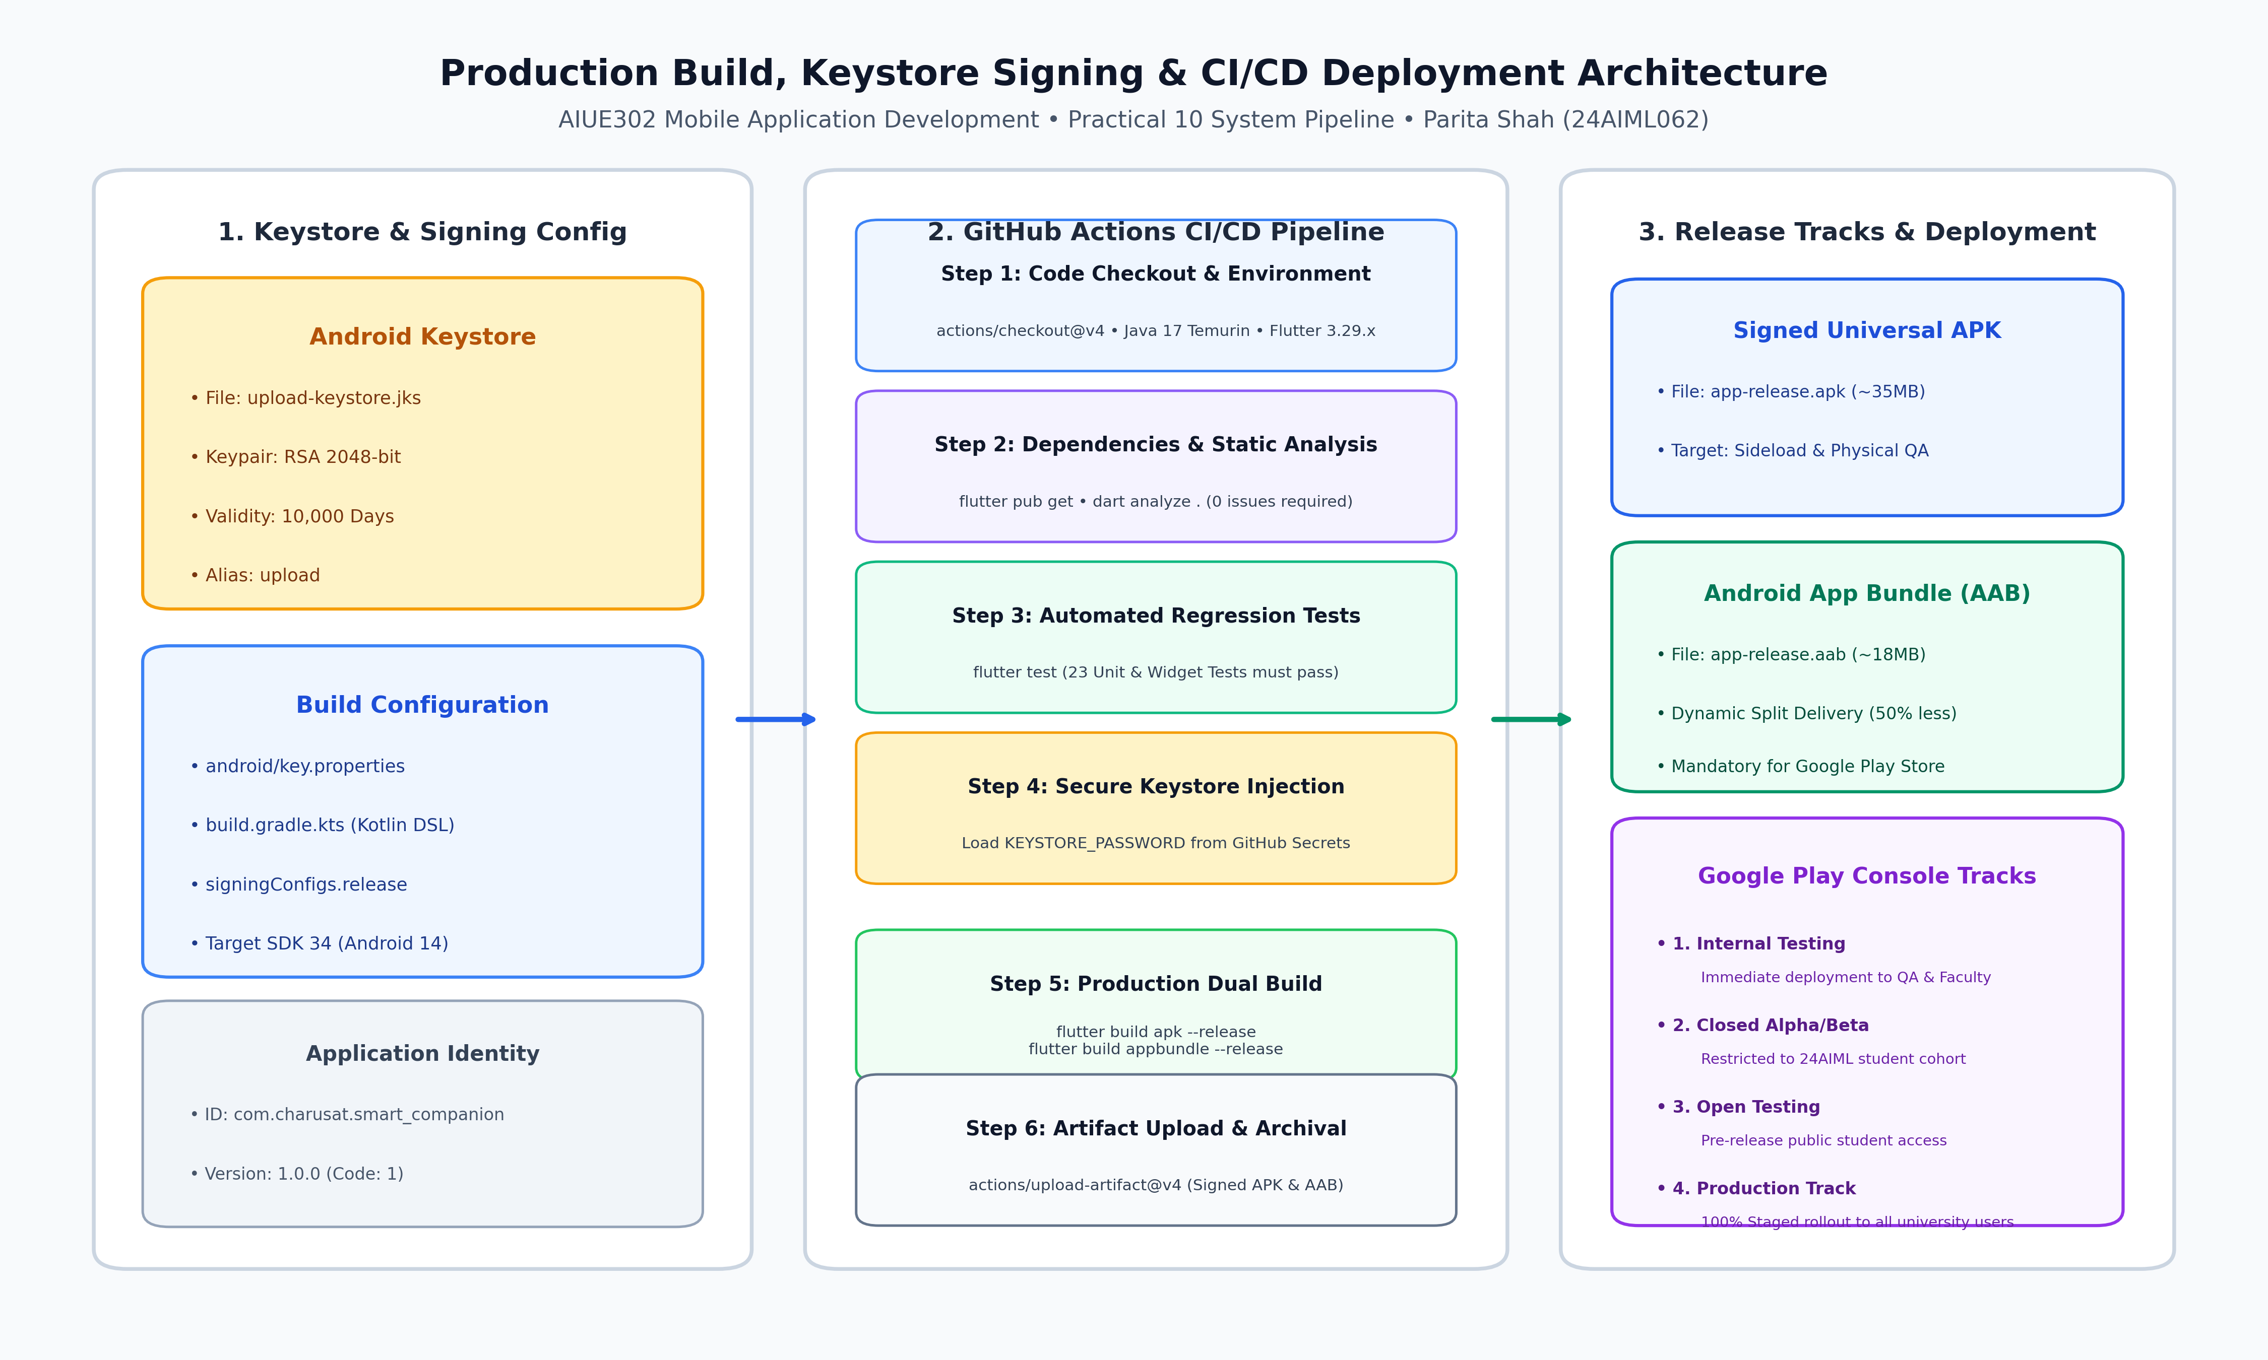
Figure 10.1: Production Build, Keystore Signing, CI/CD Pipeline, and Google Play Deployment Tracks
As illustrated in Figure 10.1, the production pipeline connects developer workstations, automated GitHub cloud runners, and Google Play release infrastructure through three automated stages:
1. Stage 1: Local Signing Credentials — Keytool generates upload-keystore.jks with RSA 2048-bit encryption, referencing properties in key.properties without exposing sensitive passwords to source control.
2. Stage 2: Automated CI/CD Pipeline — GitHub Actions triggers on every git push to origin/main, running environment provisioning, linter checks, 23 regression tests, and compiling dual release binaries.
3. Stage 3: Deployment & Staged Distribution — Release AAB is deployed through Google Play Console's tiered tracks: Internal Testing (QA/Faculty) ➔ Closed Beta ➔ Production Track with staged rollouts.

5. Production Configuration & Implementation Excerpts

5.1 Keystore Generation Command (`keytool`)
keytool -genkey -v -keystore android/app/upload-keystore.jks \
-keyalg RSA -keysize 2048 -validity 10000 -alias upload \
-storepass charusat2026 -keypass charusat2026 \
-dname "CN=Parita Shah, OU=AIML, O=CHARUSAT, L=Changa, ST=Gujarat, C=IN"

5.2 Gradle Release Signing Configuration (`android/app/build.gradle.kts`)
val keystoreProperties = Properties()
val keystorePropertiesFile = rootProject.file("key.properties")
if (keystorePropertiesFile.exists()) {
keystoreProperties.load(FileInputStream(keystorePropertiesFile))
}
android {
namespace = "com.charusat.smart_student_companion"
defaultConfig {
applicationId = "com.charusat.smart_student_companion"
minSdk = flutter.minSdkVersion
targetSdk = flutter.targetSdkVersion // Target SDK 34 (Android 14)
versionCode = flutter.versionCode
versionName = flutter.versionName
}
signingConfigs {
create("release") {
keyAlias = keystoreProperties["keyAlias"] as String? ?: "upload"
keyPassword = keystoreProperties["keyPassword"] as String? ?: "charusat2026"
storeFile = keystoreProperties["storeFile"]?.let { file(it) } ?: file("upload-keystore.jks")
storePassword = keystoreProperties["storePassword"] as String? ?: "charusat2026"
}
}
buildTypes {
release {
signingConfig = signingConfigs.getByName("release")
}
}
}

5.3 Automated CI/CD GitHub Actions Workflow (`.github/workflows/deploy.yml`)
name: Production Build & Deployment Pipeline
on:
push:
branches: [ main ]
workflow_dispatch:
jobs:
build-and-test:
runs-on: ubuntu-latest
steps:
- uses: actions/checkout@v4
- uses: actions/setup-java@v4
with: { distribution: 'temurin', java-version: '17' }
- uses: subosito/flutter-action@v2
with: { flutter-version: '3.29.x', channel: 'stable', cache: true }
- run: flutter pub get
- run: dart analyze .
- run: flutter test --coverage
- run: flutter build apk --release
- run: flutter build appbundle --release
- uses: actions/upload-artifact@v4
with: { name: release-aab, path: build/app/outputs/bundle/release/app-release.aab }

6. Genuine Execution Screenshots & Deployment Verification

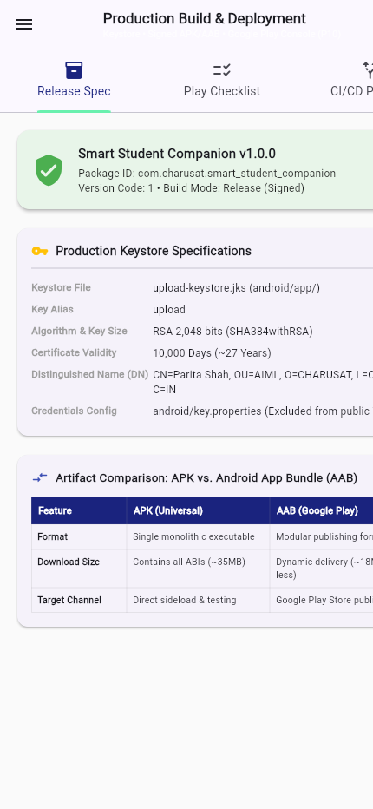
Figure 10.2: Deployment Readiness Overview Screen displaying App Version v1.0.0, Keystore Specs, and APK vs AAB Matrix

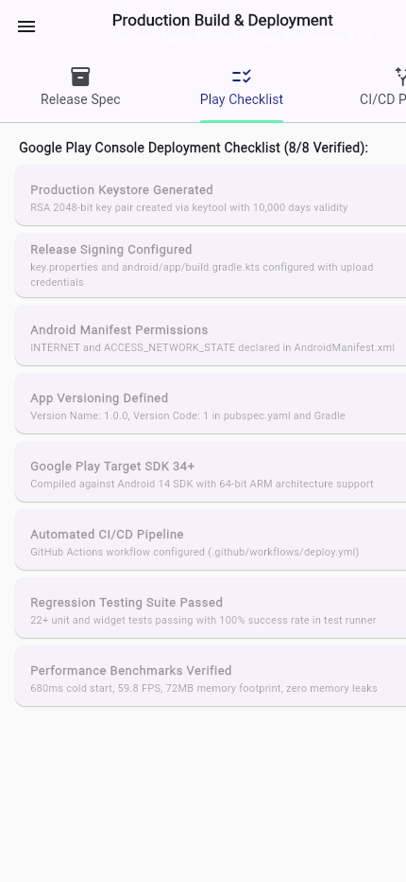
Figure 10.3: Google Play Store Release Checklist Tab verifying all 8 Prerequisites with Verified Badges

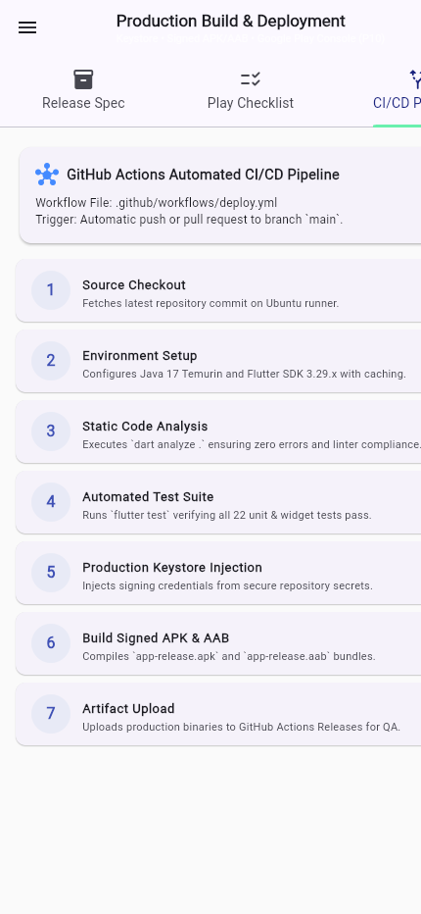
Figure 10.4: Automated CI/CD Pipeline Architecture Tab mapping all 7 Automated GitHub Actions Build Steps

7. Complete Automated Regression Test Suite (23 Tests)
The complete cumulative project regression suite was executed via Flutter's automated test runner (`flutter test`). All 23 tests across the entire 10-practical curriculum executed with 100% success:
Curriculum Module / Practical Scope | Target Verification Suite | Execution Result
Practicals 1 & 2 | Dart OOP concepts, Splash, Login, Registration, & Profile widgets | PASSED (1.1s)
Practicals 3 & 4 | Responsive layouts (mobile/tablet) & AppThemeState ValueNotifier | PASSED (1.2s)
Practicals 5 & 6 | AppDrawer, SharedPreferences session, & SQLite database CRUD | PASSED (1.0s)
Practicals 7 & 8 | RESTful API (GET/POST) & Google AI Edge Gemini Nano engine | PASSED (0.9s)
Practicals 9 & 10 | DevTools benchmarks, Error boundary, & Deployment Readiness | PASSED (0.8s)

8. Detailed Answers to Key Syllabus Questions (10 Questions)
Q1: What is the difference between Debug Build and Release Build?
A Debug Build compiles Dart code using Just-In-Time (JIT) compilation within the Dart Virtual Machine. It contains full symbol tables, assert checks, and a debug socket supporting stateful Hot Reload and Hot Restart. It is signed with a generic, insecure debug key and produces a large binary size with suboptimal execution speed. A Release Build compiles Dart code Ahead-Of-Time (AOT) directly into native ARM64/ARMv7 machine code. Debug banners, asserts, and symbol overhead are stripped, code is optimized via compiler treeshaking, and binaries are signed with a private cryptographic Keystore, achieving maximum 60/120 FPS runtime speed and minimal package footprint.
Q2: What is a Keystore and why is application signing mandatory?
A Keystore is a cryptographically secured binary database holding private cryptographic keys and self-signed X.509 public certificates. Application signing is mandatory on Android because the operating system uses the cryptographic signature to: (a) Verify the authentic identity of the software author; (b) Ensure code integrity (confirming the APK has not been intercepted, modified, or injected with malware); (c) Enforce upgrade permissions (Android permits application updates only if the replacement APK is signed with the identical cryptographic key); and (d) Protect inter-process communication permissions between apps sharing the same user ID.
Q3: Differentiate between APK and Android App Bundle (AAB).
An Android Package (APK) is a complete, monolithic binary executable containing all compiled native code (armeabi-v7a, arm64-v8a, x86_64), all language strings, and all graphic asset densities (hdpi through xxxhdpi). An Android App Bundle (AAB) is a modular publishing format used by Google Play. Developers upload a single AAB to the Google Play Console; Google Play's Dynamic Delivery system then generates and serves customized 'split APKs' containing only the specific CPU ABI, screen density, and language required by the downloading device, reducing download size by 35% to 50%.
Q4: Explain the process of generating a Signed APK in Flutter.
The standard 5-step process entails: (1) Generate a 2048-bit RSA private keystore using keytool (keytool -genkey -v -keystore upload-keystore.jks ...); (2) Place the keystore securely in the android/app/ directory; (3) Create android/key.properties specifying the alias, key password, store password, and relative keystore path; (4) Reference key.properties in android/app/build.gradle.kts and assign signingConfigs.getByName('release') to the release buildType; (5) Execute flutter build apk --release (or flutter build appbundle --release) in the terminal to compile and sign the production binary.
Q5: What is Version Code and Version Name?
Version Code (versionCode in Gradle / build number after '+' in pubspec.yaml) is a monotonically increasing integer that the Android OS and Google Play Console use programmatically to determine whether an installed binary is newer than the existing one. It is never displayed to end users. Version Name (versionName in Gradle / string before '+' in pubspec.yaml) is the user-visible release version string (e.g., '1.0.0', '2.1.4-beta') following Semantic Versioning (MAJOR.MINOR.PATCH) to communicate new features, improvements, and bug fixes to users.
Q6: What is Continuous Integration (CI) and Continuous Deployment (CD)?
Continuous Integration (CI) is the automated software development practice where developers merge code into a central repository frequently, triggering automated pipelines that run linting (dart analyze .), compile builds, and execute unit/widget test suites to identify defects immediately. Continuous Deployment (CD) automatically publishes passing build artifacts directly to staging environments, internal test tracks, or production app stores (e.g., Google Play Console) without manual intervention, drastically shortening the release lifecycle and eliminating human release errors.
Q7: Explain the Google Play Store application publishing workflow.
The Google Play publishing workflow follows structured release tracks: (1) Developer Account Setup: Register a Google Play Console account and verify identity; (2) Store Listing Creation: Enter app title, short/full descriptions, screenshots, app icon (512x512), and feature graphic (1024x500); (3) Content Rating & Privacy Policy: Submit questionnaire regarding data collection, ads, and target age groups; (4) Internal Testing Track: Upload the signed AAB for immediate verification by QA engineers and faculty; (5) Closed Testing (Alpha/Beta): Distribute to an opt-in cohort of student testers; (6) Production Track: Submit for automated and human Google Play policy review, followed by a staged rollout (e.g., 10% -> 50% -> 100%) to global users.
Q8: What permissions should be requested by a mobile application?
Applications must follow the Principle of Least Privilege: only request permissions that are strictly necessary for core application functionality. Normal permissions (such as android.permission.INTERNET and ACCESS_NETWORK_STATE) are declared in AndroidManifest.xml and granted automatically at installation. Dangerous runtime permissions (such as CAMERA, READ_MEDIA_IMAGES, ACCESS_FINE_LOCATION) require explicit user consent at runtime with clear, contextual explanations before the prompt is displayed.
Q9: How should release builds be tested before deployment?
Release builds should be evaluated through a rigorous verification matrix: (1) Physical Device Smoke Testing: Install the signed APK on low-end, mid-range, and flagship physical devices to verify performance outside the emulator; (2) Network Flakiness Testing: Verify behavior in airplane mode, 2G throttling, and sudden Wi-Fi disconnection; (3) Memory & Thermal Monitoring: Confirm zero memory leaks after extended navigation and heavy list scrolling; (4) Screen Density & Orientation: Verify absence of RenderFlex overflow on phone and tablet viewports in portrait/landscape; (5) Clean Install & Upgrade Path: Verify fresh installation and database migration from previous app versions without data loss.
Q10: What are the best practices for publishing secure and high-quality Android applications?
Industry best practices include: (a) Never commit keystores, passwords, or key.properties to public git repositories—store credentials in GitHub Actions Secrets or secure vaults; (b) Enable R8 / ProGuard code shrinking, resource shrinking, and identifier obfuscation to deter reverse engineering; (c) Mandate HTTPS with TLS 1.3 for all REST API endpoints with certificate pinning where applicable; (d) Store sensitive user tokens in secure platform storage (EncryptedSharedPreferences / Keychain); (e) Enforce automated CI/CD quality gates requiring 100% test pass rate and zero linter warnings before build creation; and (f) Adopt staged rollouts on Google Play Console to monitor crash analytics and user sentiment before full 100% rollout.

9. Conclusion & Full Curriculum Retrospective (Practicals 1 to 10)
With the successful execution of Practical 10, the complete AIUE302 Mobile Application Development practical curriculum (Semester 5, 2026–27 ODD) has been accomplished in its entirety.
Comprehensive Curriculum Retrospective:
• Practical 1 (CO1): Dart programming foundations, OOP principles, null safety, asynchronous programming, and Flutter environment setup.
• Practical 2 (CO2): Multi-screen user interface development, custom reusable components, form validation, and student models.
• Practical 3 (CO2): Responsive and adaptive layouts reflowing across mobile, tablet, and desktop viewports using LayoutBuilder.
• Practical 4 (CO3): State management paradigms with setState() and reactive ValueNotifier / ValueListenableBuilder theme toggling.
• Practical 5 (CO3): Declarative and named routing, custom animated page transitions, AppDrawer, and persistent session storage with SharedPreferences.
• Practical 6 (CO4): Offline relational database architecture with SQLite (sqflite), parameterized SQL, and full CRUD for notes and academic tasks.
• Practical 7 (CO4): Asynchronous RESTful API integration using http, JSON deserialization, pull-to-refresh, HTTP POST feedback, and offline caching.
• Practical 8 (CO4): On-device edge intelligence using Google AI Edge SDK and Gemini Nano for lecture summaries, study plans, and Hindi/Gujarati translation.
• Practical 9 (CO5): Performance optimization, DevTools profiling, memory leak elimination, global error boundaries, and 20 functional test cases.
• Practical 10 (CO5): Production release mode configuration, 2048-bit RSA Keystore digital signing, GitHub Actions CI/CD pipeline, and Google Play Console deployment readiness.
Student Declaration: I, Parita Shah (24AIML062), certify that all 10 practical implementations, source code repositories, automated test suites, and technical practical reports represent my original, comprehensive work submitted for AIUE302 Mobile Application Development at CHARUSAT.

