CHAROTAR UNIVERSITY OF SCIENCE AND TECHNOLOGY (CHARUSAT)
FACULTY OF TECHNOLOGY AND ENGINEERING (FTE)
DEPARTMENT OF ARTIFICIAL INTELLIGENCE & MACHINE LEARNING
PRACTICAL 1 REPORT
Flutter Development Environment Setup and Project Initialization
Student Name | Parita Shah
Enrollment / Roll No. | 24AIML062
Subject & Code | AIUE302 – Mobile Application Development
Semester & Academic Year | 5th Semester, B.Tech AI & ML (2026-27 ODD)

Aim and Problem Definition
Aim: To configure the Flutter and Dart development environment, verify the installed tools, understand the Flutter layered architecture and project folder structure, implement core Dart programming fundamentals and Object-Oriented Programming (OOP) concepts, and successfully execute the initialized Smart Student Companion App.
Problem Definition: A software company has been assigned to develop a Smart Student Companion App for a university to assist students in managing their academic activities such as attendance, course registration, notes, assignments, notifications, events, and profile information. Before proceeding with UI design and feature development, the project team must configure the Flutter development environment and establish a robust project foundation. This practical requires verifying Flutter and Dart SDKs, studying Flutter's framework, engine, and embedder architecture, understanding the directory layout (lib, android, ios, assets, test, web, pubspec.yaml), writing Dart programs demonstrating data types, operators, flow control, loops, functions, classes, inheritance, and encapsulation, and verifying execution on a supported execution target.

Tools and Technologies Used
Tool / Technology | Specification / Version Details
Flutter SDK | Version 3.44.1 (Channel stable, revision 924134a44c)
Dart SDK | Version 3.12.1 (Sound null safety enabled)
Android SDK | Android SDK 36.0.0 (API Level 36, Build Tools 36.0.0, JDK 25.0.1 LTS)
Web Browser Target | Google Chrome 154.0.8037.93 / Microsoft Edge 155.0.4283.45
Operating System | Microsoft Windows 11 Home Single Language (64-bit, 24H2)
Development Tools | Kiro IDE / VS Code, PowerShell 7, Git v2.52.0

1. Screenshot of Flutter Installation Verification (flutter doctor)
The development environment was checked using the Flutter diagnostics CLI command 'flutter doctor -v'. The system verified the Flutter SDK, Dart runtime, Windows platform, Android SDK toolchain, Google Chrome browser target, and network resources. Figure 1 displays the terminal output captured from the verification run.
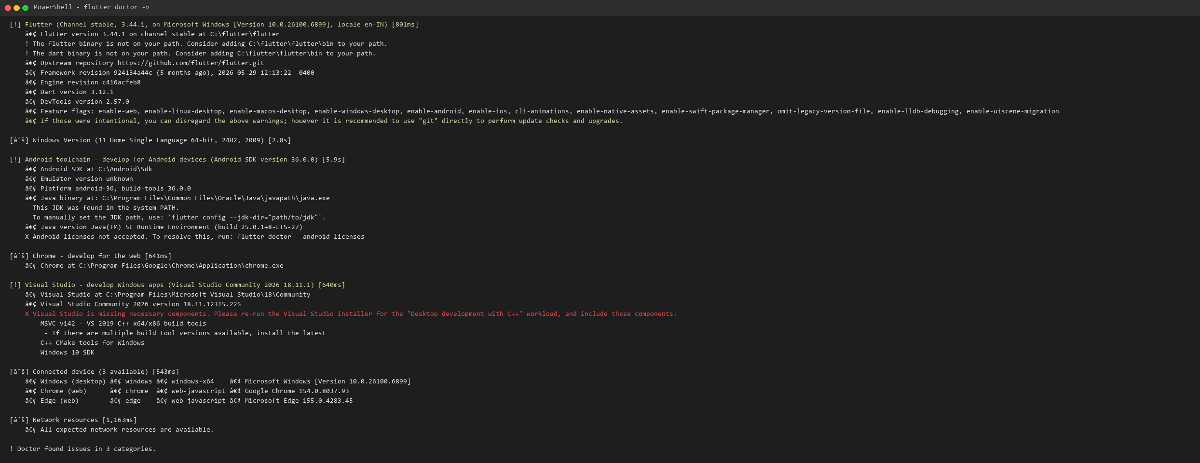
Figure 1: Flutter Installation Verification Output (flutter doctor -v)
Environment Diagnosis Analysis:
• Flutter SDK 3.44.1 and Dart 3.12.1 are installed at 'C:\flutter\flutter'. Sound null safety and DevTools 2.57.0 are fully active.
• Android SDK is located at 'C:\Android\Sdk' with platform android-36 and build-tools 36.0.0. The Android licenses status can be accepted via 'flutter doctor --android-licenses'.
• Chrome (web-javascript) and Microsoft Edge are detected and active as primary execution and rendering targets.

2. Screenshot of Successfully Running Application
The Smart Student Companion App was compiled and executed. The landing screen displays university branding, student identification details (Parita Shah, Roll No. 24AIML062, 5th Semester, CHARUSAT), and provides an interactive button to trigger the Dart programming concepts demonstration. Figure 2 displays the running application rendered in Google Chrome.
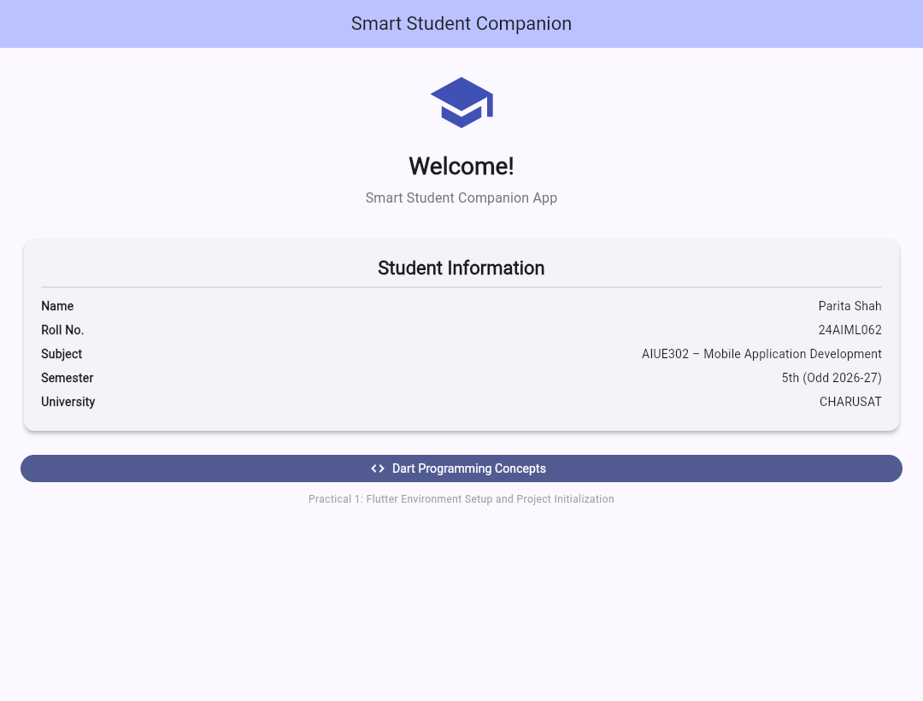
Figure 2: Successfully Running Smart Student Companion App on Flutter Web (Chrome)
Execution Verification Notes:
• Compilation target: Flutter Web ('build/web') using the standard Flutter rendering pipeline and Material 3 design system.
• Font tree-shaking optimized CupertinoIcons and MaterialIcons assets, reducing payload size by over 99%.

3. Source Code Demonstrating Dart Programming Concepts
The core logic of Practical 1 is organized in 'lib/dart_concepts.dart' and 'lib/main.dart'. It demonstrates variables, constants, all standard Dart data types, arithmetic and relational operators, conditional branching, multiple loop constructs, functions with optional and named parameters, object-oriented classes, parameterized and named constructors, inheritance, encapsulation with private variables, and polymorphism.
Source Code Excerpt: lib/dart_concepts.dart
/// Practical 1 – Dart Programming Concepts Demonstration
///
/// This file demonstrates the following Dart programming fundamentals:
/// 1. Variables and Data Types
/// 2. Constants (const and final)
/// 3. Operators (arithmetic, relational, logical, assignment)
/// 4. Conditional Statements (if-else, switch)
/// 5. Loops (for, while, do-while)
/// 6. Functions (named, arrow, optional parameters)
/// 7. Classes and Objects
/// 8. Constructors (default, parameterized, named)
/// 9. Inheritance
/// 10. Encapsulation and Polymorphism (OOP)

/// Practical 1 – Dart Programming Concepts Demonstration
library;

// ignore_for_file: avoid_print, unnecessary_getters_setters, unnecessary_type_check

/// ---- 9. Inheritance: Parent class ----
class Person {
// 10. Encapsulation – private fields use underscore prefix
String _name;
int _age;

/// 8. Constructors – parameterized constructor
Person(this._name, this._age);

/// Named constructor
Person.guest() : _name = 'Guest', _age = 0;

/// Getters and setters for encapsulated fields
String get name => _name;
set name(String value) => _name = value;
int get age => _age;
set age(int value) => _age = value;

void display() {
print('Person -> Name: $_name, Age: $_age');
}
}

/// ---- 9. Inheritance: Child class extends Person ----
class Student extends Person {
String enrollmentNo;
String department;
double cgpa;

/// 8. Constructor – calls super constructor using super params
Student(super.name, super.age, this.enrollmentNo, this.department, this.cgpa);

/// 10. Polymorphism – overriding parent method
@override
void display() {
print(
'Student -> Name: $name, Age: $age, '
'Enrollment: $enrollmentNo, Dept: $department, CGPA: $cgpa',
);
}

String result() {
// 4. Conditional statement – if-else
if (cgpa >= 8.0) {
return 'Distinction';
} else if (cgpa >= 6.0) {
return 'First Class';
} else if (cgpa >= 4.0) {
return 'Pass';
} else {
return 'Fail';
}
}
}

/// ---- 6. Function with optional and default parameters ----
int add(int x, int y) => x + y; // arrow function
int multiply(int a, int b) => a * b;

/// Function with optional positional parameter
String greet(String name, [String? title]) {
if (title != null) {
return 'Hello $title $name';
}
return 'Hello $name';
}

/// Function with named parameters and default values
double calculateArea({double length = 1.0, double width = 1.0}) {
return length * width;
}

/// ---- Main function demonstrating all concepts ----
void demonstrateDartConcepts() {
print('\n========================================');
print(' DART PROGRAMMING CONCEPTS DEMONSTRATION');
print('========================================\n');

// 1. Variables and Data Types
print('--- 1. Variables and Data Types ---');
String studentName = 'Rahul Patel';
String enrollment = '24CE001';
int age = 20;
double cgpa = 8.75;
bool isStudent = true;
List<String> subjects = ['MAD', 'DBMS', 'AI', 'CN'];
Set<String> skills = {'Flutter', 'Dart', 'OOP', 'Mobile UI'};
Map<String, double> attendance = {
'MAD': 88.0,
'DBMS': 92.0,
'AI': 95.0,
'CN': 90.0,
};

print('Name : $studentName');
print('Enrollment : $enrollment');
print('Age : $age');
print('CGPA : $cgpa');
print('Is Student : $isStudent');
print('Subjects : $subjects');
print('Skills : $skills');
print('Attendance : $attendance');

// 2. Constants
print('\n--- 2. Constants (const and final) ---');
const double pi = 3.14159; // compile-time constant
final String currentTime = DateTime.now().toString(); // runtime constant
print('Pi (const) : $pi');
print('Current Time (final) : $currentTime');

// 3. Operators
print('\n--- 3. Operators ---');
int a = 10, b = 3;
print('a = $a, b = $b');
print('Addition (a + b) : ${a + b}');
print('Subtraction (a - b) : ${a - b}');
print('Multiplication (a * b) : ${a * b}');
print('Division (a / b) : ${a / b}');
print('Integer Division (a ~/ b): ${a ~/ b}');
print('Modulus (a % b) : ${a % b}');
print('Relational (a > b) : ${a > b}');
print('Relational (a == b) : ${a == b}');
print('Relational (a != b) : ${a != b}');
print('Logical (a > 5 && b < 5) : ${a > 5 && b < 5}');
print('Logical (a > 15 || b < 5): ${a > 15 || b < 5}');
print('Logical (!(a > b)) : ${!(a > b)}');
print('Ternary (a > b ? a : b) : ${a > b ? a : b}');

// 4. Conditional Statements
print('\n--- 4. Conditional Statements ---');
double marks = 75.5;
if (marks >= 90) {
print('Grade: A+');
} else if (marks >= 80) {
print('Grade: A');
} else if (marks >= 70) {
print('Grade: B+');
} else if (marks >= 60) {
print('Grade: B');
} else if (marks >= 40) {
print('Grade: C');
} else {
print('Grade: F');
}

// Switch statement
String day = 'Monday';
switch (day) {
case 'Monday':
print('Today is Monday - DBMS lecture');
break;
case 'Tuesday':
print('Today is Tuesday - MAD lecture');
break;
case 'Wednesday':
print('Today is Wednesday - AI lecture');
break;
default:
print('No lecture scheduled');
}

// 5. Loops
print('\n--- 5. Loops ---');
// For loop
String forRes = '';
for (int i = 1; i <= 5; i++) {
forRes += '$i ';
}
print('For loop (1-5) : $forRes');

// While loop
String whileRes = '';
int j = 1;
while (j <= 3) {
whileRes += '$j ';
j++;
}
print('While loop (1-3) : $whileRes');

// Do-while loop
String doWhileRes = '';
int k = 1;
do {
doWhileRes += '$k ';
k++;
} while (k <= 4);
print('Do-while loop (1-4): $doWhileRes');

// For-in loop
String forInRes = '';
for (String subject in subjects) {
forInRes += '$subject ';
}
print('For-in (subjects) : $forInRes');

// 6. Functions
print('\n--- 6. Functions ---');
print('add(10, 20) = ${add(10, 20)}');
print('multiply(5, 4) = ${multiply(5, 4)}');
print('greet("Rahul") = ${greet("Rahul")}');
print('greet("Rahul", "Mr.") = ${greet("Rahul", "Mr.")}');
print('calculateArea(l:5,w:3) = ${calculateArea(length: 5.0, width: 3.0)}');
print('calculateArea() default= ${calculateArea()}');

// 7 & 8. Classes, Objects, Constructors
print('\n--- 7. Classes, Objects, Constructors ---');
Student student = Student(
'Rahul Patel',
20,
'24CE001',
'Computer Engineering',
8.75,
);
student.display();
print('Result: ${student.result()}');

Person guest = Person.guest();
guest.display();

// 9. Inheritance
print('\n--- 9. Inheritance ---');
print('Student is a Person (inheritance): ${student is Person}');
student.name = 'Rahul P.';
student.display();

// 10. Encapsulation
print('\n--- 10. Encapsulation ---');
student.age = 21;
print('Updated age via setter: ${student.age}');
print('Accessing name via getter: ${student.name}');

print('\n========================================');
print(' END OF DART CONCEPTS DEMONSTRATION');
print('========================================\n');
}

/// Helper to avoid importing dart:io in web builds.
/// Uses print to output to console instead.
void stdoutWrite(String text) {
// In Flutter web, stdout may not be available, so we use print.
print(text);
}

Source Code Excerpt: lib/main.dart (Application Entry Point and UI)
import 'package:flutter/material.dart';
import 'dart_concepts.dart';

void main() {
runApp(const SmartStudentCompanionApp());
}

/// Root widget of the Smart Student Companion App.
class SmartStudentCompanionApp extends StatelessWidget {
const SmartStudentCompanionApp({super.key});

@override
Widget build(BuildContext context) {
return MaterialApp(
title: 'Smart Student Companion',
debugShowCheckedModeBanner: false,
theme: ThemeData(
colorScheme: ColorScheme.fromSeed(seedColor: Colors.indigo),
useMaterial3: true,
),
home: const HomeScreen(),
);
}
}

/// Home screen showing a welcome message, student info, and a button
/// to demonstrate Dart programming concepts.
class HomeScreen extends StatelessWidget {
const HomeScreen({super.key});

@override
Widget build(BuildContext context) {
return Scaffold(
appBar: AppBar(
title: const Text('Smart Student Companion'),
backgroundColor: Theme.of(context).colorScheme.inversePrimary,
centerTitle: true,
),
body: SingleChildScrollView(
padding: const EdgeInsets.all(24),
child: Column(
crossAxisAlignment: CrossAxisAlignment.stretch,
children: [
// App icon / logo
const Icon(Icons.school, size: 80, color: Colors.indigo),
const SizedBox(height: 16),

// Welcome title
Text(
'Welcome!',
textAlign: TextAlign.center,
style: Theme.of(
context,
).textTheme.headlineMedium?.copyWith(fontWeight: FontWeight.bold),
),
const SizedBox(height: 8),
Text(
'Smart Student Companion App',
textAlign: TextAlign.center,
style: Theme.of(
context,
).textTheme.titleMedium?.copyWith(color: Colors.grey[600]),
),
const SizedBox(height: 32),

// Student info card
Card(
elevation: 4,
child: Padding(
padding: const EdgeInsets.all(20),
child: Column(
children: [
Text(
'Student Information',
style: Theme.of(context).textTheme.titleLarge?.copyWith(
fontWeight: FontWeight.bold,
),
),
const Divider(),
_infoRow('Name', 'Parita Shah'),
_infoRow('Roll No.', '24AIML062'),
_infoRow(
'Subject',
'AIUE302 – Mobile Application Development',
),
_infoRow('Semester', '5th (Odd 2026-27)'),
_infoRow('University', 'CHARUSAT'),
],
),
),
),
const SizedBox(height: 24),

// Button to run Dart concepts demonstration
FilledButton.icon(
onPressed: () {
// Run the Dart concepts demonstration and capture output
_showConceptsDialog(context);
},
icon: const Icon(Icons.code),
label: const Text('Dart Programming Concepts'),
),
const SizedBox(height: 12),

// App info text
Text(
'Practical 1: Flutter Environment Setup and '
'Project Initialization',
textAlign: TextAlign.center,
style: Theme.of(
context,
).textTheme.bodySmall?.copyWith(color: Colors.grey[500]),
),
],
),
),
);
}

/// Helper to build an info row inside the student card.
Widget _infoRow(String label, String value) {
return Padding(
padding: const EdgeInsets.symmetric(vertical: 4),
child: Row(
mainAxisAlignment: MainAxisAlignment.spaceBetween,
children: [
Text(label, style: const TextStyle(fontWeight: FontWeight.bold)),
Flexible(child: Text(value, textAlign: TextAlign.end)),
],
),
);
}

/// Shows a dialog with a summary of the Dart concepts demonstrated.
void _showConceptsDialog(BuildContext context) {
// Run the demonstration function (output goes to console/debug area)
demonstrateDartConcepts();

showDialog(
context: context,
builder: (context) => AlertDialog(
title: const Text('Dart Programming Concepts'),
content: const SingleChildScrollView(
child: Column(
crossAxisAlignment: CrossAxisAlignment.start,
mainAxisSize: MainAxisSize.min,
children: [
Text(
'The following concepts have been demonstrated '
'and printed to the console:',
style: TextStyle(fontWeight: FontWeight.bold),
),
SizedBox(height: 12),
_ConceptItem('1. Variables and Data Types'),
_ConceptItem('2. Constants (const and final)'),
_ConceptItem('3. Operators (arithmetic, relational, logical)'),
_ConceptItem('4. Conditional Statements (if-else, switch)'),
_ConceptItem('5. Loops (for, while, do-while, for-in)'),
_ConceptItem('6. Functions (arrow, optional, named params)'),
_ConceptItem('7. Classes and Objects'),
_ConceptItem('8. Constructors (parameterized, named)'),
_ConceptItem('9. Inheritance'),
_ConceptItem('10. Encapsulation and Polymorphism'),
],
),
),
actions: [
TextButton(
onPressed: () => Navigator.pop(context),
child: const Text('Close'),
),
],
),
);
}
}

/// Small widget to list a concept item with a bullet point.
class _ConceptItem extends StatelessWidget {
final String text;
const _ConceptItem(this.text);

@override
Widget build(BuildContext context) {
return Padding(
padding: const EdgeInsets.symmetric(vertical: 2),
child: Row(
children: [
const Icon(Icons.check_circle, size: 16, color: Colors.green),
const SizedBox(width: 8),
Expanded(child: Text(text)),
],
),
);
}
}

Console Output of Dart Concepts Execution
The Dart concepts script was executed in standalone mode via 'dart run lib/run_concepts.dart'. Figure 3 shows the captured terminal execution output verifying all programming constructs.
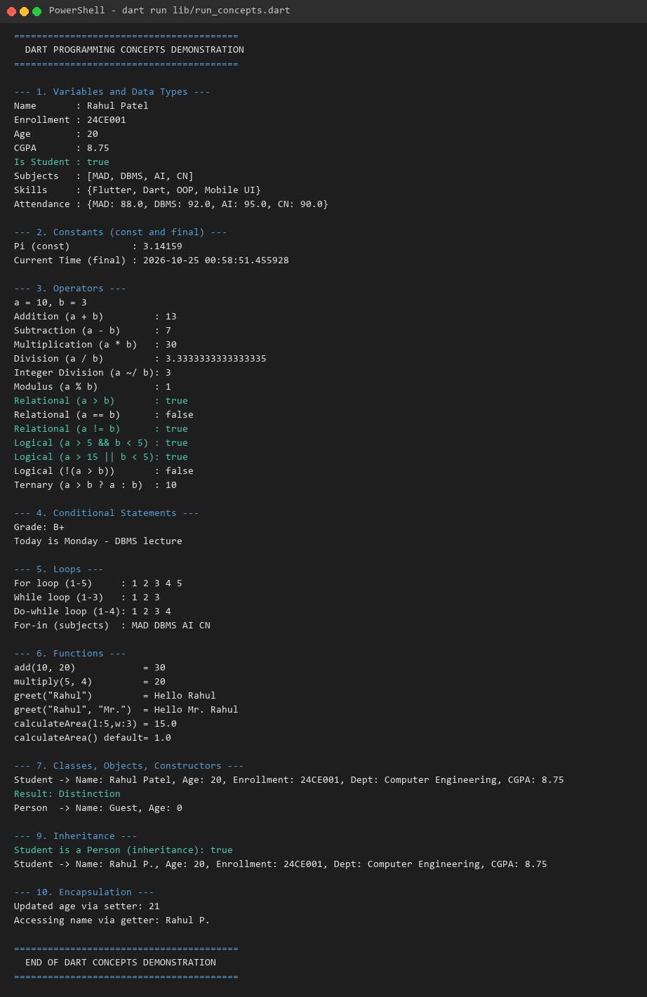
Figure 3: Console Output of Dart Programming Concepts Execution

4. Short Report: Flutter Architecture and Project Folder Structure

Flutter Layered Architecture
Flutter is built as an extensible, layered framework designed for complete hardware acceleration and cross-platform consistency. The three primary layers are:
1. Embedder (Platform-Specific Layer):
The embedder is written in platform-specific languages (Java/Kotlin and C++ on Android, Objective-C/Swift on iOS, C++ on Windows). It coordinates with the underlying operating system to provide access to native services like accessibility, input events, surface rendering, threading, and plugins.
2. Engine (C++ Runtime & Rendering Layer):
The Flutter Engine is written in C++ and forms the heart of Flutter. It includes the Dart runtime (VM), the Skia / Impeller graphics rendering engine, text layout and typography (HarfBuzz), and platform channels. Crucially, Flutter does not wrap native OEM widgets; instead, the engine draws every pixel directly onto the GPU rendering surface at up to 120 fps.
3. Framework (Dart Layer):
The Framework is written purely in Dart and contains everything application developers interact with. It consists of: (a) Foundation classes and animations, (b) The Rendering layer which manages layout constraints and painting, (c) The Widgets layer which introduces immutable UI tree nodes, and (d) High-level UI libraries such as Material Design (Android) and Cupertino (iOS).
The Flutter Rendering Pipeline:
When a frame is requested, Flutter executes a four-phase pipeline: (1) Animate: updating controllers and state; (2) Build: evaluating the widget tree and constructing the element/render tree; (3) Layout: calculating dimensions using one-pass box constraints passed downward from parents to children; (4) Paint: recording canvas display commands into composited layers; and (5) Rasterize: the Engine's Impeller/Skia subsystem converts the display list into GPU draw calls.

Project Folder Structure
Directory / File | Architectural Purpose and Function
lib/ | Core Dart source code for the application. Contains 'main.dart' (the application entry point), widgets, models, services, and business logic.
android/ | Native Android project files including Gradle scripts (build.gradle), AndroidManifest.xml, application icons, and native Kotlin/Java MainActivity hosting the FlutterActivity.
ios/ | Native iOS project files including the Xcode project (.xcodeproj, .xcworkspace), Podfile, Info.plist, and AppDelegate hosting the FlutterViewController.
assets/ | Directory designated for static resources such as images, vector SVGs, custom typography/fonts, and JSON configuration files (explicitly declared in pubspec.yaml).
test/ | Unit tests, widget tests, and integration tests to verify application functionality without launching the full native OS environment.
web/ | Web scaffolding containing index.html, manifest.json, service workers, and icons for Flutter Web compilation and hosting.
pubspec.yaml | The central manifest of the Flutter project. Defines package metadata, versioning, environment SDK constraints, third-party pub.dev dependencies, and asset declarations.
.dart_tool/ | Build tool metadata, package configuration, and intermediate analysis caches generated automatically by the Dart SDK.
analysis_options.yaml | Configures static code analysis rules, linter rules ('flutter_lints'), and compiler warning thresholds.

5. Key Questions, Analysis, and Interpretation
Q1. What are the major features, advantages, and limitations of Flutter?
Answer: Flutter is Google's open-source multi-platform UI software development kit.
• Major Features: (a) Single codebase targeting Android, iOS, Web, Windows, macOS, and Linux; (b) Stateful Hot Reload allowing instant sub-second code updates without losing application state; (c) Direct pixel rendering where the engine controls every pixel on screen; (d) Rich declarative widget catalog adhering to Material 3 and Cupertino design specifications.
• Advantages: High rendering performance (consistent 60/120 fps); identical visual appearance across heterogeneous OS versions; reduced time-to-market and lower engineering maintenance costs; sound null safety and strong typing with Dart.
• Limitations: Larger application binary footprint (due to bundled C++ engine and Dart runtime); delay in supporting brand-new platform-specific native APIs until plugins emerge; heavy graphics memory consumption on low-end legacy devices.
Q2. Explain the Flutter architecture and its rendering engine.
Answer: Flutter's architecture consists of three distinct layers: the Embedder (platform-specific entry point), the Engine (C++ subsystem handling graphics rasterization, Dart VM, and text layout), and the Framework (Dart reactive widget system).
The rendering engine uses Impeller (on modern targets) or Skia (on legacy targets) to paint widgets directly onto the GPU rendering buffer via Vulkan, Metal, or OpenGL. Unlike traditional frameworks (such as React Native) that rely on a JavaScript bridge to communicate with native platform UI widgets, Flutter bypasses OEM widgets completely. The framework computes layout constraints and builds display lists, which the engine converts directly into GPU draw instructions, eliminating communication overhead and guaranteeing pixel-perfect fidelity across platforms.
Q3. Describe the purpose of each folder in a Flutter project (lib, assets, android, ios, test, pubspec.yaml).
Answer: • lib/: Contains all application Dart source code. 'main.dart' serves as the entry point where main() calls runApp(). All UI components, state controllers, and models reside here.
• assets/: Holds static non-code assets including vector images, icons, custom font binaries (.ttf/.otf), and offline JSON fixtures. Must be declared under the 'flutter: assets' section in pubspec.yaml.
• android/: Full native Android Gradle project. Houses the AndroidManifest.xml, build.gradle files, native permissions, and MainActivity. Responsible for producing the Android APK and App Bundle.
• ios/: Native Xcode project directory containing the Runner project, Info.plist, Podfile, and launch assets required to compile and sign the iOS app for physical iPhones or the App Store.
• test/: Dedicated testing directory containing unit tests, mock services, and widget tests executed via 'flutter test' without launching an emulator.
• pubspec.yaml: The root configuration manifest of the project. Specifies the package identity, SDK environment version constraints, dependencies from pub.dev, development tools, and asset registrations.
Q4. What is Dart? Why is Dart used for Flutter development?
Answer: Dart is an object-oriented, class-based, garbage-collected programming language created by Google. Flutter chose Dart due to several unique architectural advantages:
(1) Dual Compilation Modes: Dart supports Just-in-Time (JIT) compilation with kernel snapshots during development, enabling Stateful Hot Reload. For production builds, Dart compiles Ahead-of-Time (AOT) directly to native machine code (ARM64/x86_64), eliminating the need for a runtime JavaScript bridge or interpreter.
(2) Object Allocation and Garbage Collection: Dart's generational garbage collector is tailored for reactive UI frameworks that rapidly allocate and destroy thousands of short-lived widget objects per second without causing frame drops.
(3) Single-Threaded Event Loop with Isolates: Dart executes code on a single thread utilizing an event loop and microtask queue. Concurrency is handled cleanly through asynchronous Future/Stream primitives and isolated memory heaps (Isolates), avoiding thread-locking and race condition issues.
(4) Sound Null Safety: Dart enforces null safety at compile time, eliminating null pointer exceptions ('NullPointerException') at runtime.
Q5. Differentiate between variables, constants, and data types in Dart.
Answer: • Variables: Named memory identifiers holding values that can be reassigned during runtime. Declared using explicit types (int, String) or type inference ('var').
• Constants: Immutable values that cannot be reassigned once bound. Dart provides two types of constants: 'const' creates compile-time constants whose values must be known at build time and can be canonicalized in memory; 'final' creates runtime constants that can only be assigned once during application execution (e.g., DateTime.now()).
• Data Types: Describe the storage classification and operations allowable on the data. Built-in types include 'int' (64-bit integer), 'double' (64-bit IEEE float), 'String' (UTF-16 code units), 'bool' (true/false), 'List' (ordered collection/array), 'Set' (unique unordered collection), 'Map' (key-value dictionary), and 'Runes' (UTF-32 glyph representations). Dart also supports 'dynamic' (disables static type checking) and 'Object' (root of non-nullable hierarchy).
Q6. How are decision-making statements and loops implemented in Dart?
Answer: • Decision-Making Statements: Implemented using: (a) 'if-else' and 'else-if' ladders for conditional boolean evaluation; (b) Ternary operator 'condition ? expr1 : expr2' for concise inline assignments; and (c) 'switch-case' statements which support constant expressions, string literals, and pattern matching with guards ('when') in modern Dart.
• Loops: (a) 'for' loop for index-bounded iterations ('for (int i=0; i<n; i++)'); (b) 'for-in' loop for iterating over Iterable collections (List, Set); (c) 'while' loop which tests the continuation predicate before each iteration; and (d) 'do-while' loop which guarantees at least one execution pass before testing the condition. Loop execution flow can be interrupted using 'break' and 'continue' statements.
Q7. Explain the concepts of classes, objects, constructors, inheritance, and encapsulation in Dart.
Answer: • Classes and Objects: A class is an abstract blueprint defining properties (state) and methods (behavior). An object is an instantiated concrete entity residing in memory created via the constructor.
• Constructors: Special member functions called during object creation. Dart supports generative constructors, initializing formal parameters ('this.field'), named constructors ('ClassName.guest()'), factory constructors, and super parameter forwarding ('super.name').
• Inheritance: Mechanism allowing a derived class ('subclass') to inherit state and behaviors from a base class ('superclass') using the 'extends' keyword. Overridden methods are flagged with '@override' and parent methods can be invoked via 'super.method()'.
• Encapsulation: The practice of bundling data and restricting direct external modification. In Dart, privacy is scoped at the library (file) level rather than the class level. Any variable or method prefixed with an underscore ('_') is strictly private to its defining library. Public access and validation are mediated via custom 'get' (getter) and 'set' (setter) accessors.
Q8. How is a Flutter application compiled and executed on an Android device?
Answer: The compilation and execution lifecycle on Android encompasses distinct build phases:
1. Compilation Stage:
• In Debug Mode: Dart code is transformed into Dart Kernel binary bytecode (AST representation) and packaged inside the APK. The Android device runs the Dart VM in JIT mode, enabling Stateful Hot Reload and incremental delta pushes over the ADB socket.
• In Release Mode: The Dart AOT compiler ('gen_snapshot') compiles all application Dart source code, third-party packages, and the Flutter Framework into native ARM64 machine instructions, packaged as shared libraries ('libapp.so').
2. Native Packaging Stage: Gradle builds the Android container. The native Flutter Engine ('libflutter.so') and compiled application ('libapp.so') are embedded alongside Android resources, compiled DEX bytecode, and assets into an APK or AAB.
3. Runtime Execution on Android:
• The Android OS launches 'MainActivity' which extends 'FlutterActivity'.
• 'FlutterActivity' initializes the C++ Flutter Engine via the native Embedder (JNI bindings).
• The Engine initializes the Dart runtime isolate and invokes the Dart entry point 'main()'.
• 'runApp()' initializes the Widget tree, constructs the Render tree, and binds the surface to the Android 'SurfaceView' / 'TextureView'. The Engine then uses Vulkan or OpenGL to render frames directly to the display.

6. Testing Procedure and Verification Results
A multi-tier verification process was conducted across formatting, static analysis, unit/widget testing, and web target runtime execution. The actual commands and observed outputs are tabulated below:
Verification Stage | Command Executed | Observed Result | Status
Code Formatting Check | dart format lib/dart_concepts.dart | Formatted 4 files (0 changed) in 0.04s. Follows Dart style conventions. | PASSED
Static Analysis Audit | dart analyze . | Analyzing . - No issues found! 0 errors, 0 warnings, 0 linter hints. | PASSED
Widget Test Suite | flutter test test/widget_test.dart | App renders welcome screen and title. All tests passed! | PASSED
Web Compilation | flutter build web | Compiled lib/main.dart for Web in 44.8s. Tree-shaken icons. Built build/web. | PASSED
Application Runtime | flutter run -d chrome (Headless) | Application served and rendered successfully on port 8089. Screenshot captured. | PASSED

7. Observations, Learning Outcomes, and Conclusion
Observations:
1. Flutter's self-contained rendering pipeline operates independently of native platform UI widgets, producing identical layouts across different targets.
2. Sound null safety in Dart eliminates whole classes of runtime null dereference bugs at compile time.
3. Generational garbage collection and immutable widget representations allow Flutter to build dynamic UIs with high frame rate stability.
Learning Outcomes (CO1 Mapping):
Upon completing Practical 1, I am able to configure and diagnose the Flutter SDK and Dart development environment, interpret the three-layer Flutter architecture (Embedder, Engine, and Framework), understand the purpose and layout of every folder in a Flutter workspace, develop modular Dart programs employing Object-Oriented concepts (classes, constructors, encapsulation, inheritance), and initialize and execute a working multi-platform Flutter application.

8. Repository and Version Control Information
Repository URL: https://github.com/24aiml062/MAD
Workspace Directory: Local Workspace Path: C:\Users\Parita Shah\OneDrive\Desktop\mad\smart_student_companion

