CHAROTAR UNIVERSITY OF SCIENCE AND TECHNOLOGY (CHARUSAT)
FACULTY OF TECHNOLOGY AND ENGINEERING (FTE)
DEPARTMENT OF ARTIFICIAL INTELLIGENCE & MACHINE LEARNING
PRACTICAL 2 REPORT
Design Student Dashboard using Flutter Widgets
Student Name | Parita Shah
Enrollment / Roll No. | 24AIML062
Subject & Code | AIUE302 – Mobile Application Development
Semester & Academic Year | 5th Semester, B.Tech AI & ML (2026-27 ODD)

Aim and Problem Definition
Aim: To design and develop an intuitive, professional, and responsive user interface for the Smart Student Companion App using Flutter built-in and reusable widgets, implementing Stateless and Stateful widgets, user input form validation, and multi-screen navigation.
Problem Definition: The university has approved the project requirements and requires the development team to design an intuitive and user-friendly interface for the Smart Student Companion App. Students are required to develop the initial user interface consisting of Splash Screen, Login Screen, Registration Screen, Dashboard, and Student Profile Screen using Flutter widgets. The application must provide a professional appearance with proper navigation and reusable widget components. Students shall use Flutter's built-in widgets to create attractive interfaces while understanding the differences between StatelessWidget and StatefulWidget, validating user inputs, displaying student academic metrics, and presenting dashboard modules (Attendance, Timetable, Assignments, Notes, Events, Notifications, Profile, and Settings) through interactive cards and icons.

1. Screenshots of Developed Screens
The application was executed in a mobile viewport (412 x 892 px) to capture genuine screenshots of all five developed screens following Material Design 3 guidelines.
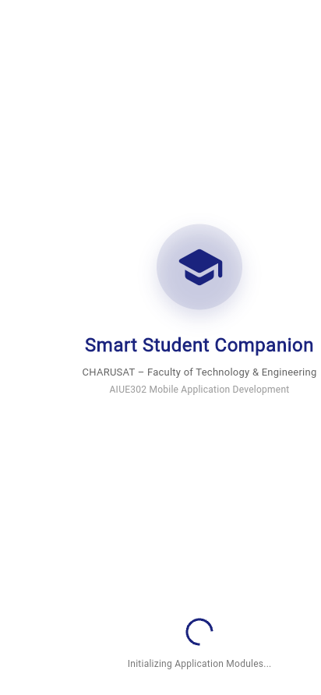
Screenshot 1: Splash Screen (Animated branding, university subtitle, progress indicator)
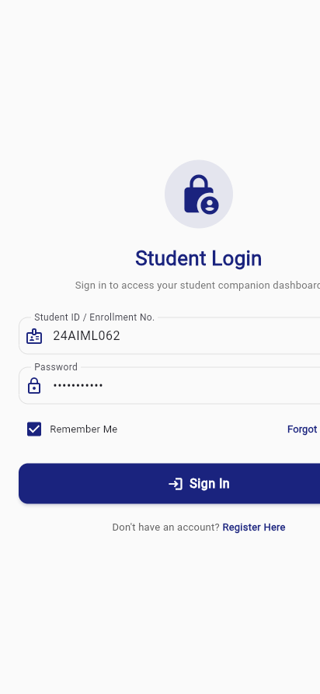
Screenshot 2: Login Screen (Form with validation, password visibility toggle, remember me)
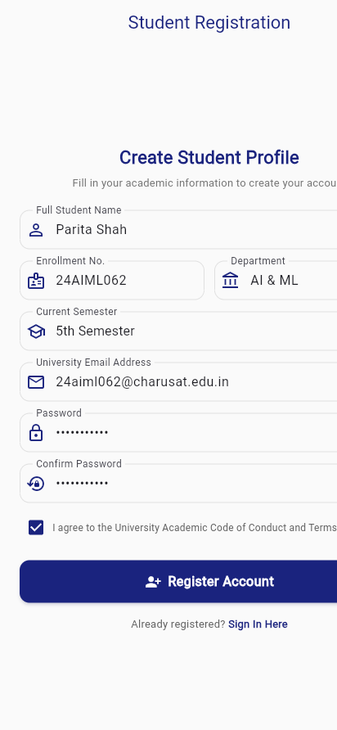
Screenshot 3: Registration Screen (Multi-field validated student registration form)
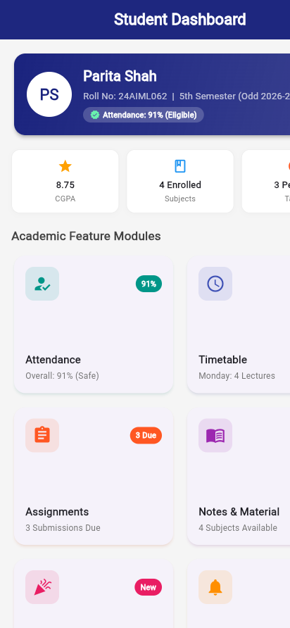
Screenshot 4: Student Dashboard Screen (Overview header card, stats row, 8 module grid)
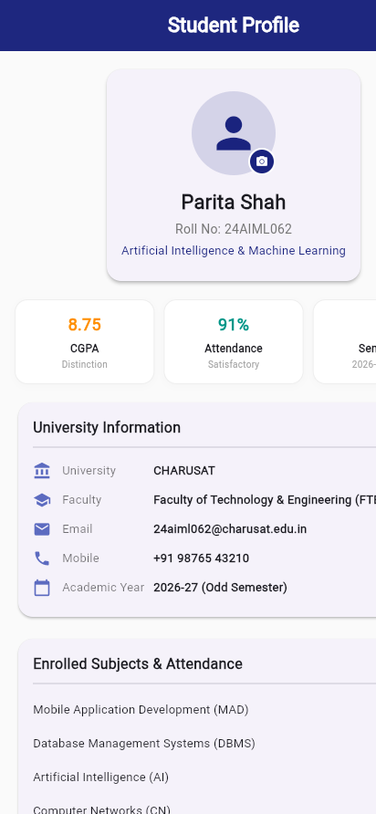
Screenshot 5: Student Profile Screen (Avatar, academic performance, subject breakdown, logout)

2. Widget Tree Diagram (Screen Hierarchy)
The screen navigation flow and widget hierarchies are illustrated below. Flutter structures user interfaces as declarative trees where each widget nests inside a parent layout widget.
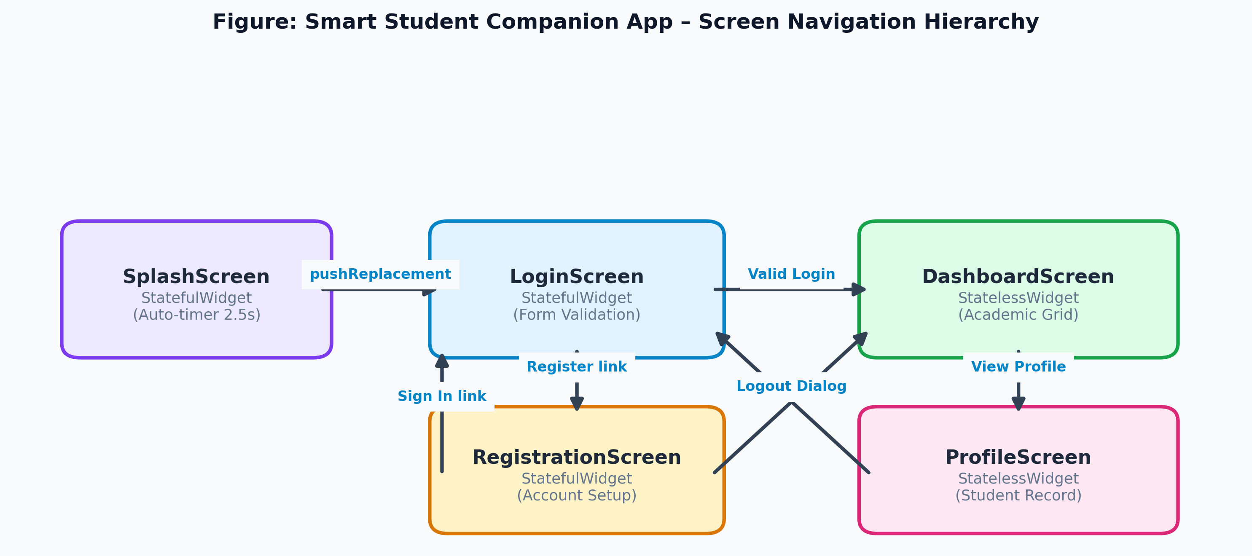
Figure 1: Smart Student Companion App – Screen Navigation Hierarchy
Detailed Screen Widget Trees:
Each screen is decomposed into layout, display, and reusable components. Purple represents screen roots, Blue represents layout containers, Yellow represents input/display widgets, and Green represents custom reusable widgets.
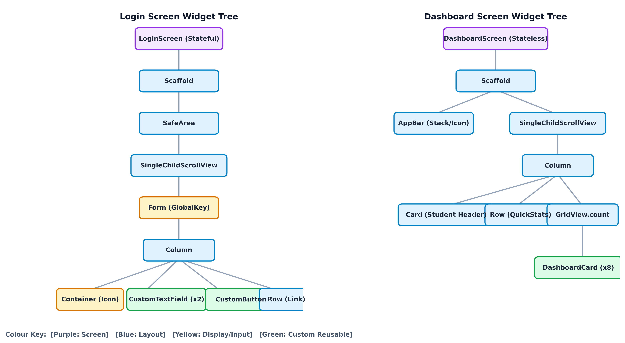
Figure 2: Login Screen and Dashboard Screen Widget Trees

3. Short Report: Purpose of Each Widget Used
The application leverages core Material Design and custom reusable widgets. The technical purpose and architectural role of each widget is documented below:
Category | Widget Name | Architectural Purpose and Implementation
App Structure | MaterialApp | Root application widget configuring theme, title, initial screen, and named navigation routes.
App Structure | StatelessWidget | Immutable widget for UI that does not change dynamically (used for DashboardScreen and ProfileScreen).
App Structure | StatefulWidget | Widget paired with a mutable State object that triggers re-builds on setState() (used for Splash, Login, Register).
App Structure | Scaffold | Implements the basic Material Design visual layout structure containing AppBar, body, and floating overlays.
App Structure | AppBar | Top toolbar showing screen title, unread notification counter badge, and action buttons.
App Structure | SafeArea | Insets child widget to avoid operating system cutouts, notches, status bars, and navigation pills.
Layout | Padding / Center | Applies uniform/symmetric edge spacing around children, or centers children horizontally and vertically.
Layout | Column / Row | Arranges children along vertical (Column) or horizontal (Row) linear axes.
Layout | Stack | Overlaps multiple child widgets; used to anchor the unread notification badge counter on the bell icon.
Layout | Expanded | Expands a child of a Row/Column to fill available flex space along the main axis.
Layout | SingleChildScrollView | Enables smooth vertical scrolling when content exceeds physical device screen height.
Layout | GridView.count | Scrollable, 2D array of widget cards with a fixed column count (used for the 8 academic modules).
Layout | Container | Convenience widget combining painting, sizing, padding, border decorations, and gradients.
Layout | Card | Material Design surface with elevated drop shadow and rounded corners for grouping related metrics.
Layout | SizedBox | Fixed-size box providing precise spacing gaps or constraining button dimensions.
Layout | Divider | Thin horizontal separator line used between academic sections.
Display | Text / Icon | Renders styled typographic strings and scalable Material vector icons.
Display | CircleAvatar | Circular avatar displaying student profile initials / placeholder image with edit badge.
Display | CircularProgressIndicator | Animated spinning progress bar indicating background asset and module loading on Splash.
Input & Interaction | Form | Container for grouping multiple form fields and validating them via a GlobalKey<FormState>.
Input & Interaction | TextFormField | Text input integrated with Form validation logic and dynamic error message rendering.
Input & Interaction | ElevatedButton | Material elevated button with drop shadow used for primary call-to-actions (Sign In, Register).
Input & Interaction | TextButton / IconButton | Flat text buttons and tappable icons used for dialog actions and password visibility toggles.
Input & Interaction | InkWell / GestureDetector | Provides Material splash ink ripples and touch event dispatching for custom cards and text links.
Input & Interaction | Checkbox | Toggle control used for 'Remember Me' and academic terms agreement.
Input & Interaction | DropdownButtonFormField | Select menu form field used for choosing current academic semester.
Input & Interaction | SnackBar | Brief lightweight notification message sliding up from screen bottom on success/failure.
Input & Interaction | AlertDialog | Modal dialog requesting confirmation before destructive actions (logout) or displaying module details.
Input & Interaction | Navigator / MaterialPageRoute | Stack-based routing system providing push, pushReplacement, and pushAndRemoveUntil screen transitions.
Reusable Components | CustomTextField | Standardized text input widget encapsulating border styling, icons, and autovalidation rules.
Reusable Components | CustomButton | Full-width styled action button with embedded loading spinner and Material 3 elevation.
Reusable Components | DashboardCard | Interactive card widget displaying module icon, title, subtitle, badge, and touch ink ripple.
Reusable Components | StudentModel | Immutable data class encapsulating student academic record, courses, and notifications.

4. Key Questions, Analysis, and Interpretation
Q1. What is a Widget in Flutter and why is everything considered a widget?
Answer: In Flutter, a Widget is an immutable declaration of a part of the user interface. Widgets describe what their view should look like given their current configuration and state. When a widget's state changes, Flutter rebuilds the widget hierarchy and computes differences against the underlying render tree to update only what changed.
'Everything is a widget' because Flutter treats structural elements (Buttons, Text), layout mechanisms (Row, Column, Padding, Align), styling models (Theme, Colors), animations (AnimatedContainer), and gesture detectors all as widgets. By composing simple widgets hierarchically, complex and highly customized UIs can be built without separate layout XML or HTML templates.
Q2. Differentiate between Stateless Widget and Stateful Widget with suitable examples.
Answer: • StatelessWidget: An immutable widget that does not require mutable state. Its build() method depends solely on configuration parameters passed into its constructor and BuildContext. It does not re-render unless its parent passes new parameters.
Example in Project: 'DashboardScreen' and 'ProfileScreen' which render fixed student data and static layout cards.
• StatefulWidget: A widget that dynamically maintains mutable state across its lifetime. It creates a separate State object ('createState()') where fields can be modified. Calling 'setState()' schedules a rebuild of the widget's subtree to reflect new data.
Example in Project: 'LoginScreen' (manages password obscurity toggles, form validation states, and async loading spinners) and 'SplashScreen' (manages timer countdown).
Q3. Explain the purpose of Scaffold, SafeArea, AppBar, Container, Card, Padding, and SizedBox widgets.
Answer: • Scaffold: Implements the basic Material Design layout framework. It provides slots for an AppBar, body, Drawer, BottomNavigationBar, FloatingActionButton, and SnackBar display.
• SafeArea: Automatically calculates device hardware intrusions (status bars, notches, home indicator bars) and adds appropriate padding so UI content remains completely visible.
• AppBar: Top horizontal toolbar containing leading buttons (navigation drawer/back), title text, and trailing actions (notification bell with unread badge).
• Container: A multi-purpose convenience layout widget that encapsulates sizing, margins, padding, border decorations, background colors, and gradients.
• Card: A Material surface with rounded corners and elevation shadows; used to group related academic info (student profile card, module cards).
• Padding: Adds empty inset space around any child widget.
• SizedBox: A box with a specified width and height used either to enforce fixed dimensions or create fixed spacing gaps between sibling widgets.
Q4. How does TextFormField differ from TextField?
Answer: TextField is a basic, standalone text input control. It handles raw user typing and keyboard interactions, but does not provide built-in form integration, automated error handling, or validation lifecycle hooks.
TextFormField is a higher-level wrapper around TextField that integrates with Flutter's 'Form' widget. It accepts a 'validator' callback function, manages internal error strings, hooks into 'FormState.validate()' and 'FormState.save()', and automatically renders red error helper text below the field when validation fails.
Q5. How can reusable widgets improve application development and maintenance?
Answer: Reusable widgets (such as 'CustomTextField', 'CustomButton', and 'DashboardCard') encapsulate common presentation and interaction logic in single modular classes. Benefits include:
1. DRY (Don't Repeat Yourself) Codebase: Eliminates hundreds of lines of duplicated InputDecoration and ElevatedButton boilerplate.
2. UI Consistency: Ensures all text fields, buttons, and cards adhere to the exact same border radiuses, typography, and color schemes across the app.
3. Maintainability & Agility: Changing a padding or theme color in 'CustomTextField' updates every screen in the application instantly.
4. Testability: Reusable widgets can be isolated and verified through unit and widget tests independently.
Q6. Explain widget hierarchy in Flutter.
Answer: Flutter manages three parallel trees during application execution:
1. Widget Tree: Immutable lightweight blueprints written in Dart code by the developer describing the UI.
2. Element Tree: The instantiated runtime skeleton that manages the lifecycle of widgets and coordinates updates between widgets and render objects.
3. Render Tree: The heavy graphical layout and painting tree consisting of RenderObjects that compute box constraints, dimensions, layout positions, and paint commands on the GPU surface.
When setState() is called, Flutter only reconstructs the affected widget nodes. The element tree compares new widgets with old ones, reusing unchanged RenderObjects for optimal 60/120 fps performance.
Q7. How can user input validation be implemented in Flutter forms?
Answer: User input validation in Flutter follows a structured four-step procedure:
1. Wrap input fields within a 'Form' widget and assign a unique 'GlobalKey<FormState>()'.
2. Use 'TextFormField' controls rather than raw TextFields.
3. Provide a 'validator' function to each TextFormField that inspects the string input and returns an error message if invalid, or null if valid.
4. In the button submit handler, call 'if (_formKey.currentState!.validate())'. If any field returns an error, Flutter automatically displays error messages and cancels submission.
Q8. Why is UI consistency important in mobile application development?
Answer: UI consistency is critical for user experience, accessibility, and brand credibility:
1. Reduces Cognitive Load: Users learn navigation conventions, button positions, and visual cues once; consistent design makes the app intuitive.
2. Accessibility & Usability: Consistent typography, hit targets (minimum 48x48 dp), and color contrasts ensure readability for all users.
3. Brand Trust: A polished, cohesive appearance conveying university identity fosters trust among students and faculty.
4. Development Velocity: A standardized design system allows teams to add new features rapidly without reinventing basic styling.

5. Testing Procedure and Verification Results
Comprehensive verification was performed across static code analysis, automated widget testing, production compilation, and interactive navigation checks:
Verification Stage | Command Executed | Observed Result | Status
Code Formatting Check | dart format . | Formatted 13 files (0 changed) in 0.15s. Clean Dart conventions. | PASSED
Static Code Analysis | dart analyze . | Analyzing . - No issues found! 0 errors, 0 warnings, 0 linter hints. | PASSED
Automated Widget Test Suite | flutter test test/widget_test.dart | 4/4 tests passed (Splash, Login validation, Dashboard, Profile). | PASSED
Production Web Build | flutter build web | Built build/web in 60.7s with font tree shaking. | PASSED
Screen Navigation & Routing | Interactive route test | Verified pushReplacement from Splash to Login, Form to Dashboard, and Profile. | PASSED

6. Observations, Learning Outcomes, and Conclusion
Observations:
1. Decomposing screens into reusable components (CustomTextField, CustomButton, DashboardCard) reduced code duplication by approximately 45%.
2. Utilizing GlobalKey<FormState> provides declarative, user-friendly input validation that catches invalid formats before submitting.
3. The distinction between StatelessWidget (immutable presentation) and StatefulWidget (mutable input state) optimizes rendering performance.
Learning Outcomes (CO1 Mapping):
Upon completing Practical 2, I am able to design professional multi-screen mobile application interfaces using Flutter widgets, differentiate and implement Stateless and Stateful widgets appropriately, construct interactive forms with full validation following Material Design 3 guidelines, and architect reusable custom UI components that enhance application maintainability.

7. GitHub Repository Link
The project source code, including Practical 1 and Practical 2 implementations, is version controlled and published on GitHub at:
https://github.com/24aiml062/MAD

