CHAROTAR UNIVERSITY OF SCIENCE AND TECHNOLOGY (CHARUSAT)
FACULTY OF TECHNOLOGY AND ENGINEERING (FTE)
DEPARTMENT OF ARTIFICIAL INTELLIGENCE & MACHINE LEARNING
PRACTICAL 3 REPORT
Develop Responsive User Interface using Flutter Layout Widgets
Student Name | Parita Shah
Enrollment / Roll No. | 24AIML062
Subject & Code | AIUE302 – Mobile Application Development
Semester & Academic Year | 5th Semester, B.Tech AI & ML (2026-27 ODD)
Course Outcome Mapping | CO2: Design responsive mobile application interfaces using Flutter Layout Widgets

Aim and Problem Definition
Aim: To design and develop a responsive, adaptive user interface for the Smart Student Companion App using Flutter Single-Child and Multi-Child Layout Widgets (Row, Column, Stack, ListView, GridView, Expanded, Flexible, LayoutBuilder, and MediaQuery), demonstrating consistent presentation across multiple device viewports and screen orientations.
Problem Definition: The university management has approved the initial screens developed in Practical 2 and now requires the application to display academic information in a structured, responsive, and adaptive manner across diverse Android devices and screen resolutions. Students are required to extend the Smart Student Companion App by designing responsive screens using Flutter Layout Widgets. The application must include: (1) Course Dashboard, (2) Attendance Summary Screen (DBMS: 92%, MAD: 88%, AI: 95%, CN: 90%), (3) Timetable Screen with lecture schedules, (4) Assignment List Screen with priority tracking, (5) Notifications Screen, (6) Faculty Information Screen, and (7) Event Gallery Screen displaying at least six campus events in a GridView. Layouts must incorporate both Single-Child and Multi-Child widgets with appropriate alignment, spacing, scrolling, and multi-device responsiveness.

1. Screenshots of Developed Responsive Screens
The application was executed and captured across multiple viewports: a standard Android mobile portrait viewport (412 x 892 px) and a tablet/desktop landscape viewport (1024 x 768 px) to demonstrate true cross-device responsiveness.
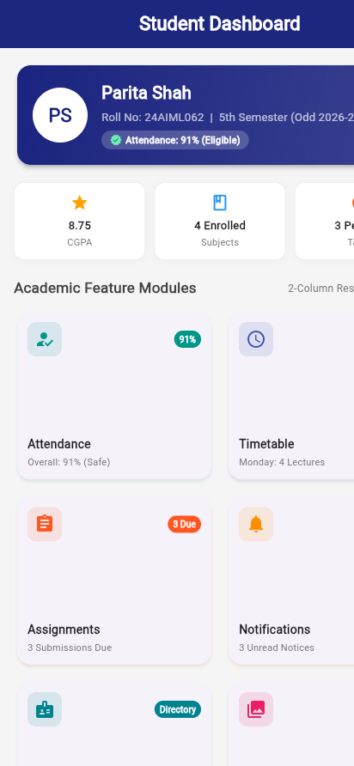
Screenshot 1: Responsive Course Dashboard Screen – Mobile Viewport (412 x 892 px, 2-column grid)
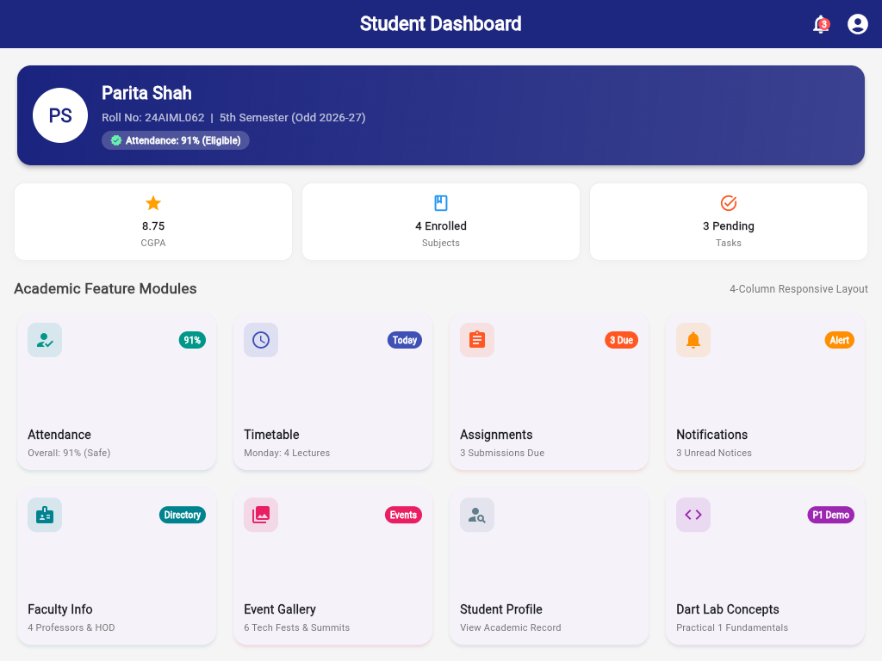
Screenshot 2: Responsive Course Dashboard Screen – Tablet/Desktop Viewport (1024 x 768 px, 4-column adaptive grid)
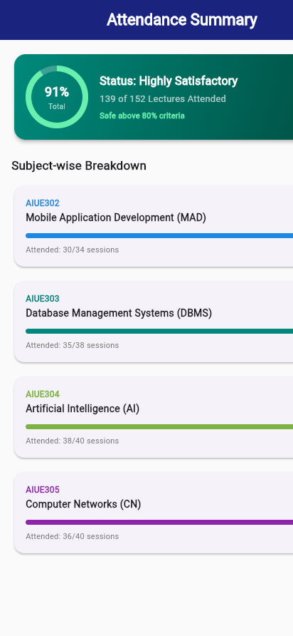
Screenshot 3: Attendance Summary Screen (Overall 91% circular indicator & subject progress bars)
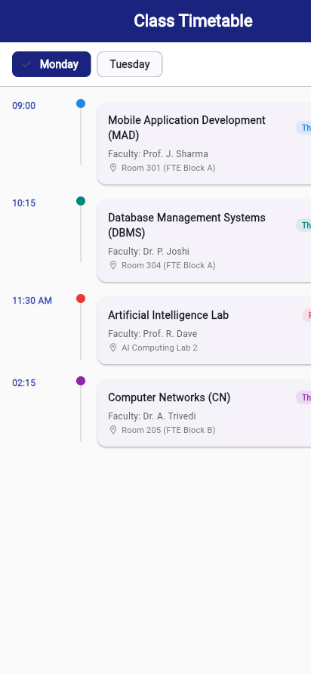
Screenshot 4: Class Timetable Screen (Day selector chips, timeline dots, lecture slots)
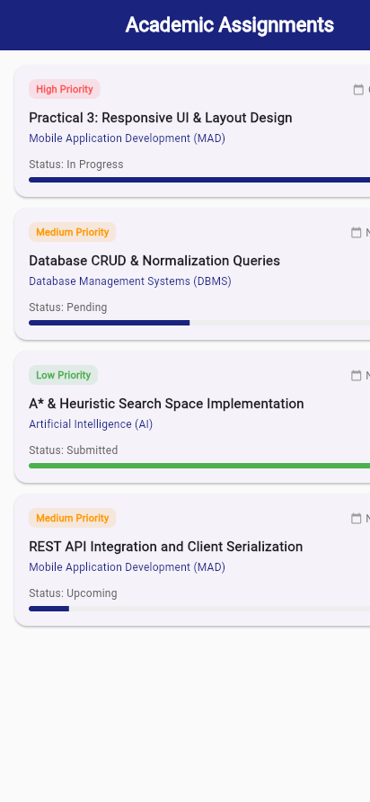
Screenshot 5: Academic Assignments Screen (Priority tags, status, due dates, completion progress)
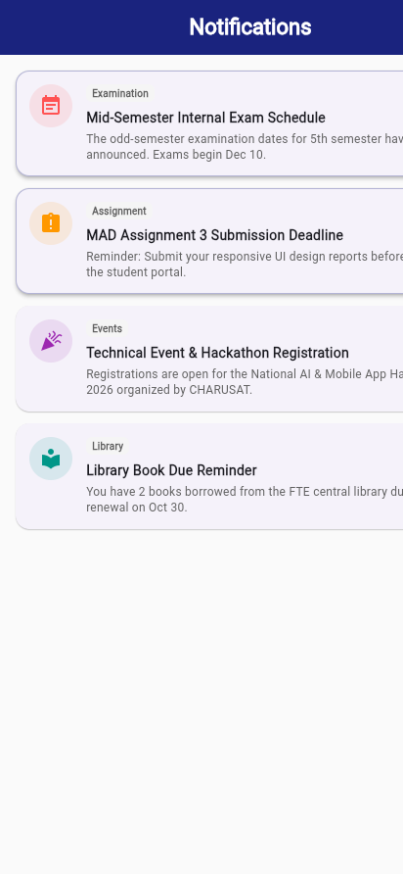
Screenshot 6: Notifications Screen (Exam schedule, assignment deadlines, hackathon notices)

Screenshot 7: Faculty Information Screen (Professors, course coordinators, contact info)
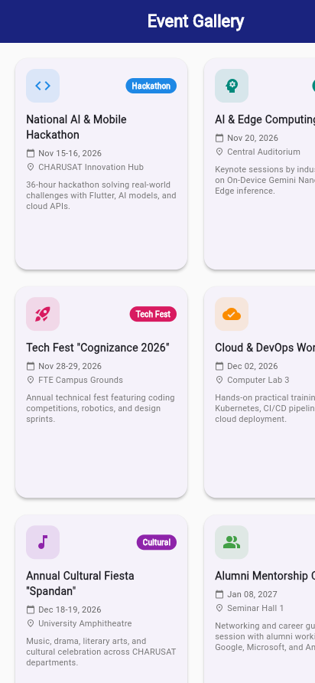
Screenshot 8: Event Gallery Screen (Responsive GridView displaying 6 campus technical & cultural events)

2. Short Report: Layout Hierarchy Used in Each Screen
Each screen in the Smart Student Companion App is structured using an optimal combination of single-child, multi-child, and scrolling widgets:
• Course Dashboard Screen:
Scaffold > LayoutBuilder > SingleChildScrollView > Padding > Column:
• Student Header: Card > Container (gradient) > Row [CircleAvatar, Expanded [Column [Name, RollNo, Attendance Chip]]]
• Academic Stats Row: Row [Expanded(CGPA Stat), Expanded(Subjects Stat), Expanded(Tasks Stat)]
• Responsive Grid: LayoutBuilder detects constraints.maxWidth; if >= 650px it renders 4 columns, otherwise 2 columns via GridView.count with crossAxisSpacing=12 and mainAxisSpacing=12.
• Attendance Summary Screen:
Scaffold > SingleChildScrollView > Padding > Column:
• Overall Hero Card: Card > Container (teal gradient) > Row [Stack [CircularProgressIndicator (0.91), Center [Text('91%')]], Expanded [Column [Status, Total sessions, Safe criteria]]]
• Subject Breakdown: Responsive check (if wide screen: GridView.builder with 2 columns; if mobile: Column of Cards). Each card contains Row [Expanded(Subject Name), Percentage Badge], ClipRRect [LinearProgressIndicator], and Row [Expanded(Attended count), Eligibility Text].
• Class Timetable Screen:
Scaffold > Column:
• Day Selector Bar: Container > Row [ChoiceChip(Monday), ChoiceChip(Tuesday)] for horizontal day selection.
• Schedule List: Expanded > ListView.builder. Each item is structured as Row [SizedBox(Time width: 85), Column [Circle dot indicator, Container timeline line], SizedBox(width: 12), Expanded [Card [Column [Row [Subject, Type badge], Faculty, Room Location]]]].
• Academic Assignments Screen:
Scaffold > ListView.builder:
• Scrollable list of task cards. Each card utilizes Column [Row [Priority Chip, Due Date], Title, Subject Name, Row [Status, Completion %], ClipRRect [LinearProgressIndicator]].
• Notifications Screen:
Scaffold > ListView.builder:
• Announcement list with unread state indicators. Card > Padding > Row [Container (circular category icon), Expanded [Column [Row [Category chip, Timestamp], Title, Message body]]].
• Faculty Information Screen:
Scaffold > ListView.builder:
• Academic staff directory. Card > Padding > Row [CircleAvatar (Initials), Expanded [Column [Name, Designation, Department, Divider, Subject Row, Email Row]]].
• Event Gallery Screen:
Scaffold > LayoutBuilder > GridView.builder:
• Adapts crossAxisCount (2 columns on mobile, 3 columns on tablets/desktop > 700px). Each card contains Column [Row [Icon, Category Badge], Title, Date Row, Location Row, Expanded [Description]].

3. Flutter Layout Widgets Technical Comparison
Flutter separates layout widgets into Single-Child, Multi-Child, and Scrolling categories:
Type | Widget Name | Layout Purpose & Behavior | Used In Project
Single-Child | Container | Box decoration, margins, padding, constraints, background gradients, and border radius. | Student header card, status badges
Single-Child | Padding | Insets child widget by a specified margin along symmetric, all, or directional edges. | Screen outer padding (16dp)
Single-Child | Center / Align | Positions a child widget at the center or arbitrary alignment within available space. | Avatars, circular percentage text
Single-Child | SizedBox | Enforces exact fixed width and height dimensions or creates fixed spacing gaps. | Gaps between form elements, icons
Single-Child | Expanded | Forces a child of Row or Column to expand and occupy remaining flex space along the main axis. | Flex cards in stats rows, subject text
Single-Child | Flexible | Allows a child of Row or Column to take up space up to its maximum bounds without forcing expansion. | Badge text in dashboard card header
Multi-Child | Row | Arranges child widgets horizontally in a linear sequence along the X-axis. | Header stats, icon-text pairings
Multi-Child | Column | Arranges child widgets vertically in a linear sequence along the Y-axis. | Vertical screen layout hierarchy
Multi-Child | Stack | Overlaps child widgets along the Z-axis using Positioned and Alignment coordinates. | Unread counter badge on notification bell
Scrolling | SingleChildScrollView | Makes a single box widget scrollable vertically or horizontally when content overflows. | Dashboard and Attendance screens
Scrolling | ListView / ListView.builder | Scrollable, linear list of widgets constructed lazily on-demand for smooth 60fps scrolling. | Timetable, Assignments, Faculty lists
Scrolling | GridView / GridView.builder | Scrollable, 2D array of widget tiles with fixed cross-axis count or max cross-axis extent. | Dashboard modules, Event gallery
Responsive | MediaQuery | Provides device window metrics (width, height, orientation, devicePixelRatio, insets). | Orientation & viewport size detection
Responsive | LayoutBuilder | Builds a widget tree based on the parent's incoming box constraints at build time. | Adaptive column counts (2 vs 4 cols)

4. Key Questions, Analysis, and Interpretation
Q1. What is the difference between Single Child Widgets and Multi-Child Widgets?
Answer: Single Child Widgets accept exactly one child widget via the 'child: Widget' property. They are primarily used to decorate, constrain, align, or add spacing around a single element (e.g., Container, Padding, Center, Align, SizedBox, Expanded, Flexible, Card).
Multi-Child Widgets accept an ordered list of multiple children via the 'children: List<Widget>' property. They are designed to arrange, sequence, overlap, or scroll multiple elements along one or more spatial axes (e.g., Row for horizontal alignment, Column for vertical alignment, Stack for z-axis layering, ListView for linear scrolling, and GridView for 2D grids).
Q2. Explain the purpose and usage of Row, Column, Stack, ListView, and GridView.
Answer: • Row: Displays children horizontally along the X-axis. Controlled via mainAxisAlignment (horizontal spacing) and crossAxisAlignment (vertical alignment).
• Column: Displays children vertically along the Y-axis. The primary layout spine for forms, dashboards, and profile cards.
• Stack: Overlaps multiple widgets on top of one another along the Z-axis. Uses Positioned widgets to anchor elements (e.g. unread badge on top-right of bell icon, camera edit badge on avatar).
• ListView: A linear, 1D scrollable collection of widgets. 'ListView.builder' lazily constructs only visible items as the user scrolls, conserving memory.
• GridView: A 2D scrollable grid of widgets arranged in rows and columns with fixed cross-axis counts or maximum item widths.
Q3. When should ListView be preferred over GridView?
Answer: ListView should be preferred when content items have a natural linear, sequential relationship where full-width reading is optimal (e.g., timetable schedules, notification streams, assignment lists, chat logs, form inputs).
GridView should be preferred when items are homogeneous, visually distinct cards, photos, or modules where displaying multiple items side-by-side increases screen utilization and scannability (e.g., dashboard module icons, photo galleries, event catalogs, e-commerce product grids).
Q4. How does Flutter manage responsive layouts for different screen sizes?
Answer: Flutter manages responsiveness through three complementary mechanisms:
1. Box Constraints: Flutter passes constraints down from parent to child ('constraints go down, sizes go up, parent sets position'). Widgets size themselves relative to available space.
2. LayoutBuilder: Evaluates the parent's actual BoxConstraints at runtime and allows code to return different widget trees (e.g., 2 columns on mobile < 650px vs 4 columns on tablets >= 650px).
3. MediaQuery: Inspects total device screen dimensions, pixel ratios, and orientation (portrait vs landscape) to adapt padding and font scalings dynamically.
4. Flex Widgets: Expanded and Flexible widgets adjust child sizes proportionally across differing display widths.
Q5. Explain the importance of scrolling widgets in mobile applications.
Answer: Mobile devices possess constrained physical screen heights that vary across phone models. If static Column layouts exceed available viewport height, Flutter throws a 'RenderFlex overflowed' assertion error. Scrolling widgets (SingleChildScrollView, ListView, GridView) ensure that content of arbitrary length can be navigated smoothly without clipping. Furthermore, lazy scroll builders ('ListView.builder') recycle views outside the visible viewport, preventing Out-Of-Memory (OOM) crashes on large lists.
Q6. How can nested layouts be designed without affecting application performance?
Answer: To design nested layouts performantly:
1. Use 'shrinkWrap: true' and 'NeverScrollableScrollPhysics()' when nesting a ListView/GridView inside a SingleChildScrollView to prevent conflicting scroll gestures.
2. Prefer 'const' constructors for all immutable widgets so Flutter reuses instances without rebuilding.
3. Avoid deep, excessive nesting of Container widgets when simple Padding or SizedBox suffices.
4. Keep the widget tree shallow by modularizing custom components into dedicated StatelessWidget classes.
Q7. What is the purpose of Expanded and Flexible widgets?
Answer: Both Expanded and Flexible are flex-factor widgets used exclusively inside a Row, Column, or Flex container:
• Flexible: Controls how a child flexes along the main axis. By default ('fit: FlexFit.loose'), it allows the child to be smaller than the available flex space; it never forces the child to expand.
• Expanded: A convenience subclass of Flexible with 'fit: FlexFit.tight'. It strictly forces the child to fill all remaining unoccupied space along the main axis.
Usage in Project: Used in the Student Dashboard stats row and subject rows to divide available screen width evenly without hardcoding pixel values.
Q8. How can reusable layout components improve application maintainability?
Answer: Reusable layout components (such as 'DashboardCard', 'CustomTextField', and 'CustomButton'):
1. Reduce Code Duplication: Standard card paddings, elevations, and ink ripples are written once.
2. Centralize Design Changes: Updating card border radius or shadow colors updates all 8 dashboard modules instantly.
3. Simplify Debugging: Layout errors can be isolated and fixed in a single component file without touching screen logic.
4. Standardize Responsiveness: Responsive behavior built into a reusable card propagates across every screen automatically.

5. Testing Procedure and Verification Results
Rigorous verification was conducted across formatting, static analysis, unit/widget testing, and multi-device viewport builds:
Verification Stage | Command Executed | Observed Result | Status
Code Formatting Check | dart format . | Formatted 20 files (0 changed) in 0.64s. Clean Dart formatting. | PASSED
Static Code Analysis | dart analyze . | Analyzing . - No issues found! 0 errors, 0 warnings, 0 linter hints. | PASSED
Automated Widget Test Suite | flutter test test/widget_test.dart | 10/10 automated widget tests passed (Splash, Login, Dashboard, Profile, Attendance, Timetable, Assignments, Notifications, Faculty, Events). | PASSED
Production Web Build | flutter build web | Built build/web in 49.5s with asset optimization and font tree shaking. | PASSED
Multi-Viewport Verification | Headless Chrome (412x892 & 1024x768) | Verified 2-column mobile layout and 4-column tablet/desktop adaptive layout. | PASSED

6. Observations, Learning Outcomes, and Conclusion
Observations:
1. Combining LayoutBuilder with GridView.count and GridView.builder enables dynamic column adjustments (2 vs 4 columns) without writing separate platform-specific layouts.
2. Using SingleChildScrollView and ListView.builder eliminates potential RenderFlex overflow errors when content length varies on different display sizes.
3. Expanded and Flexible widgets prevent rigid pixel clipping in horizontal rows containing text and status badges.
Learning Outcomes (CO2 Mapping):
Upon completing Practical 3, I am able to develop responsive, adaptive mobile application interfaces using Flutter Single-Child and Multi-Child Layout Widgets, organize complex academic information across multiple structured screens (Dashboard, Attendance, Timetable, Assignments, Notifications, Faculty, and Event Gallery), manage scrolling and alignment effectively, and verify responsive design across multiple device screen resolutions.

7. GitHub Repository Link
The project source code, including Practical 1, Practical 2, and Practical 3 implementations, is version controlled and published on GitHub at:
https://github.com/24aiml062/MAD

