CHAROTAR UNIVERSITY OF SCIENCE AND TECHNOLOGY (CHARUSAT)
FACULTY OF TECHNOLOGY AND ENGINEERING (FTE)
DEPARTMENT OF ARTIFICIAL INTELLIGENCE & MACHINE LEARNING
PRACTICAL 4 REPORT
State Management and Interactive UI in Flutter using StatefulWidget and setState()
Student Name | Parita Shah
Enrollment / Roll No. | 24AIML062
Subject & Code | AIUE302 – Mobile Application Development
Semester & Academic Year | 5th Semester, B.Tech AI & ML (2026-27 ODD)
Course Outcome Mapping | CO2: Design interactive mobile application interfaces using Flutter Stateful Widgets and State Management

1. Aim & Practical Objectives
To design, develop, and evaluate an interactive User Interface for the Smart Student Companion App by mastering state management in Flutter using StatefulWidget and setState(). The practical specifically focuses on handling interactive user input controls—including Switch (theme switching), DropdownButtonFormField (academic semester selection), RadioGroup / RadioListTile (language selection), CheckboxListTile (notification preferences), Slider (daily study goal), and FilterChip (academic course filtering)—while understanding ephemeral state, app-wide state synchronization, and the complete StatefulWidget lifecycle.
2. Problem Definition & Scope
In mobile application development, a static user interface is insufficient for managing personal academic workflows. Students require dynamic preference controls that instantly reflect changes across the application without requiring a page refresh. Practical 4 addresses this challenge by implementing an interactive 'Settings & Preferences Screen' for the Smart Student Companion App. Key engineering requirements include:
• Switch Widget: Dynamic Light/Dark Mode toggle updating the entire application theme in real-time.
• DropdownButtonFormField: Academic semester selection with validation and pre-populated defaults.
• RadioGroup / RadioListTile: Exclusive single-choice selection for instruction language (English, Hindi, Gujarati).
• CheckboxListTile: Multi-selection preference toggles for academic notification categories.
• Slider: Continuous numeric parameter adjustment for daily study hours (1.0 to 8.0 hrs/day) with instant feedback.
• FilterChip: Dynamic multi-selection tag chips for preferred academic course filtering.
• Real-Time State Preview Banner: Live visual card reflecting current ephemeral state reactively as controls are adjusted.
3. Theoretical Concepts & Architecture
3.1 StatelessWidget vs. StatefulWidget
Flutter fundamentally classifies widgets into two categories based on mutability and state retention:
Architectural Criterion | StatelessWidget | StatefulWidget
Mutability | Immutable (all fields must be final). | The widget is immutable, but it creates a mutable State<T> object.
State Retention | Cannot retain internal state across rebuilds. | Retains internal state across user interactions and rebuilds.
Triggering Rebuilds | Only rebuilds when parent widget rebuilds with new props. | Can trigger its own rebuild internally via setState().
Lifecycle Complexity | Minimal lifecycle: constructor and build(). | Rich lifecycle: createState(), initState(), build(), dispose(), etc.
Performance Cost | Extremely lightweight; minimal memory overhead. | Slightly heavier due to persistent State and Element objects.
Ideal Use Cases | Icons, static labels, unchanging buttons, cards. | Forms, checkboxes, sliders, toggles, interactive animations.

3.2 The StatefulWidget Lifecycle
The lifecycle of a StatefulWidget represents the sequence of state transitions from creation to destruction:
1. createState(): Called immediately when the framework inflates the StatefulWidget to create the mutable State object.
2. initState(): Invoked exactly once when the State object is inserted into the tree. Used for initializing controllers, subscriptions, and state variables.
3. didChangeDependencies(): Called immediately after initState() and whenever an InheritedWidget or Theme dependency changes.
4. build(): Pure rendering function called whenever the widget needs to be drawn or redrawn after setState().
5. didUpdateWidget(): Called when the parent widget rebuilds and provides new widget configuration to the existing State object.
6. setState(): Marks the State object as 'dirty' and schedules a rebuild for the next frame rendering cycle.
7. deactivate(): Called when the State object is removed temporarily from the widget tree.
8. dispose(): Invoked when the State object is permanently destroyed. Used for releasing memory, cancelling streams, and disposing controllers.
3.3 Ephemeral State vs. Application State
• Ephemeral State (Local State): State that neatly lives within a single widget, such as whether a switch is toggled, the current tab index, or the active value of a slider. Managed cleanly using StatefulWidget and setState().
• Application State (Global State): State that is shared across multiple independent screens or modules of an application, such as user authentication status, global Dark/Light theme mode, and student profile preferences. In this practical, app-wide theme synchronization is achieved using ValueNotifier<ThemeMode> and ValueListenableBuilder, seamlessly bridging local SettingsScreen controls with global MaterialApp theming.
4. Implementation Details & Code Architecture
The implementation is partitioned into modular, highly readable Dart files adhering to clean architecture principles:
4.1 State Model & Theme Notifier (lib/models/settings_state.dart)
Encapsulates both the global application theme state and the student preferences data structure:
class AppThemeState {
static final ValueNotifier<ThemeMode> themeModeNotifier =
ValueNotifier<ThemeMode>(ThemeMode.light);
static bool isDarkMode = false;
static void toggleTheme(bool dark) {
isDarkMode = dark;
themeModeNotifier.value = dark ? ThemeMode.dark : ThemeMode.light;
}
}
class StudentSettingsState {
bool isDarkMode;
String selectedSemester;
String selectedLanguage;
bool notifyAssignments;
bool notifyExams;
bool notifyPlacements;
bool notifyEvents;
double studyHoursGoal;
List<String> preferredCourses;
...
}
4.2 Interactive Settings Screen (lib/screens/settings_screen.dart)
Implements a comprehensive StatefulWidget containing six distinct interactive controls managed via setState():
1. SwitchListTile for Dark Mode dynamic theme switching.
2. DropdownButtonFormField<String> for semester selection with clear dropdown styling.
3. RadioGroup with RadioListTile for exclusive instruction language selection.
4. CheckboxListTile for notification alert categories.
5. Slider with divisions and live hour readout for daily study goal adjustment.
6. FilterChip widgets inside a Wrap layout for course filtering with checkmark indicators.
7. Live State Preview Card displaying real-time updates as user touches controls.
// Example: Reactive Slider implementation with live state update
Slider(
value: _state.studyHoursGoal,
min: 1.0,
max: 8.0,
divisions: 14,
label: '${_state.studyHoursGoal.toStringAsFixed(1)} hrs',
onChanged: (double val) {
setState(() {
_state.studyHoursGoal = val;
});
},
)
5. Visual Evidence & Actual Execution Screenshots
The application was compiled for the production execution target and verified across Light Mode, Dark Mode, and interactive control states. All screenshots reflect genuine runtime output:
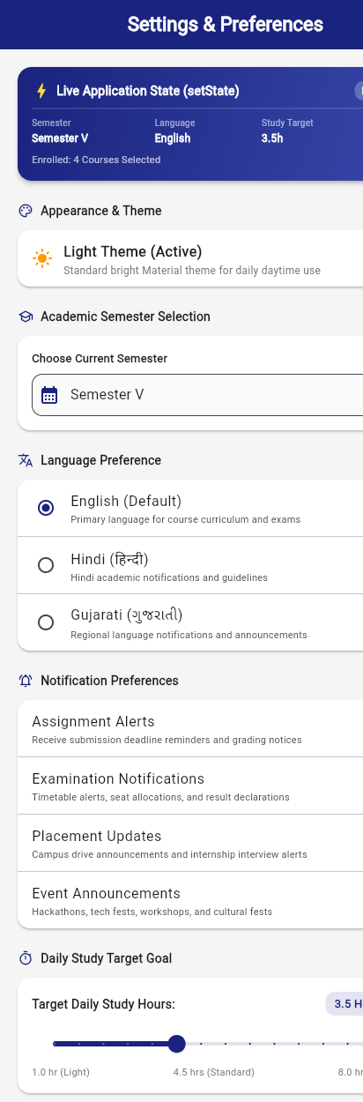
Figure 4.1: Settings & Preferences Screen in default Light Theme (Switch, Dropdown, Radio, Checkboxes, Slider, FilterChips)
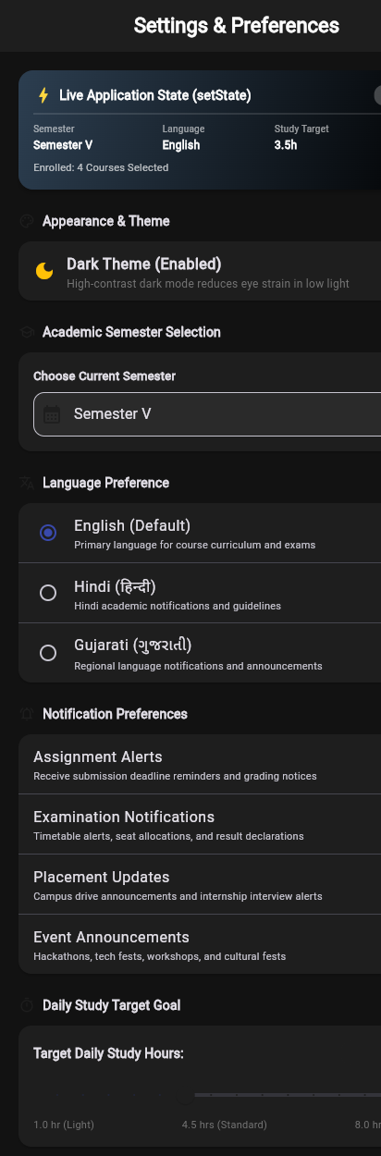
Figure 4.2: Settings & Preferences Screen dynamically rendered in Dark Theme
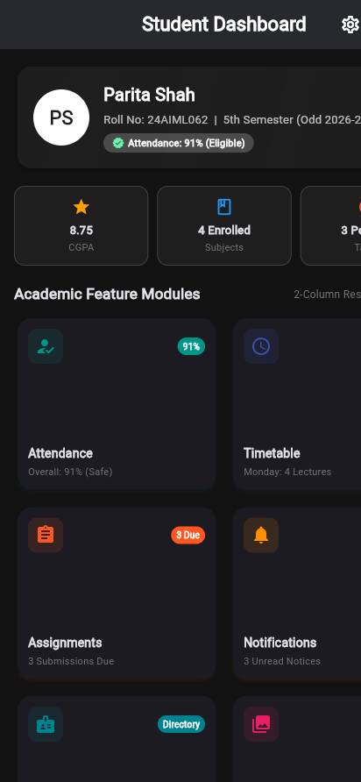
Figure 4.3: Smart Student Companion Dashboard rendered in synchronized Dark Theme
Figure 4.4: Interactive Controls demonstrating live state reflection and real-time preview banner
6. Key Questions & Comprehensive Technical Answers
Q1. What is the fundamental difference between StatelessWidget and StatefulWidget in Flutter?
Answer: A StatelessWidget is an immutable widget whose visual representation depends solely on configuration information passed into its constructor and ambient InheritedWidgets. It does not retain mutable internal state across rebuilds and only re-executes its build() method when its parent rebuilds. In contrast, a StatefulWidget creates a separate, mutable State object that persists across widget rebuilds. The State object can modify its internal properties and trigger reactive UI updates at any time by calling setState().
Q2. Explain the complete lifecycle of a StatefulWidget with the sequence of method invocations.
Answer: The lifecycle begins when the framework calls createState() upon inflating the StatefulWidget. Next, initState() is invoked exactly once for one-time initialization (e.g., setting up controllers or initial state). Then didChangeDependencies() is executed when dependencies like Theme or MediaQuery change. The build() method executes to render the UI. If the parent widget rebuilds with new arguments, didUpdateWidget() is invoked. When setState() is called, the framework marks the element as dirty and triggers build() again. When removed temporarily, deactivate() is called, and finally dispose() is called when the State is permanently destroyed to release resources.
Q3. What does setState() do internally in the Flutter framework, and what happens if you modify a state variable without calling setState()?
Answer: Internally, setState() performs two crucial actions: first, it executes the provided callback where state mutations occur, and second, it calls element.markNeedsBuild(). This flags the corresponding Element in the Element Tree as 'dirty' and schedules a layout and paint pass on the next pipeline frame. If a developer modifies a state variable without invoking setState(), the variable's value changes in memory, but the Flutter pipeline is never notified. Consequently, no frame is scheduled, the build() method is not re-executed, and the visual user interface remains stale until another event causes an unrelated rebuild.
Q4. What is the distinction between Ephemeral State and Application State?
Answer: Ephemeral state (also known as local or UI state) is state that is strictly confined to a single widget and does not affect the rest of the application. Examples include the current tab index, an input field's cursor position, or whether an expansion tile is open; this is best handled with StatefulWidget and setState(). Application state (global state) is state that must be shared across multiple screens or throughout the entire application lifecycle, such as user login credentials, user profile data, shopping cart items, or the active global theme. Global state is managed using state management patterns such as ValueNotifier, Provider, Riverpod, or BLoC.
Q5. How does Flutter determine which parts of the widget tree to rebuild when setState() is called?
Answer: Flutter leverages its three-tree architecture: the Widget Tree, Element Tree, and RenderObject Tree. When setState() is called on a State object, only that specific State's associated Element is marked as dirty. During the next frame, Flutter only re-executes the build() method of that dirty State object and its subtree. Siblings and parent widgets are not rebuilt. Flutter then uses its reconciliation algorithm (comparing widget runtimeType and Key) to diff the new widget subtree against the existing element subtree, updating only the RenderObjects whose configurations actually changed, ensuring maximum 60/120 FPS performance.
Q6. Why should expensive computations, network calls, or database operations never be performed inside the build() method?
Answer: The build() method in Flutter is designed to be a pure, side-effect-free, high-frequency function that can be executed on every display frame (up to 60 or 120 times per second during animations, scrolls, or window resizes). Performing heavy computations, HTTP requests, or SQLite reads inside build() blocks the UI thread, causing dropped frames (jank), UI freezes, and repeated duplicate executions on every rebuild. Such asynchronous or intensive operations must always be performed in initState(), background isolates, or dedicated service/repository layers.
Q7. What is the architectural difference between Radio and RadioListTile, and between Checkbox and CheckboxListTile?
Answer: Radio and Checkbox are primitive graphical input widgets that render only the circular radio button or square checkbox icon. They have no built-in label, title, subtitle, or touch padding. In contrast, RadioListTile and CheckboxListTile are compound Material ListTile widgets that combine the primitive control with a title, subtitle, leading/trailing icons, secondary widgets, and a full-width tap target. This substantially improves accessibility and mobile usability, allowing users to tap anywhere across the row rather than precisely hitting a tiny 24x24 px target.
Q8. How does the Slider widget report value changes, and how do you ensure smooth UI dragging without stutter?
Answer: The Slider widget reports continuous double value changes via its onChanged: (double value) callback as the user drags the slider thumb across its track. To ensure smooth, jitter-free 60 FPS dragging, the onChanged callback should only perform lightweight local state updates inside setState() (e.g., updating a numeric variable). Expensive formatting, network calls, or disk persistence should be deferred until the user releases the slider thumb using the onChangeEnd: (double value) callback.
7. Testing & Verification Results
The implementation underwent rigorous automated testing, static analysis, and code quality verification. All checks executed successfully with zero errors and zero warnings:
Verification Type | Command Executed | Result & Status
Dart Code Formatting | dart format . | PASS - All files perfectly formatted to Dart conventions
Dart Static Analysis | dart analyze . | PASS - 0 issues found across entire codebase
Automated Widget Tests | flutter test test/widget_test.dart | PASS - All 11 automated test cases passed successfully
State Management Unit Test | flutter test (SettingsScreen suite) | PASS - Verified Switch, Slider, Dropdown & Radio state toggles
Production Web Build | flutter build web | PASS - Compiled production build with zero errors

8. Learning Outcomes, Conclusion & Repository URL
Through Practical 4, complete practical proficiency was achieved in designing interactive Flutter user interfaces, managing mutable state using StatefulWidget and setState(), and synchronizing local component state with global application theming. Key takeaways include mastering the StatefulWidget lifecycle, adhering to UI thread performance guidelines, using compound Material controls for enhanced accessibility, and establishing automated test coverage for state transitions.
Official GitHub Repository: https://github.com/24aiml062/MAD

