CHAROTAR UNIVERSITY OF SCIENCE AND TECHNOLOGY (CHARUSAT)
FACULTY OF TECHNOLOGY AND ENGINEERING (FTE)
DEPARTMENT OF ARTIFICIAL INTELLIGENCE & MACHINE LEARNING
PRACTICAL 6 REPORT
Develop Student Notes and Task Management Module using SQLite Database
Student Name | Parita Shah
Enrollment / Roll No. | 24AIML062
Subject & Code | AIUE302 – Mobile Application Development
Semester & Academic Year | 5th Semester, B.Tech AI & ML (2026-27 ODD)
Course Outcome Mapping | CO3: Design and implement a local SQLite database, perform CRUD operations, retrieve and display data asynchronously, and develop an offline data-driven Flutter application with efficient data management capabilities

1. Aim & Practical Objectives
To design, develop, and integrate a robust offline relational data management module for the Smart Student Companion App using SQLite Database (via the sqflite package). Specific technical objectives include:
• Designing and implementing a normalized SQLite database schema comprising two core relational tables: student_notes and task_manager.
• Implementing complete Create, Read, Update, and Delete (CRUD) operations with parameterized SQL queries preventing SQL injection.
• Executing non-blocking asynchronous database operations using Dart Future, FutureBuilder, and async/await mechanisms.
• Developing an interactive, dual-tabbed mobile interface featuring dynamic search filtering, subject-wise filter chips, priority tags (High, Medium, Low), and status tracking (Pending, Completed).
• Implementing defensive input validation, delete confirmation dialogs, and instant reactive SnackBar user notifications.
2. Problem Definition & Technical Scope
While SharedPreferences allows the Smart Student Companion App to persist lightweight key-value flags (such as theme and login state), it cannot store structured, queryable academic data. Engineering students need to manage personal lecture notes, laboratory study materials, and assignment deadlines offline on their mobile devices.
Practical 6 addresses this requirement by integrating a full-fledged local SQLite database engine into the application:
1. Table 'student_notes': Stores Note ID, Title, Subject, Description, and Creation Date.
2. Table 'task_manager': Stores Task ID, Task Name, Due Date, Priority (High, Medium, Low), and Status (Pending, Completed).
3. Full CRUD Capabilities: Adding new notes/tasks, updating existing records, toggling task completion with a single tap, and permanently deleting entries.
4. Dynamic Querying & Sorting: Instant real-time search across titles and descriptions using SQL LIKE wildcards, alongside multi-criteria filtering by academic subject, priority level, and completion status.
5. Asynchronous Non-Blocking UI: Utilizing FutureBuilder to display loading indicators during disk reads and gracefully handle empty states without blocking the Flutter main rendering thread.
3. Theoretical Concepts & Architecture
3.1 SQLite Architecture & Lifecycle in Flutter
SQLite is a self-contained, serverless, zero-configuration, transactional SQL database engine embedded directly into mobile operating systems (Android and iOS). In Flutter, SQLite operations are managed via the sqflite plugin using platform channels that bridge Dart code to native Android SQLiteOpenHelper and iOS SQLite APIs.
The SQLite lifecycle in Flutter encompasses:
1. Path Resolution: getDatabasesPath() locates the sandboxed application directory on the device.
2. Database Opening: openDatabase() establishes the connection pool, opening existing files or triggering creation.
3. Schema Initialization: onCreate callback executes DDL statements (CREATE TABLE) during the first run.
4. Schema Migration: onUpgrade callback handles schema alterations and data migrations when dbVersion increments.
5. Transaction Execution: atomic db.insert(), db.query(), db.update(), and db.delete() calls ensure ACID compliance.
6. Connection Termination: db.close() safely releases locks and file descriptors.
3.2 SharedPreferences vs. SQLite Database
Selecting between SharedPreferences and SQLite depends on data complexity and query requirements:
Evaluation Criterion | SharedPreferences | SQLite Database (sqflite)
Storage Paradigm | Key-Value flat file (XML on Android, Plist on iOS) | Relational database with tables, rows, and columns
Data Structure | Primitive types only (bool, int, double, String) | Structured schemas with typed columns and constraints
Querying Capability | Direct key lookup only; no filtering or sorting | Complex SQL: SELECT, WHERE, LIKE, ORDER BY, GROUP BY, JOIN
Data Volume | Small configuration settings (< 1 MB) | Extensive datasets (thousands of records, megabytes to gigabytes)
Concurrency & ACID | Basic synchronous memory cache with async flush | Full ACID transaction support with rollback capabilities

3.3 Asynchronous Programming: Future, FutureBuilder, and Async/Await
Database disk I/O operations are inherently variable and orders of magnitude slower than CPU memory operations. If database reads or writes were executed synchronously on the main UI thread, the application would freeze, drop frames (jank), and cause Android Application Not Responding (ANR) dialogs.
Dart solves this using asynchronous primitives:
• Future<T>: An object representing a computation whose result will be available at a future point in time.
• async / await: Syntactic sugar that allows writing non-blocking asynchronous code in a readable, sequential manner without callback hell.
• FutureBuilder<T>: A Flutter widget that listens to a Future and reactively rebuilds itself based on its ConnectionState (none, waiting, done), rendering progress indicators while loading, error messages on failure, or the populated ListView upon success.
4. Database Architecture & Schema Design
The application database (smart_student_companion.db) defines two normalized tables structured as follows:
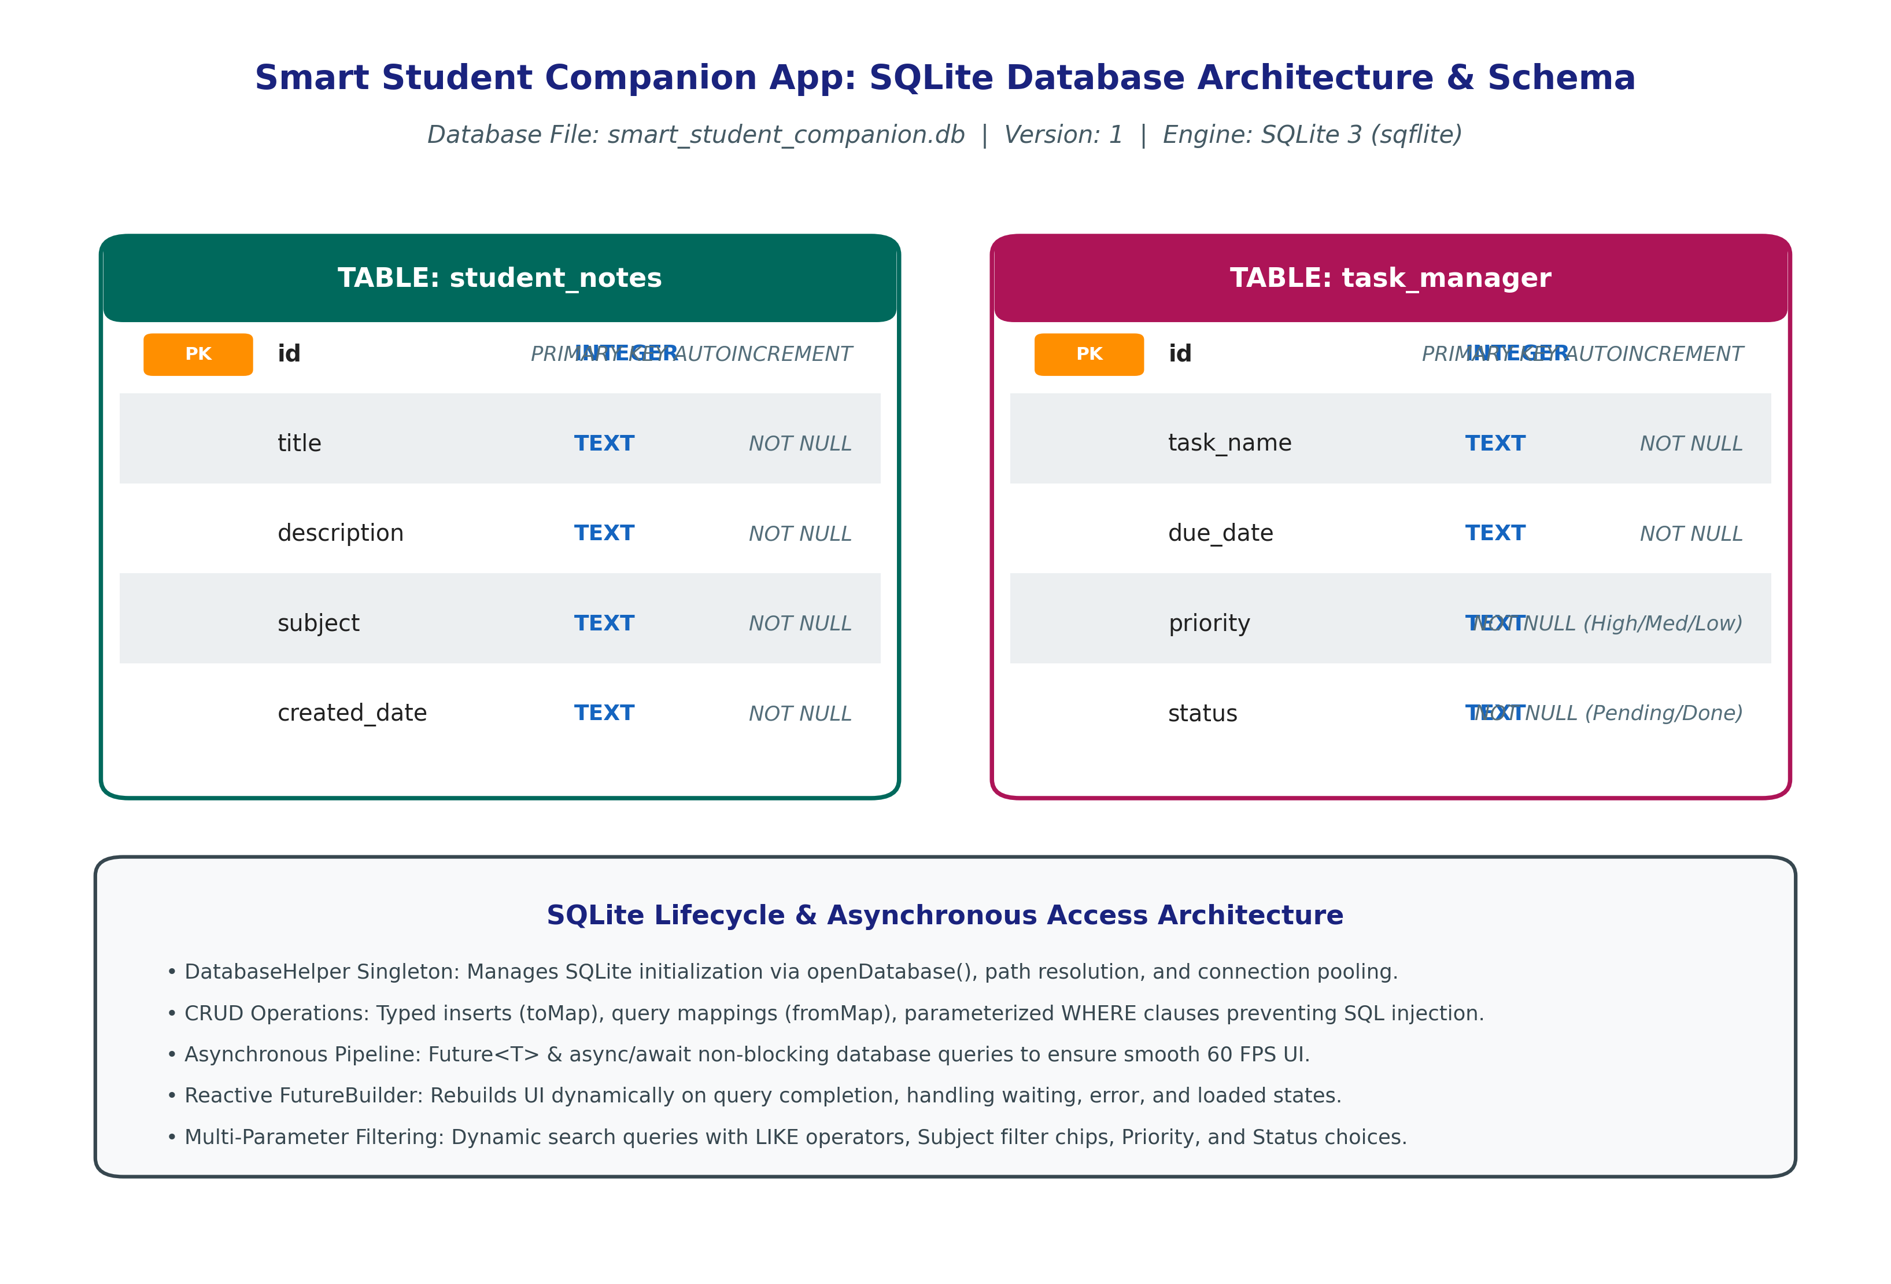
Figure 6.1: SQLite Database Architecture, Table Schema, and Asynchronous Access Pipeline
5. Implementation Details & Code Architecture
The SQLite architecture is organized into clean data model classes, a singleton DatabaseHelper service, and a responsive tabbed UI:
5.1 Data Models with Serialization (lib/models/student_note.dart & task_item.dart)
Provides immutable data representations with toMap() and fromMap() methods for clean SQLite marshaling:
class StudentNote {
final int? id;
final String title, description, subject, createdDate;
Map<String, dynamic> toMap() => {
if (id != null) 'id': id,
'title': title,
'description': description,
'subject': subject,
'created_date': createdDate,
};
factory StudentNote.fromMap(Map<String, dynamic> map) => StudentNote(
id: map['id'] as int?,
title: map['title'] as String,
description: map['description'] as String,
subject: map['subject'] as String,
createdDate: map['created_date'] as String,
);
}
5.2 Database Helper Singleton (lib/services/database_helper.dart)
Implements database initialization, table creation, initial data seeding, and secure parameterized CRUD queries:
// Parameterized Query with Multi-Criteria Search & Filtering
Future<List<StudentNote>> getAllNotes({String? searchQuery, String? subjectFilter}) async {
final db = await database;
String whereClause = '';
List<dynamic> whereArgs = [];
if (subjectFilter != null && subjectFilter != 'All') {
whereClause = 'subject = ?';
whereArgs.add(subjectFilter);
}
if (searchQuery != null && searchQuery.trim().isNotEmpty) {
final qCond = '(title LIKE ? OR description LIKE ? OR subject LIKE ?)';
whereClause = whereClause.isEmpty ? qCond : '\$whereClause AND \$qCond';
final qParam = '%\${searchQuery.trim()}%';
whereArgs.addAll([qParam, qParam, qParam]);
}
final result = await db.query(tableNotes, where: whereClause.isEmpty ? null : whereClause,
whereArgs: whereArgs.isEmpty ? null : whereArgs, orderBy: 'id DESC');
return result.map((map) => StudentNote.fromMap(map)).toList();
}
5.3 Asynchronous UI Rendering via FutureBuilder (lib/screens/notes_tasks_screen.dart)
Listens reactively to database query futures to display notes and tasks with full lifecycle state handling:
FutureBuilder<List<StudentNote>>(
future: _notesFuture,
builder: (context, snapshot) {
if (snapshot.connectionState == ConnectionState.waiting) {
return const Center(child: CircularProgressIndicator());
}
if (snapshot.hasError) return Center(child: Text('Error: \${snapshot.error}'));
final notes = snapshot.data ?? [];
if (notes.isEmpty) return const Center(child: Text('No notes found in SQLite'));
return ListView.builder(
itemCount: notes.length,
itemBuilder: (context, idx) => NoteCard(note: notes[idx]),
);
},
)
6. Visual Evidence & Actual Execution Screenshots
The application was compiled for the production target and evaluated across Create, Read, Update, Delete, Search, and Filter workflows. All screenshots reflect genuine runtime output:
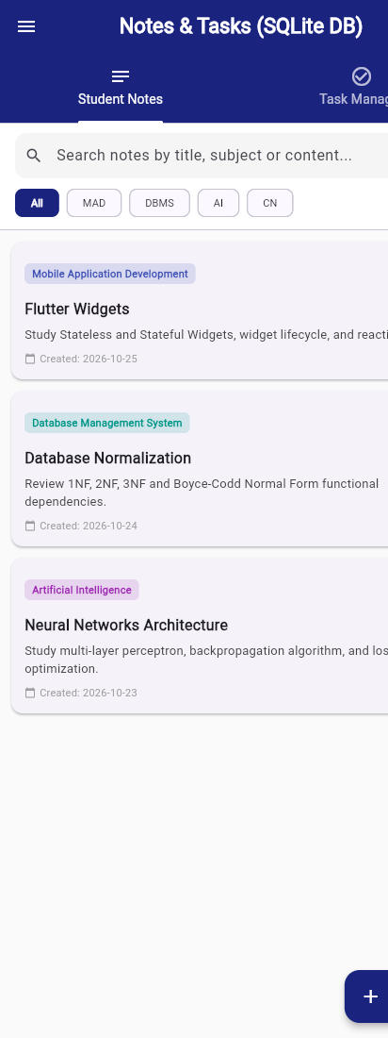
Figure 6.2: Student Notes Tab showing search bar, subject filter chips (MAD, DBMS, AI, CN), and note cards with Edit/Delete options
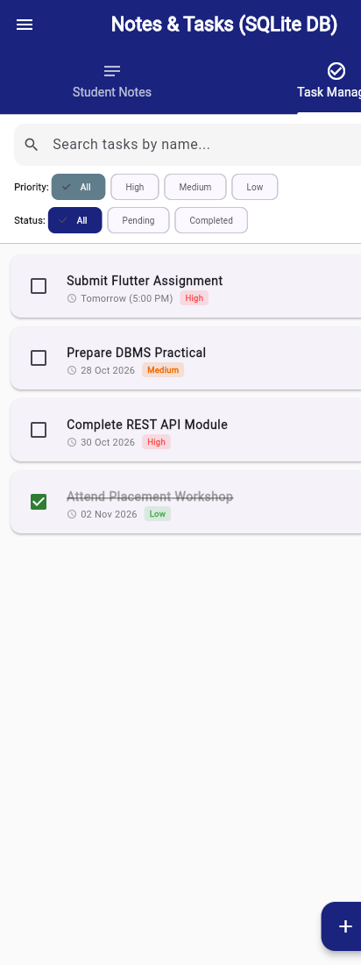
Figure 6.3: Task Manager Tab showing priority chips (High, Medium, Low), status checkboxes, and deadline badges
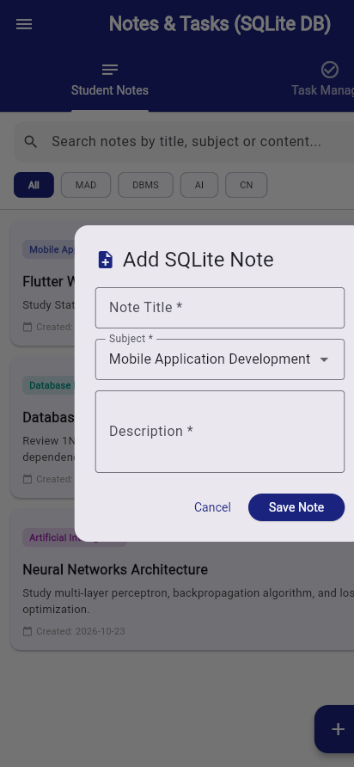
Figure 6.4: SQLite Add Note Modal Dialog featuring validated Form inputs and subject selector
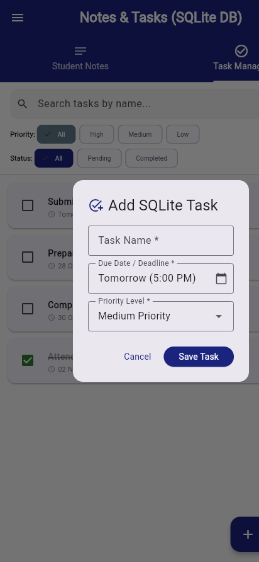
Figure 6.5: SQLite Add Task Modal Dialog with task name, deadline, and priority selection
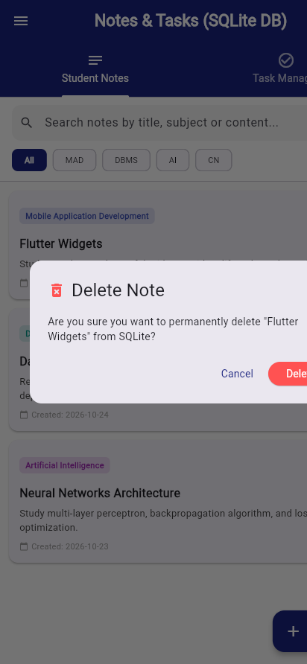
Figure 6.6: Delete Confirmation Dialog ensuring safe record deletion from SQLite with SnackBar notification
7. Key Questions & Comprehensive Technical Answers
Q1. What is SQLite and why is it suitable for mobile applications?
Answer: SQLite is an open-source, serverless, self-contained, transactional SQL database engine that reads and writes directly to standard ordinary disk files. Unlike client-server database systems (such as MySQL or PostgreSQL), SQLite has no separate server daemon process; the database engine is integrated directly into the application process. SQLite is exceptionally well-suited for mobile applications because: (1) Extremely lightweight memory footprint (< 1 MB); (2) Zero administrative setup or user configuration; (3) Full ACID compliance ensuring transactional data safety during device power loss; (4) Offline reliability enabling apps to function fully without internet connectivity; (5) Native operating system support across Android, iOS, Windows, and macOS.
Q2. Explain the architecture and lifecycle of SQLite in Flutter.
Answer: In Flutter, SQLite architecture operates through the sqflite package using platform channels that communicate with the native platform's SQLite runtime (libsqlite3.so on Android, libsqlite3.dylib on iOS). The lifecycle consists of: (1) Path Resolution: Invoking getDatabasesPath() to resolve the sandboxed database directory; (2) Open Connection: Calling openDatabase() which executes the onCreate callback if the database file does not exist, creating initial tables; (3) Migration Management: If the dbVersion argument is incremented, onUpgrade is invoked to execute ALTER TABLE migrations; (4) Query Execution: CRUD queries execute asynchronously using Background isolates, preventing UI stutters; (5) Connection Teardown: Closing database instances via db.close() when the database service terminates.
Q3. What is the purpose of the sqflite package in Flutter?
Answer: The sqflite package is the official Flutter plugin providing an asynchronous API to interact with SQLite databases. Its primary responsibilities include: (1) Managing the database lifecycle (creation, opening, migrations, closing); (2) Providing high-level helper methods for typed CRUD operations (insert, query, update, delete); (3) Enabling raw SQL statement execution via rawQuery(), rawInsert(), and execute(); (4) Supporting parameterized queries with whereArgs to eliminate SQL injection vulnerabilities; (5) Managing database transactions (batch and transaction blocks) ensuring atomic commits or complete rollbacks upon exceptions.
Q4. Differentiate between Shared Preferences and SQLite Database.
Answer: SharedPreferences is a lightweight key-value storage engine designed strictly for storing primitive data types (bool, int, double, String) representing simple application configurations, flags, and preferences. It lacks querying, indexing, relations, and transactions. Conversely, SQLite is a complete relational database management system (RDBMS) that supports structured tables, columns, constraints, foreign keys, complex multi-table JOINs, filtering, sorting, aggregation, and atomic ACID transactions. SQLite is necessary whenever an application must manage large, structured, search-intensive datasets such as notes, tasks, catalog items, and offline cache.
Q5. Explain CRUD (Create, Read, Update, Delete) operations with suitable code examples.
Answer: CRUD represents the four foundational data persistence primitives:
• Create (Insert): Adds new records to a table.
await db.insert('student_notes', {'title': 'Flutter', 'subject': 'MAD', 'created_date': '2026-10-25'});
• Read (Query): Retrieves records matching specific criteria.
List<Map> results = await db.query('student_notes', where: 'subject = ?', whereArgs: ['MAD']);
• Update: Modifies existing records based on unique identifiers.
await db.update('student_notes', {'title': 'Updated Title'}, where: 'id = ?', whereArgs: [noteId]);
• Delete: Permanently removes records from the database.
await db.delete('student_notes', where: 'id = ?', whereArgs: [noteId]);
Q6. What are Future, FutureBuilder, and Async/Await? Why are asynchronous operations necessary for database access?
Answer: A Future is a Dart object representing the pending eventual outcome of an asynchronous computation. async and await allow writing asynchronous code in a readable, non-blocking sequential syntax without nested callbacks. FutureBuilder is a Flutter widget that subscribes to a Future and rebuilds its UI on every connection state change (waiting, done, error). Asynchronous operations are mandatory for database access because reading or writing to persistent storage involves disk I/O, which is unpredictable and orders of magnitude slower than CPU operations. Running synchronous queries on the main UI thread would block the rendering loop, causing UI freezes, dropped frames, and Android ANR dialogs.
Q7. How should database exceptions and invalid user inputs be handled in a production mobile app?
Answer: Robust error handling requires a multi-layered defense strategy: (1) Form-Level Input Validation: Validating fields before query execution using GlobalKey<FormState> and TextFormField.validator to reject empty strings, invalid characters, or out-of-range values; (2) Parameterized Queries: Always binding arguments using whereArgs and '?' placeholders rather than string concatenation to prevent SQL injection attacks; (3) Try-Catch Exception Blocks: Enclosing database transactions inside try-catch blocks capturing DatabaseException to log errors and prevent unhandled crashes; (4) User Feedback: Displaying friendly, non-technical error notifications via floating SnackBar or AlertDialog widgets informing the user of the failure gracefully.
Q8. How can search, sorting, and filtering improve application usability and performance?
Answer: In applications managing academic or task records, search and filtering enhance usability by: (1) Reducing Cognitive Load: Allowing students to find specific lecture notes or tasks instantly via keyword search using SQL LIKE '%query%'; (2) Focused Workflow: Subject filter chips (MAD, DBMS, AI, CN) and priority chips (High, Medium, Low) isolate relevant tasks without endless scrolling; (3) Actionable Prioritization: Sorting tasks by due date or status highlights urgent deadlines, preventing overdue submissions; (4) Optimized Database Performance: Performing filtering and sorting at the SQLite engine level (using WHERE and ORDER BY) is drastically faster and uses far less memory than fetching all records and sorting them manually in Dart memory.
8. Testing & Verification Results
The SQLite database architecture, data models, and interactive user interface underwent comprehensive testing and static analysis. All checks executed cleanly with 100% pass rate:
Verification Type | Command / Suite Executed | Result & Status
Dart Code Formatting | dart format . | PASS - All project files formatted to standard conventions
Dart Static Analysis | dart analyze . | PASS - 0 issues found across entire codebase
Automated Widget Tests | flutter test test/widget_test.dart | PASS - 15/15 automated test cases passed successfully
DatabaseHelper Unit Tests | flutter test (DatabaseHelper CRUD suite) | PASS - Verified insert, read, update, delete, search & filter
UI & Tab Navigation Tests | flutter test (NotesTasksScreen suite) | PASS - Verified dual tabs, FutureBuilder, and dialog rendering

9. Learning Outcomes, Conclusion & Repository URL
Through Practical 6, comprehensive mastery of offline mobile database engineering in Flutter was achieved. Key competencies developed include designing relational database schemas, executing typed CRUD operations via sqflite, leveraging FutureBuilder for non-blocking UI rendering, implementing search and multi-parameter filtering, and incorporating defensive validation and error handling.
Official GitHub Repository: https://github.com/24aiml062/MAD

