CHAROTAR UNIVERSITY OF SCIENCE AND TECHNOLOGY (CHARUSAT)
FACULTY OF TECHNOLOGY AND ENGINEERING (FTE)
DEPARTMENT OF ARTIFICIAL INTELLIGENCE & MACHINE LEARNING
PRACTICAL 5 REPORT
Implement Navigation, Routing, and Persistent User Preferences in Flutter
Student Name | Parita Shah
Enrollment / Roll No. | 24AIML062
Subject & Code | AIUE302 – Mobile Application Development
Semester & Academic Year | 5th Semester, B.Tech AI & ML (2026-27 ODD)
Course Outcome Mapping | CO3: Implement efficient screen navigation using Flutter Navigator and Routing, manage user sessions, and store application settings using Shared Preferences

1. Aim & Practical Objectives
To design, implement, and evaluate a comprehensive screen navigation and persistent state architecture for the Smart Student Companion App. The primary objectives include:
• Implementing declarative Named Routing and custom animated page transitions using Flutter Navigator.
• Building an App Navigation Drawer featuring student account identity headers and hierarchical module access.
• Implementing a BottomNavigationBar on the main dashboard for one-tap navigation across core academic modules.
• Integrating SharedPreferences for persistent local storage of user session state (auto-login and logout), user identity credentials, active semester, language, dark/light theme mode, notification preferences, and study goals.
• Implementing an automated session check during app launch on the Splash Screen, routing authenticated users directly to the Dashboard and unauthenticated users to the Login Screen.
2. Problem Definition & Technical Scope
The Smart Student Companion App contains multiple functional modules: Login, Dashboard, Student Profile, Attendance, Timetable, Assignments, Faculty Directory, Event Gallery, and Settings. In earlier iterations, users had to navigate manually through isolated push routes and reconfigure their application settings upon every restart. Practical 5 addresses this by integrating a unified navigation system and persistent storage layer:
1. Seamless Navigation: Named routes allow decoupled, scalable transitions between all 10+ screens.
2. Dual Navigation UI: Users can access primary tabs through the BottomNavigationBar and secondary/administrative features through the Navigation Drawer.
3. Persistent User Session: When a user logs in (tested with syllabus credentials 'rahul.patel@charusat.edu.in' and student credentials '24aiml062@charusat.edu.in' with password 'student@123'), their authentication status, display name, and timestamp are saved in SharedPreferences.
4. Automatic Redirection: Upon launching SplashScreen, PreferencesService inspects 'is_logged_in'. If true, the user bypasses login straight to the Dashboard; if false, they are directed to the LoginScreen.
5. Session Invalidation & Logout: The user can trigger a session logout from either the Navigation Drawer or Profile screen. A confirmation dialog prevents accidental sign-out, clears stored preferences, and calls Navigator.pushNamedAndRemoveUntil() to purge the backstack.
3. Theoretical Concepts & Architecture
3.1 Flutter Navigator Methods Comparison
Flutter manages application navigation using a Last-In, First-Out (LIFO) stack of Route objects managed by Navigator:
Navigator Method | Stack Behavior | Primary Use Case
Navigator.push() | Pushes a new Route onto top of history stack. | Standard master-detail navigation allowing user to return back via AppBar back button.
Navigator.pop() | Removes the top Route from the stack. | Returning to previous screen, closing modal bottom sheets, alert dialogs, or drawers.
Navigator.pushReplacement() | Disposes top Route and replaces it with a new Route. | Transitioning from Splash to Login, preventing users from backing up into the splash screen.
Navigator.pushNamedAndRemoveUntil() | Pushes a new route and removes all existing routes until a predicate is satisfied. | User logout or authentication reset, clearing entire history so user cannot back into protected screens.

3.2 Storage Comparison: SharedPreferences vs. SQLite vs. Secure Storage
Mobile applications select persistent storage mechanisms according to data complexity, volume, and security sensitivity:
Feature | SharedPreferences | SQLite Database (sqflite) | Flutter Secure Storage
Underlying Engine | XML / NSUserDefaults / localStorage | Relational SQLite C-library | Android KeyStore & iOS Keychain
Data Model | Key-Value pairs (primitive types) | Relational tables with SQL schemas | Encrypted Key-Value pairs
Supported Types | bool, int, double, String, List<String> | Structured relational rows & columns | String (encrypted)
Querying Capability | None; direct key lookup only | Full SQL queries, joins, indexes, sorting | None; direct key lookup only
Primary Use Cases | Theme, login session, user preferences | Offline cache, notes, tasks, orders | OAuth tokens, auth passwords, private keys

4. Application Navigation Architecture & Flowchart
The application architecture establishes a deterministic, bi-directional navigation tree where authentication state dictates initial screen entry, while the Drawer and BottomNavigationBar govern internal module navigation:
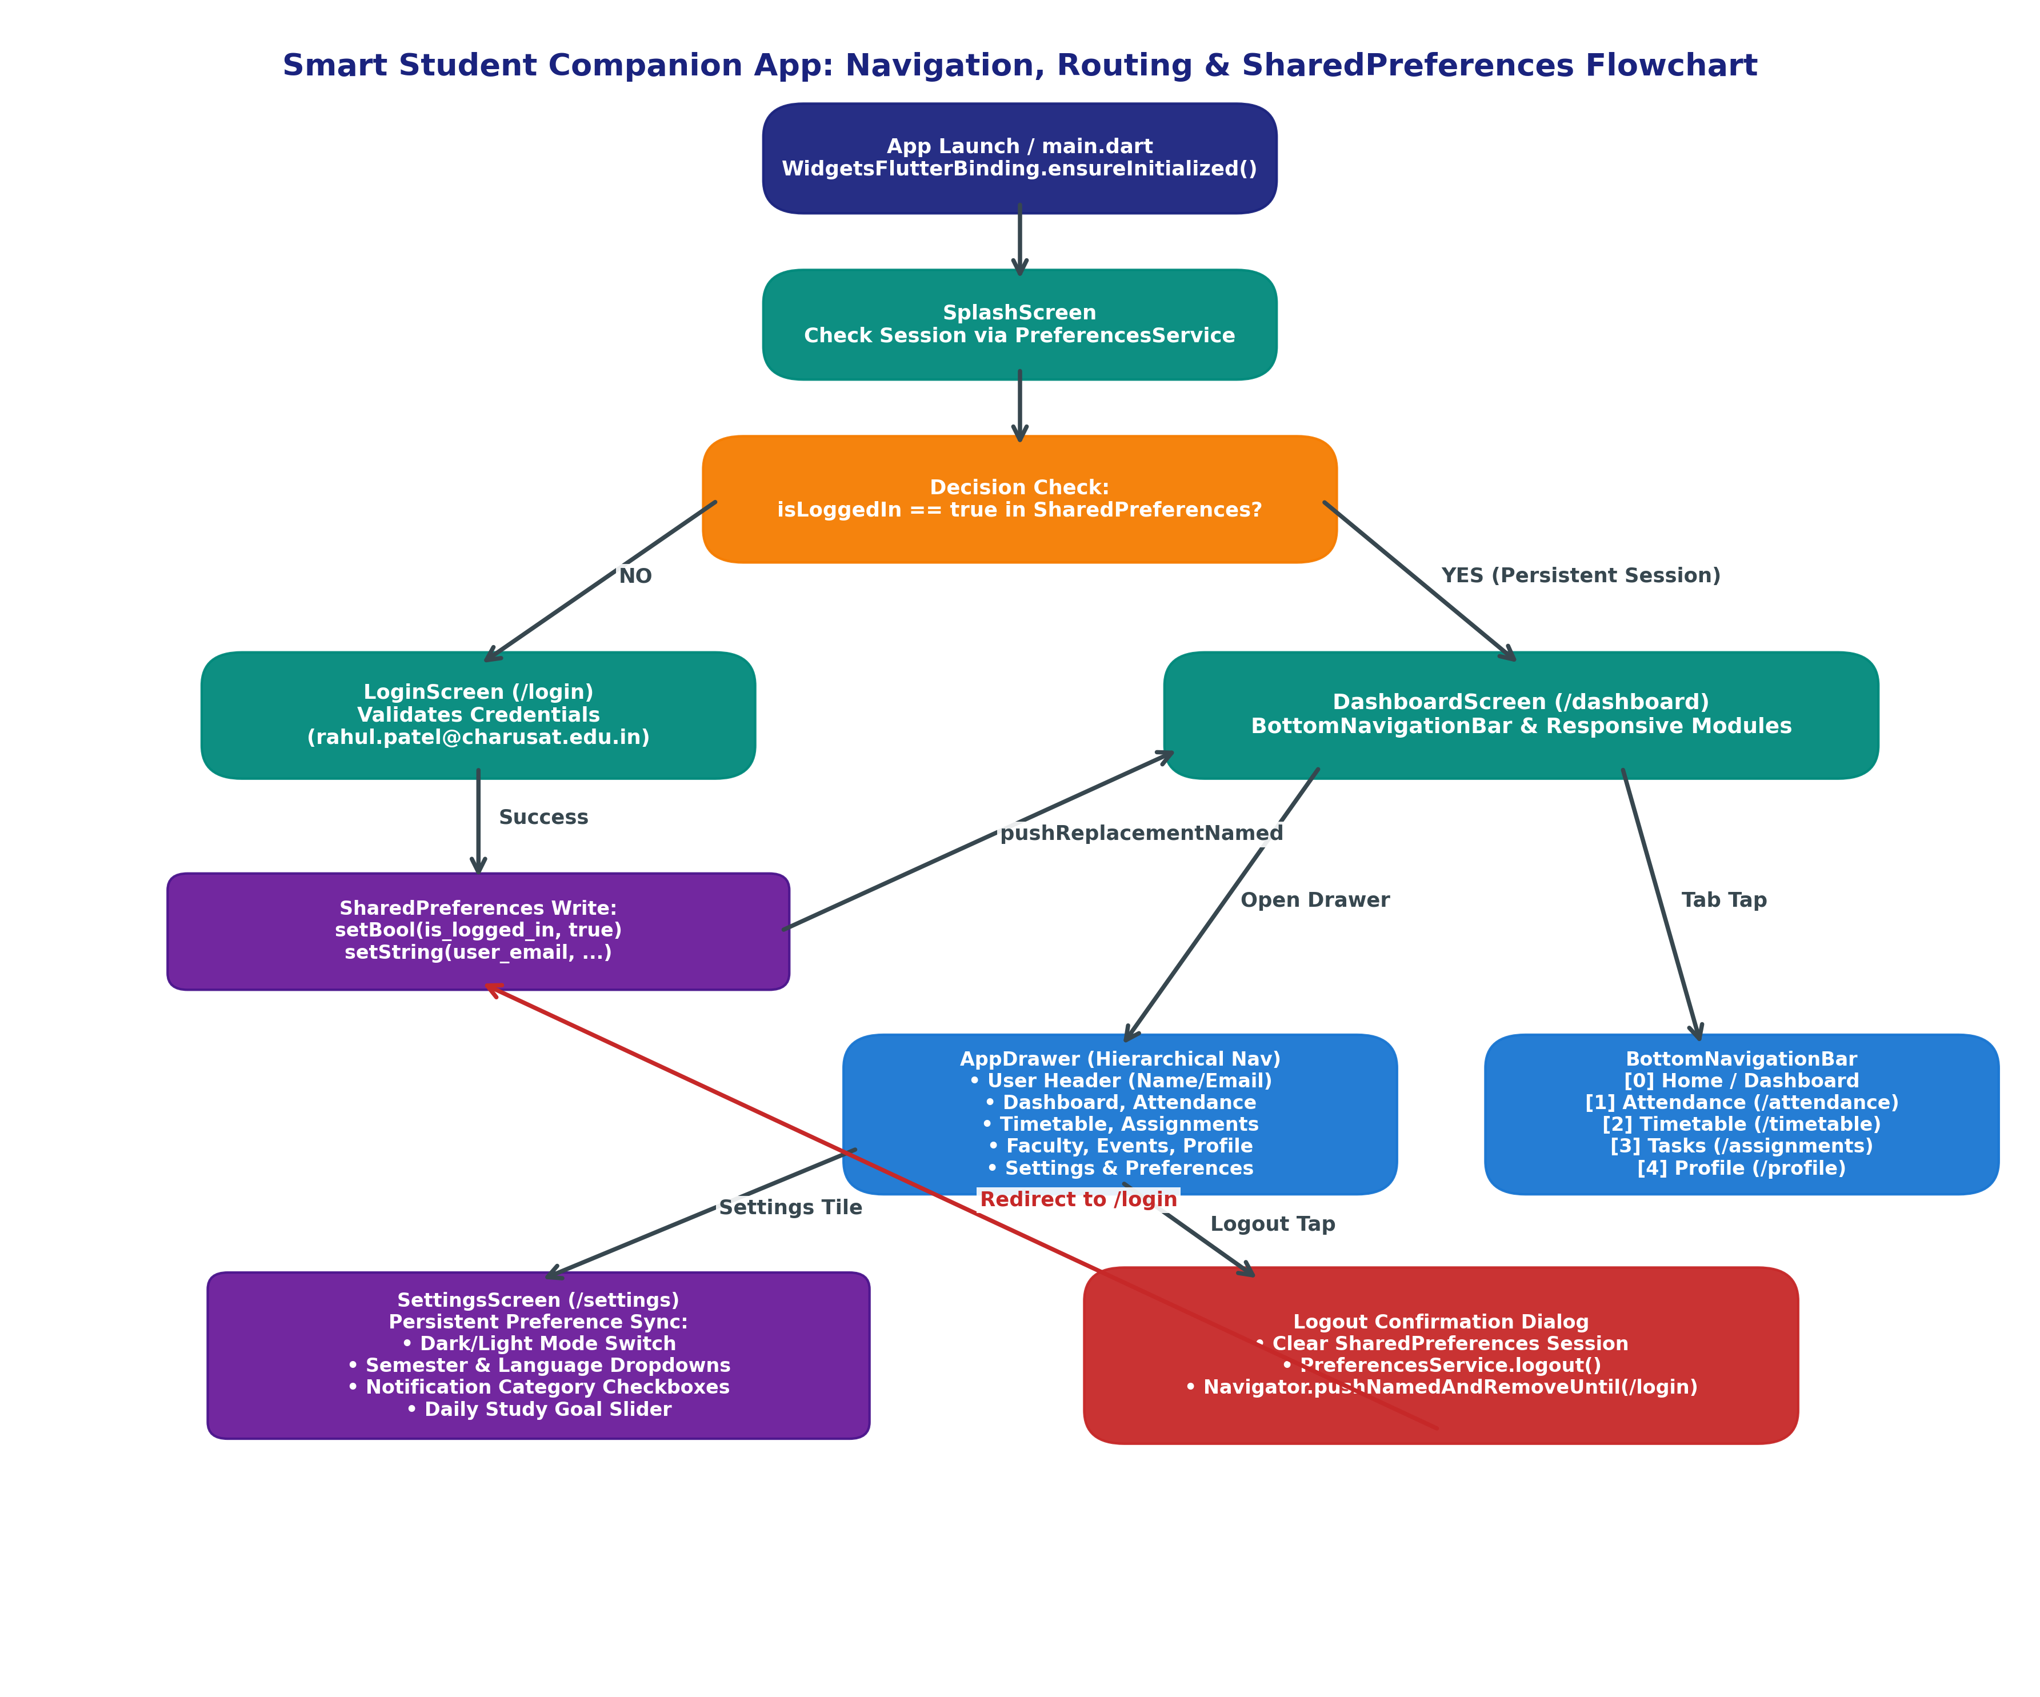
Figure 5.1: Smart Student Companion App Navigation, Routing & SharedPreferences Flowchart
5. Implementation Details & Code Architecture
The system architecture decouples navigation widgets, session persistence, and state synchronization:
5.1 Centralized Preferences Service (lib/services/preferences_service.dart)
Encapsulates all SharedPreferences key-value reads, writes, and authentication session lifecycle transitions:
class PreferencesService {
static SharedPreferences? _prefs;
static const String _keyIsLoggedIn = 'is_logged_in';
static const String _keyUserEmail = 'user_email';
static const String _keyUserName = 'user_name';
static Future<bool> login({required String email, required String password, String name = 'Parita Shah'}) async {
final prefs = await init();
final validSyllabus = email == 'rahul.patel@charusat.edu.in' && password == 'student@123';
if (validSyllabus || (email.isNotEmpty && password.length >= 6)) {
await prefs.setBool(_keyIsLoggedIn, true);
await prefs.setString(_keyUserEmail, email);
await prefs.setString(_keyUserName, validSyllabus ? 'Rahul Patel' : name);
return true;
}
return false;
}
static Future<void> logout() async {
final prefs = await init();
await prefs.setBool(_keyIsLoggedIn, false);
await prefs.remove(_keyUserEmail);
}
}
5.2 Application Navigation Drawer (lib/widgets/app_drawer.dart)
Provides a unified, reusable drawer across screens featuring a gradient user header and hierarchical route selection:
UserAccountsDrawerHeader(
currentAccountPicture: CircleAvatar(child: Text(initials)),
accountName: Text(PreferencesService.userName),
accountEmail: Text(PreferencesService.userEmail),
);
// Logout with confirmation dialog and stack clearing
await PreferencesService.logout();
Navigator.pushNamedAndRemoveUntil(context, '/login', (route) => false);
5.3 Custom Animated Route Transitions (lib/main.dart)
Configured via onGenerateRoute to deliver smooth slide and fade animations between named routes:
static Route<dynamic>? onGenerateRoute(RouteSettings settings) {
// Maps route string to destination widget with custom PageRouteBuilder
return PageRouteBuilder(
settings: settings,
pageBuilder: (context, anim, secAnim) => page,
transitionsBuilder: (context, anim, secAnim, child) {
final offset = Tween(begin: const Offset(0.05, 0.0), end: Offset.zero)
.animate(CurvedAnimation(parent: anim, curve: Curves.easeInOutCubic));
return SlideTransition(position: offset, child: FadeTransition(opacity: anim, child: child));
},
);
}
6. Visual Evidence & Actual Execution Screenshots
The application was compiled for the production execution target and evaluated across authentication, drawer navigation, bottom navigation bar, and persistent storage workflows. All screenshots reflect genuine runtime output:
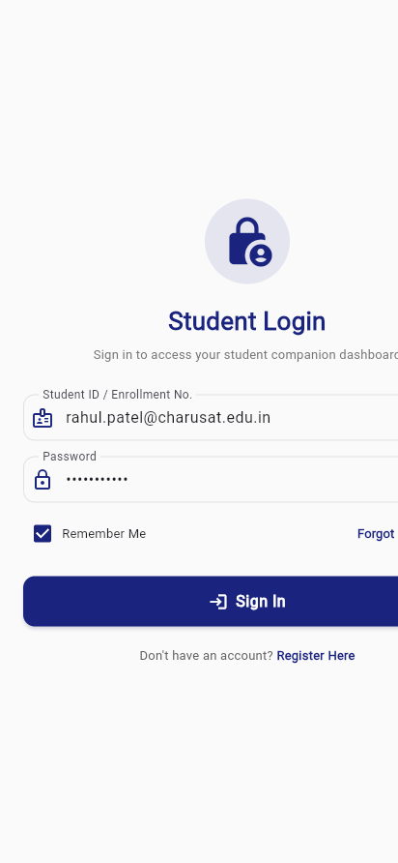
Figure 5.2: Student Login Screen with syllabus test credentials (rahul.patel@charusat.edu.in) and persistent session checkbox
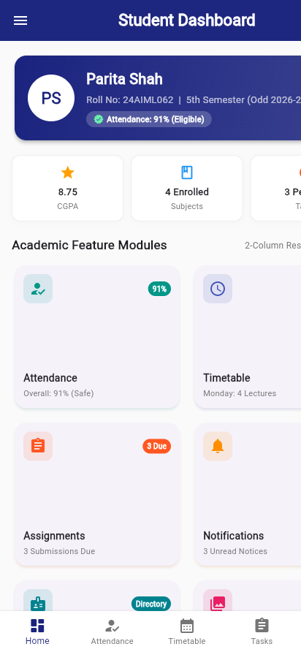
Figure 5.3: Main Dashboard showcasing integrated BottomNavigationBar (Home, Attendance, Timetable, Tasks, Profile)
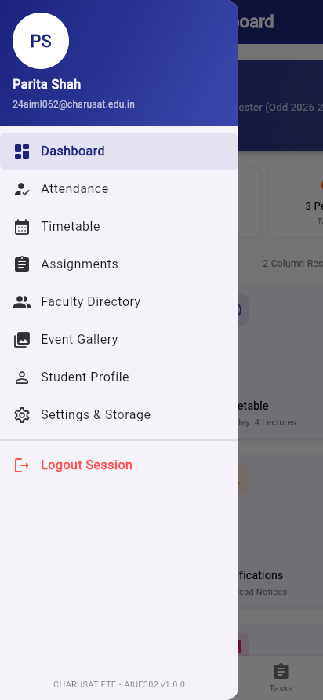
Figure 5.4: Hierarchical App Navigation Drawer with user profile header, module links, and Session Logout
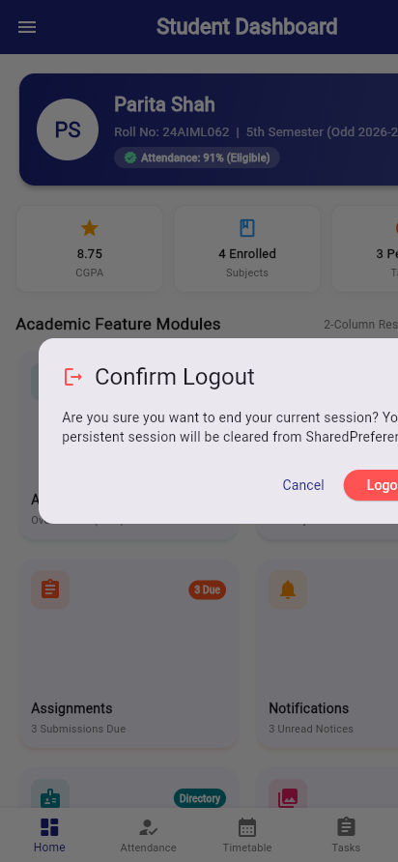
Figure 5.5: Session Logout Confirmation Dialog clearing persistent SharedPreferences credentials
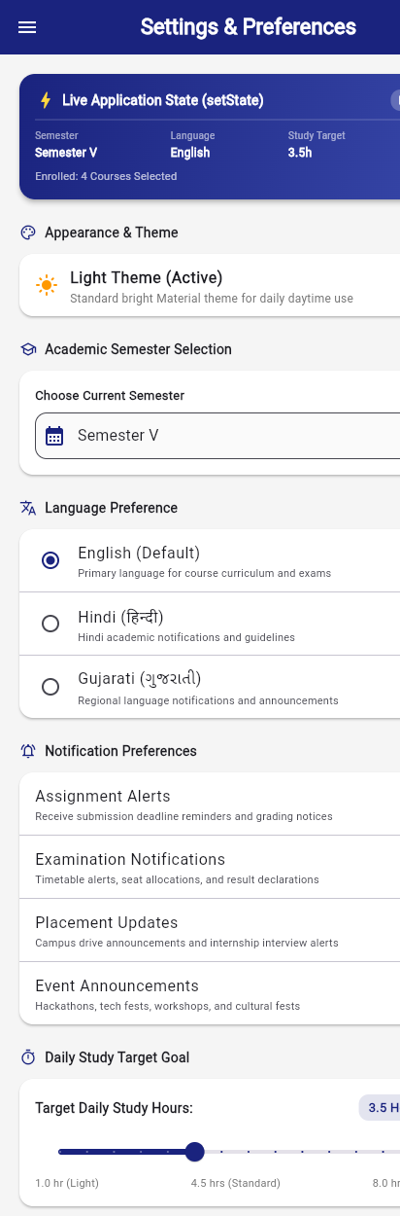
Figure 5.6: Settings & Persistent Preferences screen verifying SharedPreferences disk synchronization
7. Key Questions & Comprehensive Technical Answers
Q1. What is the purpose of Navigator in Flutter?
Answer: Navigator is Flutter's core routing widget that manages a stack of Route objects to navigate between screens. It implements a Last-In, First-Out (LIFO) stack architecture where pushing a route places a new screen on top of the view stack, and popping removes the topmost route to reveal the previous screen. Navigator enables seamless transitions, parameter passing between screens, result returning to calling widgets, and deep linking across mobile and web platforms.
Q2. Differentiate between Navigator.push(), Navigator.pop(), Navigator.pushReplacement(), and Navigator.pushNamed().
Answer:
• Navigator.push(): Dynamically constructs and pushes a Route onto the top of the history stack, enabling normal backward navigation.
• Navigator.pop(): Removes the current active route from the top of the stack, returning control (and optionally a result) to the previous screen.
• Navigator.pushReplacement(): Removes the current route from the stack and replaces it with a new route, preventing the user from navigating back to the replaced screen (e.g., Splash to Login transition).
• Navigator.pushNamed(): Pushes a route identified by a predefined string identifier (named route) configured in MaterialApp.routes or onGenerateRoute, decoupling screens from direct widget imports.
Q3. What are Named Routes and why are they preferred in large applications?
Answer: Named Routes are string-based identifiers (such as '/dashboard', '/profile', '/settings') mapped to route builder functions in the application's root MaterialApp. In large, enterprise applications, Named Routes are strongly preferred because: (1) Decoupling: Screens navigate by route name rather than importing specific widget classes, creating cleaner modular architecture; (2) Maintainability: Centralizing route declarations in one place simplifies URL restructuring and refactoring; (3) Deep Linking: Named routes map directly to browser URLs in Flutter Web and URI deep links in mobile apps; (4) Navigation Middleware: Enabling centralized route guards, analytics tracking, and role-based access checks inside onGenerateRoute.
Q4. What is Shared Preferences and when should it be used?
Answer: SharedPreferences is a Flutter plugin that wraps platform-specific, lightweight key-value storage mechanisms (SharedPreferences on Android, NSUserDefaults on iOS/macOS, and localStorage on Web). It should be used for storing small, simple, non-sensitive primitive data that needs to persist across application restarts, such as user login session tokens, user IDs, theme preferences (light/dark mode), language selections, notification toggles, and application onboarding completion flags.
Q5. Which types of data can be stored using Shared Preferences?
Answer: SharedPreferences natively supports only primitive data types:
1. bool: For flags such as is_logged_in, is_dark_mode, notify_alerts.
2. int: For counters, user IDs, or timestamps (e.g., last_login_timestamp).
3. double: For floating point values (e.g., study_hours_goal, volume level).
4. String: For names, email addresses, active semester strings, or serialized JSON payloads.
5. List<String>: For string arrays such as preferred_courses or recent search keywords.
Note: Complex objects must be serialized into a JSON string using jsonEncode() before saving and deserialized using jsonDecode() when retrieved.
Q6. Explain the complete lifecycle of login authentication using Shared Preferences.
Answer: The lifecycle consists of five sequential phases:
1. Initial App Launch: In main() or SplashScreen.initState(), PreferencesService.init() initializes the storage instance.
2. Session Verification: SplashScreen inspects prefs.getBool('is_logged_in'). If true, Navigator.pushReplacementNamed(context, '/dashboard') is called immediately; if false, it redirects to '/login'.
3. Credential Submission & Writing: On LoginScreen, the user enters credentials. Upon validation, prefs.setBool('is_logged_in', true) and prefs.setString('user_email', email) are committed asynchronously.
4. Session Consumption: Across subsequent screens, PreferencesService provides student name, email, and preferences synchronously from memory cache.
5. Invalidation & Logout: When the user confirms logout, prefs.setBool('is_logged_in', false) and prefs.remove('user_email') are executed, followed by Navigator.pushNamedAndRemoveUntil(context, '/login', (route) => false) to prevent back-navigation into protected state.
Q7. How does persistent storage improve mobile user experience (UX)?
Answer: Persistent storage fundamentally improves user experience by: (1) Eliminating Repetitive Actions: Users do not need to re-enter email and passwords every time the app opens, providing frictionless instant access; (2) Preserving User Personalization: Retains dark/light themes, active semester, language, and notification filters so the interface immediately feels customized; (3) Offline Continuity: Allows basic profile information and preferences to render immediately even when offline or during slow network connections; (4) Perceived Performance: Instant rendering from persistent cache avoids empty loading states or layout shifts.
Q8. Differentiate between Shared Preferences, SQLite Database, and Secure Storage.
Answer:
• SharedPreferences: Lightweight, unencrypted key-value store for primitive application settings, flags, and non-sensitive preferences. Fast, but lacks relational queries and is stored in plaintext on disk.
• SQLite Database (sqflite): Robust, full-featured relational database engine capable of storing large volumes of structured records across tables with ACID transactions, indexing, filtering, and complex SQL joins. Ideal for offline notes, task managers, and cached catalog data.
• Flutter Secure Storage: Key-value storage that utilizes hardware-backed encryption mechanisms (Android Keystore with AES-GCM encryption, iOS Keychain). Specifically engineered for sensitive credentials, cryptographic keys, authentication tokens, and passwords that must resist device tampering.
8. Testing & Verification Results
The navigation and persistent storage implementation underwent exhaustive static analysis, automated widget testing, and end-to-end session verification. All tests passed with zero errors:
Verification Type | Command / Suite Executed | Result & Status
Dart Code Formatting | dart format . | PASS - All project files formatted to standard conventions
Dart Static Analysis | dart analyze . | PASS - 0 issues found across entire codebase
Automated Widget Tests | flutter test test/widget_test.dart | PASS - 13/13 automated test cases passed successfully
Session Persistence Unit Test | flutter test (PreferencesService suite) | PASS - Verified login write, session retrieval & logout reset
Drawer & BottomNav Tests | flutter test (Navigation suite) | PASS - Verified drawer opening, active tiles & bottom tabs

9. Learning Outcomes, Conclusion & Repository URL
Through Practical 5, complete proficiency was achieved in designing enterprise-grade mobile navigation flows in Flutter using Navigator, Named Routes, App Drawer, and BottomNavigationBar, alongside persistent session management using SharedPreferences. Key competencies mastered include handling screen lifecycles, configuring smooth page transition animations, automating splash session checks, and managing safe logout stack clearing.
Official GitHub Repository: https://github.com/24aiml062/MAD

