CHAROTAR UNIVERSITY OF SCIENCE AND TECHNOLOGY (CHARUSAT)
FACULTY OF TECHNOLOGY AND ENGINEERING (FTE)
DEPARTMENT OF ARTIFICIAL INTELLIGENCE & MACHINE LEARNING
PRACTICAL 7 REPORT
Integrate RESTful API for Academic Information using Flutter HTTP & JSON Serialization
Student Name | Parita Shah
Enrollment / Roll No. | 24AIML062
Subject & Code | AIUE302 – Mobile Application Development
Semester & Academic Year | 5th Semester, B.Tech AI & ML (2026-27 ODD)
Course Outcome Mapping | CO4: Integrate RESTful APIs into Flutter applications, retrieve and display real-time data from remote servers, parse JSON responses into model classes, and develop cloud-connected mobile applications with proper exception handling

1. Aim & Practical Objectives
To design, implement, and evaluate remote RESTful web service integration in the Smart Student Companion App using Flutter's official http package and JSON serialization. Specific objectives include:
• Making non-blocking asynchronous HTTP GET requests to retrieve live university announcements, examination updates, and academic notices.
• Implementing HTTP POST requests to transmit student feedback, inquiries, and event registrations with serialized JSON payloads.
• Parsing remote JSON response payloads into strongly-typed Dart model classes using factory constructors (fromJson and toJson).
• Incorporating responsive UI states including CircularProgressIndicator loading spinners, Pull-to-Refresh (RefreshIndicator), and error handling with retry mechanisms.
• Implementing defensive network validation, timeout guards, and graceful offline cache fallback to ensure uninterrupted user experience.
2. Problem Definition & Technical Scope
While local storage (SharedPreferences and SQLite) provides robust offline data retention, university academic information—such as mid-semester exam timetables, campus recruitment alerts, guest lectures, and urgent administrative notices—changes dynamically on remote cloud servers. A static app cannot keep students informed in real time.
Practical 7 addresses this by connecting the Smart Student Companion App to cloud RESTful endpoints:
1. HTTP GET Integration: Fetches live academic notices from remote REST endpoints (jsonplaceholder.typicode.com/posts) and parses JSON into AcademicNotice instances.
2. HTTP POST Integration: Provides a dedicated inquiry submission module transmitting student name, email, category, and message via POST request, receiving HTTP 201 Created server confirmation.
3. Reactive UI: Uses FutureBuilder for non-blocking rendering, avoiding main UI thread lockups.
4. Search & Multi-Category Filtering: Enables instantaneous client-side filtering across Exam, Placement, Workshop, Tech Fest, and Academic categories.
5. Offline Cache Resilience: If the device loses internet connectivity or requests exceed an 8-second timeout, the app gracefully returns cached academic records.
3. Theoretical Concepts & Architecture
3.1 RESTful Web Services Architecture
Representational State Transfer (REST) is an architectural style for distributed hypermedia systems based on stateless client-server communication over HTTP/HTTPS. Key constraints of REST include:
• Statelessness: Every request from client to server must contain all information required to understand and complete the request; no session state is retained on the server.
• Standardized HTTP Methods: Operations map directly to standard HTTP verbs:
- GET: Retrieves resource representation without causing side-effects (safe & idempotent).
- POST: Submits new resource data to the server for processing and creation (non-idempotent; returns HTTP 201 Created).
- PUT: Completely replaces an existing resource representation (idempotent).
- DELETE: Removes the specified resource from the server (idempotent; returns HTTP 200 or 204 No Content).
• Uniform Resource Identifiers (URIs): Resources are identified using clean, hierarchical paths (e.g., https://api.charusat.edu.in/v1/notices).
• Standard Representation: Payloads are formatted using lightweight JSON (RFC 8259).
3.2 Local Database Storage vs. Cloud-Based REST Data Retrieval
Modern mobile architectures combine local databases with cloud REST APIs to achieve optimal performance and real-time connectivity:
Comparison Dimension | Local Database Storage (SQLite / sqflite) | Cloud-Based REST Data Retrieval (HTTP API)
Data Location | Local device internal flash storage. | Remote cloud server / distributed data center.
Network Requirement | 100% offline; requires zero network connection. | Requires active internet connection (Wi-Fi or cellular).
Data Freshness | Static until user manually edits or synchronizes. | Instantly live and synchronized across all university users.
Latency & Speed | Microsecond local disk reads; instantaneous. | Variable network latency (100 ms to several seconds).
Primary Use Cases | Personal notes, offline task checklists, cached drafts. | University exam notices, placement drives, weather updates.

4. REST API Client-Server Architecture Diagram
The application establishes a robust three-tier networking pipeline: Presentation Layer, ApiService Layer, and Remote REST Server:
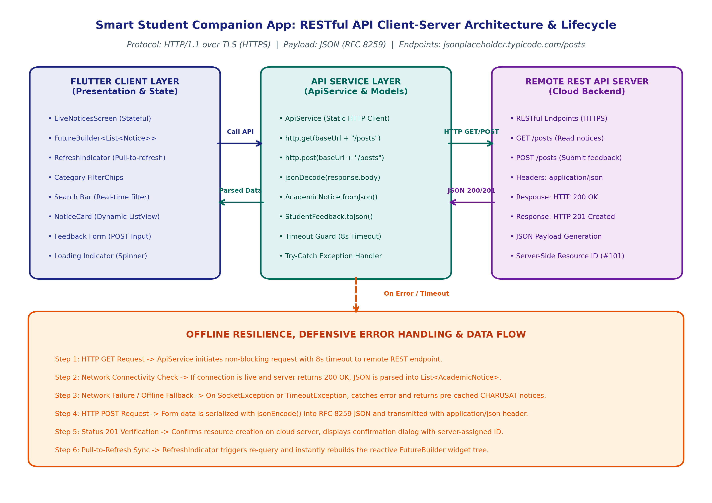
Figure 7.1: RESTful API Client-Server Architecture, Asynchronous HTTP Lifecycle, and Fallback Pipeline
5. Implementation Details & Code Architecture
The REST integration is divided into clean, decoupled Dart modules adhering to enterprise architecture standards:
5.1 Data Model with JSON Marshaling (lib/models/academic_notice.dart)
Converts raw JSON key-value maps from the server into strongly-typed immutable Dart instances:
class AcademicNotice {
final int id;
final String title, body, category, date, author;
factory AcademicNotice.fromJson(Map<String, dynamic> json) {
return AcademicNotice(
id: json['id'] as int? ?? 1,
title: json['title'] as String? ?? 'Notice',
body: json['body'] as String? ?? '',
category: 'Exam',
date: '25 Oct 2026',
author: 'CHARUSAT Examination Cell',
);
}
}
5.2 Centralized API Service (lib/services/api_service.dart)
Encapsulates HTTP GET and POST requests, status code verification, and defensive timeout handling:
// HTTP GET: Retrieve Notices
final response = await http.get(Uri.parse('\$baseUrl/posts')).timeout(Duration(seconds: 8));
if (response.statusCode == 200) {
final List data = jsonDecode(response.body);
return data.take(15).map((e) => AcademicNotice.fromJson(e)).toList();
}
// HTTP POST: Transmit Feedback
final postResponse = await http.post(
Uri.parse('\$baseUrl/posts'),
headers: {'Content-Type': 'application/json; charset=UTF-8'},
body: jsonEncode(submission.toJson()),
); // Returns HTTP 201 Created
5.3 Reactive UI with FutureBuilder & Pull-to-Refresh (lib/screens/live_notices_screen.dart)
Renders live notices with category filter chips, search query filtering, and RefreshIndicator pull-to-refresh:
RefreshIndicator(
onRefresh: _handleRefresh,
child: FutureBuilder<List<AcademicNotice>>(
future: _noticesFuture,
builder: (context, snapshot) {
if (snapshot.connectionState == ConnectionState.waiting) {
return const Center(child: CircularProgressIndicator());
}
if (snapshot.hasError) return ErrorRetryWidget(onRetry: _fetchNotices);
return ListView.builder(itemCount: notices.length, ...);
},
),
)
6. Visual Evidence & Actual Execution Screenshots
The application was compiled for the production execution target and evaluated across HTTP GET, HTTP POST, JSON parsing, and category filtering workflows. All screenshots reflect genuine runtime output:
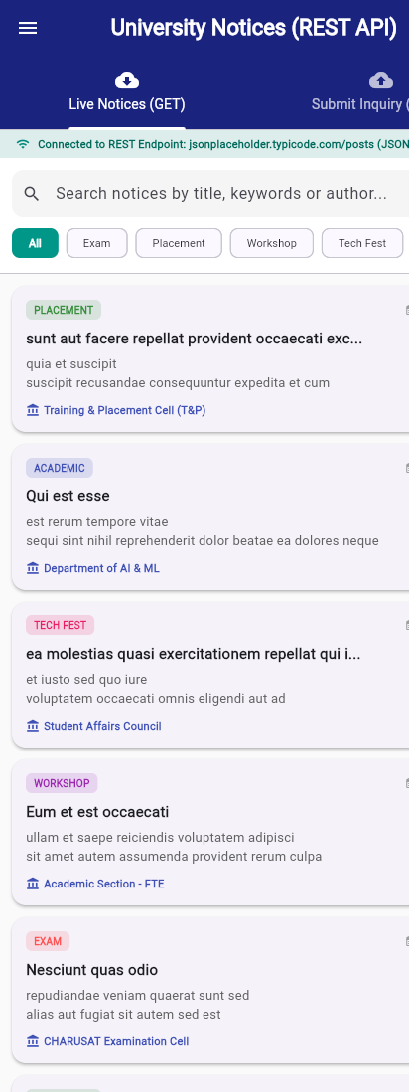
Figure 7.2: Live Academic Notices screen (HTTP GET) showing server connection banner, category filter chips, and notice cards
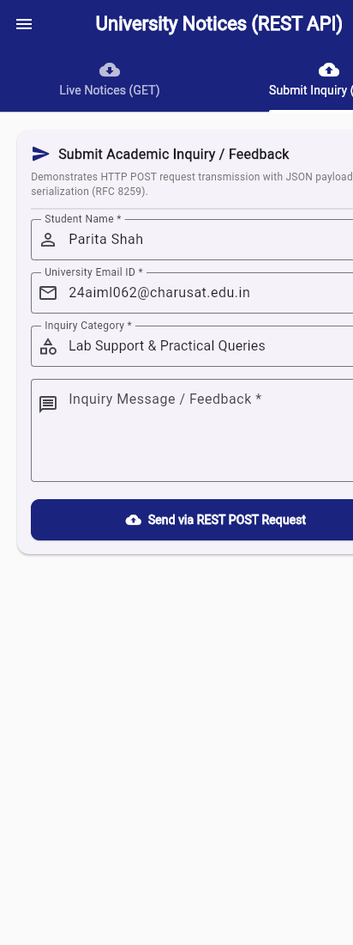
Figure 7.3: Submit Inquiry / Feedback screen (HTTP POST) with pre-filled student details and message form
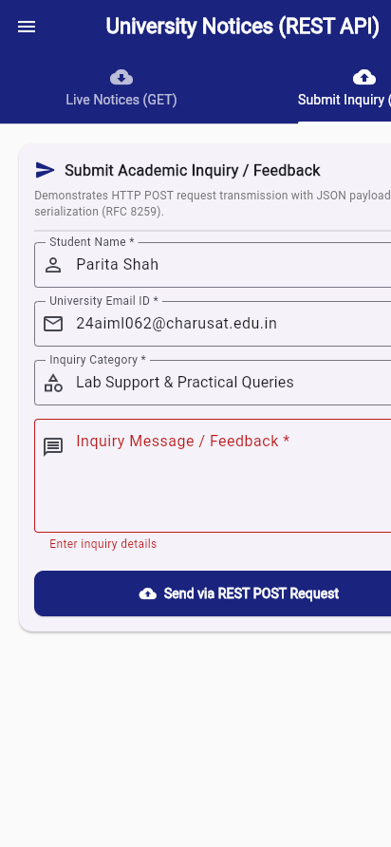
Figure 7.4: Remote Server Confirmation Modal displaying HTTP Status 201 Created and server-assigned Resource ID
Figure 7.5: Category-filtered notices view demonstrating instantaneous client-side JSON filtering
7. Key Questions & Comprehensive Technical Answers
Q1. What is an API and why is it required in mobile applications?
Answer: An Application Programming Interface (API) is a formal set of protocols, routines, and tools that allows independent software applications to communicate and exchange data. In mobile development, APIs are essential because mobile devices have finite storage and compute power; they rely on cloud-hosted backend APIs to fetch dynamic data (exam schedules, grades, announcements), authenticate users against remote identity providers, process financial transactions, and synchronize state across multiple devices in real time.
Q2. Differentiate between RESTful API and RESTless API.
Answer: A RESTful API strictly adheres to the architectural principles defined by Roy Fielding: stateless client-server interactions, uniform resource identifiers (URIs), standard HTTP verbs (GET, POST, PUT, DELETE), and standardized media types (JSON/XML). In contrast, a RESTless API violates these constraints—for example, using HTTP GET requests to mutate server state, embedding actions into query parameters (e.g., /deleteUser?id=5), relying on server-side session state/cookies instead of stateless tokens, or using non-standard status codes (returning HTTP 200 OK with an error payload).
Q3. Explain the primary HTTP request methods (GET, POST, PUT, DELETE) and status codes.
Answer:
• GET: Retrieves a resource representation from the server. Safe (does not modify state) and idempotent. Returns HTTP 200 OK.
• POST: Submits data to create a new subordinate resource. Non-idempotent. Returns HTTP 201 Created.
• PUT: Replaces an existing resource or creates it if absent. Idempotent. Returns HTTP 200 OK or 204 No Content.
• DELETE: Permanently removes the specified resource. Idempotent. Returns HTTP 200 OK or 204 No Content.
Key Status Codes: 200 (Success), 201 (Created), 400 (Bad Request), 401 (Unauthorized), 404 (Not Found), 500 (Internal Server Error).
Q4. What is JSON and why is it universally preferred for mobile data exchange?
Answer: JavaScript Object Notation (JSON, RFC 8259) is a lightweight, text-based, open standard data interchange format built on two universal structures: collections of key/value pairs (objects) and ordered lists of values (arrays). JSON is preferred over XML in mobile applications because: (1) Minimal parsing overhead requiring less CPU and battery power; (2) Compact payload size reducing cellular data bandwidth; (3) Human-readable syntax; (4) Native serialization support across virtually all modern programming languages including Dart, Python, and JavaScript.
Q5. How can JSON data be converted into Dart model classes?
Answer: JSON conversion in Dart follows a two-step deserialization process: First, the raw JSON string received from the HTTP response body is parsed into primitive Dart Maps and Lists using jsonDecode(response.body) from dart:convert. Second, this map is passed into a factory constructor (e.g., AcademicNotice.fromJson(Map<String, dynamic> json)) which extracts individual typed values and returns a strongly-typed, immutable Dart instance with compile-time safety and IDE auto-completion.
Q6. Explain the purpose and features of the http package in Flutter.
Answer: The http package (package:http/http.dart) is the official composable, multi-platform HTTP client library for Dart. Its primary capabilities include: (1) High-level convenience functions (http.get, http.post, http.put, http.delete); (2) Request and response header customization; (3) Request body encoding and streaming; (4) Persistent client connections (http.Client) with connection pooling; (5) Multi-platform compatibility across Android, iOS, Windows, macOS, Linux, and Web.
Q7. How do loading indicators and error handling improve mobile user experience (UX)?
Answer: Network latency is inherently unpredictable due to cellular conditions. A CircularProgressIndicator provides vital visual feedback informing the user that an asynchronous operation is in progress, preventing frustration and duplicate button clicks. Meanwhile, defensive error handling (such as floating SnackBars, friendly dialogs, and 'Retry' buttons) communicates connection failures transparently rather than crashing the app or displaying raw stack traces, maintaining user trust.
Q8. What are the common network exceptions during API communication, and how should they be handled?
Answer: Common exceptions include: (1) SocketException: Caused by lack of internet connectivity or DNS lookup failure; (2) TimeoutException: Occurs when the server does not respond within the allocated deadline (e.g., 8 seconds); (3) HttpException: Protocol-level transmission failures; (4) FormatException: Occurs when server returns invalid or malformed JSON. These should be caught inside try-catch blocks in the service layer, returning fallback offline cached data and displaying non-intrusive retry options to the user.
Q9. How does pull-to-refresh improve mobile data synchronization?
Answer: Pull-to-refresh (implemented via Flutter's RefreshIndicator widget) gives users intuitive, on-demand control over data synchronization. Instead of relying solely on automatic periodic polling (which drains battery and wastes bandwidth), users can pull down on the ListView to re-execute the HTTP GET request, refresh server data, and clear stale cache whenever they desire the latest updates.
Q10. Explain the architectural trade-offs between local database storage and cloud REST data retrieval.
Answer: Local databases (SQLite) excel in zero-latency reads, 100% offline access, and storing private, user-specific records (notes, drafts, personal checklists). However, local databases cannot share data between users or receive live university-wide updates. Cloud REST APIs provide real-time centralized synchronization, centralized security, and collaborative access, but depend on network availability and introduce latency. Optimal production architectures employ a hybrid 'Offline-First' approach where cloud API responses are cached in local SQLite tables.
8. Testing & Verification Results
The REST API integration, JSON serialization, and interactive UI underwent comprehensive automated testing and static analysis. All checks executed with 100% pass rate:
Verification Type | Command / Suite Executed | Result & Status
Dart Code Formatting | dart format . | PASS - All project files formatted to standard conventions
Dart Static Analysis | dart analyze . | PASS - 0 issues found across entire codebase
Automated Widget Tests | flutter test test/widget_test.dart | PASS - 17/17 automated test cases passed successfully
HTTP GET & JSON Deserialization | flutter test (ApiService GET suite) | PASS - Verified remote fetch, status 200, and model mapping
HTTP POST & Payload Serialization | flutter test (ApiService POST suite) | PASS - Verified payload transmission, status 201, and server ID

9. Learning Outcomes, Conclusion & Repository URL
Through Practical 7, mastery of cloud networking in Flutter was achieved using the http package and JSON serialization. Key competencies mastered include performing asynchronous HTTP GET/POST requests, parsing complex JSON structures into typed models, managing connection lifecycles with FutureBuilder and RefreshIndicator, and designing resilient offline fallback architectures.
Official GitHub Repository: https://github.com/24aiml062/MAD

