<https://lucene.apache.org/solr/downloads.html>

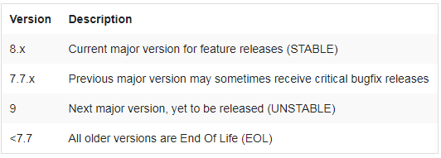

1. JDK should be downloaded
2. Then install it and set JAVA_HOME environment variable
3. Check the jdk is installed by using cmd :> Java bin path
4. Then cmd>java -version
5. Download the solr search zip then extract it in some drive then on cmd administrator mode
6. Go to the solr bin path then type solr start to start the solr
7. Then type in browser localhost:8983
8. Then we will see the solr admin screen
9. For stopping solr , go to cmd and type solr stop –all

Reference Link :

<https://www.apache.org/dyn/closer.cgi#verify>

<https://www.youtube.com/watch?v=_fW98B84lXA>

<https://lucene.apache.org/solr/guide/8_5/getting-started.html>

<https://stacksecrets.com/dot-net-core/integrate-solr-instance-with-net-core>

<https://github.com/solrnet/SolrNetSampleApps>

<https://github.com/SolrNet/SolrNet>

<http://hemkant-webapps.blogspot.com/2016/06/apache-solr-search-with-asp.net.html>

<https://www.nuget.org/packages/SolrNet.Core/>

<https://forums.asp.net/t/2162188.aspx?ASP+NET+core+3+0+with+SOLR>

<https://dotnet.libhunt.com/compare-solrnet-vs-solr-express?rel=cmp-cmp>

<https://stackoverflow.com/questions/10800919/implementing-solr-with-net-web-application>

<https://stacksecrets.com/dot-net-core/integrate-solr-instance-with-net-core#Solr_Client_Nuget_Package_For_NET_Core>

<https://docs.microsoft.com/en-us/archive/msdn-magazine/2019/april/net-implementing-your-own-enterprise-search>

<https://github.com/SolrNet/SolrNet/blob/master/Documentation/Initialization.md#microsoftextensionsdependencyinjection-aspnet-core>