# Scope of Work

**Project Statement**:

The CLAD team wants to create a new application called **DigiBadges**. Using this application, CLAD will be able to issue digital badges to the employees and they can share those digital badges on social media platforms such as LinkedIn, FB, GitHub etc and with other communities.

**What is a digital badge?**

A digital badge is similar in appearance to a physical badge or medal.

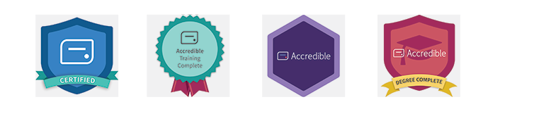

A digital badge is a symbol that is presented of accomplishment, skill, quality, or interest that can be earned in many learning environments. Digital badging makes it easy for anyone to issue, earn, and display badges across the web.

There are two major roles in this system Issuer and Earner.

**Issuer (CLAD)**: Issuer creates badges and a pathway to achieve it.

**Earner (Employee)**: Earner demonstrates skills and accomplishments, often by submitting evidence to the issuer to earn a Badge.

[Here](https://badgr.com/) you can find a sample application.

**Basic flow to understand badges**

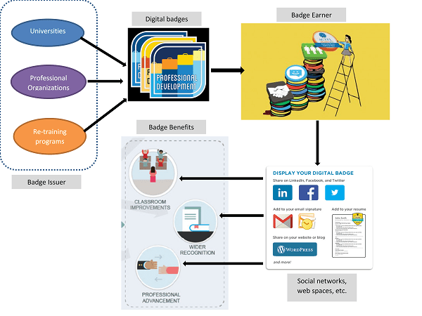

## Project Screenshots

**Issuers Screen -**

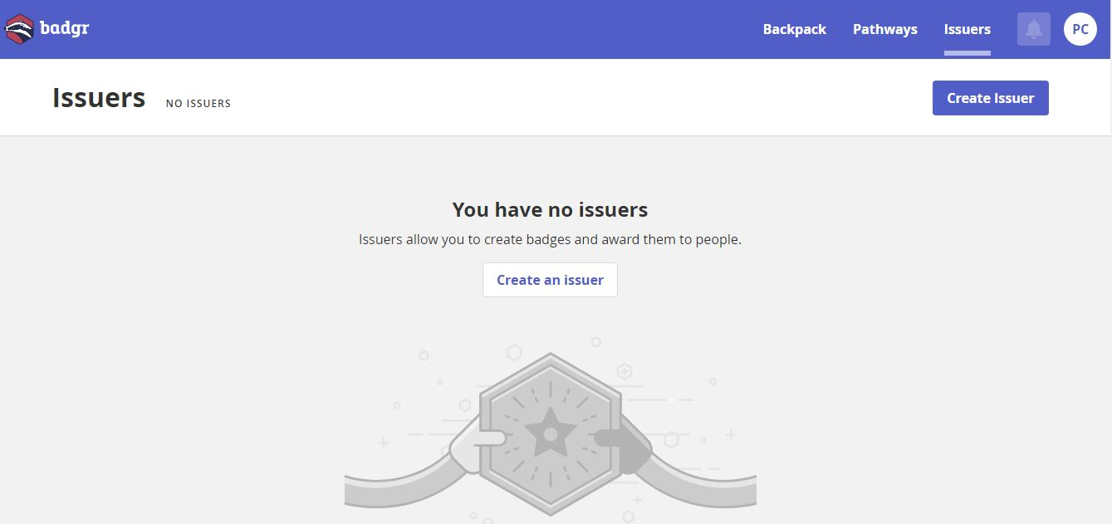

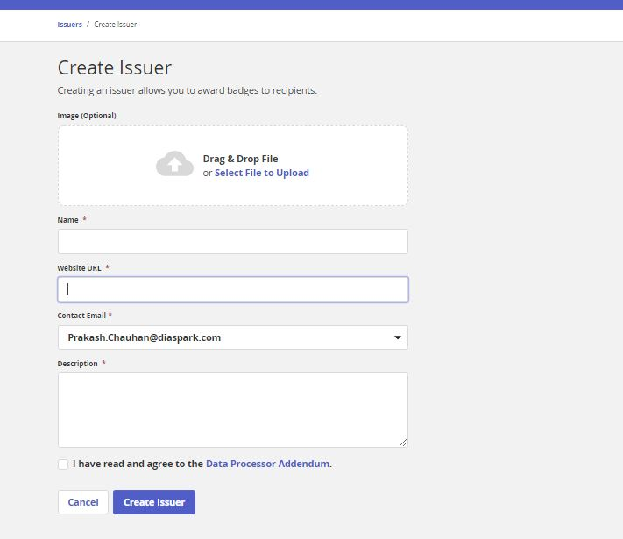

**Create Badges-**

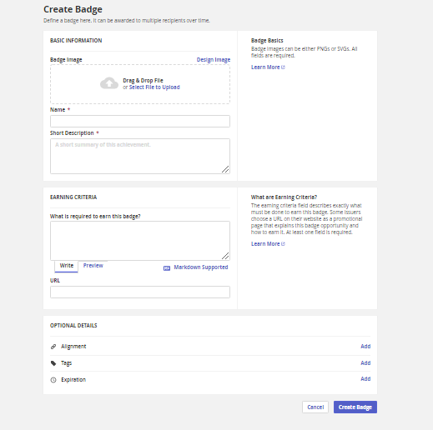

**Badges earner screen-**

# C:\Users\PCCHAUHAN\Desktop\Badgr\bager earn screen.JPG

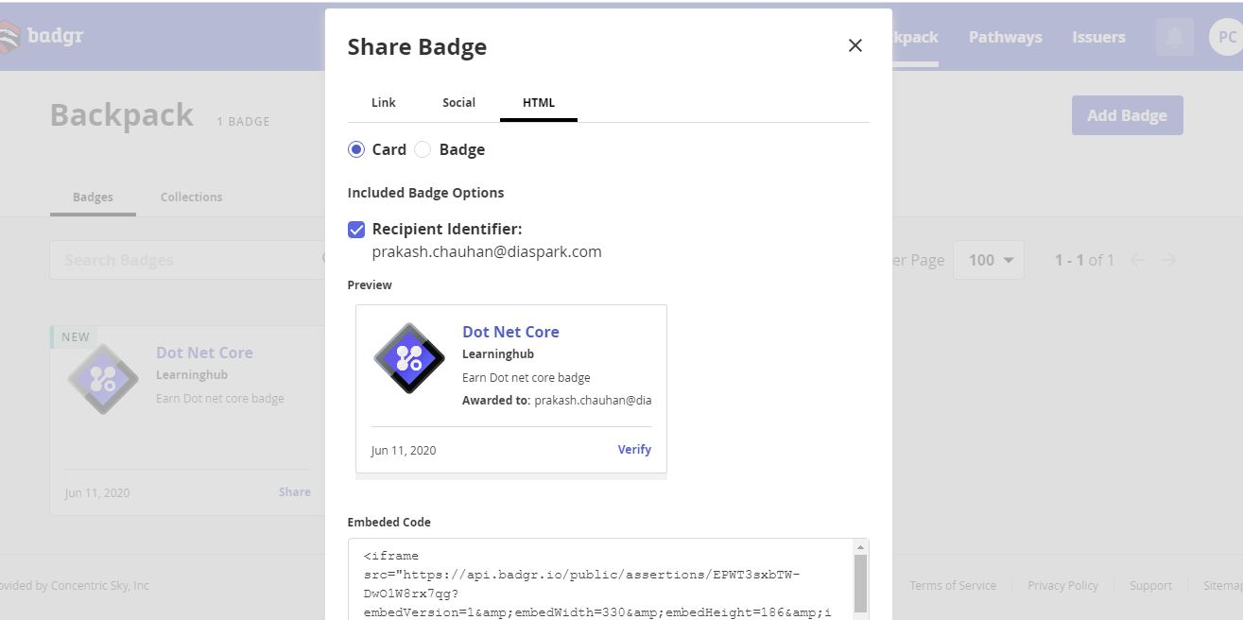

**Pathway to earn badges -**

# C:\Users\PCCHAUHAN\Desktop\Badgr\pathways.JPG

## Technology Use

1. ASP .Net Core
2. Mongo DB
3. Redis
4. Solr Search
5. Azure for deployment

## Project Steps & Timeline

1. Week 1

* Software installation and setup
* POC for Solr search with .NET Core
* POC for Redis cache with .NET Core
* POC for Mongo DB with .NET Core
* Architecture design

1. Week 2

* To be prepared by team lead on the based on research done in the first week