# DigiBadges

**What is a digital badge?**

A digital badge is similar in appearance to a physical badge or medal.

A digital badge is a symbol that is presented of accomplishment, skill, quality, or interest that can be earned in many learning environments. Digital badging makes it easy for anyone to issue, earn, and display badges across the web.

There are two major roles in this system Issuer and Earner.

**Issuer (CLAD)**: Issuer creates badges and a pathway to achieve it.

**Earner (Employee)**: Earner demonstrates skills and accomplishments, often by submitting evidence to the issuer to earn a Badge.

**Functional diagram**:

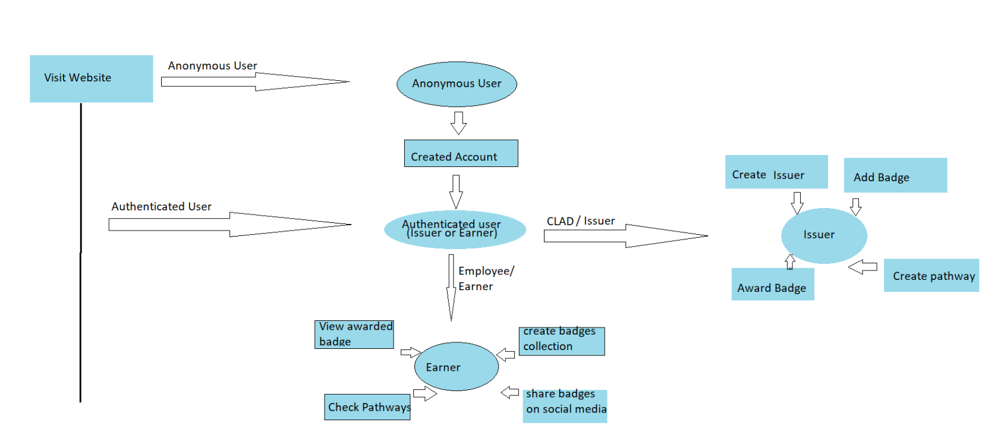

**Various modules in Earner (Employee)**:

1. Sign Up
2. Sign In
3. Backpack/Badges
4. Backpack/Collection
5. Pathways
6. Profile

**Various modules in Issuer (CLAD)**:

1. Sign In
2. Backpack/badges
3. Backpack/Collection
4. Pathways (To create pathways for employee)
5. To create Issuer
6. Awarded the badge by issuer to employee(Individual and bulk)(shared on post as well as on wallpost)
7. Profile

**Various Screens in Earner (Employee)**:

1. Sign Up

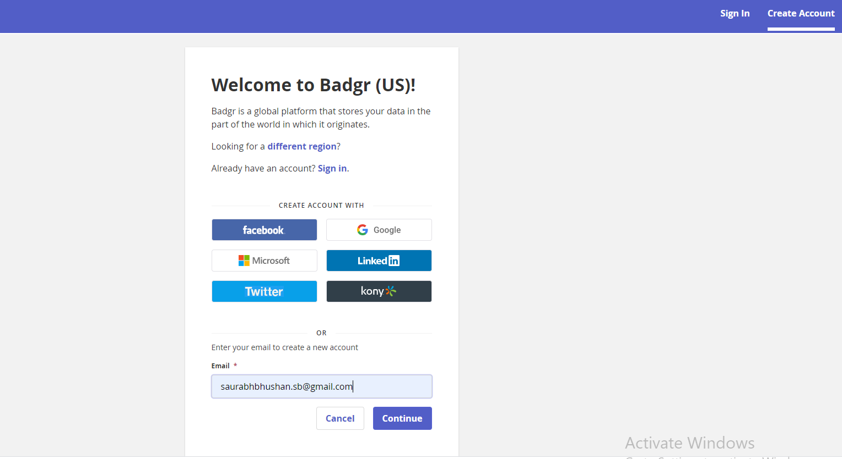

Then

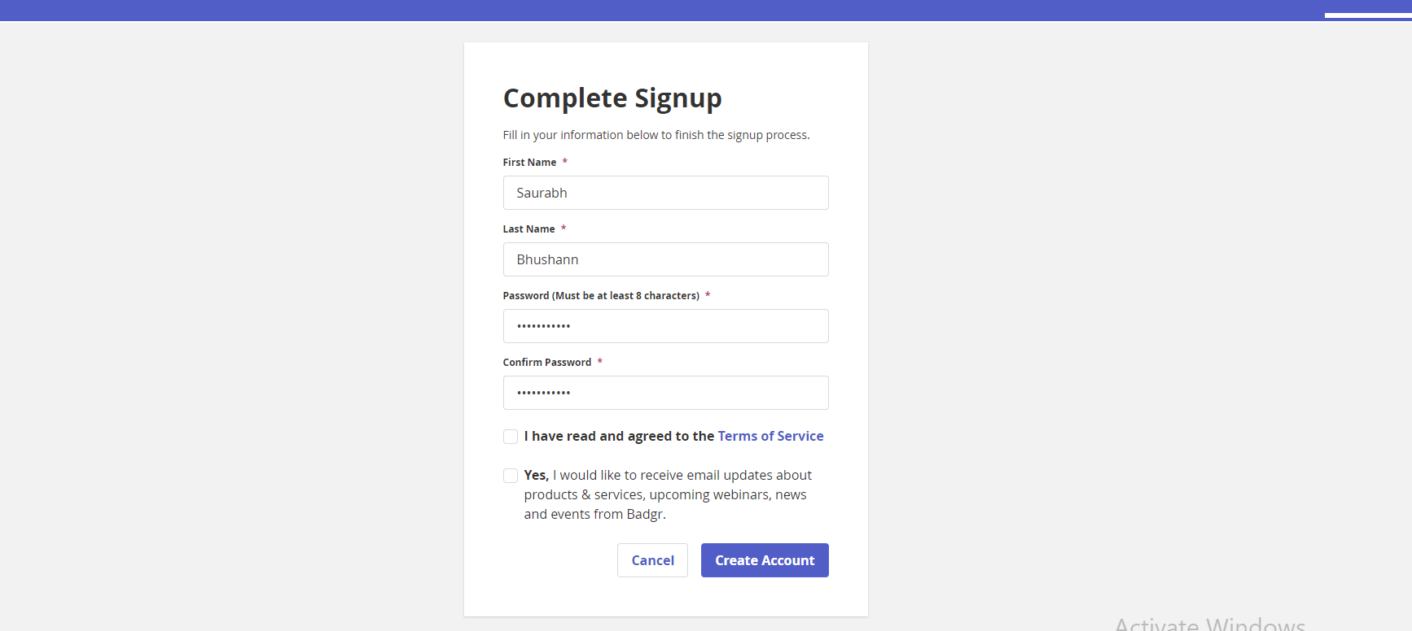

1. Sign In

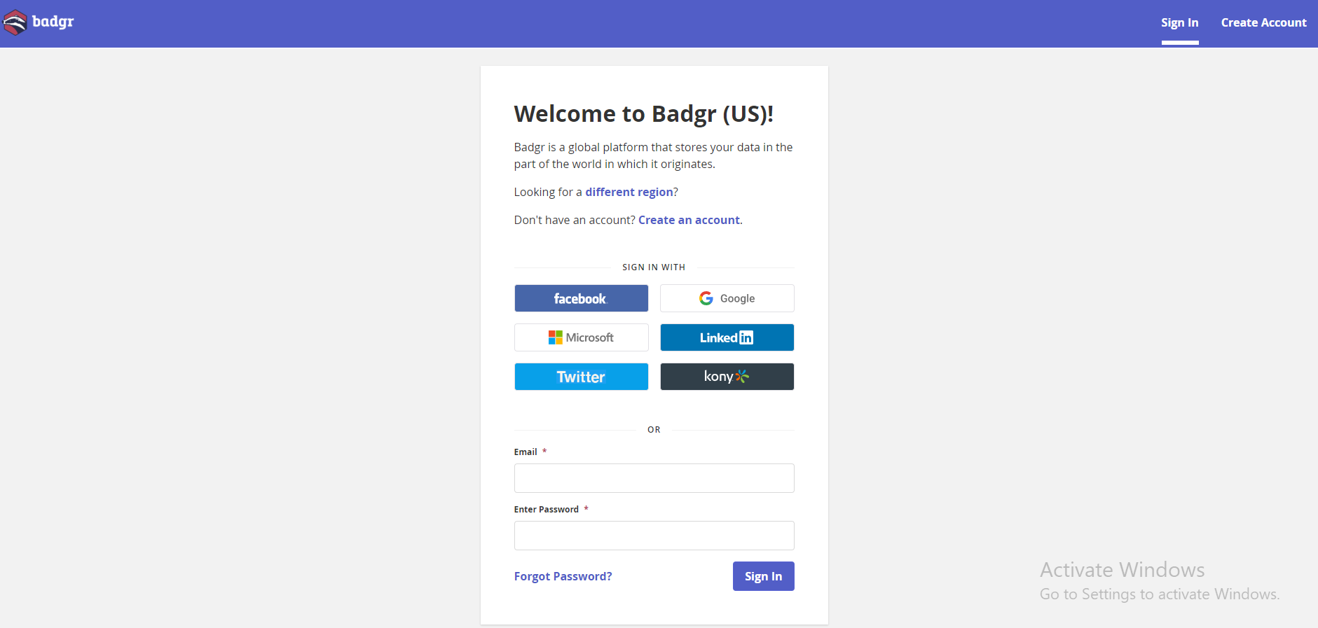

After Sign In display Employee dashboard except Issuers–

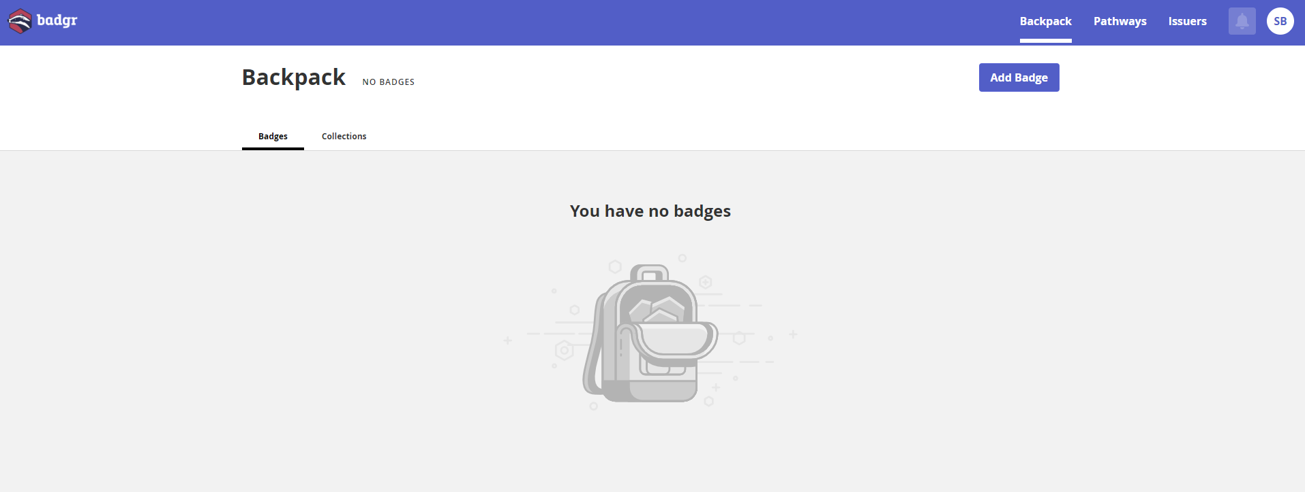

1. Backpack/Badges

If you earned badge from issuers

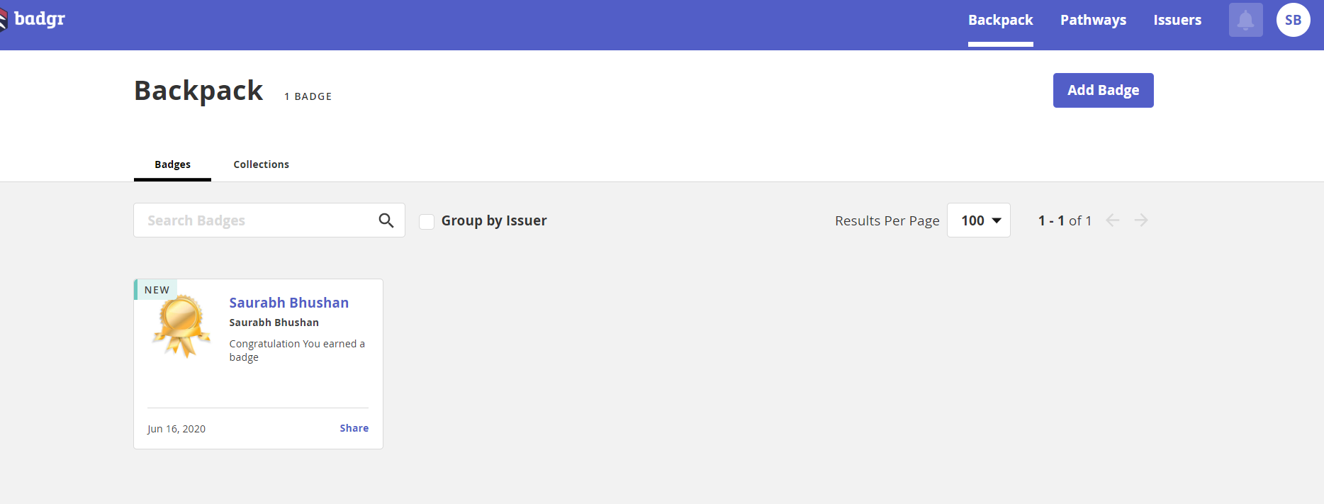

Share badges on social media

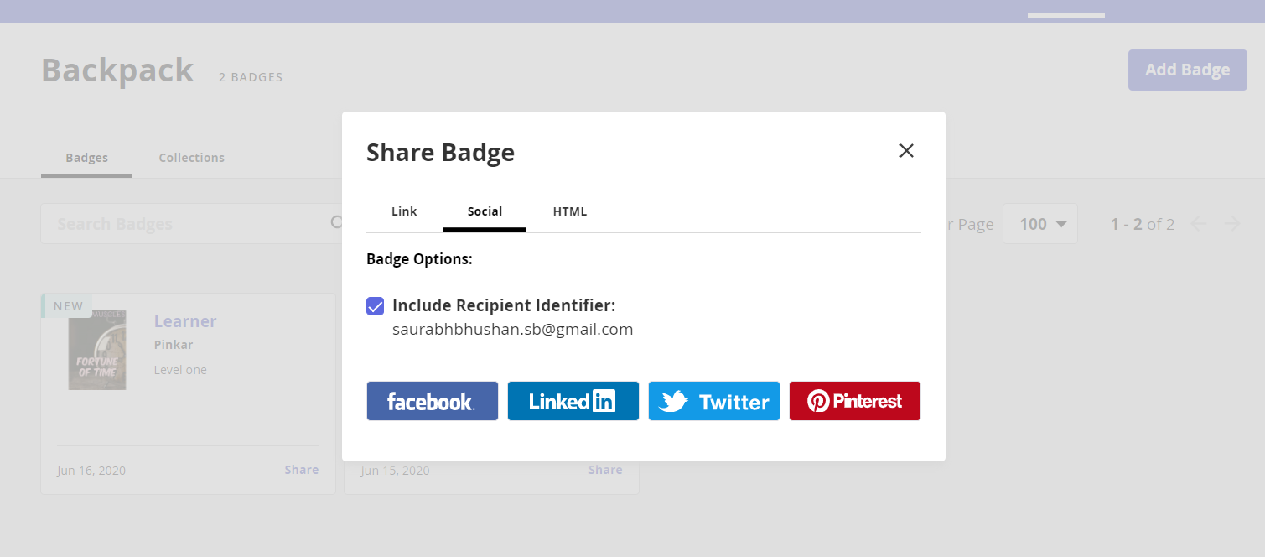

1. Backpack/Collections

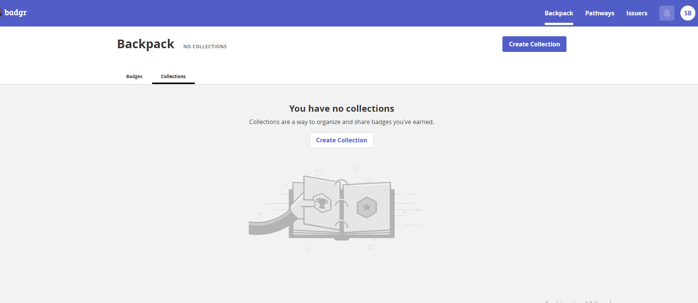

**On clicking Create collection**

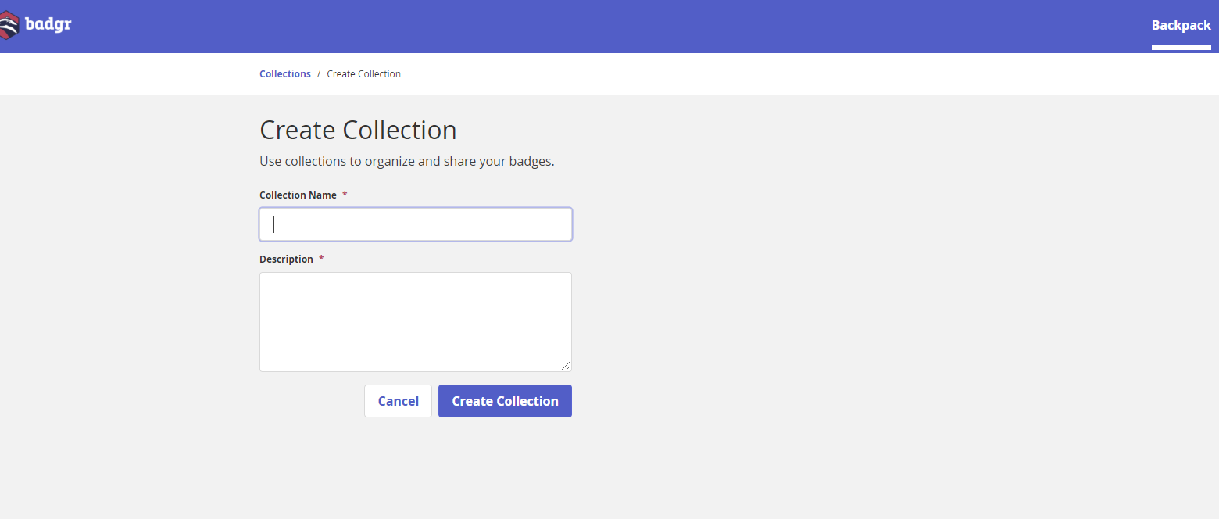

**After create collection**

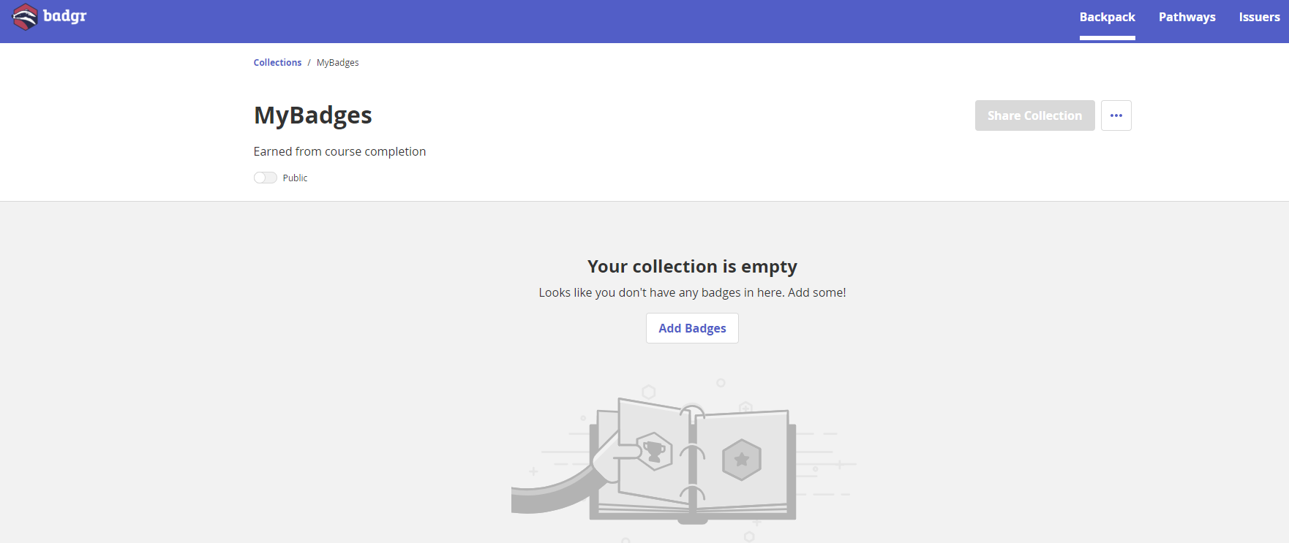

**After clicking add badge in above screen**

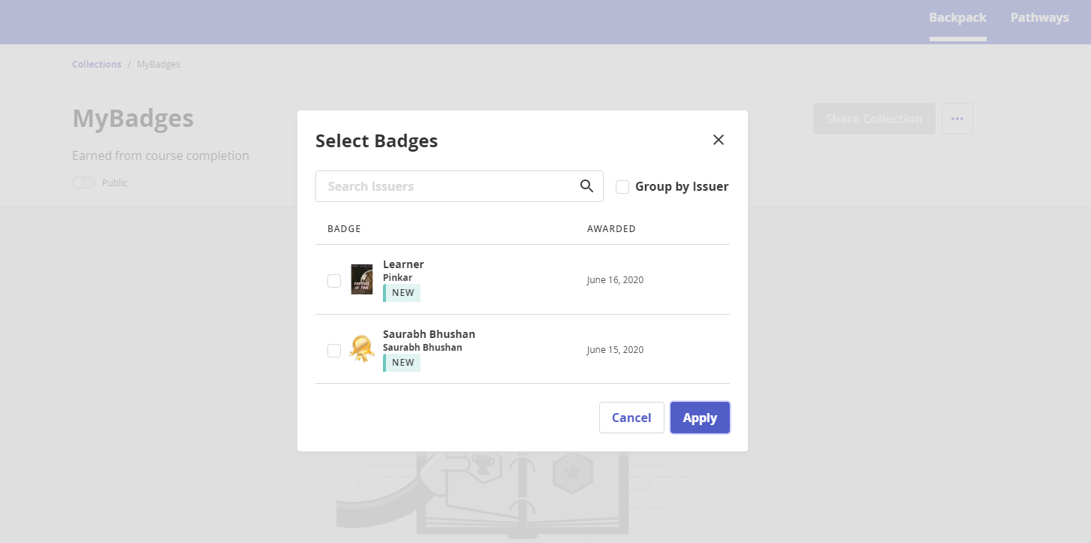

**After clicking apply button**

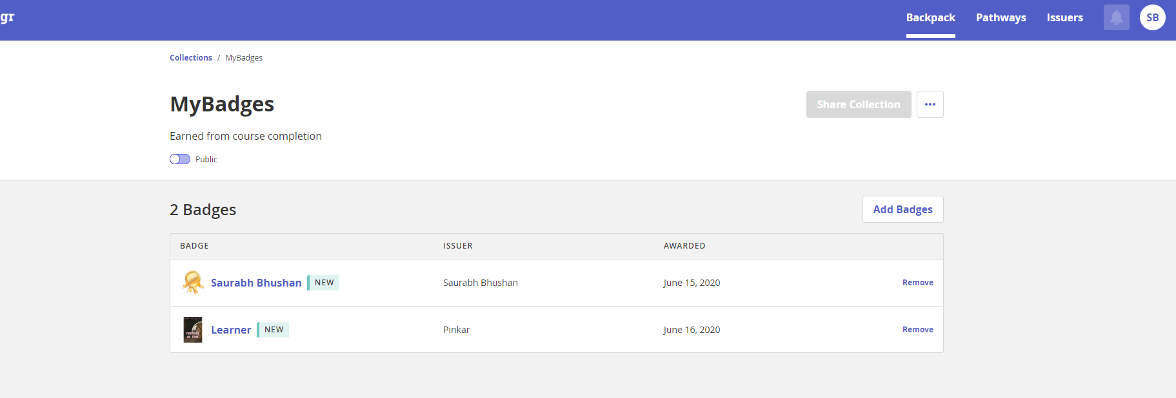

**On enabling Public button then share collection button become clickable**

**On clicking share collection**

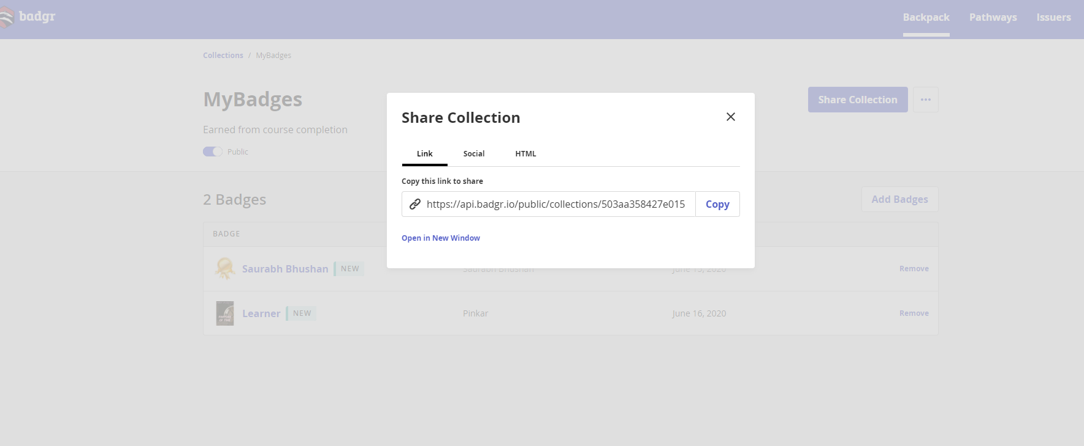

1. **Pathways**
2. **Profiles**

**Various Screens in Issuer (CLAD)**:

1. Sign In



After Sign In display dashboard –



1. Backpack/Badges

If you earned badge from issuers



Share badges on social media



1. Backpack/Collections



**On clicking Create collection**



**After create collection**



**After clicking add badge in above screen**



**After clicking apply button**



**On enabling Public button then share collection button become clickable**

**On clicking share collection**



1. Pathways (To create pathways for employee)
2. To create Issuer

**In Issuers tab –**

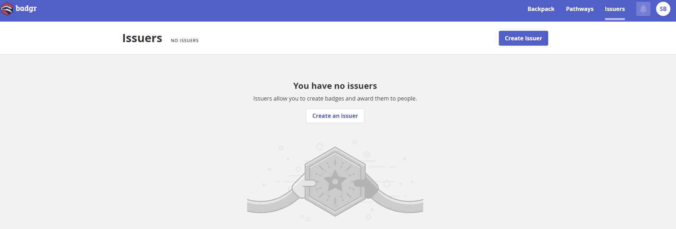

**–––On clicking create issuers –**

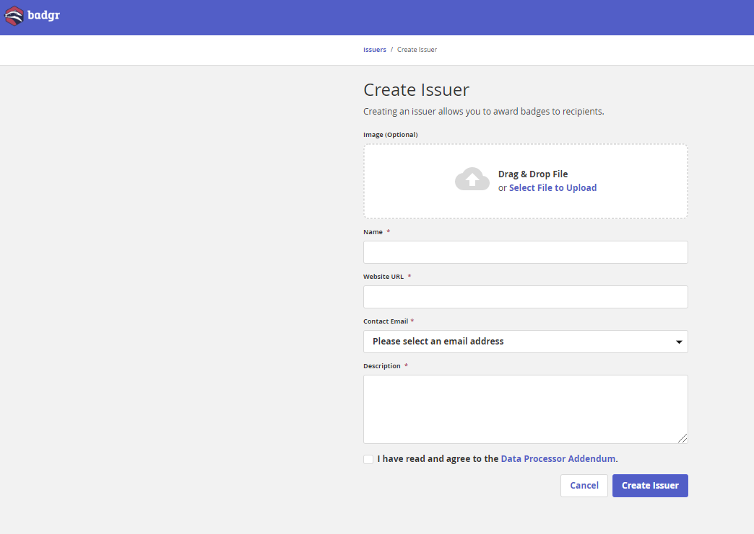

**After creating Issuer –**

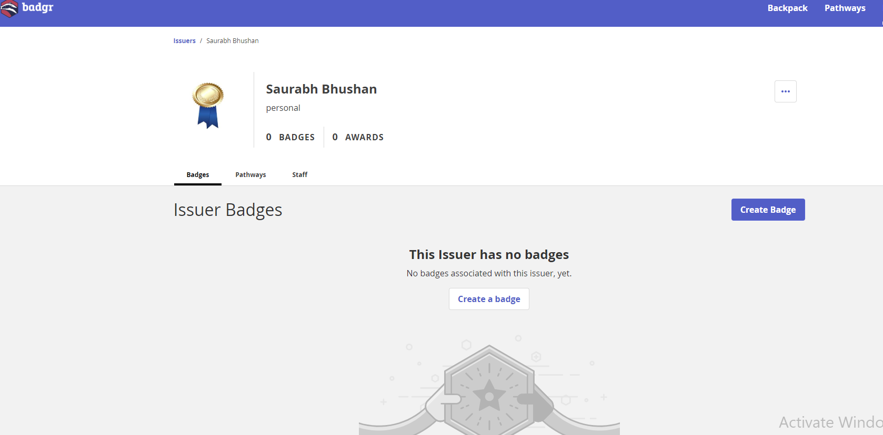

**On clicking create badge after creating issuers (screen 1) –**

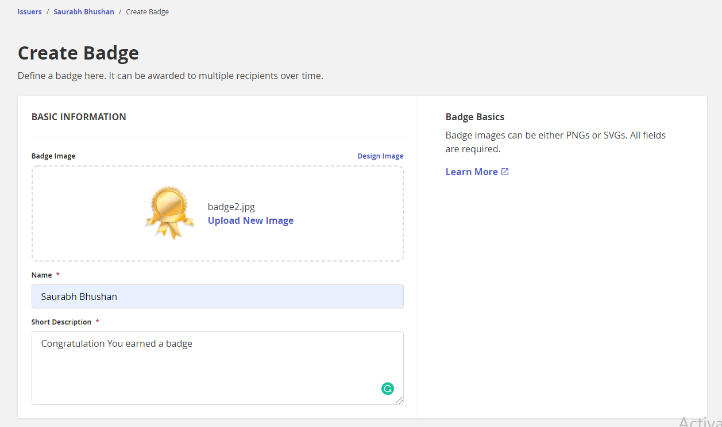

**Cont. –**

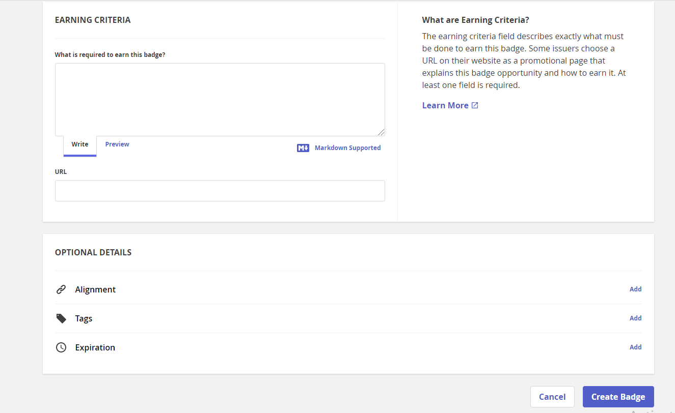

**After creating badge following screen appears-**

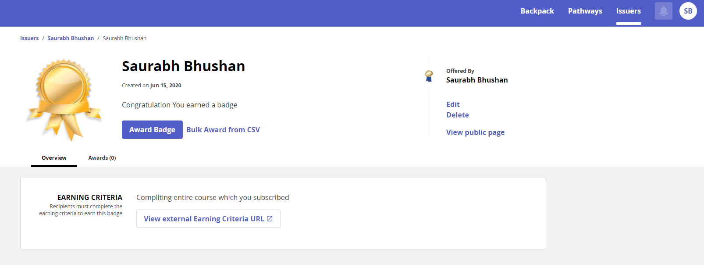

1. Awarded the badge by issuer to employee(Individual and bulk)

**Clicking award badge**

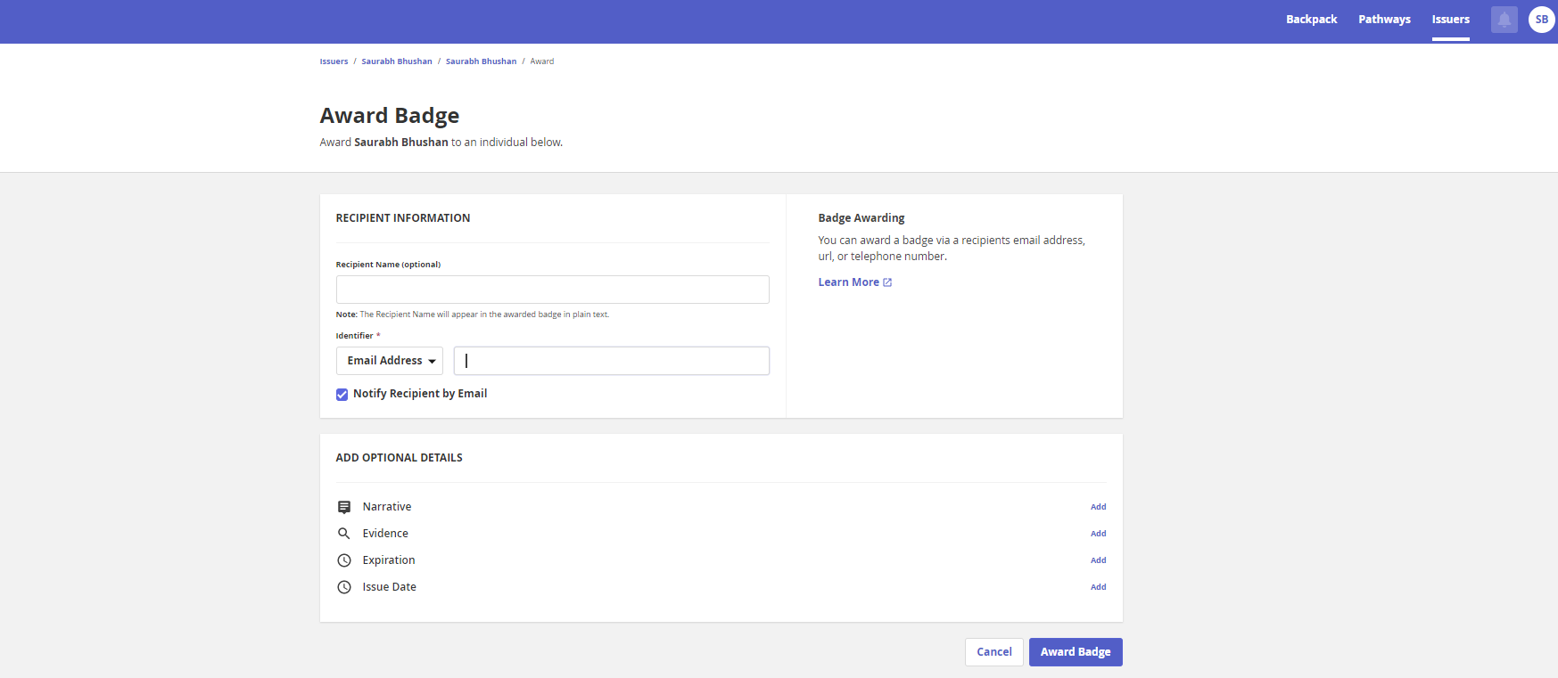

**After awarding screen looks like and send the email to recepients**

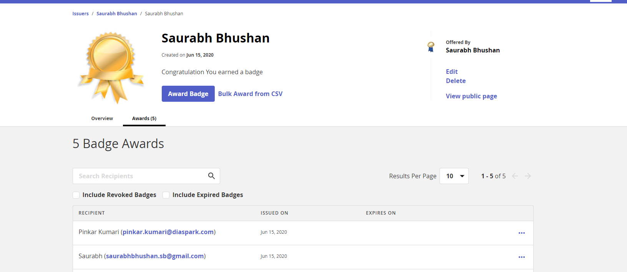

1. Profile