DEPARTMENT OF ELECTRONICS AND
COMMUNICATION ENGINEERING

PROJECT REPORT
LPG GAS DETECTOR WITH
GSM ALERT SYSTEM

Submitted By  ECE-B | Group 6 | Course  Microcontroller

Name | Roll No.
Archana M | 22
Mohammed Sinan | 50
Surya Sajikumar | 66
Abin Biju | 70

Abstract

This project presents the design and implementation of an LPG (Liquefied Petroleum Gas) gas detector system built around the AT89C51 microcontroller. The system continuously monitors ambient LPG concentration using an MQ-6 chemiresistive gas sensor, converts the analog sensor output to a digital value using an ADC0808 external analog-to-digital converter, and applies a physics-based mathematical model to compute the gas concentration in parts per million (PPM).

The system features a user-adjustable alarm threshold configured via a potentiometer, a 16×2 LCD display for real-time readout of gas concentration and status, a buzzer for local audible alerting, and an exhaust fan driven through an L293D motor driver for early ventilation. A GSM module provides remote SMS alerts to a pre-configured phone number when a dangerous gas level persists for more than three seconds, thereby eliminating false alarms caused by momentary sensor spikes.

The firmware is written in Embedded C and makes use of both hardware timers of the AT89C51 — Timer 0 for a software persist timer implemented via interrupt-driven overflow counting, and Timer 1 for precise UART baud rate generation. The project demonstrates the integration of analog sensing, mathematical signal processing, hardware interfacing, interrupt-driven timing, and wireless communication within a resource-constrained 8-bit microcontroller environment.

1. Introduction

LPG is widely used as a domestic cooking fuel across India and globally. Being heavier than air, LPG tends to accumulate near floor level in poorly ventilated spaces when a leak occurs. This makes it particularly hazardous — even small leaks can build up to explosive concentrations before being detected by smell alone. The Lower Explosive Limit (LEL) of LPG is approximately 2.2% by volume in air (~22,000 PPM), meaning any concentration above this threshold can ignite with a spark.

Electronic gas detection systems provide a reliable, continuous, and automated means of monitoring for LPG leaks, triggering graduated safety responses well before gas reaches dangerous concentrations. Embedding such a system within a microcontroller platform makes it compact, affordable, and programmable.

This project implements a complete LPG detection and alerting system on the AT89C51 microcontroller. The design philosophy is layered safety — the system responds progressively as gas concentration rises, beginning with ventilation, escalating to audible alarm, and finally dispatching a remote SMS alert. The alert threshold is user-programmable via a potentiometer, making the system adaptable to different deployment environments.

1.1 Motivation
Conventional household LPG detectors available in the market are either purely audible alarm devices with fixed thresholds, or expensive smart devices requiring internet connectivity. This project bridges the gap by implementing a microcontroller-based solution that includes remote SMS alerting without requiring internet infrastructure, using only a basic GSM network — making it suitable for rural and semi-urban deployments where smartphones and internet access may be limited.

2. Objectives

The following objectives were defined for this project:

- To interface the MQ-6 LPG gas sensor with the AT89C51 microcontroller through an external ADC0808 analog-to-digital converter.
- To provide a user-adjustable alarm threshold through a potentiometer mapped to a 0–4400 PPM (0–20% LEL) range.
- To implement a graduated safety response: fan activation at 10% LEL, buzzer alarm at the user threshold, and GSM SMS alert after sustained three-second detection.
- To use hardware Timer 0 in interrupt-driven mode for a debounced 3-second GSM persist timer, preventing false alarms.
- To use hardware Timer 1 for UART baud rate generation at 9600 bps for GSM module communication.
- To display real-time gas concentration, threshold, and system status on a 16×2 LCD.
- To simulate and validate the complete system in Proteus and compile the firmware using the Keil µVision IDE.

3. Components and Tools

3.1 Hardware Components

Component | Specification | Role in the System
AT89C51 MCU | 8051 family, 11.0592 MHz | Central controller — processes sensor data, drives all peripherals
MQ-6 Gas Sensor | Chemiresistive, SnO₂ | Detects LPG concentration; outputs analog voltage proportional to gas level
ADC0808 | 8-channel, 8-bit | Converts analog sensor and pot voltages to 8-bit digital values
16×2 LCD (LM016L) | 8-bit parallel, HD44780 | Displays real-time PPM, threshold, and system status
L293D Motor Driver | 600 mA per channel | Safely drives the exhaust fan from a MCU output pin
GSM Module | AT command, 9600 baud | Sends SMS alerts to a pre-configured phone number
Potentiometer | 10 kΩ | User-adjustable alarm threshold (0–4400 PPM)
Buzzer | Active, 5V | Local audible alert when gas exceeds threshold
Exhaust Fan | DC motor | Ventilates the area when gas exceeds 2200 PPM (10% LEL)
Crystal Oscillator | 11.0592 MHz | Provides UART-error-free clock for the AT89C51
Pull-up Resistors | 10 kΩ | Required for Port 0 open-drain output when driving LCD

3.2 Software Tools

The following software tools were used for development and simulation:

- Keil µVision IDE — Used for writing, compiling, and debugging the Embedded C firmware for the AT89C51 microcontroller.
- Proteus Design Suite — Used for schematic capture, circuit design, and full microcontroller simulation including virtual instruments.
- Embedded C (C89/C90 compatible) — The programming language used, providing direct hardware register access with structured, readable code.

4. System Architecture

4.1 Block Diagram Description
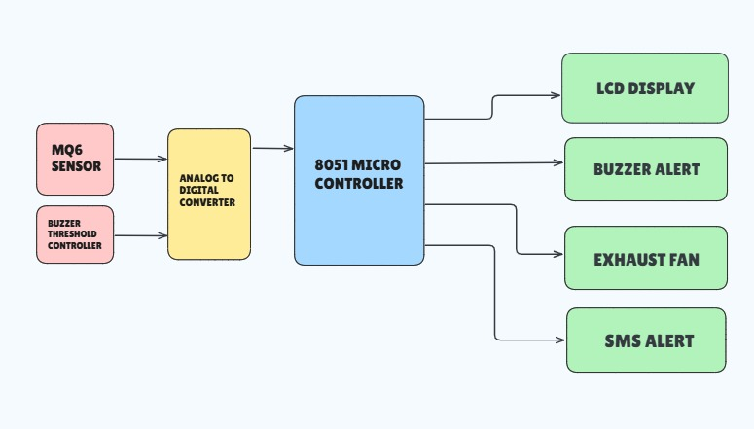
The system is organized around the AT89C51 microcontroller as the central processing unit. All peripherals connect directly to the microcontroller's I/O ports. The data flow begins at the MQ-6 sensor and potentiometer (analog inputs), passes through the ADC0808, enters the microcontroller for computation, and results in outputs to the LCD, buzzer, fan, and GSM module.

4.2 Pin and Port Assignment

Port / Pin | Signal | Connected Peripheral
P0 (8-bit bus) | DATA[7:0] | ADC0808 data output bus (8-bit digital result)
P1 (8-bit) | LCD data D0–D7 | 16×2 LCD data lines (8-bit mode)
P2.0 | ADC_START | ADC0808 conversion start signal
P2.1 | ADC_ALE | ADC0808 address latch enable
P2.2 | ADC_OE | ADC0808 output enable (read strobe)
P2.3 | ADC_ADDA | ADC0808 channel select (LSB of channel address)
P2.4 | LCD_RS | LCD Register Select (command / data)
P2.5 | LCD_RW | LCD Read/Write (held LOW = write)
P2.6 | LCD_EN | LCD Enable pulse
P3.0 | UART RXD | GSM module serial receive
P3.1 | UART TXD | GSM module serial transmit
P3.2 | ADC_EOC | ADC0808 End-of-Conversion (interrupt-polled)
P3.4 | FAN | L293D IN1 — exhaust fan drive signal
P3.5 | ADC_CLK | Software-generated ADC clock (bit-bang)
P3.7 | BUZZER | Active buzzer drive
5. Working Principle

5.1 MQ-6 Sensor Physics and PPM Calculation
The MQ-6 is a Metal Oxide Semiconductor (MOS) gas sensor whose tin dioxide (SnO₂) sensing element exhibits a resistance that decreases as LPG concentration in the surrounding air increases. This resistance change is converted to a voltage through a load resistor (RL = 20 kΩ) in a voltage divider configuration with the sensor's internal resistance Rs. The firmware converts the raw 8-bit ADC reading to a gas concentration in PPM through the following steps:

Step 1 — ADC to Voltage: The 8-bit ADC value (0–255) is linearly mapped to the supply voltage range (0–5V). Each ADC count represents approximately 19.6 mV.

Vout = (ADC_raw / 255) × 5.0 V

Step 2 — Voltage to Sensor Resistance: The load resistor voltage divider equation is rearranged to compute Rs, the current resistance of the MQ-6 sensing element:

Rs = RL × (Vcc − Vout) / Vout

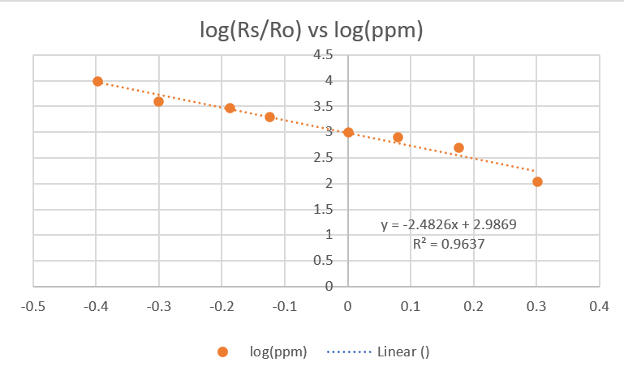
Step 3 — Rs/R0 to PPM (MQ-6 Power Law): The MQ-6 datasheet provides a log-log sensitivity curve for LPG. Fitting this curve yields a power-law relationship:

PPM = 970 × (Rs / R0)^(−2.48)

Here R0 = 10 kΩ is the sensor resistance in clean air (the calibration baseline). The negative exponent ensures that as Rs decreases (more gas), PPM increases — reflecting the physical behaviour of the sensor. The result is clamped to the range 0–9999 PPM for safe LCD display.

5.2 Threshold Potentiometer Mapping
The second ADC channel reads the wiper voltage of a potentiometer (0–5V). This is linearly mapped to a threshold range of 0–4400 PPM, which represents 0–20% of the LEL of LPG. The formula is:

Threshold PPM = (ADC_raw / 255) × 4400

20% LEL (4400 PPM) is widely adopted as the industry-standard alarm threshold — it provides a substantial safety margin before gas reaches explosive concentrations while still giving occupants time to respond and evacuate.

5.3 ADC0808 Interface (Bit-Bang Protocol)
Since the AT89C51 has no built-in ADC, the ADC0808 is driven by the microcontroller entirely in software (bit-banging). The read sequence for each channel is:

- Set the channel address on ADDA (P2.3) — Channel 0 for MQ-6, Channel 1 for potentiometer.
- Pulse ALE (P2.1) high for 2 clock cycles to latch the channel address into the ADC.
- Pulse START (P2.0) high for 2 clock cycles to begin the successive approximation conversion.
- Poll EOC (P3.2) — wait for it to go LOW (conversion started) then HIGH (conversion complete).
- Assert OE (P2.2) HIGH and read the 8-bit result from Port 0 (P0).
- De-assert OE to release the data bus.

The software clock function toggles P3.5 to provide the ADC's required external clock. Providing 80 clock pulses after the START pulse ensures the ADC has sufficient time to complete all 8 bits of successive approximation before the EOC polling begins.
5.4 Timer Architecture

Timer | Configuration | Function
Timer 0 | Mode 2 (8-bit auto-reload), Reload = 0x38, ISR-driven overflow counter | 3-second GSM persist timer — counts 13,820 overflows (~217 µs each) to confirm sustained gas detection before sending SMS
Timer 1 | Mode 2 (8-bit auto-reload), TH1 = TL1 = 0xFD | UART baud rate generation at exactly 9600 bps for GSM AT command communication (0% error at 11.0592 MHz)

Timer 0 Overflow Calculation: At 11.0592 MHz, one machine cycle = 12 / 11,059,200 s ≈ 1.085 µs. With reload value 0x38 (56 decimal), the counter runs from 56 to 255 = 200 counts per overflow. Overflow period = 200 × 1.085 µs ≈ 217 µs. Overflows for 3 seconds = 3,000,000 / 217 ≈ 13,820. This value is used as the ISR overflow threshold.

5.5 Safety Response Logic

Condition | System Response | LCD Status
Gas < 2200 PPM | All outputs OFF | SAFE — green zone, no action required
Gas ≥ 2200 PPM (10% LEL) | Fan ON via L293D | WARN — ventilation active, approaching threshold
Gas ≥ User Threshold | Fan ON + Buzzer ON + Timer starts | ALRT — local alarm active, SMS pending
Alert sustained for 3 s | GSM SMS sent once | ALRT — remote notification dispatched
Gas drops below threshold | All reset, gsm_sent cleared | SAFE — ready for next event
6. GSM Communication

The GSM module communicates with the AT89C51 via its built-in UART at 9600 bps. The system uses a sequence of AT commands to compose and transmit an SMS alert. The AT command sequence is as follows:

AT Command | Purpose
AT | Wake up and verify the GSM module is responsive. Expects OK response.
AT+CMGF=1 | Select text mode for SMS (as opposed to binary PDU mode). Simplifies message composition using plain ASCII.
AT+CMGS="9876543210" | Specify the recipient phone number and open the message entry prompt.
Message body | Plain ASCII text including gas PPM and threshold values, e.g.: LPG ALERT! Gas:XXXX PPM Threshold:XXXX PPM
Ctrl+Z (0x1A) | Terminate and transmit the SMS. This is the standard end-of-message signal for GSM text mode.

The gsm_sent flag prevents repeated SMS messages during a single alarm event. It is cleared only when gas concentration drops below the threshold, ensuring exactly one SMS is sent per discrete leak event regardless of duration.

7. LCD Display Interface

The 16×2 LCD operates in 8-bit parallel mode. Port 1 carries the 8 data lines (D0–D7) and Port 2 pins carry the control signals RS, RW, and EN. The LCD is initialized at startup with the standard HD44780 initialization sequence: function set (0x38), display ON with cursor OFF (0x0C), entry mode set (0x06), and display clear (0x01).

The display updates at 500 ms intervals (2 Hz refresh rate), which balances readability against responsiveness. Each update cycle writes two rows:

Row | Format | Content
Row 0 | GAS:XXXX PPM | Real-time gas concentration in PPM (4-digit, zero-padded)
Row 1 | TH: XXXX SAFE/WARN/ALRT | User-set threshold PPM followed by system status indicator

8. Simulation Result

SAFE: gas concentration < 2200ppm and threshold

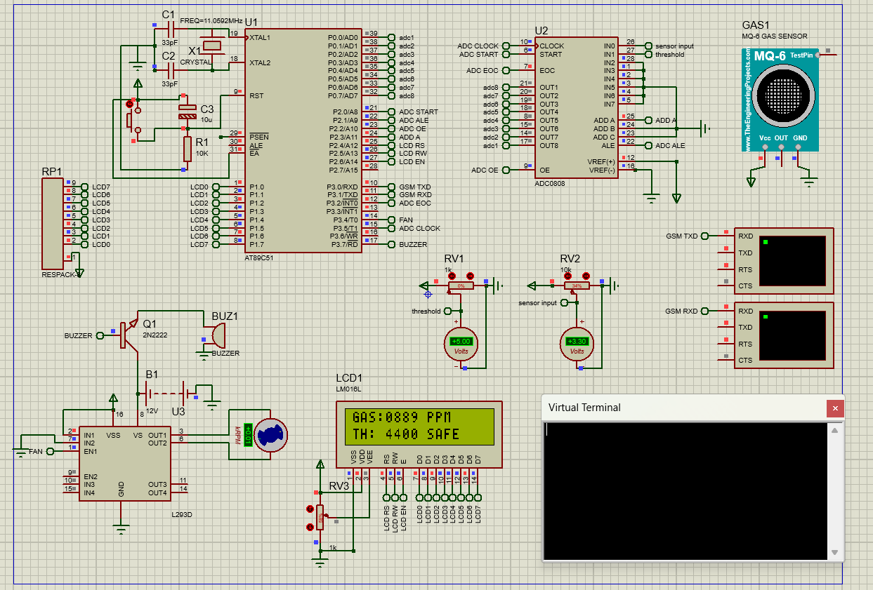

WARN: gas concentration >2200ppm but less than threshold

(Exhaustive fan active)
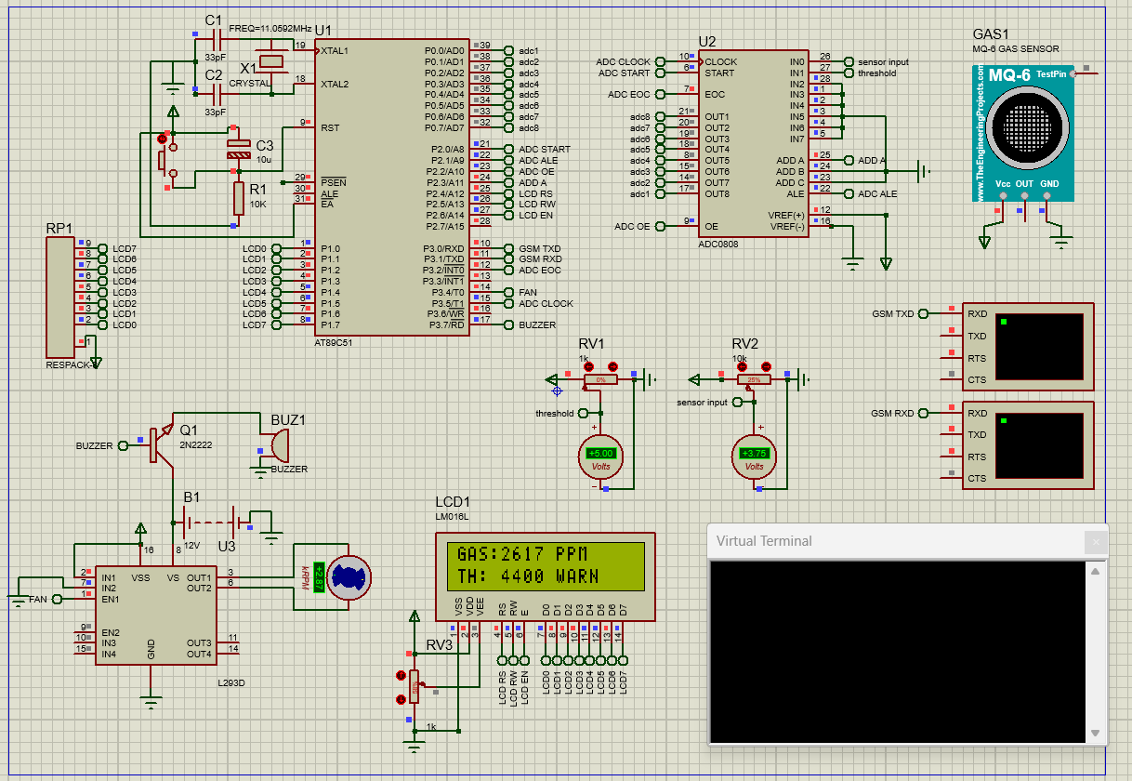

ALERT: gas concentration > 2200ppm and threshold
(Exhaustive fan + buzzer + SMS alert acive)

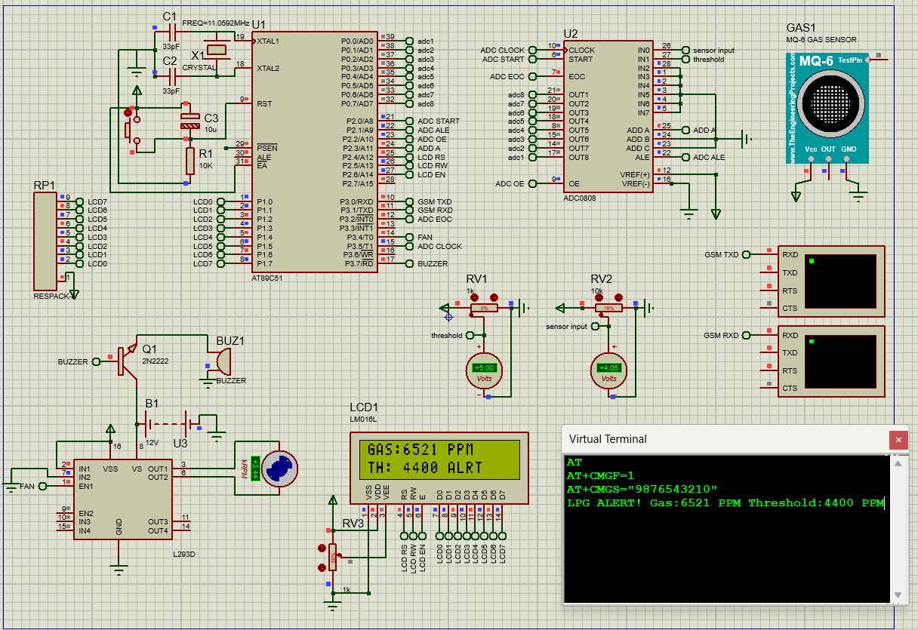

9. Applications and Advantages

9.1 Applications
- Domestic kitchens and households using LPG cylinders for cooking — provides early warning and remote alert to residents.
- Commercial restaurants and hotel kitchens where multiple LPG connections exist and monitoring is essential.
- Industrial facilities storing or processing LPG — the adjustable threshold allows calibration to site-specific safety regulations.
- LPG bottling and distribution plants where leak detection during filling operations is critical.
- Rural and semi-urban homes where internet connectivity is unavailable — GSM SMS alert works on basic cellular networks.
- Vehicles modified to run on LPG (autogas) — the compact design allows installation in engine compartments.

9.2 Advantages
- Graduated safety response — fan, buzzer, and SMS alerts are triggered at progressively higher gas concentrations, mimicking industry best practice.
- Debounced GSM alerting — the 3-second persist timer eliminates false alarms from transient sensor spikes (cooking steam, aerosols).
- User-programmable threshold — the potentiometer allows on-site adjustment without reprogramming or firmware changes.
- Single SMS per event — the gsm_sent flag prevents message flooding during prolonged alarm conditions.
- No internet dependency — SMS-based alerting works on any GSM network, making deployment universally accessible.
- Physics-based PPM calculation — the MQ-6 sensor model produces meaningful concentration values rather than arbitrary ADC counts.
- Dual timer design — both hardware timers are fully utilized with no conflicts, thanks to safe TMOD OR-masking.

10. Limitations and Future Scope

10.1 Current Limitations
- The MQ-6 sensor requires approximately 48 hours of initial burn-in and a 20-second warm-up on each power cycle for stable readings. The current firmware does not enforce a mandatory warm-up period beyond the 1.5-second initialisation delay.
- R0 (clean-air resistance baseline) is hard-coded at 10 kΩ. Individual sensor variation means this value should ideally be calibrated per-unit and stored in EEPROM.
- The ADC read loop contains a polling wait (while EOC == 0) with no timeout, which can cause the system to hang indefinitely if the ADC0808 develops a hardware fault.
- The phone number is hard-coded in firmware. Changing the recipient requires recompilation and reflashing.
- The system does not log alarm events for later review.

10.2 Future Enhancements
- Implement sensor warm-up enforcement on power-up with an LCD countdown and locked-out outputs during the warm-up period.
- Add EEPROM storage for the calibrated R0 value and the alert phone number, making both field-configurable without reprogramming.
- Incorporate a watchdog timer (WDT) to recover the system from any software hang caused by ADC or GSM communication failures.
- Add temperature and humidity compensation to the PPM calculation, since MQ-6 sensitivity curves shift with ambient conditions.
- Replace the GSM module with an IoT module (ESP8266/ESP32) for internet-based alerting, dashboard logging, and multiple contact notification.
- Upgrade to a 32-bit ARM Cortex-M microcontroller with built-in ADC to eliminate the external ADC0808 and reduce BOM cost.

11. Conclusion

This project successfully demonstrates the design and simulation of a complete LPG gas detection and alerting system based on the AT89C51 microcontroller. By integrating an MQ-6 chemiresistive sensor, an ADC0808 external converter, a real-time LCD display, local buzzer and fan outputs, and a GSM module for remote SMS alerts, the system achieves a layered safety response that reflects genuine engineering principles used in industrial gas detection.

The implementation highlights several important aspects of embedded systems design: the deliberate selection of an 11.0592 MHz crystal for zero-error UART baud generation, the use of Mode 2 auto-reload timers for consistent and jitter-free overflow intervals, safe TMOD register manipulation through OR-masking to prevent inter-timer conflicts, and the application of MQ-6 sensor physics through a power-law curve-fit equation to convert raw ADC readings into meaningful PPM values.

The 3-second persist timer implemented via Timer 0 interrupt-driven overflow counting provides effective debouncing of the GSM alert, preventing nuisance messages from transient sensor responses. The gsm_sent state flag ensures that exactly one SMS is dispatched per alarm event, making the system both reliable and considerate of the recipient.

This project demonstrates how a resource-constrained 8-bit microcontroller, when programmed thoughtfully, can implement a safety-critical embedded application with real-world applicability — making it a strong foundation for further development into a commercially viable LPG safety device.

References

1. Muhammad Ali Mazidi, Janice Gillispie Mazidi, and Rolin McKinlay, The 8051 Microcontroller and Embedded Systems, 2nd ed., Pearson Education, 2007.
- Winsen Electronics, MQ-6 Semiconductor Sensor for Combustible Gas — Datasheet, Zhengzhou Winsen Electronics Technology Co., Ltd.
- National Semiconductor / Texas Instruments, ADC0808/ADC0809 8-Bit µP Compatible A/D Converters with 8-Channel Multiplexer — Datasheet.
- STMicroelectronics / Texas Instruments, L293D Push-Pull Four Channel Driver with Diodes — Datasheet.
- Labcenter Electronics, Proteus Design Suite, Version 8.x, www.labcenter.com.
- ARM/Keil, µVision IDE for 8051, www.keil.com.
- Material safety data sheet, Gas Authority of India Limited

