Name- Bhoomi Batra
Section- A2 Batch- B4
Rollno- 60
DAA Practical 5

Aim: Implement Longest Common Subsequence (LCS) algorithm to find the length and LCS
for DNA sequences.

Problem Statement:
DNA sequences can be viewed as strings of A, C, G, and T characters, which represent
nucleotides. Finding the similarities between two DNA sequences are an important
computation performed in bioinformatics.
[Note that a subsequence might not include consecutive elements of the original sequence.]

TASK-1: Find the similarity between the given X and Y sequence.
X=AGCCCTAAGGGCTACCTAGCTT
Y= GACAGCCTACAAGCGTTAGCTTG
Output: Cost matrix with all costs and direction, final cost of LCS and the LCS.
LCS is:

CODE-
#include <stdio.h>
#include <string.h>

#define MAX 100

typedef struct {
int length;
char sequence[MAX];
} Cell;

char* findLCS(const char* X, const char* Y) {
static char result[MAX];
int m = strlen(X);
int n = strlen(Y);
Cell sub[MAX][MAX];

for (int i = 0; i <= m; i++)
for (int j = 0; j <= n; j++) {
sub[i][j].length = 0;
sub[i][j].sequence[0] = '\0';
}

for (int i = 1; i <= m; i++)
for (int j = 1; j <= n; j++) {
if (X[i - 1] == Y[j - 1]) {
sub[i][j].length = sub[i - 1][j - 1].length + 1;
strcpy(sub[i][j].sequence, sub[i - 1][j - 1].sequence);
int len = strlen(sub[i][j].sequence);
sub[i][j].sequence[len] = X[i - 1];
sub[i][j].sequence[len + 1] = '\0';
} else if (sub[i - 1][j].length >= sub[i][j - 1].length) {
sub[i][j].length = sub[i - 1][j].length;
strcpy(sub[i][j].sequence, sub[i - 1][j].sequence);
} else {
sub[i][j].length = sub[i][j - 1].length;
strcpy(sub[i][j].sequence, sub[i][j - 1].sequence);
}
}

strcpy(result, sub[m][n].sequence);
printf("LCS Sequence: %s\n", result);
printf("Length of LCS: %d\n", sub[m][n].length);
return result;
}

int main() {
char X[] = "AGCCCTAAGGGCTACCTAGCTT";
char Y[] = "GACAGCCTACAAGCGTTAGCTTG";
findLCS(X, Y);
return 0;
}

OUTPUT-
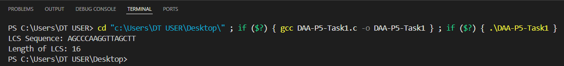

TASK-2: Find the longest repeating subsequence (LRS). Consider it as a variation of the
longest common subsequence (LCS) problem.
Let the given string be S. You need to find the LRS within S. To use the LCS framework, you
effectively compare S with itself. So, consider string1 = S and string2 = S.
Example:
AABCBDC
LRS= ABC or ABD

CODE-
#include <stdio.h>
#include <string.h>

#define MAX 100

void longestRepeatingSubsequence(char* str) {
int n = strlen(str);
int dp[MAX][MAX];

for (int i = 0; i <= n; i++)
for (int j = 0; j <= n; j++)
dp[i][j] = 0;

for (int i = 1; i <= n; i++) {
for (int j = 1; j <= n; j++) {
if (str[i-1] == str[j-1] && i != j)
dp[i][j] = 1 + dp[i-1][j-1];
else if (dp[i-1][j] > dp[i][j-1])
dp[i][j] = dp[i-1][j];
else
dp[i][j] = dp[i][j-1];
}
}

int i = n, j = n;
char lrs[MAX];
int index = 0;

while (i > 0 && j > 0) {
if (str[i-1] == str[j-1] && i != j && dp[i][j] == dp[i-1][j-1]+1) {
lrs[index++] = str[i-1];
i--; j--;
} else if (dp[i-1][j] >= dp[i][j-1]) {
i--;
} else {
j--;
}
}

lrs[index] = '\0';

for (int k = 0; k < index/2; k++) {
char temp = lrs[k];
lrs[k] = lrs[index-1-k];
lrs[index-1-k] = temp;
}

printf("Longest Repeating Subsequence: %s\n", lrs);
}

int main() {
char str[MAX];
printf("Enter the string: ");
scanf("%s", str);
longestRepeatingSubsequence(str);
return 0;
}

OUTPUT-
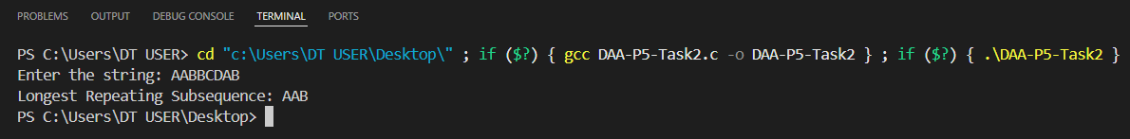

LEETCODE-
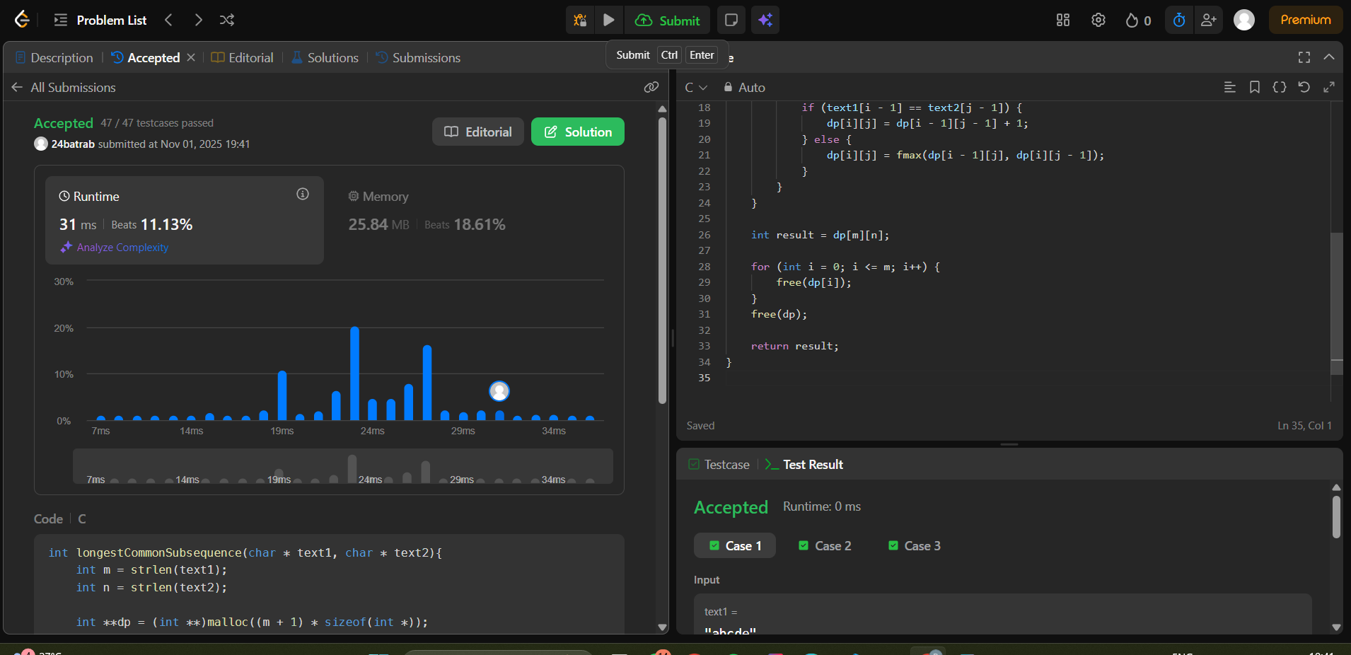

Github Link-
https://github.com/24batrab-dot

