Name- Bhoomi Batra
Sec-A2-B4-60
PRACTICAL NO. 7

Aim: Implement Hamiltonian Cycle using Backtracking.
Problem Statement:
The Smart City Transportation Department is designing a night-patrol route for security vehicles.
Each area of the city is represented as a vertex in a graph, and a road between two areas is represented as an edge.
The goal is to find a route that starts from the main headquarters (Area A), visits each area exactly once, and returns back to the headquarters — forming a
Hamiltonian Cycle.
If such a route is not possible, display a suitable message.
1) Adjacency Matrix
A B C D E
- 0 1 1 0 1
- 1 0 1 1 0
- 1 1 0 1 0
- 0 1 1 0 1
- 1 0 0 1 0

1) Adjacency Matrix
T M S H C
T 0 1 1 0 1
M 1 0 1 1 0
S 1 1 0 1 1
H 0 1 1 0 1
C 1 0 1 1 0
Output:
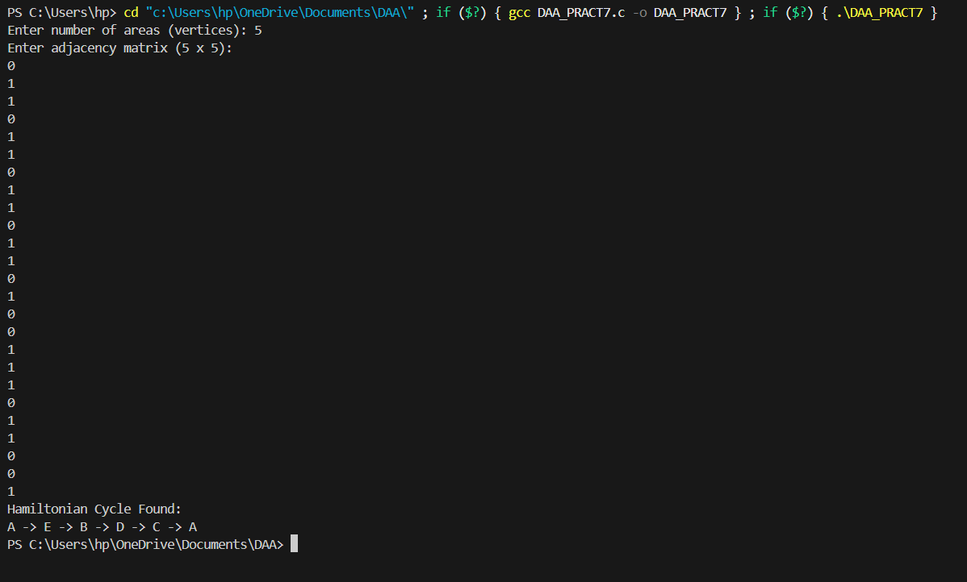

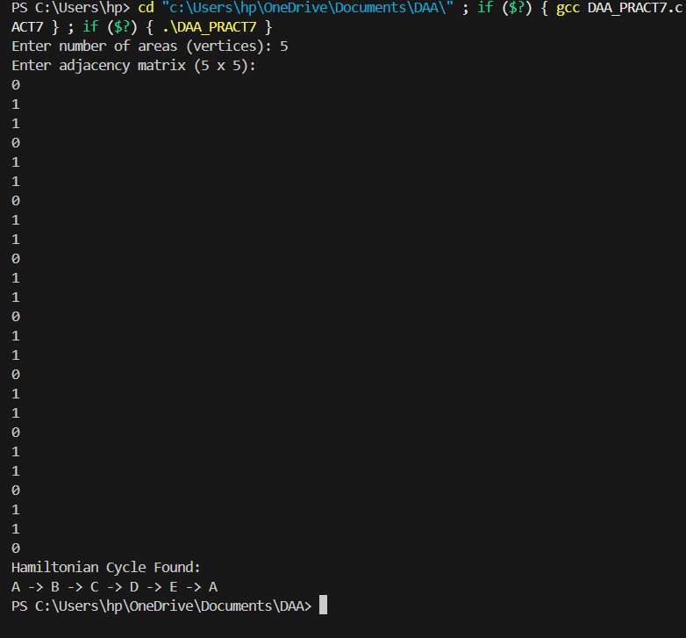

GitHub Link:
https://github.com/24batrab-dot

