Name | Bhoomi Batra
Section | A2
Roll no. | 60
Batch | B4

Aim: Implement maximum sum of subarray for the given scenario of resource allocation
using the divide and conquer approach.
PART A
Problem Statement:
A project requires allocating resources to various tasks over a period of time. Each task
requires a certain number of resources, and you want to maximize the overall efficiency of
resource usage. You’re given an array resource where resources[i] represents the amount of
resources required for the ith task. Your goal is to find the contiguous subarray of tasks that
maximizes the total resources utilized without exceeding a given resource constraint.

Handle cases where the total resources exceed the constraint by adjusting the subarray
window accordingly. Your implementation should handle various cases, including scenarios
where there’s no feasible subarray given the constraint and scenarios were multiple
subarrays yield the same maximum resource utilization.
1. Basic small array
resources = [2, 1, 3, 4], constraint = 5
o best subarray: [2, 1] or [1, 3] → sum = 4
o Checks simple working.

2. Exact match to constraint
resources = [2, 2, 2, 2], constraint = 4
o best subarray: [2, 2] → sum = 4
o Tests exact utilization.

3. Single element equals constraint
resources = [1, 5, 2, 3], constraint = 5
o best subarray: [5] → sum = 5
o Tests one-element solution.

4. All elements smaller but no combination fits
resources = [6, 7, 8], constraint = 5
o No feasible subarray.
o Tests “NO SOLUTION” case.

5. Multiple optimal subarrays
resources = [1, 2, 3, 2, 1], constraint = 5
o best subarrays: [2, 3] and [3, 2] → sum = 5
o Tests tie-breaking (should return either valid subarray).

6. Large window valid
resources = [1, 1, 1, 1, 1], constraint = 4
o best subarray: [1, 1, 1, 1] → sum = 4
o Ensures long window works.

7. Sliding window shrink needed
resources = [4, 2, 3, 1], constraint = 5
o Start [4,2] = 6 (too big) → shrink to [2,3] = 5.
o Tests dynamic window adjustment.

8. Empty array
resources = [], constraint = 10
o Output: no subarray.
o Edge case: empty input.

9. Constraint = 0
resources = [1, 2, 3], constraint = 0
o No subarray possible.
o Edge case: zero constraint.

10. Very large input (stress test)
resources = [1, 2, 3, ..., 100000], constraint = 10^9
o Valid subarray near full array.
o Performance test.
Output:
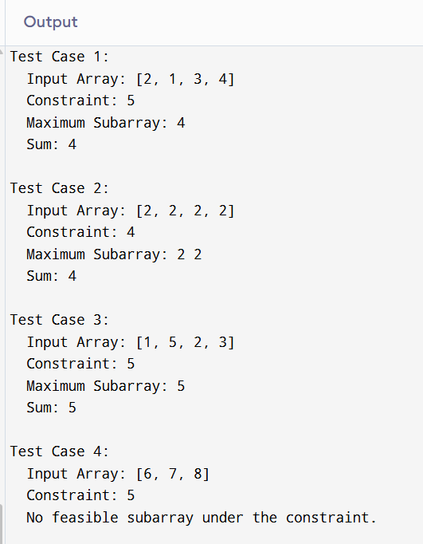
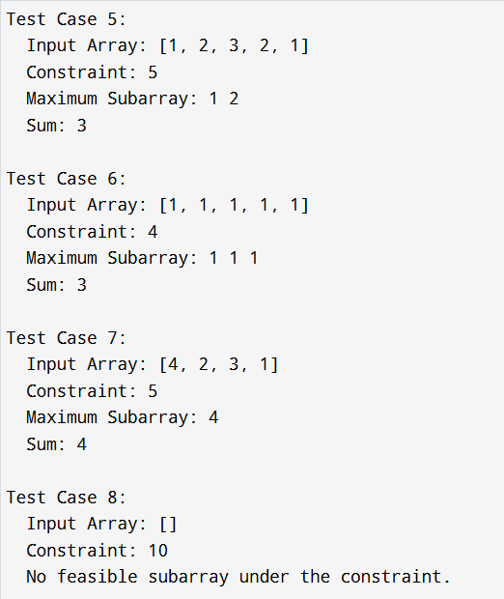
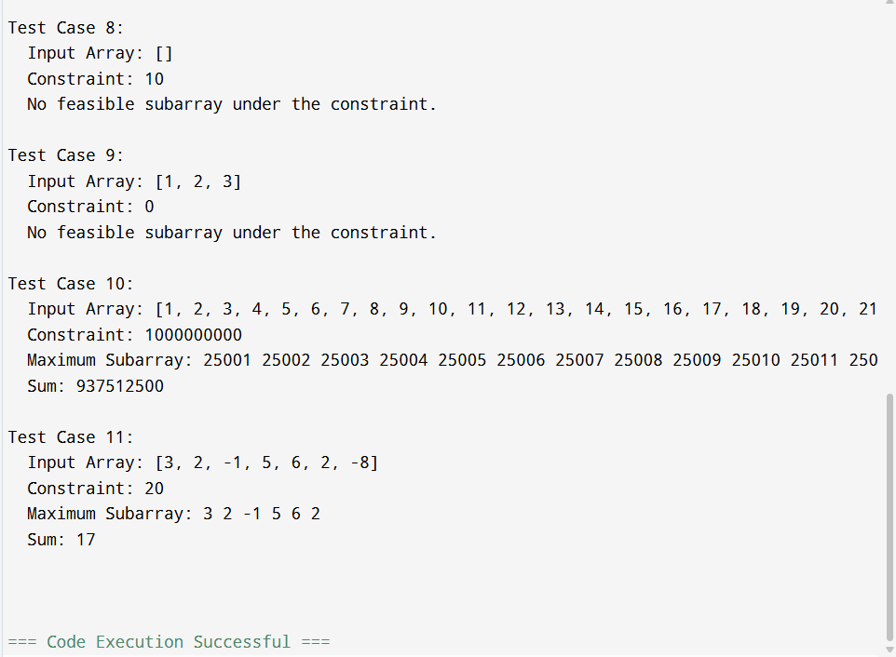
PART B
LEETCODE
OUTPUT:
