Project Design Phase
Solution Architecture

Date | 29 September 2026
Team ID | SWTID-2026-5028
Project Name | AI Blog Nest API
Maximum Marks | 4 Marks

Solution Architecture:
Solution architecture is a complex process – with many sub-processes – that bridges the gap between business problems and technology solutions. Its goals are to:
- Find the best tech solution to solve existing business problems.
- Describe the structure, characteristics, behavior, and other aspects of the software to project stakeholders.
- Define features, development phases, and solution requirements.
- Provide specifications according to which the solution is defined, managed, and delivered.

Example - Solution Architecture Diagram:

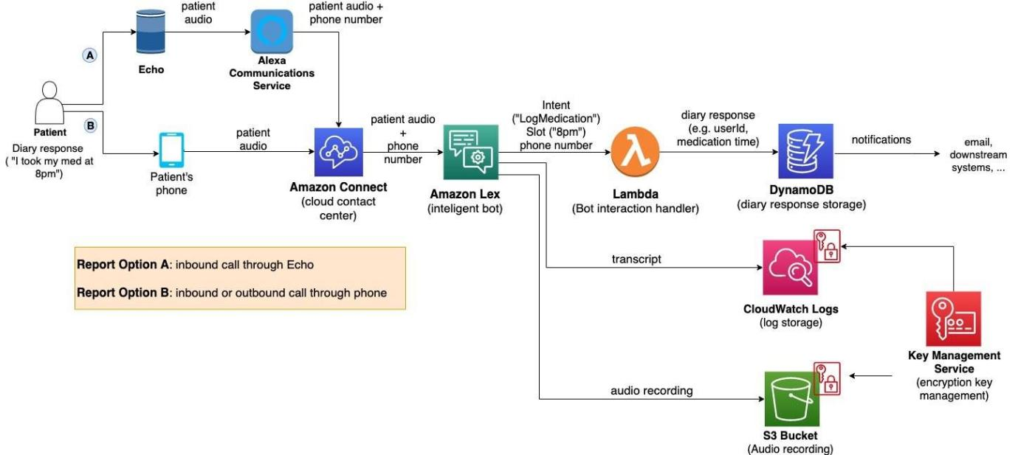
Figure 1: Architecture and data flow of the voice patient diary sample application
Reference: https://aws.amazon.com/blogs/industries/voice-applications-in-clinical-research-powered-by-ai-on-aws-part-1-architecture-and-design-considerations/

AI Blog Nest API – Solution Architecture
College: C.T.T.E. College for Women
Team: M.Susmitha (Team Leader); A.Sathya priya,E.Suvasini,M.Shaheena.

Architecture Overview
AI Blog Nest API follows a layered REST API architecture. Client requests are authenticated using token-based access control and routed according to user roles. Controllers process validated requests, business logic manages blog, category, comment, generation, and summarization operations, and the database stores users, blogs, tags, comments, and related metadata.

Core Architecture Components
Client / API Consumer – Sends requests for blog creation, management, generation, summarization, and moderation.
Authentication & Role-Based Route Guard – Validates tokens and restricts protected operations according to user roles.
API Routes & Controllers – Receives requests and coordinates the required backend operations.
Validation & Sanitization Layer – Sanitizes payload parameters and helps prevent XSS vectors and NoSQL parameter manipulation.
Blog Management Module – Performs CRUD operations for content definitions, status states, and asset assignment paths.
Categorization Module – Maintains tags/categories to support filtering and content discovery.
Comment Moderation Module – Manages approved, pending, and spam moderation states through protected endpoints.
AI Blog Generation Pipeline – Uses external LLM abstractions and context-aware prompt templates to generate structured full-length blog posts.
Content Summarization Engine – Produces concise abstracts and automated metadata summaries from extensive article content.
Database Layer – Persists application data and supports efficient content retrieval and management.

High-Level Data Flow
Client → Authentication / Route Guard → API Routes & Controllers → Validation / Sanitization → Business Modules → Database. AI generation and summarization modules communicate with the configured external LLM abstraction when AI processing is requested, then return the generated result to the API client.

Key Requirements
Secure token-based authentication and role-based authorization.
Complete CRUD management for blog content.
Categorization and tag-based filtering.
Comment moderation with approved, pending, and spam states.
Input sanitization for security protection.
AI-based blog generation from thematic inputs.
AI-based article summarization and metadata generation.

