Project Design Phase-II
Data Flow Diagram & User Stories

Date | 29 September 2026
Team ID | SWTID-2026-6565
Project Name | AI FitTrack API
Maximum Marks | 4 Marks

Data Flow Diagrams:
A Data Flow Diagram (DFD) is a traditional visual representation of the information flows within a system. A neat and clear DFD can depict the right amount of the system requirement graphically. It shows how data enters and leaves the system, what changes the information, and where data is stored.
AI FitTrack API – Level 0 Data Flow Diagram
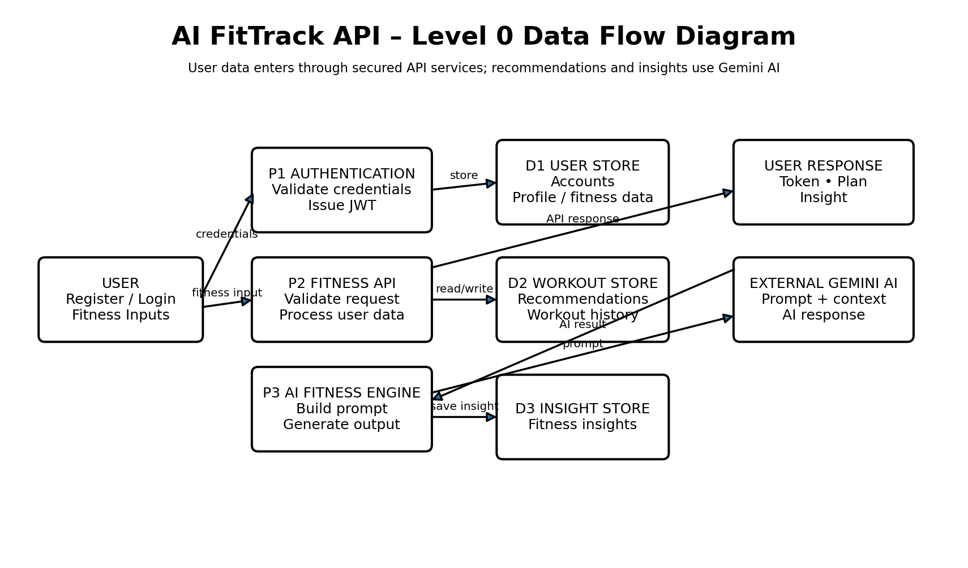
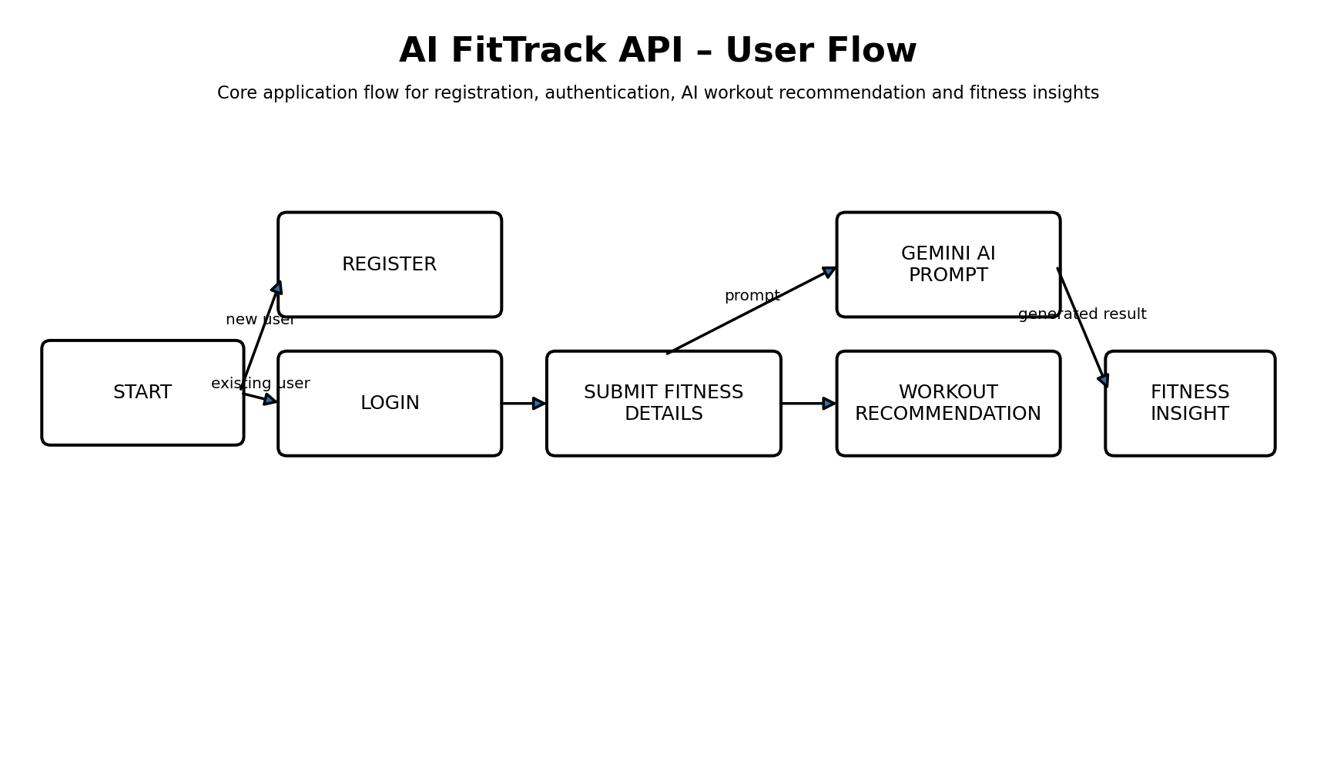

User Stories
Use the below template to list all the user stories for the product.
User Type | Functional Requirement (Epic) | User Story Number | User Story / Task | Acceptance criteria | Priority | Release
User | Registration | USN-1 | As a user, I can register with my email and password so that I can create an AI FitTrack account. | Valid account is created and credentials are accepted. | High | Sprint-1
User | Login | USN-2 | As a user, I can log in with valid credentials and receive an authenticated token. | Valid token is issued; invalid credentials are rejected. | High | Sprint-1
User | Authentication | USN-3 | As a user, I can access protected fitness endpoints only after authentication. | Unauthenticated requests receive an access error. | High | Sprint-1
User | Fitness Profile | USN-4 | As a user, I can provide and update my fitness details for personalized recommendations. | Valid fitness details are stored and can be updated. | High | Sprint-1
User | Fitness Inputs | USN-5 | As a user, I can submit relevant fitness information to the API. | Required inputs are validated before processing. | High | Sprint-1
User | Workout Recommendation | USN-6 | As a user, I can request a personalized workout recommendation using my fitness data. | Gemini returns a structured recommendation that can be returned to the user. | High | Sprint-2
User | AI Prompt Processing | USN-7 | As a user, I can have my fitness context included in a structured Gemini prompt. | Prompt contains validated context and is sent to the AI service. | High | Sprint-2
User | Workout Recommendation | USN-8 | As a user, I can view the workout recommendation generated for me. | Generated recommendation is returned in a readable API response. | High | Sprint-2
User | Workout Recommendation | USN-9 | As a user, I can request a new workout recommendation when my fitness context changes. | A new validated request generates an updated recommendation. | Medium | Sprint-2
User | Fitness Insight | USN-10 | As a user, I can request an AI-generated fitness insight from my available fitness information. | Gemini returns a concise fitness insight. | High | Sprint-2
User | Fitness Insight | USN-11 | As a user, I can view my generated fitness insight through the API. | Authorized user receives the corresponding insight. | High | Sprint-2
User | Workout History | USN-12 | As a user, I can retrieve my saved workout recommendation/history data. | Only the authenticated user's records are returned. | Medium | Sprint-3
User | Fitness Insight History | USN-13 | As a user, I can retrieve previous fitness insights associated with my account. | Only authorized insight records are returned. | Medium | Sprint-3
System | Input Security | USN-14 | As the system, I must validate and sanitize fitness inputs before processing. | Invalid or unsafe payloads are rejected or sanitized. | High | Sprint-1
System | NoSQL Injection Protection | USN-15 | As the system, I must prevent unsafe query parameters from manipulating database operations. | Unsafe operators/parameters are blocked or sanitized. | High | Sprint-1
System | AI Failure Handling | USN-16 | As the system, I must handle Gemini AI failures without corrupting fitness data. | Controlled error is returned and invalid AI output is not saved. | Medium | Sprint-2
System | API Error Handling | USN-17 | As the system, I must return safe error responses when database or service failures occur. | Controlled error response is returned and failure is logged. | Medium | Sprint-2
System | API Performance | USN-18 | As the system, I should use indexed queries and bounded payloads for fitness records. | Large collections return bounded result sets efficiently. | Medium | Sprint-3
System | Rate Limiting | USN-19 | As the system, I must limit excessive API requests to protect the service and AI usage. | Excessive requests are throttled or rejected safely. | Medium | Sprint-3
System | Secure Data Access | USN-20 | As the system, I must ensure users can access only their own protected fitness records. | Cross-user access is rejected. | High | Sprint-3

College: C.T.T.E College for Women
Team Leader: DANIYA FATHIMA B
Team Members: KATHIJA RAYHANA A, FAIZA FATHIMA I, AYSHA MAFAZHA A S
DFD Data Stores & Interfaces: D1 MongoDB stores user accounts, fitness profiles, workout recommendations, workout history and fitness insights. D2 stores application fitness records as required. D3 External Gemini AI receives structured prompts/context and returns workout recommendations or fitness insights. Authentication and JWT checks occur before protected operations.

