Project Design Phase-II
API Technologies Stack

Date | 29 September 2026
Team ID | SWTID-2026-6565
Project Name | AI FitTrack API
Maximum Marks | 4 Marks

Technical Architecture:
The Deliverable shall include the architectural diagram as below and the information as per the table1 & table 2
Project Architecture: AI FitTrack API – secure AI-powered fitness recommendation backend
Architecture focus: secure API layer, MongoDB fitness data storage, Gemini AI integration and cloud deployment.
Guidelines:
Include all the processes (As an application logic / Technology Block)
Provide infrastructural demarcation (Local / Cloud)
Indicate external interfaces (third party API’s etc.)
Indicate Data Storage components / services
Indicate interface to machine learning models (if applicable)
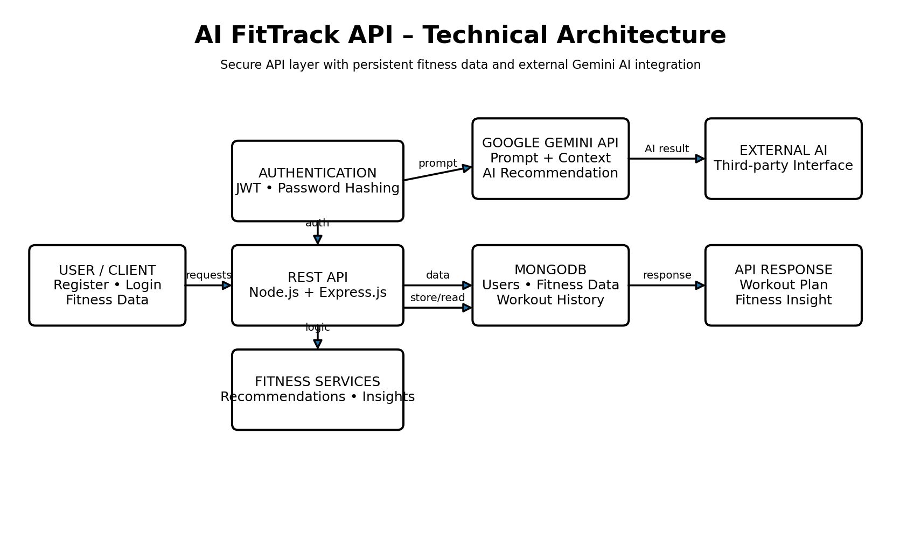

Table-1 : Components & Technologies:
S.No | Component | Description | Technology
1 | User / Client Interface | Client application that sends registration, login and fitness-data requests to the API. | Web/Mobile Client, HTTP/JSON
2 | Application Logic-1 | REST API, routing, authentication, authorization and request processing. | Node.js, Express.js
3 | Application Logic-2 | Fitness profile and workout data processing, validation and persistence. | Express.js, Mongoose
4 | Application Logic-3 | Prompt construction and AI response handling for workout recommendations and fitness insights. | Gemini API, prompt templates, Node.js
5 | Database | Users, credentials, fitness profiles, recommendations, insights and workout history. | MongoDB, Mongoose
6 | Cloud Database | Managed cloud database for scalable application storage. | MongoDB Atlas
7 | Authentication | Secure account registration, password hashing and protected API access. | JWT, bcrypt
8 | External API | External AI service used for workout recommendation and fitness insight generation. | Google Gemini API
9 | Validation & Security | Request validation, sanitization, security headers and controlled API access. | express-validator, Helmet, CORS, rate limiting
10 | Machine Learning Model | Generates personalized workout recommendations and fitness insights from supplied prompts/context. | Google Gemini AI / LLM
11 | Infrastructure (Server / Cloud) | Cloud-ready API deployment with managed database and container support. | Node.js runtime, Docker, cloud hosting

Table-2: Application Characteristics:
S.No | Characteristics | Description | Technology
1 | Open-Source Frameworks | Open-source backend, API and database libraries support maintainability. | Node.js, Express.js, Mongoose
2 | Security Implementations | JWT authentication, password hashing, protected routes, validation, sanitization, security headers, CORS and rate limiting. | JWT, bcrypt, Helmet, express-validator
3 | Scalable Architecture | Layered separation of client, API/business logic, AI integration and data storage allows independent scaling. | 3-tier/layered architecture, REST API, Docker
4 | Availability | Stateless API instances and managed database services support restart/recovery and cloud availability. | MongoDB Atlas, cloud hosting, health checks
5 | Performance | Indexed fitness queries, bounded payloads and controlled AI requests reduce API/database workload. | MongoDB indexes, pagination, caching-ready API design

References:
https://c4model.com/
https://developer.ibm.com/patterns/online-order-processing-system-during-pandemic/
https://www.ibm.com/cloud/architecture
https://aws.amazon.com/architecture
https://medium.com/the-internal-startup/how-to-draw-useful-technical-architecture-diagrams-2d20c9fda90d

College: C.T.T.E College for Women
Team Leader: DANIYA FATHIMA B
Team Members: KATHIJA RAYHANA A, FAIZA FATHIMA I, AYSHA MAFAZHA A S
Architecture Flow: Client → Authentication & JWT Guard → REST API → Fitness Services → MongoDB. Workout recommendation and fitness-insight requests are routed to the external Gemini AI service using structured prompts and user fitness context.
Implementation note: The AI FitTrack API stack above is a proposed implementation aligned with the stated fitness authentication, Gemini AI workout recommendation and fitness insight capabilities.

