Project Design Phase-II
Data Flow Diagram & User Stories

Date | 29 September 2026
Team ID | SWTID-2026-1202
Project Name | AI StudyBuddy
Maximum Marks | 4 Marks

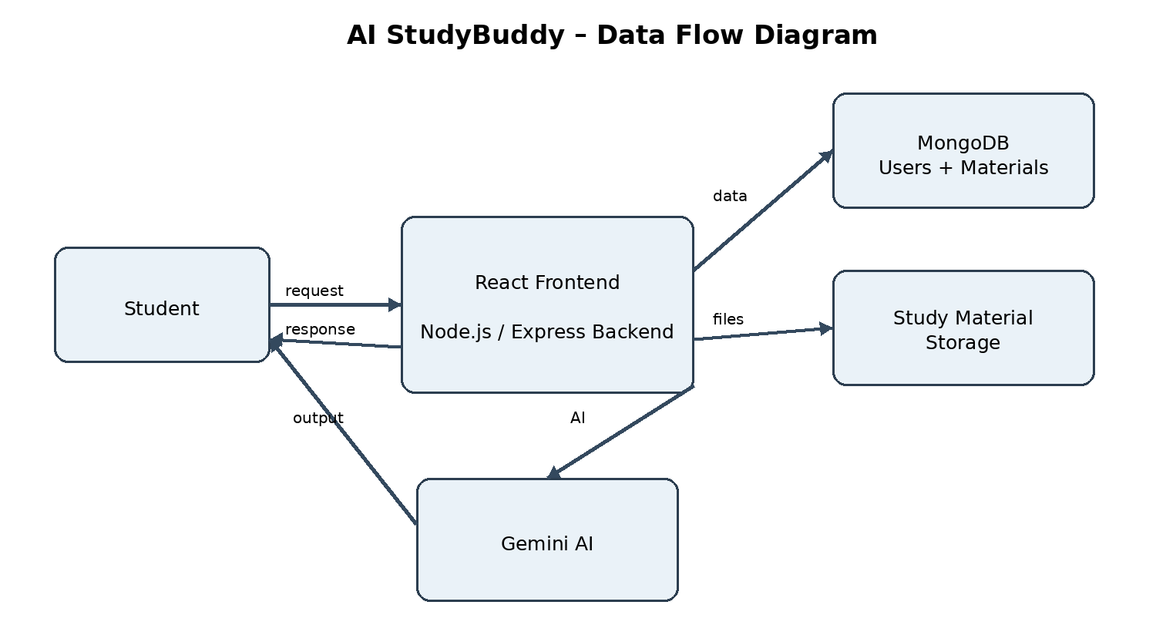
Data Flow Diagrams:
A Data Flow Diagram (DFD) is a traditional visual representation of the information flows within a system. A neat and clear DFD can depict the right amount of the system requirement graphically. It shows how data enters and leaves the system, what changes the information, and where data is stored.
Example: DFD Level 0 (Industry Standard)
Example: (Simplified)



User Stories
Use the below template to list all the user stories for the product.
User Type | Functional Requirement (Epic) | User Story Number | User Story / Task | Acceptance criteria | Priority | Release
Student | Registration | USN-1 | As a student, I can register using my email and password. | Valid account is created. | High | Sprint-1
Student | Login | USN-2 | As a student, I can log in using my registered email and password. | Valid credentials grant access. | High | Sprint-1
Student | Authentication | USN-3 | As a student, I can use protected features after authentication. | Valid JWT is required for protected operations. | High | Sprint-1
Student | Study Material Upload | USN-4 | As a student, I can upload study material files. | Valid file is accepted and stored. | High | Sprint-1
Student | Study Material | USN-5 | As a student, I can access uploaded study materials. | Uploaded materials are available for study operations. | High | Sprint-1
Student | AI Summarization | USN-6 | As a student, I can generate a summary from study material. | AI returns a readable summary. | High | Sprint-2
Student | AI Notes | USN-7 | As a student, I can generate study notes from my material. | AI returns structured notes. | High | Sprint-2
Student | AI Flashcards | USN-8 | As a student, I can generate flashcards from my material. | AI returns flashcards. | High | Sprint-2
Student | AI Quiz | USN-9 | As a student, I can generate a quiz from my material. | AI returns quiz content. | High | Sprint-2
Student | Study Plan | USN-10 | As a student, I can generate a personalized study plan. | AI returns a study plan. | Medium | Sprint-2
Administrator | User Management | USN-11 | As an administrator, I can manage application users. | Authorized admin can perform supported actions. | High | Sprint-3
Administrator | Study-Material Management | USN-12 | As an administrator, I can manage study-material records/files. | Authorized admin can perform supported actions. | High | Sprint-3

Confirmed core flows: Student → React Frontend → Node.js/Express Backend → MongoDB; Student → Backend → Gemini AI → Backend → Student; Student → File Upload → Multer/Backend → Study Material Storage → AI Processing.

