AI BLOGNEST API
• Project Title : Ai Blognest Api
➢ Aafila Parveen I - TL / Coding
➢ Asma Khatoon G - Github
➢ Mary Jeniliya P - Document Creation
➢ Bhuvaneshwari H - Demo Video
• Team No : 1

Introduction
AI Blognest is an intelligent blog management system designed to provide users with a convenient platform for creating, managing, and organizing blog content. The system is developed as a RESTful backend API that handles blog-related requests and provides structured responses.
The application can integrate an AI service to assist with blog content generation and related operations. Instead of managing blog content through separate manual processes, the platform provides centralized API services for users, blog posts, and AI-assisted functionality.

Problem Statement
Users and content creators may find it difficult to manage blog content efficiently when writing, storing, editing, and organizing posts are handled separately.
The major problems addressed by the system are:
- Difficulty in managing multiple blog posts.
- Need for centralized blog content management.
- Need for efficient creation and retrieval of content.
- Need for AI-assisted blog content operations.
- Need for secure storage and management of user information.

Proposed Solution
AI Blognest API provides a centralized backend service that manages blog information and provides AI-assisted content functionality. The backend receives API requests, validates information, performs the required operations, communicates with the database, and returns JSON responses.

OBJECTIVES AND SYSTEM REQUIREMENTS

Objectives
The main objective of AI Blognest API is to provide users with an intelligent and convenient platform for managing blog content.
The system aims to:
- Provide REST APIs for blog management.
- Allow users to create and manage blog posts.
- Provide AI-based assistance for blog content.
- Maintain user and blog information.
- Secure protected API operations.
- Provide REST APIs that can be tested using Postman.

Key Features
- User Authentication – Users can register and log in when authentication is implemented.
- Blog Management – Users can create, view, update, and delete blog posts.
- AI Blog Assistance – The AI service can provide assistance for blog-related operations.
- Content Retrieval – The backend provides APIs for retrieving stored blog information.
- Security – Authentication, validation, and protected routes can secure the application.

Software Requirements
- [Backend runtime/framework used by the project]
- [Database used by the project]
- [AI API/SDK used by the project]
- Postman or Thunder Client
- Visual Studio Code or similar code editor
- Git and GitHub

Hardware Requirements
- Intel Core i5 8th Generation or above / AMD Ryzen 5 or equivalent
- Minimum 8 GB RAM
- Minimum 1 GB available storage
- Internet connection

SYSTEM ARCHITECTURE

Architecture Pattern
AI Blognest API follows a layered REST API architecture. The architecture separates API routing, application logic, database operations, authentication, and AI integration. This structure makes the backend easier to maintain and extend.

API / Route Layer
The API routing layer receives requests from clients and forwards them to the appropriate backend operation.

Controller / Service Layer
The controller or service layer validates information, processes application logic, communicates with models and external services, and returns JSON responses.

Database Layer
The database layer manages persistent data such as users, blog posts, and other entities required by the application.

AI Service Layer
The AI service layer communicates with the configured AI provider and performs the AI-assisted operation required by the application.

Major Components
- REST API Server
- Authentication Middleware
- Controller Modules
- Database Interface
- Blog Database
- AI Service
- REST API Endpoints

Database Design
The system uses a database to maintain user and blog information. The exact database technology and schema should correspond to the implemented project.

User Entity
- _id – Primary Key
- name – Username
- email – Unique email address
- password – Secured password
- role – User role

Blog Entity
- _id – Primary Key
- title – Blog title
- content – Blog content
- author – Reference to the User
- createdAt – Creation date
- updatedAt – Last update date

Relationship
One registered user can create multiple blog posts. Therefore, the relationship between User and Blog is One-to-Many.

SYSTEM WORKFLOW AND BACKEND DEVELOPMENT

User Workflow
The basic workflow of AI Blognest API is:
- Registration / Login – The user registers or logs into an account.
- Create Blog – The user provides the required blog details.
- AI Assistance – The system sends the required request to the AI service when used.
- Store Blog – Validated blog information is stored in the database.
- Manage Blog – The user can retrieve, update, or delete blog posts.
- Authentication Validation – Protected requests are validated before access.

Backend Technology
- [Backend runtime]
- [Web framework]
- [Database]
- [Database library / ORM / ODM]
- [Authentication mechanism]
- [AI service / SDK]
- CORS – Cross-origin request handling, if used
- dotenv / environment configuration, if used
- GitHub – Version control

Project Setup
The project is initialized using the selected backend runtime and package manager. Required dependencies are installed and environment variables are configured for database connections, authentication secrets, AI API keys, and other project settings.
- Project source files
- Package configuration
- Environment configuration
- Git ignore configuration
- GitHub repository

Security
- Authentication for protected requests
- Secure password handling
- Input validation
- Environment variables for sensitive keys
- Centralized error handling
- Protected API routes

API TESTING:
Register: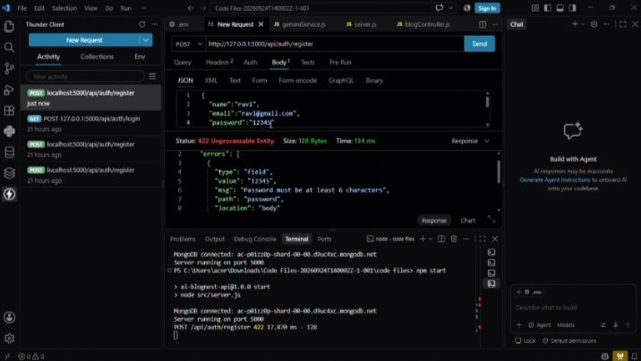
Login:
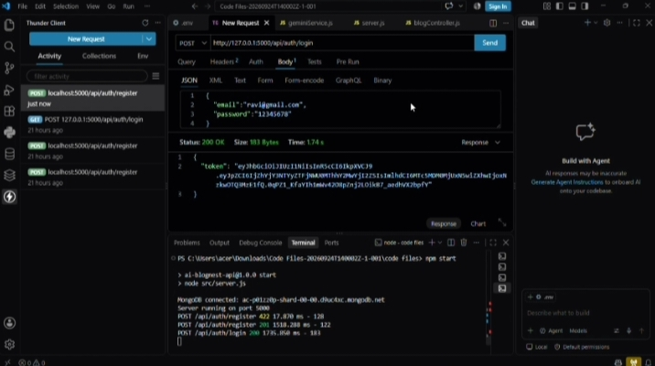
Create Blog:
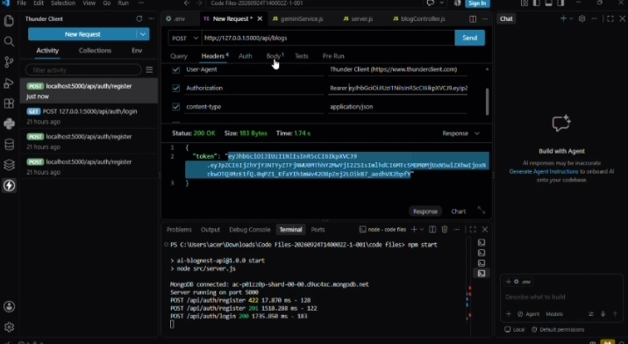
Generate AI Blog: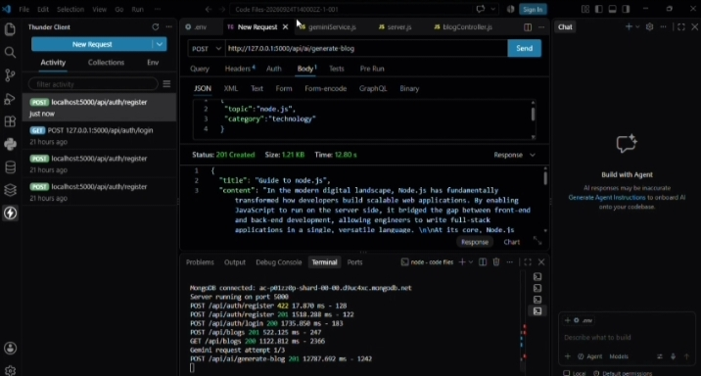
Summarize:
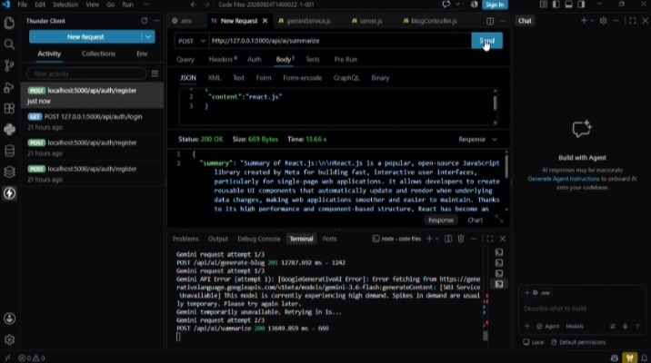

Project Execution
Before running the application, the required database or service dependencies should be running and environment variables should be configured correctly.
Required dependencies are installed using the package manager configured in the project. The development server is then started using the project's configured start command.
After successful execution, the backend starts listening for incoming API requests.

Expected Outcome
- Secure user authentication.
- Blog creation and management.
- AI-assisted blog functionality.
- Database-based data persistence.
- REST API access for client applications.
- API testing through Postman or Thunder Client.

Conclusion
AI Blognest API combines blog management, database operations, REST APIs, authentication, and artificial intelligence into a single backend platform. The system provides structured services for managing blog content and can integrate AI-assisted functionality for content-related operations.
The project demonstrates how modern backend technologies and AI services can be integrated to build an intelligent and extensible blog platform.

Team Responsibilities
Team Member | Role | Responsibility
Aafila Parveen I | TL - Coding | Team coordination, backend coding, API implementation and technical integration.
Asma Khatoon G | Github | GitHub repository creation, source-code upload and version control.
Mary Jeniliya P | Document | Project documentation, formatting and final report preparation.
Bhuvaneshwari H | Demo Video | Project demonstration video recording and presentation.
Demo link: https://drive.google.com/file/d/18EqSFQKiISeyiyBsdeUsS7JUifhm7LIO/view?usp=drivesdk
Github link: https://github.com/24bca99-cloud/AI-Blognest-API

