Experiment: 2

Student Name: Habis Prakash Deka UID:24BDA70031
Branch: CSE Section/Group: AIT-KRG-G2
Semester: 4th Date of Performance:7/01/26
Subject Name: DBMS

- Aim of the practical: To understand and implement SQL SELECT queries using various clauses such as WHERE, ORDER BY, GROUP BY, and HAVING to retrieve and manipulate data efficiently from relational database tables.

2. Tool Used:

● Database Management System:

○ PostgreSQL

● Database Administration Tool:

○ pgAdmin

- Objective:

To practice writing SQL SELECT statements.

To apply filtering conditions using the WHERE clause.

To sort query results using the ORDER BY clause.

To group records using the GROUP BY clause.

To filter grouped data using the HAVING clause.

To analyze data using aggregate functions like COUNT(), SUM(), AVG(), MIN(), and MAX().

- Practical / Experimental Steps

(1) Start the system and log in to the computer.

(2) Open PgAdmin (PostgreSQL).

(3) Create or select the required database (e.g., lab_db).

(4) Create the EMPLOYEE table using the given schema.

(5) Insert sample data into the EMPLOYEE table.

(6) Execute the queries step-by-step according to the practical steps.

(7) Verify the output after each query execution.

(8) Capture screenshots of execution and results for record.

(9) Save the work and upload worksheet (Word + PDF) on GitHub.

- I / O Analysis

DATABASE DESIGN

Query to create Table employee :

CREATE TABLE employee (

emp_id INT PRIMARY KEY,

emp_name VARCHAR(50),

department VARCHAR(50),

salary NUMERIC(10,2),

joining_date DATE

);

DATA MANIPULATION

Insert Sample records in the table

INSERT INTO employee (emp_id, emp_name, department, salary, joining_date) VALUES

(101, 'Amit Sharma', 'IT', 45000, '2022-01-10'),

(102, 'Neha Verma', 'HR', 22000, '2021-03-15'),

(103, 'Rahul Singh', 'IT', 30000, '2020-06-20'),

(104, 'Priya Mehta', 'Finance', 55000, '2019-09-05'),

(105, 'Karan Gupta', 'HR', 18000, '2023-02-12'),

(106, 'Sneha Kapoor', 'Finance', 28000, '2020-11-25'),

(107, 'Rohit Jain', 'Sales', 35000, '2021-07-30'),

(108, 'Ananya Joshi', 'Sales', 15000, '2022-12-01'),

(109, 'Vikram Rao', 'IT', 25000, '2022-04-18');

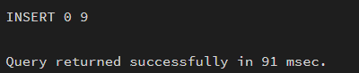

DISPLAY THE TABLE

SELECT * FROM employee;

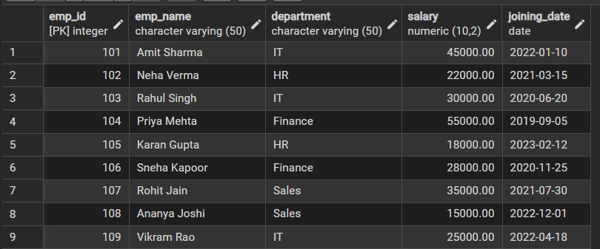

SELECT department,AVG(salary) AS avg_salary

FROM employee

GROUP BY department;

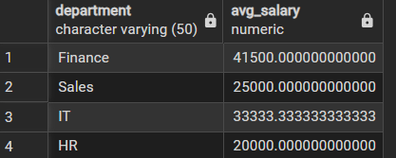

SELECT department,AVG(salary) AS avg_salary

FROM employee

WHERE salary > 20000

GROUP BY department;

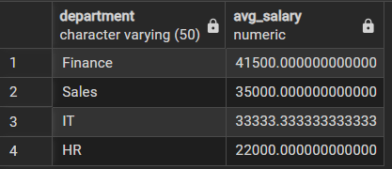

SELECT department,AVG(salary) AS avg_salary

FROM employee

WHERE salary > 20000

GROUP BY department

HAVING AVG(salary) > 30000;

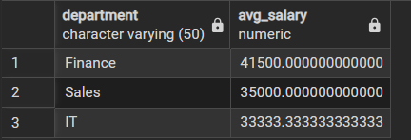

SELECT department,AVG(salary) AS avg_salary

FROM employee

WHERE salary > 20000

GROUP BY department

HAVING AVG(salary) > 30000

ORDER BY avg_salary DESC;

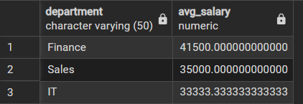

- Learning outcomes (What I have learnt):
- Understood the syntax and usage of SQL SELECT statements.
- Gained practical knowledge of WHERE clause for filtering rows.
- Learned grouping operations using GROUP BY clause.
- Applied HAVING clause to filter grouped results.
- Sorted query outputs using ORDER BY clause.
- Got hands-on experience in PostgreSQL execution using PgAdmin.

