Experiment: 4

Student Name: Habis Prakash Deka UID:24BDA70031
Branch: CSE Section/Group: AIT-KRG-GP2
Semester: 4th Date of Performance:30/01/26
Subject Name: DBMS

- Aim of the practical: To understand the basic structure of a PL/SQL program by creating and executing a simple PL/SQL block that includes declaration and execution sections, and to display output using built-in procedures.

2. Tool Used:

● Database Management System:

○ Oracle Database

- Objective:

Implement control structures in PL/SQL (IF-ELSE, ELSE-IF , ELSE-IF LADDER, CASE STATEMENTS in PL-SQL BLOCK)

- Practical / Experimental Steps

Step 1: Open SQL*Plus or Oracle SQL Developer and connect to the database.
Step 2: Enable output using SET SERVEROUTPUT ON;.
Step 3: Write and execute a PL/SQL program using IF–ELSE to check positive or non-positive number.
Step 4: Write and run a PL/SQL program using IF–ELSIF–ELSE to display student grade based on marks.
Step 5: Write and execute a PL/SQL program using an ELSIF ladder to determine performance status.
Step 6: Write and run a PL/SQL program using CASE statement to display day name from day number.
Step 7: Modify input values and re-execute programs to test different conditions.
Step 8: Observe and record the outputs for each conditional control statement program.

- I / O Analysis

- IF-Else Statement
DECLARE
num NUMBER := -5;
BEGIN
IF num > 0 THEN
DBMS_OUTPUT.PUT_LINE('The number is Positive');
ELSE
DBMS_OUTPUT.PUT_LINE('The number is Non-Positive');
END IF;
END;
/
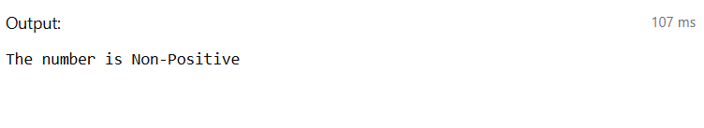

- IF-ElseIf-ELSE Statement
DECLARE
marks NUMBER := 85;
BEGIN
IF marks >= 90 THEN
DBMS_OUTPUT.PUT_LINE('Grade: A+');
ELSIF marks >= 80 THEN
DBMS_OUTPUT.PUT_LINE('Grade: A');
ELSIF marks >= 70 THEN
DBMS_OUTPUT.PUT_LINE('Grade: B');
ELSIF marks >= 60 THEN
DBMS_OUTPUT.PUT_LINE('Grade: C');
ELSE
DBMS_OUTPUT.PUT_LINE('Grade: Fail');
END IF;
END;
/
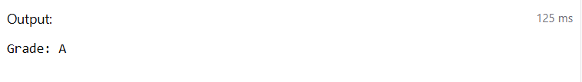

- ELSIF Ladder
DECLARE
marks NUMBER := 72;
BEGIN
IF marks >= 90 THEN
DBMS_OUTPUT.PUT_LINE('Performance: Excellent');
ELSIF marks >= 75 THEN
DBMS_OUTPUT.PUT_LINE('Performance: Very Good');
ELSIF marks >= 60 THEN
DBMS_OUTPUT.PUT_LINE('Performance: Good');
ELSIF marks >= 40 THEN
DBMS_OUTPUT.PUT_LINE('Performance: Average');
ELSE
DBMS_OUTPUT.PUT_LINE('Performance: Poor');
END;
/
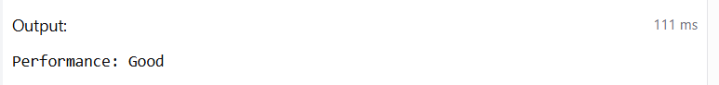

- CASE Statement
DECLARE
day_num NUMBER := 4;
day_name VARCHAR2(20);
BEGIN
CASE day_num
WHEN 1 THEN day_name := 'Sunday';
WHEN 2 THEN day_name := 'Monday';
WHEN 3 THEN day_name := 'Tuesday';
WHEN 4 THEN day_name := 'Wednesday';
WHEN 5 THEN day_name := 'Thursday';
WHEN 6 THEN day_name := 'Friday';
WHEN 7 THEN day_name := 'Saturday';
ELSE day_name := 'Invalid Day Number';
END CASE;

DBMS_OUTPUT.PUT_LINE('Day: ' || day_name);
END;
/
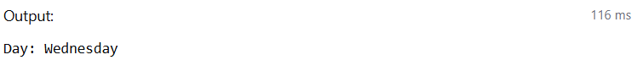

- Learning outcomes (What I have learnt):
• Understood the basic structure of a PL/SQL block, including the DECLARE and BEGIN…END sections.
• Learned how to declare and initialize variables for storing data values.
• Gained knowledge of using DBMS_OUTPUT.PUT_LINE to display results during program execution.
• Practiced performing mathematical operations on variables within PL/SQL programs.
• Developed understanding of decision-making using IF–ELSIF–ELSE conditional statements.
• Acquired practical insight into how PL/SQL can be used for simple database-related computations and logic implementation.

