Experiment: 10

Student Name: Habis Prakash Deka UID:24BDA70031
Branch: CSE Section/Group: AIT-KRG-G2
Semester: 4th Date of Performance:24/04/2026
Subject Name: DBMS

- Aim of the practical: To design a trigger that automatically implements the functionality of a primary key, ensuring unique identification of records without manual intervention.

2. Tool Used:

● Database Management System:

○ PostgreSQL

● Database Administration Tool:

○ pgAdmin

- Objective:

To create a database trigger that automatically enforces primary key constraints or generates unique key values, replicating the functionality of a stored procedure.

- Practical / Experimental Steps

Step 1: Create the required table with a primary key column.

Step 2: Create a sequence to generate unique key values.

Step 3: Write a trigger function to assign the sequence value before insertion.

Step 4: Define a BEFORE INSERT trigger on the table.

Step 5: Link the trigger to the trigger function.

Step 6: Insert multiple records without specifying the primary key.

Step 7: Verify that unique primary keys are generated automatically.

- I / O Analysis

CREATE TABLE employees (

id INT PRIMARY KEY,

name VARCHAR(100),

salary INT

);

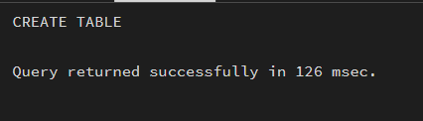

CREATE SEQUENCE emp_seq

START 1;

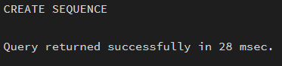

CREATE OR REPLACE FUNCTION assign_emp_id()

RETURNS TRIGGER AS $$

BEGIN

-- If ID is not provided, generate it automatically

IF NEW.id IS NULL THEN

NEW.id := nextval('emp_seq');

END IF;

RETURN NEW;

END;

$$ LANGUAGE plpgsql;

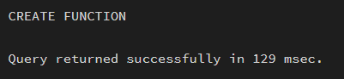

CREATE TRIGGER before_insert_emp

BEFORE INSERT ON employees

FOR EACH ROW

EXECUTE FUNCTION assign_emp_id();

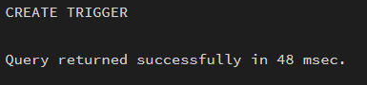

INSERT INTO employees (name, salary) VALUES ('Rahul', 50000);

INSERT INTO employees (name, salary) VALUES ('Anita', 60000);

INSERT INTO employees (name, salary) VALUES ('Vikas', 55000);

SELECT * FROM employees;

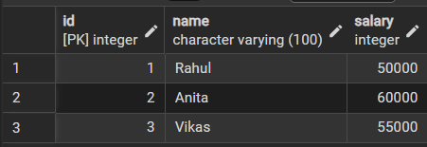

- Learning outcomes (What I have learnt):
- Understand the purpose and working of database triggers.
- Implement automated primary key functionality using triggers
- Ensure data integrity without manual key assignment.
- Apply trigger-based automation in real-world enterprise applications such as Amazon, Flipkart, and Oracle.

