THE STATE UNIVERSITY OF ZANZIBAR

GROUP NO : 15
NAME | REGISTRATION NUMBER
MUNIRA OMAR JUMA | 24BIA029
ASMA ALI ABDULLAH | 24BIA068
HASSAN MAHAMOUD AME | 24BIA070
ASYA | 24BIA030

SUBJECT NAME: OOP
LECTURE NAME : MR.MASOUD MMANGA

QUESTION 13
// BASE CLASS
class BankAccount {
protected String accountNumber;
protected String accountHolder;
protected double balance;

public BankAccount(String accountNumber, String accountHolder, double balance) {
this.accountNumber = accountNumber;
this.accountHolder = accountHolder;
this.balance = balance;
}

public void deposit(double amount) {
if (amount > 0) {
balance += amount;
System.out.printf("Deposited TZS %,.2f. New balance: TZS %,.2f\n", amount, balance);
}
}

public void withdraw(double amount) {
if (amount <= balance) {
balance -= amount;
System.out.printf("Withdrew TZS %,.2f. New balance: TZS %,.2f\n", amount, balance);
} else {
System.out.println("Insufficient balance!");
}
}

public double getBalance() {
return balance;
}

public void displayAccountInfo() {
System.out.println("Account Number: " + accountNumber);
System.out.println("Account Holder: " + accountHolder);
System.out.printf("Balance: TZS %,.2f\n", balance);
System.out.println("Account Type: General");
}

public double calculateInterest() {
return 0;
}
}

// SAVINGS ACCOUNT
class SavingsAccount extends BankAccount {
private double interestRate;
private final double MIN_BALANCE = 10000;

public SavingsAccount(String accNo, String holder, double balance, double rate) {
super(accNo, holder, balance);
this.interestRate = rate;
}

@Override
public void withdraw(double amount) {
if (balance - amount >= MIN_BALANCE) {
balance -= amount;
System.out.printf("Withdrew TZS %,.2f. New balance: TZS %,.2f\n", amount, balance);
} else {
System.out.println("Cannot withdraw. Minimum balance of TZS 10,000 required.");
}
}

@Override
public double calculateInterest() {
return balance * interestRate;
}

public void applyInterest() {
double interest = calculateInterest();
balance += interest;
System.out.printf("Interest of TZS %,.2f applied. New balance: TZS %,.2f\n", interest, balance);
}

@Override
public void displayAccountInfo() {
super.displayAccountInfo();
System.out.println("Account Type: Savings");
}
}

// CURRENT ACCOUNT

class CurrentAccount extends BankAccount {
private double overdraftLimit;

public CurrentAccount(String accNo, String holder, double balance, double overdraftLimit) {
super(accNo, holder, balance);
this.overdraftLimit = overdraftLimit;
}

@Override
public void withdraw(double amount) {
if (amount <= balance + overdraftLimit) {
balance -= amount;
System.out.printf("Withdrew TZS %,.2f. New balance: TZS %,.2f\n", amount, balance);
} else {
System.out.println("Overdraft limit exceeded!");
}
}

@Override
public double calculateInterest() {
return 0;
}

public boolean isOverdrawn() {
return balance < 0;
}

@Override
public void displayAccountInfo() {
super.displayAccountInfo();
System.out.println("Account Type: Current");
}
}

// FIXED DEPOSIT ACCOUNT

class FixedDepositAccount extends BankAccount {
private double interestRate;
private int maturityMonths;
private boolean isMatured;

public FixedDepositAccount(String accNo, String holder, double balance,
double rate, int months) {
super(accNo, holder, balance);
this.interestRate = rate;
this.maturityMonths = months;
this.isMatured = false;
}

@Override
public double calculateInterest() {
return balance * interestRate * (maturityMonths / 12.0);
}

@Override
public void withdraw(double amount) {
if (isMatured) {
super.withdraw(amount);
} else {
System.out.println("Cannot withdraw. Account not matured yet!");
}
}

public void checkMaturity() {
if (maturityMonths >= 12) {
isMatured = true;
}
}

public double getMaturityAmount() {
return balance + calculateInterest();
}

@Override
public void displayAccountInfo() {
super.displayAccountInfo();
System.out.println("Account Type: Fixed Deposit");
}
}

// BANK CLASS

class Bank {
private BankAccount[] accounts;
private int count = 0;

public Bank(int size) {
accounts = new BankAccount[size];
}

public void addAccount(BankAccount account) {
accounts[count++] = account;
}

public double getTotalDeposits() {
double total = 0;
for (int i = 0; i < count; i++) {
total += accounts[i].getBalance();
}
return total;
}

public double getTotalInterest() {
double total = 0;
for (int i = 0; i < count; i++) {
total += accounts[i].calculateInterest(); // Polymorphism
}
return total;
}

public void displayAllAccounts() {
for (int i = 0; i < count; i++) {
System.out.println("---------------------------");
accounts[i].displayAccountInfo();
}
}

public BankAccount findAccount(String accNo) {
for (int i = 0; i < count; i++) {
if (accounts[i].accountNumber.equals(accNo)) {
return accounts[i];
}
}
return null;
}
}

// MAIN CLASS

public class Exercise13_Polymorphism {

// Method Overloading
public static void transferMoney(BankAccount from, BankAccount to, double amount) {
from.withdraw(amount);
to.deposit(amount);
}

public static void transferMoney(BankAccount from, BankAccount to,
double amount, String description) {
System.out.println("Transfer Description: " + description);
transferMoney(from, to, amount);
}

public static void transferMoney(BankAccount from, String toAccNo,
double amount, Bank bank) {
BankAccount to = bank.findAccount(toAccNo);
if (to != null) {
transferMoney(from, to, amount);
} else {
System.out.println("Account not found!");
}
}

public static void main(String[] args) {

System.out.println("=== BANKING SYSTEM TEST ===\n");

SavingsAccount savings =
new SavingsAccount("SAV001", "Ali Hassan", 500000, 0.05);

CurrentAccount current =
new CurrentAccount("CUR001", "Fatma Said", 1000000, 500000);

FixedDepositAccount fixed =
new FixedDepositAccount("FD001", "Omar Juma", 2000000, 0.08, 12);

System.out.println("--- Testing Savings Account ---");
savings.displayAccountInfo();
savings.deposit(100000);
savings.withdraw(50000);
savings.applyInterest();
savings.displayAccountInfo();

System.out.println("\n--- Testing Current Account ---");
current.displayAccountInfo();
current.withdraw(1200000);
System.out.println("Is overdrawn? " + current.isOverdrawn());

System.out.println("\n--- Testing Fixed Deposit ---");
fixed.displayAccountInfo();
fixed.withdraw(500000);
System.out.printf("Maturity amount: TZS %,.2f\n", fixed.getMaturityAmount());

Bank bank = new Bank(10);
bank.addAccount(savings);
bank.addAccount(current);
bank.addAccount(fixed);

System.out.println("\n--- Bank Summary (Polymorphism) ---");
bank.displayAllAccounts();
System.out.printf("Total Deposits: TZS %,.2f\n", bank.getTotalDeposits());
System.out.printf("Total Interest: TZS %,.2f\n", bank.getTotalInterest());

System.out.println("\n--- Testing Transfers (Overloading) ---");
transferMoney(savings, current, 50000);
transferMoney(current, savings, 30000, "Rent payment");

}
}

OUTPUT:
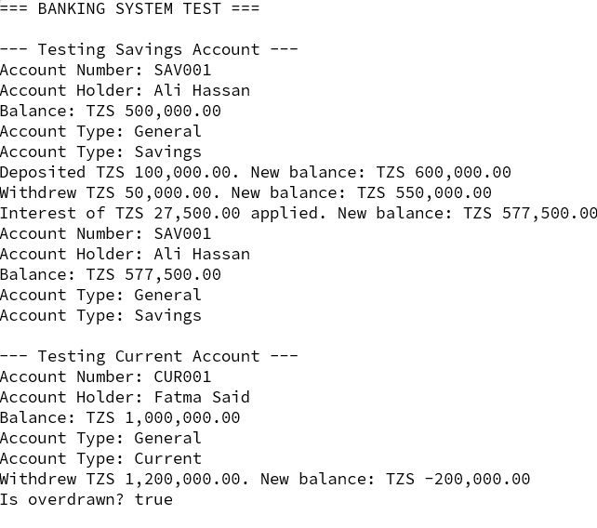
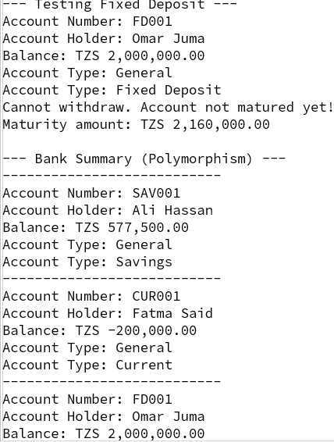
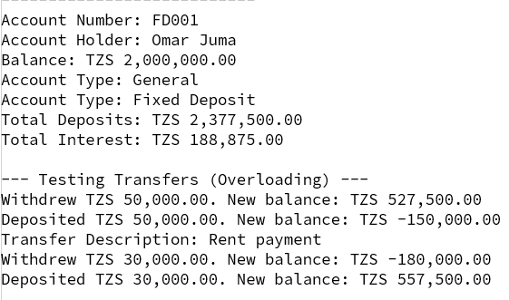

QUESTION 4.

// ABSTRACT BASE CLASS
abstract class Shape {
protected String color;
public Shape(String color) {
this.color = color;
}
public String getColor() {
return color;
}
// Abstract methods (must be implemented by subclasses)
public abstract double getArea();
public abstract double getPerimeter();

@Override
public String toString() {
return "Shape Color: " + color;
}
}
// CIRCLE CLASS
class Circle extends Shape {
private double radius;
public Circle(String color, double radius) {
super(color);
this.radius = radius;
}
public double getRadius() {
return radius;
}
@Override
public double getArea() {
return Math.PI * radius * radius;
}

@Override
public double getPerimeter() {
return 2 * Math.PI * radius;
}
@Override
public String toString() {
return "Circle [Color=" + color +
", Radius=" + radius +
", Area=" + getArea() +
", Perimeter=" + getPerimeter() + "]";
}
}
// RECTANGLE CLASS
class Rectangle extends Shape {
protected double width;
protected double length;
public Rectangle(String color, double width, double length) {
super(color);
this.width = width;
this.length = length;
}
@Override
public double getArea() {
return width * length;
}
@Override
public double getPerimeter() {
return 2 * (width + length);
}
@Override
public String toString() {
return "Rectangle [Color=" + color +
", Width=" + width +
", Length=" + length +
", Area=" + getArea() +
", Perimeter=" + getPerimeter() + "]";
}
}
// SQUARE CLASS (Inheritance from Rectangle)
class Square extends Rectangle {
public Square(String color, double side) {
super(color, side, side);
}
public double getSide() {
return width; // width == length
}
@Override
public String toString() {
return "Square [Color=" + color +
", Side=" + width +
", Area=" + getArea() +
", Perimeter=" + getPerimeter() + "]";
}
}
// MAIN CLASS
public class Lab4_ShapeHierarchy {
public static void main(String[] args) {
// Polymorphism: Shape reference, different objects
Shape s1 = new Circle("Red", 5.0);
Shape s2 = new Rectangle("Blue", 4.0, 6.0);
Shape s3 = new Square("Green", 3.0);
System.out.println("=== Shape Hierarchy Test ===\n");
System.out.println(s1);
System.out.println();
System.out.println(s2);
System.out.println();
System.out.println(s3);

System.out.println("\n=== Polymorphism Demonstration ===");
Shape[] shapes = {s1, s2, s3};
for (Shape shape : shapes) {
System.out.println("Area: " + shape.getArea());
System.out.println("Perimeter: " + shape.getPerimeter());
System.out.println("-------------------");
}
}
}

OUTPUT:

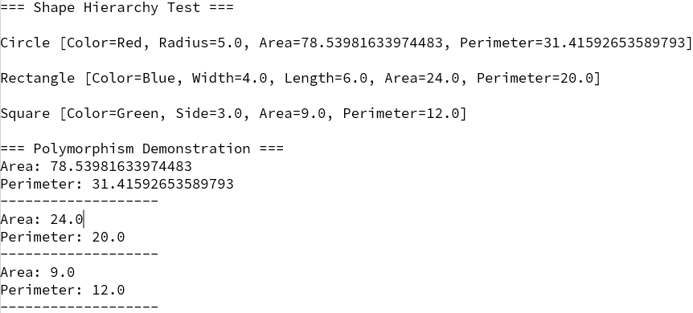

QN 2
class Person {

private String name;
private String address;

// Constructor
public Person(String name, String address) {
this.name = name;
this.address = address;
}

// Getters
public String getName() {
return name;
}

public String getAddress() {
return address;
}

// Setter (No setter for name)
public void setAddress(String address) {
this.address = address;
}

// toString()
@Override
public String toString() {
return "Person[name=" + name + ", address=" + address + "]";
}
}
class Student extends Person {

private String program;
private int year;
private double fee;

public Student(String name, String address, String program, int year, double fee) {
super(name, address); // Call parent constructor
this.program = program;
this.year = year;
this.fee = fee;
}

public String getProgram() {
return program;
}

public void setProgram(String program) {
this.program = program;
}

public int getYear() {
return year;
}

public void setYear(int year) {
this.year = year;
}

public double getFee() {
return fee;
}

public void setFee(double fee) {
this.fee = fee;
}

@Override
public String toString() {
return "Student[" + super.toString()
+ ", program=" + program
+ ", year=" + year
+ ", fee=" + fee + "]";
}
}
class Staff extends Person {

private String department;
private double salary;

public Staff(String name, String address, String department, double salary) {
super(name, address); // Call parent constructor
this.department = department;
this.salary = salary;
}

public String getDepartment() {
return department;
}

public void setDepartment(String department) {
this.department = department;
}

public double getSalary() {
return salary;
}

public void setSalary(double salary) {
this.salary = salary;
}

@Override
public String toString() {
return "Staff[" + super.toString()
+ ", department=" + department
+ ", salary=" + salary + "]";
}
}
public class Lab2_PersonStudentStaff {

public static void main(String[] args) {

System.out.println("==============================================");
System.out.println(" Lab 2: Person, Student, and Staff Hierarchy");
System.out.println("==============================================\n");

// Section 1
System.out.println("--- Section 1: Creating Objects ---");

Person p1 = new Person("Amina Hassan", "Stonetown, Zanzibar");
System.out.println(p1);

Student s1 = new Student("Juma Ali", "Chwaka, Zanzibar", "BITA", 2, 1500000);
Student s2 = new Student("Fatma Omar", "Mbweni, Zanzibar", "BCS", 1, 1800000);
System.out.println(s1);
System.out.println(s2);

Staff staff1 = new Staff("Dr. Khalid Salum", "Vuga, Zanzibar", "SCCMS", 3500000);
System.out.println(staff1);

// Section 2
System.out.println("\n--- Section 2: Inheritance in Action ---");

System.out.println("Student name: " + s1.getName());
System.out.println("Student address: " + s1.getAddress());
System.out.println("Student program: " + s1.getProgram());

System.out.println("\nStaff name: " + staff1.getName());
System.out.println("Staff department: " + staff1.getDepartment());

s1.setAddress("Fumba, Zanzibar");
System.out.println("\nAfter address change: " + s1);

// Section 3
System.out.println("\n--- Section 3: Polymorphism ---");

Person[] people = {
new Person("Bakari Juma", "Mwanakwerekwe, Zanzibar"),
new Student("Zainab Moh'd", "Kiembe Samaki, Zanzibar", "BITA", 3, 1500000),
new Student("Hassan Said", "Amani, Zanzibar", "BCS", 1, 1800000),
new Staff("Prof. Mwanaisha Ali", "Mazizini, Zanzibar", "SCCMS", 4500000)
};

System.out.println("All people at SUZA:");
for (Person p : people) {
System.out.println(" " + p);
}

// Section 4
System.out.println("\n--- Section 4: instanceof and Type Checking ---");

int studentCount = 0;
int staffCount = 0;

for (Person p : people) {
if (p instanceof Student) {
Student s = (Student) p;
System.out.println(s.getName() + " is a Student in " + s.getProgram() + " Year " + s.getYear());
studentCount++;
} else if (p instanceof Staff) {
Staff st = (Staff) p;
System.out.println(st.getName() + " is Staff in " + st.getDepartment());
staffCount++;
} else {
System.out.println(p.getName() + " is a Person (visitor/other)");
}
}

System.out.println("\nSummary: " + studentCount + " students, " + staffCount + " staff members");

System.out.println("\n==============================================");
System.out.println(" End of Lab 2");
System.out.println("==============================================");
}
}

OUTPUT
