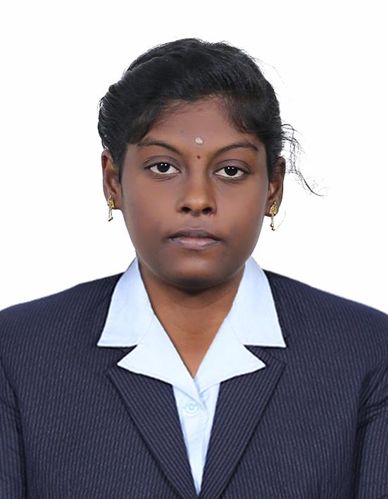

# Rithika - Portfolio

### Sri Krishna Aditya College of Arts and Science

## About Me

I am a Computer Applications student passionate about technology, programming, and design. I enjoy building projects, solving problems, and learning new IT skills.

## Projects

* Calculator based on Economics

## Skills

* Python
* SQL

## Internship

* UI/UX Design Internship

## Achievements

* Certification in Cloud Computing
* Certification in Cyber Security
* Certification in Python Programming

## Contact

[📧 24bsca143rithikaa@skacas.ac.in](mailto:24bsca143rithikaa@skacas.ac.in) 📞 8122305950