AI FAQ Assistant API
AnswerBot – AI-powered FAQ and customer support automation
Project Documentation
REST API | Node.js | Express.js | MongoDB | Mongoose | JWT | Gemini AI
Project Name | AI FAQ Assistant API
Project Type | AI-powered FAQ and customer support backend
Primary Stack | Node.js, Express.js, MongoDB, Mongoose
Testing Tool | Postman / API client

1. Introduction
The AI FAQ Assistant API is a REST API backend for FAQ and customer-support management. It supports secure user authentication, FAQ CRUD operations, FAQ search and AI-assisted FAQ generation.

Project Information
Project Title: AI FAQ Assistant API
Team ID: SWTID-2026-1297
Team Size: 4
Team Leader: SRIPRIYA P
Email ID: 24bsccs19@cttewc.edc.in
Role: Team Leader & Backend Developer
Team Members:
1. Name: Harini Karthiga G
Email ID: 24bsccs09@cttewc.edu.in
Role: Documentation
2. Name: Monisha T
Email ID: 24bsccs35@cttewc.edu.in
Role: Documentation
3. Name: Daisy rani V
Email ID: 24bsccs34@cttewc.edu.in
Role: PPT
Naan Mudhalvan Backend Development Project

Description
The AI FAQ Assistant API is a secure REST backend for user authentication, FAQ creation and management, and AI-powered question answering. The implementation uses Node.js with Express.js for routing, MongoDB with Mongoose for persistence, JWT for protected sessions, bcrypt for password hashing, and the Google Gemini SDK for AI-generated answers. The project is organized into controllers, middleware, models, routes, services, utilities, and configuration modules.

Scenario-Based Case Study

Background
A support team receives repeated questions about products, services, and technical topics. Maintaining a large FAQ collection manually can make it difficult to keep answers organized and provide quick responses.

Problem
- Manual effort is required to create, update, and remove FAQ records.
- Users need secure registration and login before performing protected operations.
- Support teams need a quick way to obtain AI-assisted answers to questions.
- FAQ records need structured storage and validation.
- API operations need consistent success and error responses.

Solution
The project provides a centralized REST API. Authentication is handled with JWT, FAQ data is stored in MongoDB, CRUD operations are exposed through Express routes, and the AI answer endpoint delegates question answering to the Gemini service. Middleware validates protected requests before controllers execute the requested operation.

Outcome
The completed API supports user registration, login, profile retrieval, FAQ creation, retrieval, update, deletion, and AI-based answer generation. The screenshots supplied with the project show successful HTTP responses for the main operations.

1. Functional Requirements
- Register a new user with name, email, and password.
- Authenticate a registered user and return a JWT token.
- Retrieve the authenticated user's profile.
- Create an FAQ with question, answer, and category.
- Retrieve an FAQ using its identifier.
- Update an existing FAQ.
- Delete an FAQ.
- Generate an AI answer for a user question through the AI endpoint.
- Store and retrieve FAQ data from MongoDB.
- Protect private endpoints using Bearer JWT authentication.

2. Non-Functional Requirements
- Security: passwords are hashed and protected routes require JWT authentication.
- Reliability: the API returns structured JSON responses and uses centralized error handling.
- Maintainability: the backend is separated into routes, controllers, models, middleware, services, and utilities.
- Scalability: MongoDB and modular Express routes support extension with additional FAQ and AI features.
- Usability: API endpoints can be tested through Postman or another REST client.
- Portability: the Node.js application can run in a standard Windows/macOS/Linux development environment.

3. Software Requirements
- Operating System: Windows 10/11, macOS, or Linux.
- Node.js: runtime for server-side JavaScript.
- npm: package manager for dependencies and scripts.
- Express.js: REST API routing framework.
- MongoDB: NoSQL database.
- Mongoose: ODM for MongoDB schemas and validation.
- jsonwebtoken: JWT creation and verification.
- bcrypt: password hashing.
- dotenv: environment variable management.
- cors: cross-origin request support.
- @google/genai: Gemini AI integration.
- Visual Studio Code: development environment.
- Postman / API client: endpoint testing.

4. Hardware Requirements
- Processor: Intel Core i5 / AMD Ryzen 5 or equivalent.
- RAM: 8 GB minimum recommended for development.
- Storage: at least 1 GB free for the project, dependencies, and local workspace.
- Internet connection: required for MongoDB Atlas and Gemini API access during integrated testing.

Epic 1: Project Architecture
The application follows a layered REST API architecture. Incoming requests enter through Express routes, protected requests pass through JWT authentication middleware, controllers perform application logic, Mongoose communicates with MongoDB, and the AI service communicates with Gemini for AI-generated answers.
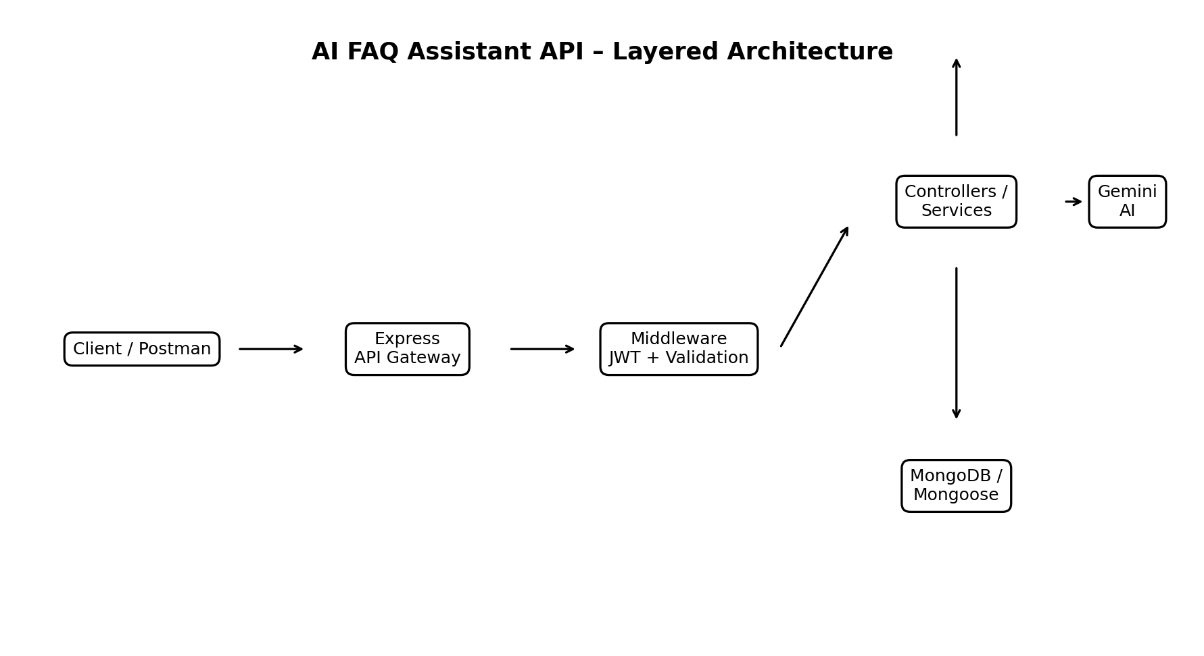
Figure 1. AI FAQ Assistant layered architecture.

Components Definition
API Client: Postman or another REST client sends HTTP requests and receives JSON responses.
Express Gateway: Receives HTTP requests and maps GET, POST, PUT, and DELETE operations to routes.
Authentication Middleware: Reads Bearer JWT tokens and verifies protected requests.
Validation / Error Middleware: Checks request data and provides consistent error handling.
Controllers: Contain the main logic for authentication, FAQ management, and AI operations.
Mongoose / MongoDB: Stores user and FAQ documents and enforces model rules.
Gemini Service: Sends question prompts to the Gemini SDK and returns the generated answer.

Project Folder Structure
Code Files/
├── src/
│ ├── config/
│ │ └── db.js
│ ├── controllers/
│ │ ├── aiController.js
│ │ ├── authController.js
│ │ └── faqController.js
│ ├── middleware/
│ │ ├── authMiddleware.js
│ │ ├── errorMiddleware.js
│ │ └── validationMiddleware.js
│ ├── models/
│ │ ├── FAQ.js
│ │ └── User.js
│ ├── routes/
│ │ ├── aiRoutes.js
│ │ ├── authRoutes.js
│ │ └── faqRoutes.js
│ ├── services/
│ │ └── geminiService.js
│ ├── utils/
│ │ └── helpers.js
│ ├── app.js
│ └── server.js
├── package.json
├── package-lock.json
├── .env
└── README.md

Entity-Relationship / Data Model
The main persistent entities visible in the project are User and FAQ. FAQ documents contain a createdBy reference to the user who created the record. AI answers are generated dynamically by the AI service and returned through the API.
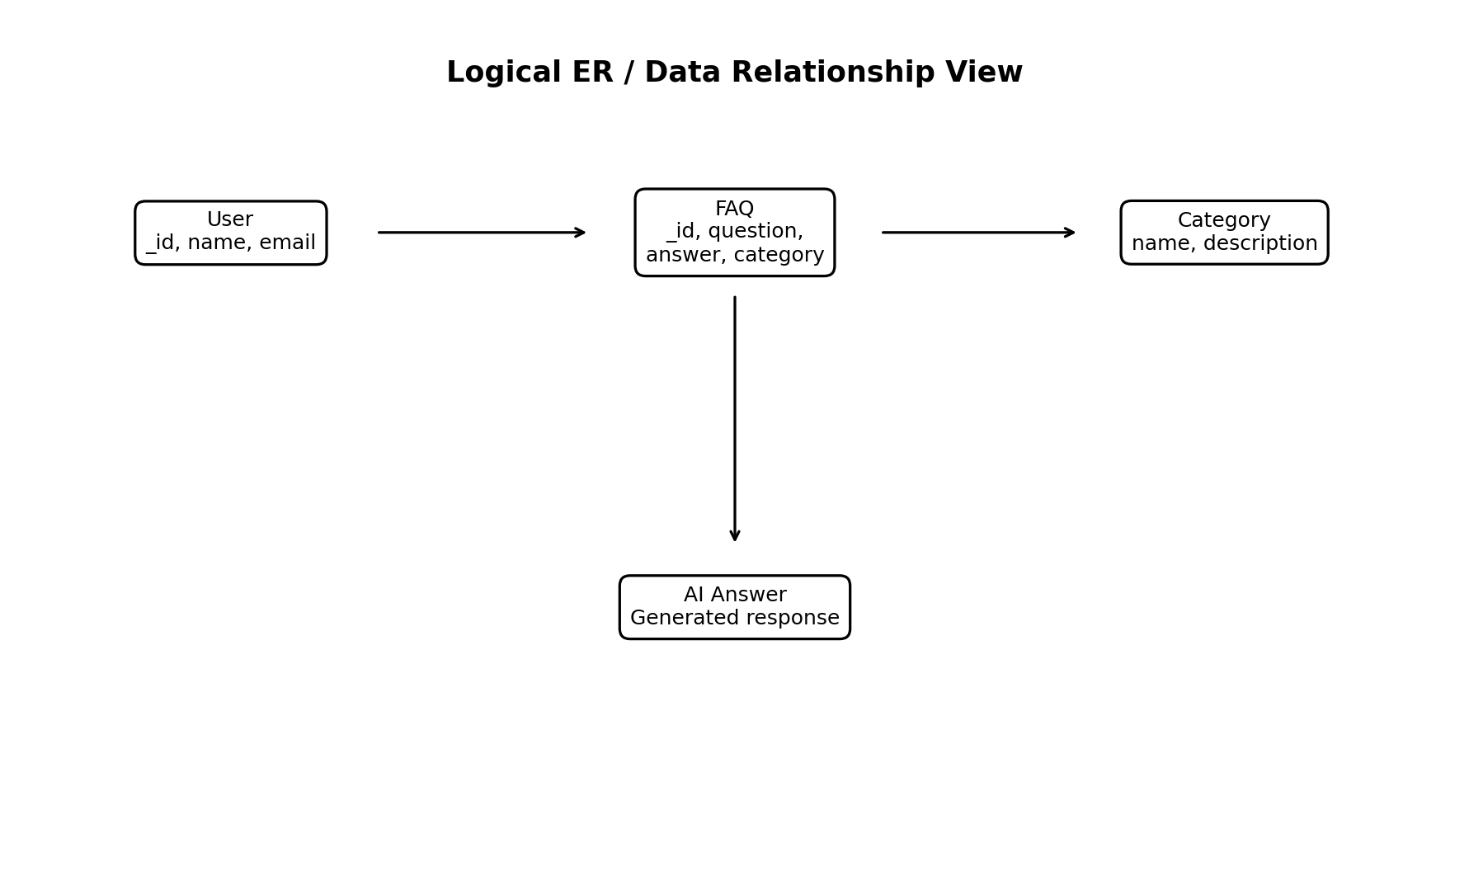
Figure 2. Logical data relationship view.

User Entity
- _id
- name
- email
- password
- createdAt
- updatedAt

FAQ Entity
- _id
- question
- answer
- category
- createdBy
- createdAt
- updatedAt

AI Answer Flow
- question
- Gemini-generated answer
- API response

Key Features
- JWT Authentication and protected routes.
- bcrypt password hashing.
- FAQ CRUD operations.
- MongoDB and Mongoose integration.
- AI-powered answer generation using Gemini.
- Structured JSON API responses.
- Centralized error handling and request validation.
- Modular Express.js route/controller/service organization.

Roles and Access
Operation | Access | Purpose
Register / Login | Public | Create account or authenticate.
Profile | Protected | Retrieve authenticated user details.
FAQ Create | Protected | Create a new FAQ.
FAQ Read | Protected / API-defined | Retrieve FAQ data.
FAQ Update | Protected | Modify an existing FAQ.
FAQ Delete | Protected | Remove an FAQ.
AI Answer | Protected | Generate an AI-assisted answer.

User Flow
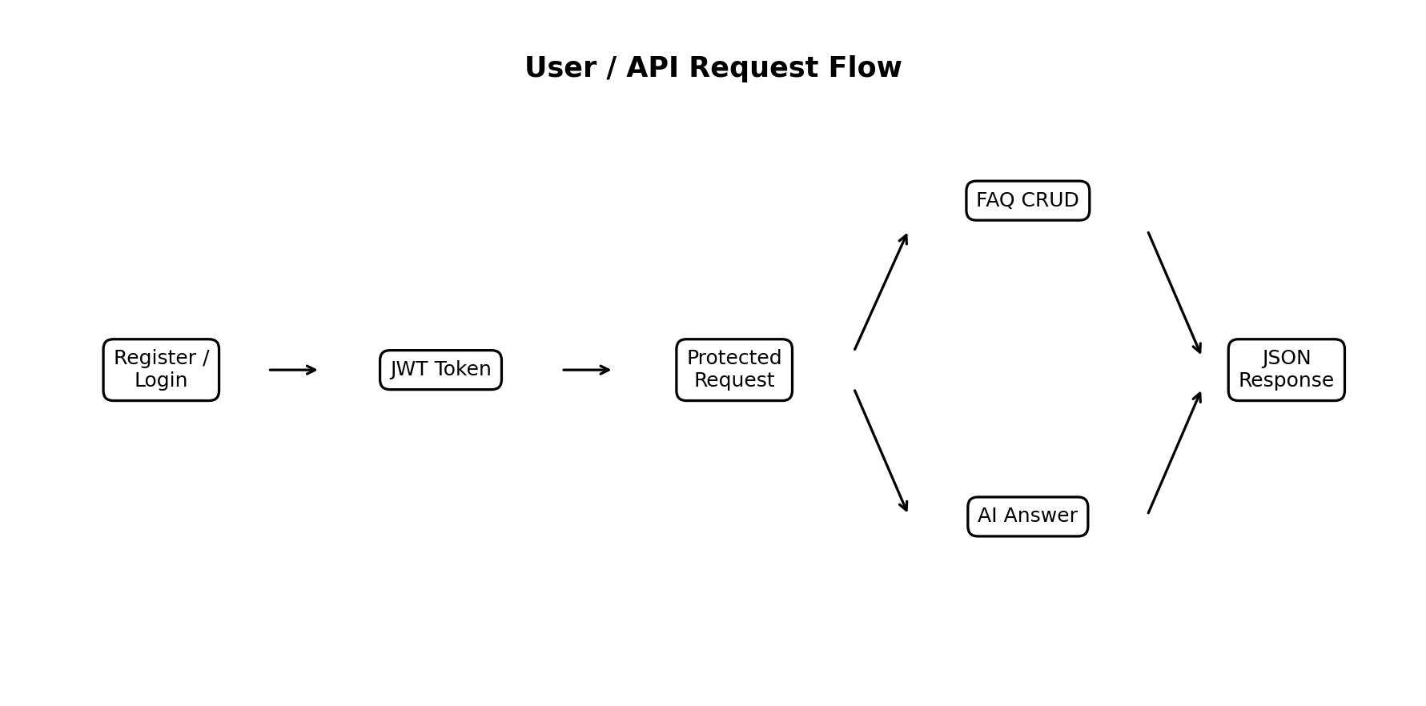
Figure 3. User and API request flow.

MVC / Modular Architecture

Model Layer
Mongoose models define the structure of User and FAQ documents and provide schema-level validation.

Controller Layer
Controllers process requests, call models/services, and return standardized JSON responses.

Routing Layer
Express route modules connect API paths to controller functions and attach authentication middleware where required.

Service Layer
geminiService.js isolates the external Gemini integration from the controller logic.

Middleware Layer
Authentication, validation, and centralized error handling are kept separate so that route logic remains modular.

Epic 2: Project Setup and Configuration
The project can be initialized with the following dependency installation:
npm init -y
npm install express mongoose dotenv cors jsonwebtoken bcrypt @google/genai
The package configuration shown in the supplied screenshot identifies the project as ai-faq-assistant-api and uses src/server.js as the main entry point.

Epic 3: Backend Development

1. server.js
Starts the backend application and listens on the configured port.

2. app.js
Configures the Express application and API routing.

3. authController.js
Handles user registration, login, and profile-related operations.

4. faqController.js
Handles FAQ create, read, update, and delete operations.

5. aiController.js
Receives a question and delegates answer generation to the Gemini service.

6. authMiddleware.js
Validates JWT Bearer tokens for protected endpoints.

7. errorMiddleware.js
Provides centralized API error handling.

8. validationMiddleware.js
Supports validation of incoming request data.

9. geminiService.js
Connects the backend to the Google Gemini SDK.

Epic 4: API Endpoint Specification
Method | Endpoint | Access | Purpose
POST | /api/auth/register | Public | Register a new user
POST | /api/auth/login | Public | Authenticate and receive JWT
GET | /api/auth/profile | Bearer JWT | Retrieve authenticated profile
POST | /api/faqs | Bearer JWT | Create FAQ
GET | /api/faqs/:id | Bearer JWT | Retrieve FAQ by ID
PUT | /api/faqs/:id | Bearer JWT | Update FAQ
DELETE | /api/faqs/:id | Bearer JWT | Delete FAQ
POST | /api/ai/answer | Bearer JWT | Generate AI answer

Epic 5: Project Execution and Testing
The supplied screenshots demonstrate successful API execution through the local server on port 5000. The terminal output shows MongoDB connection and the server running in development mode.
Testing sequence:
- Start the backend with npm start (or the configured development script).
- Confirm MongoDB connection in the terminal.
- Register a test user.
- Login and capture the returned JWT for protected requests.
- Call the profile endpoint with Bearer authentication.
- Create an FAQ.
- Retrieve, update, and delete the FAQ.
- Send a question to the AI answer endpoint and verify the returned answer.

API Testing Evidence
The following redacted screenshots were supplied with the project. Credentials and bearer tokens have been covered in this documentation for security.

Test Evidence 1
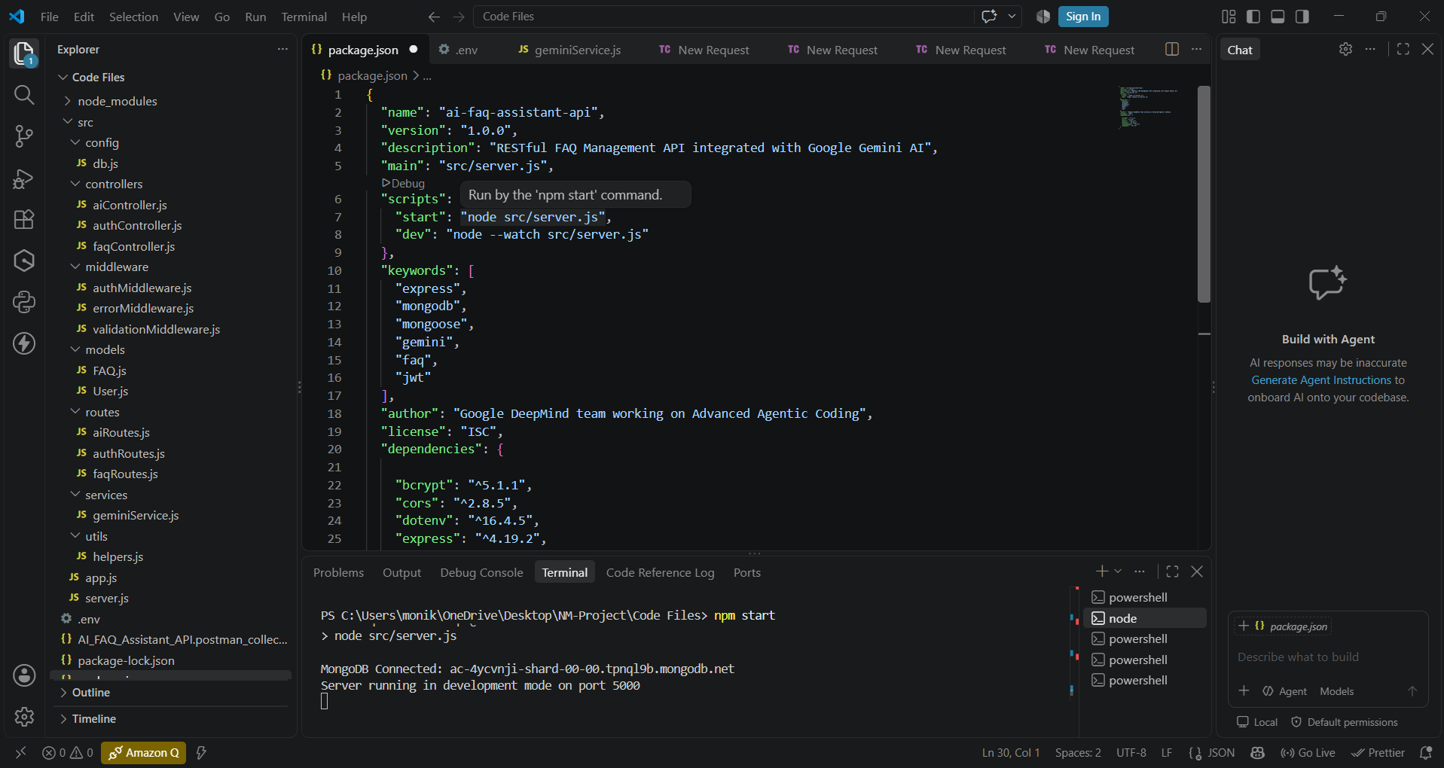
Project structure and package configuration.

Test Evidence 2
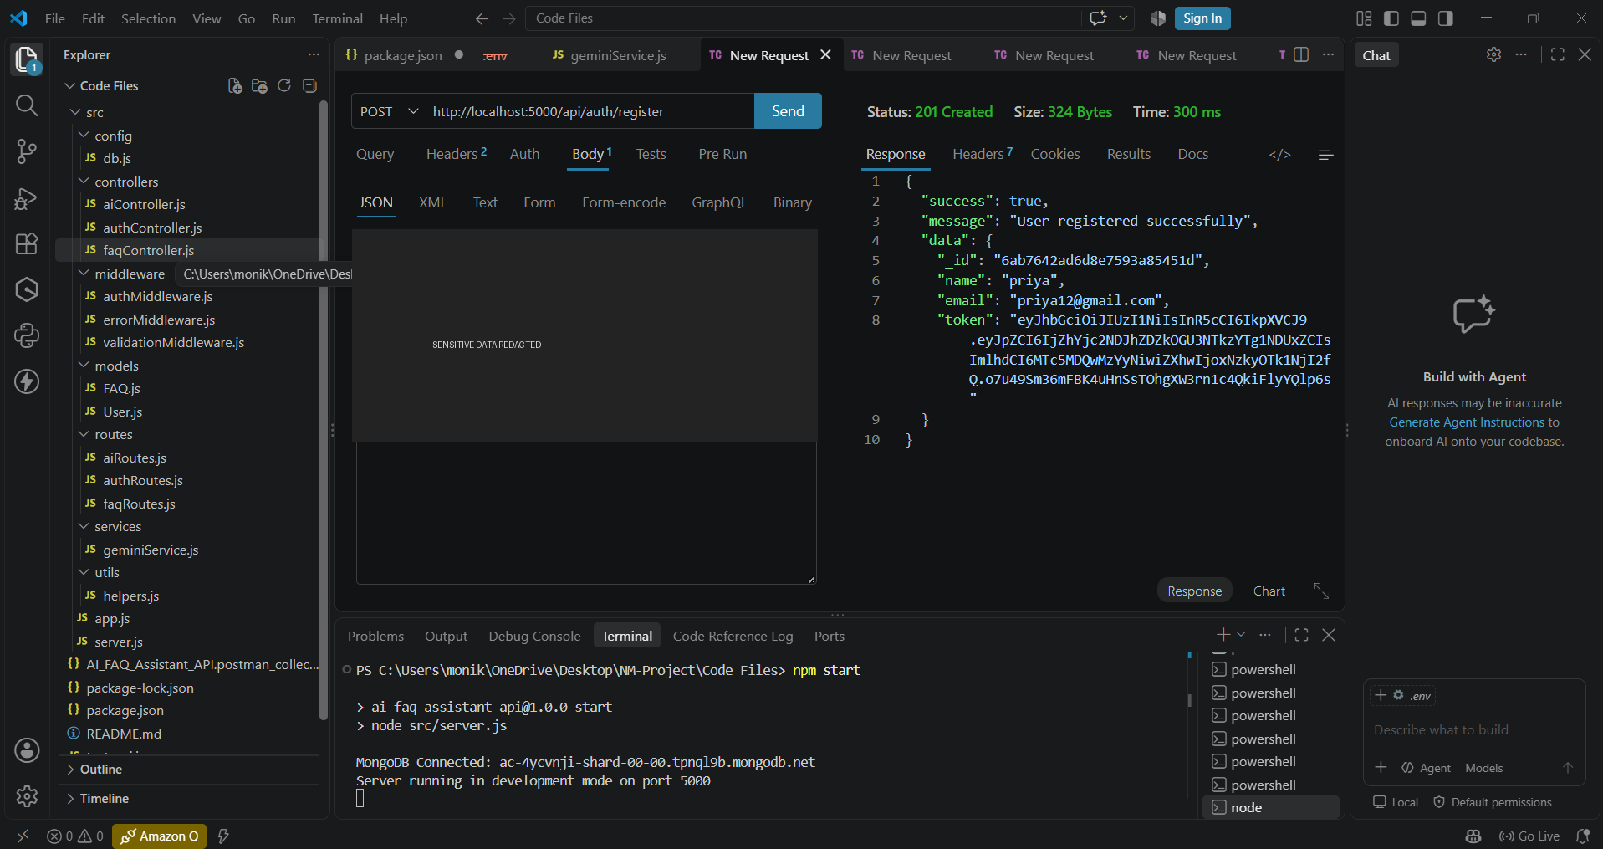
User registration response.

Test Evidence 3
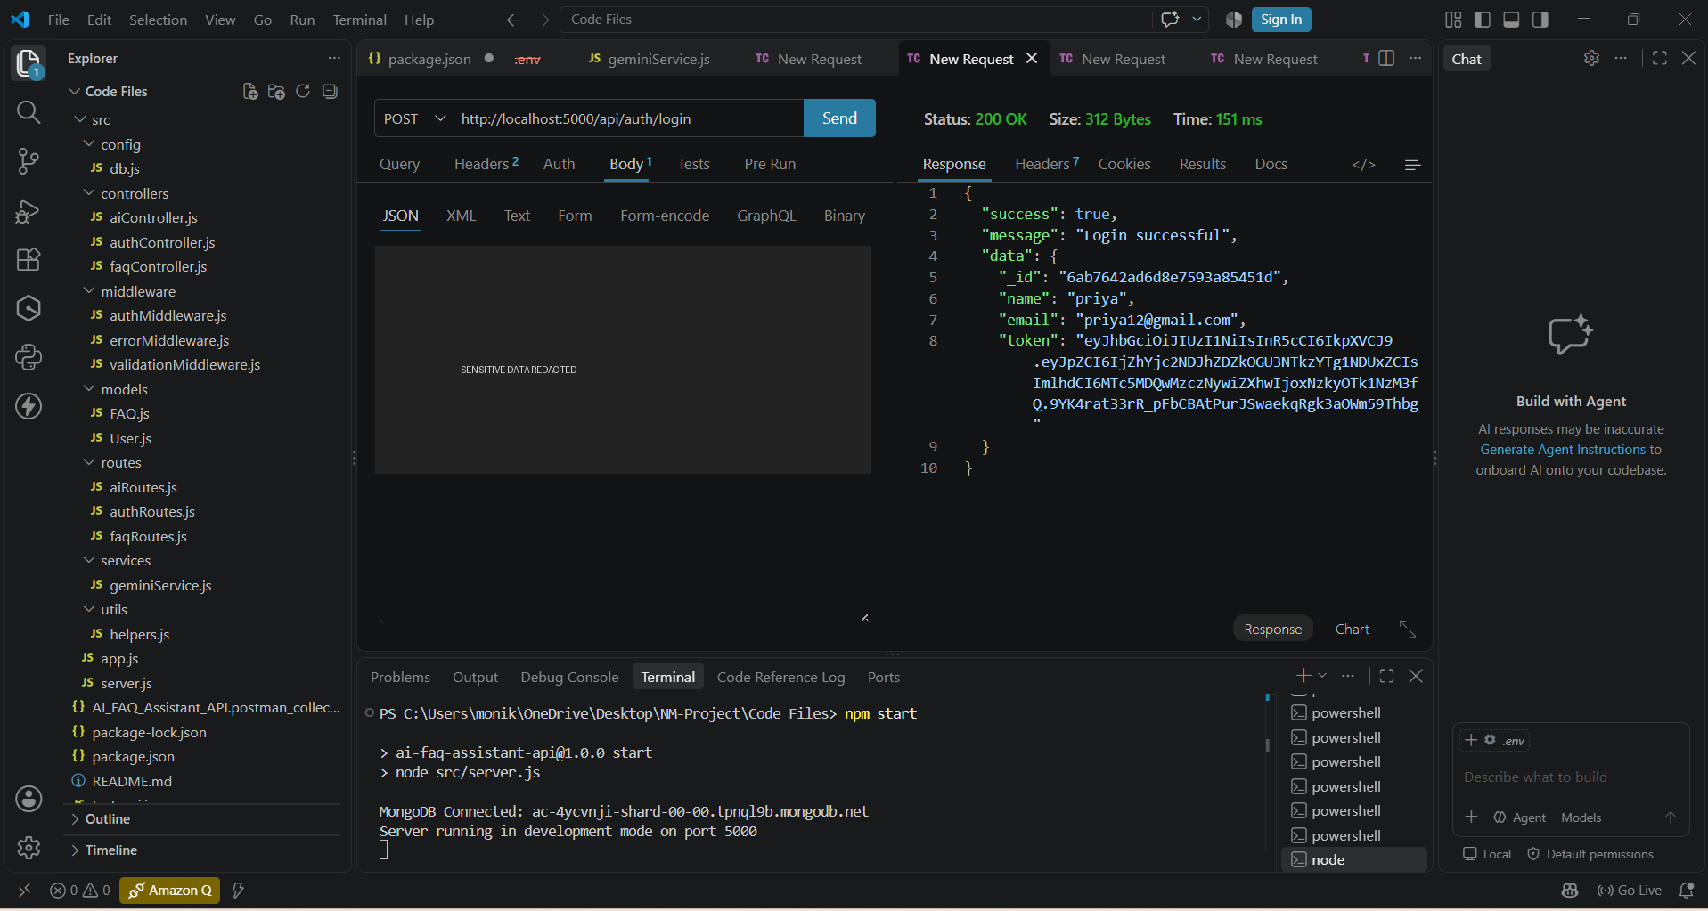
User login response.

Test Evidence 4
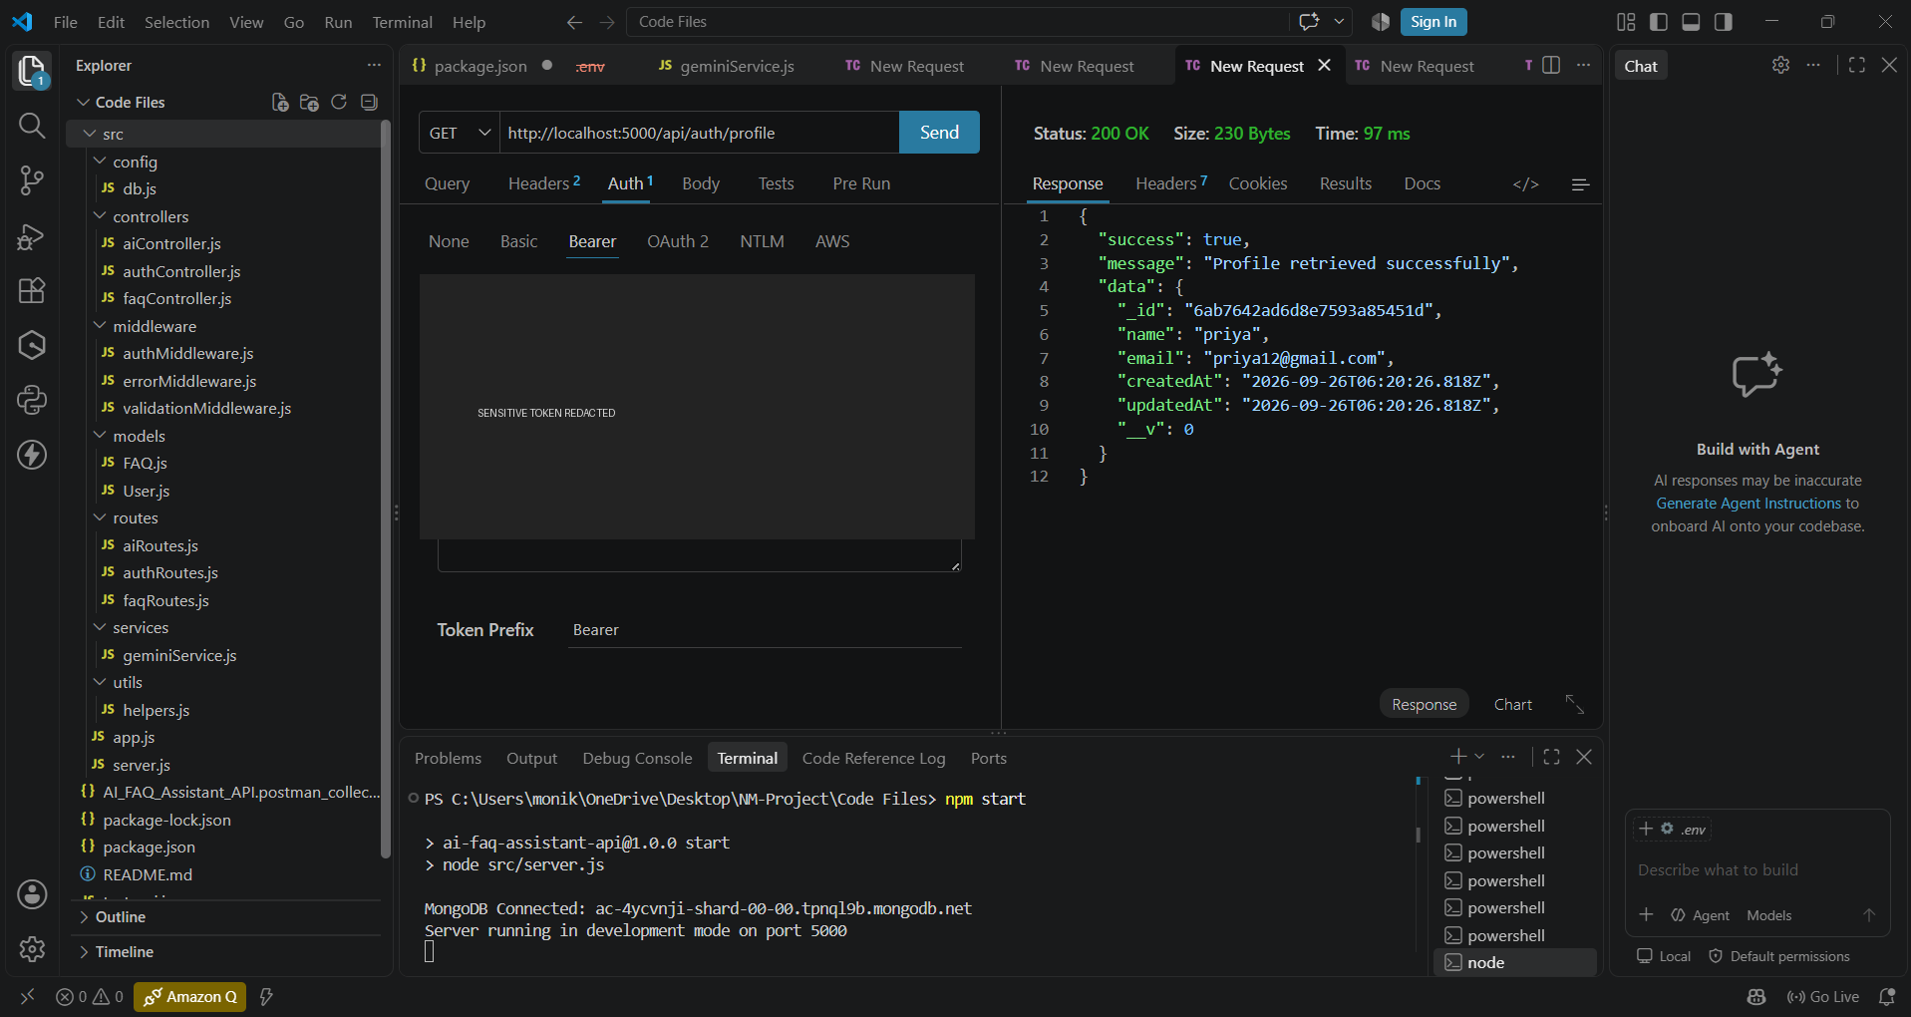
Bearer-authenticated request evidence.

Test Evidence 5
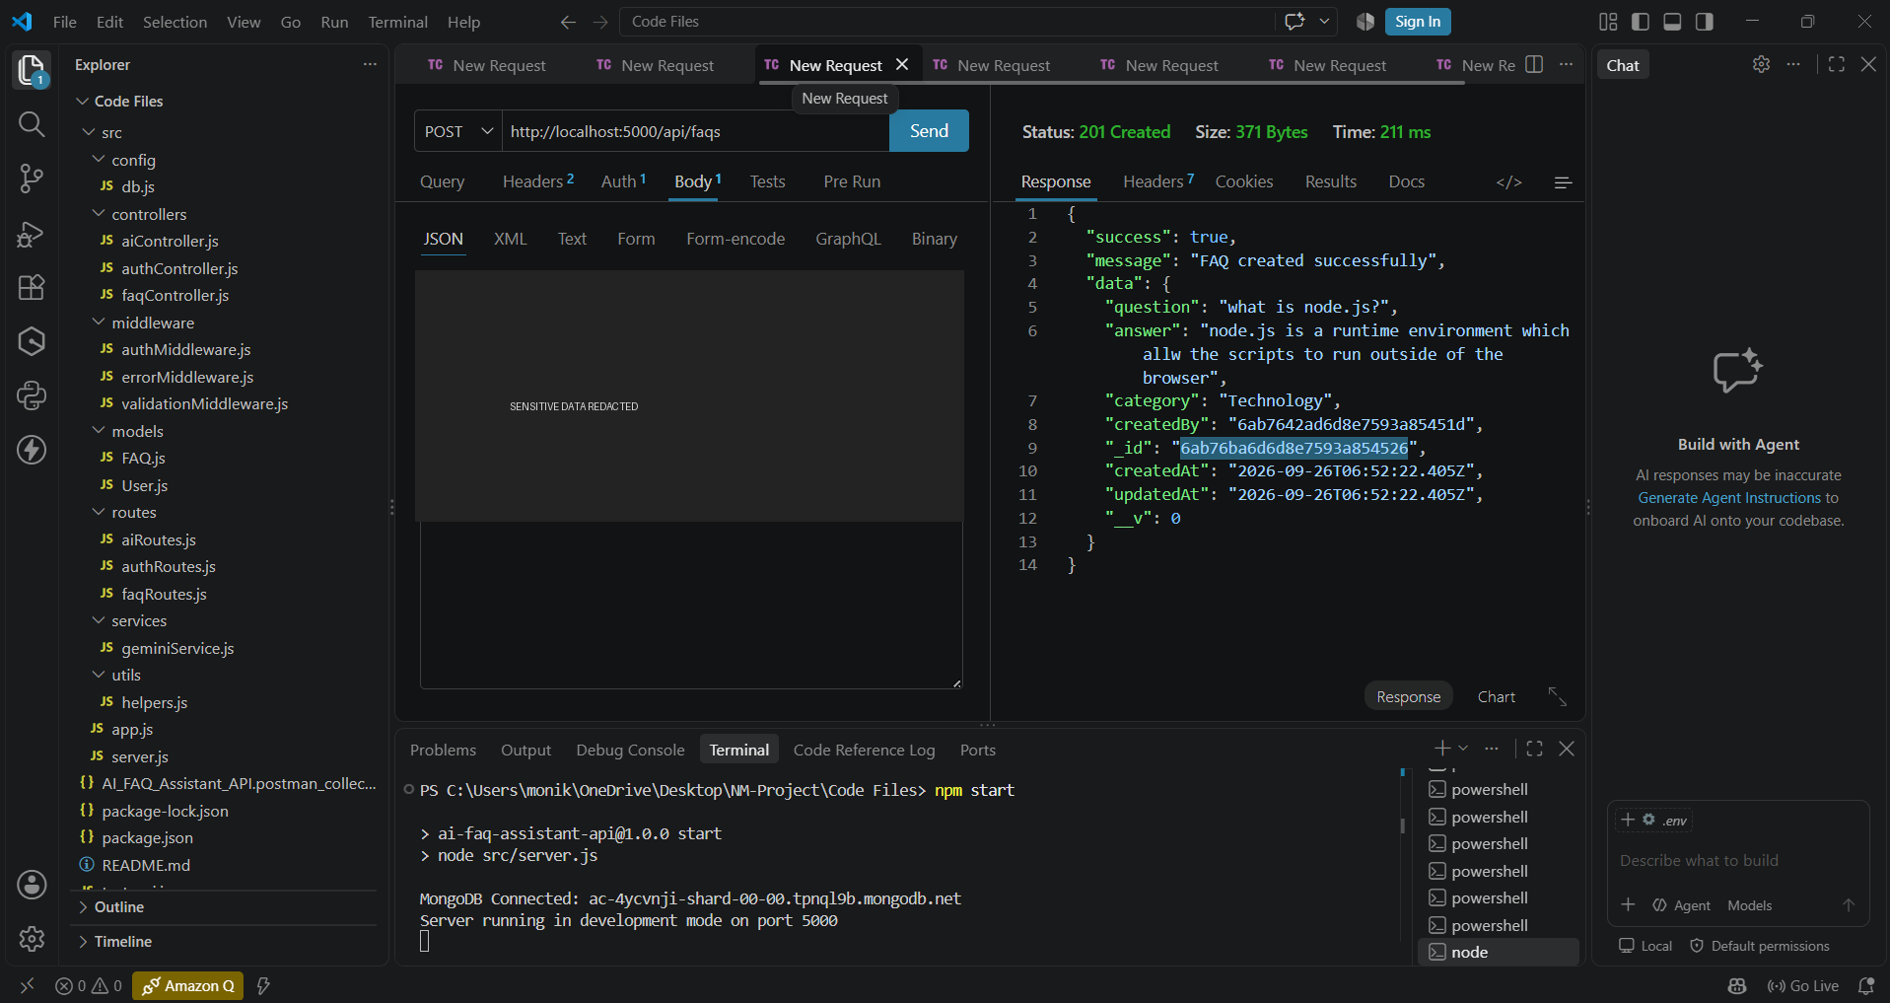
Profile retrieval response.

Test Evidence 6
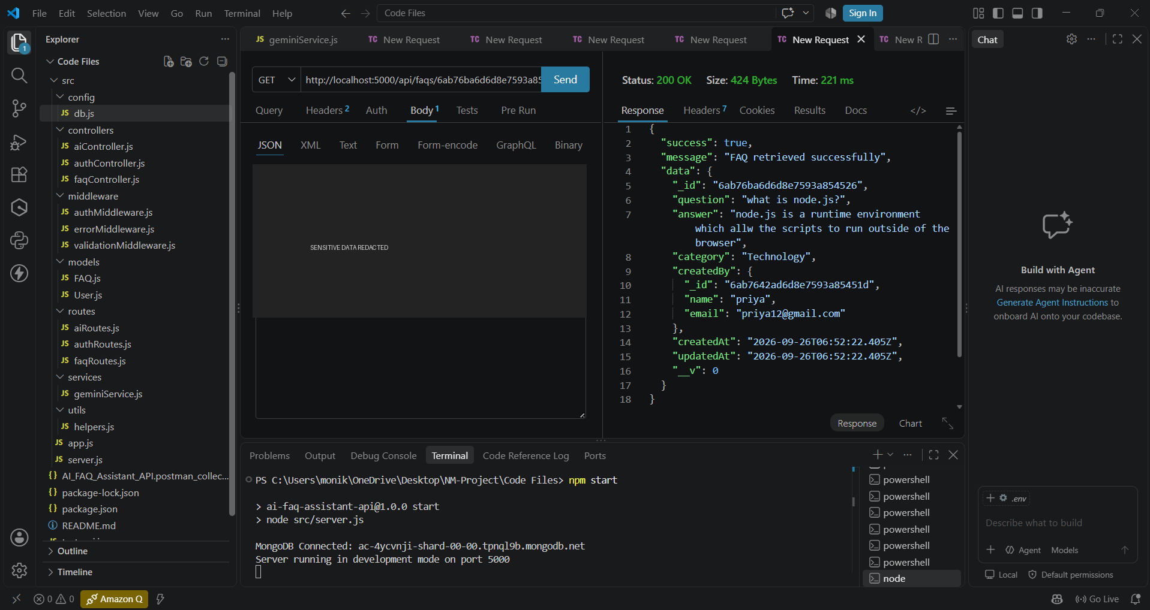
FAQ creation response.

Test Evidence 7
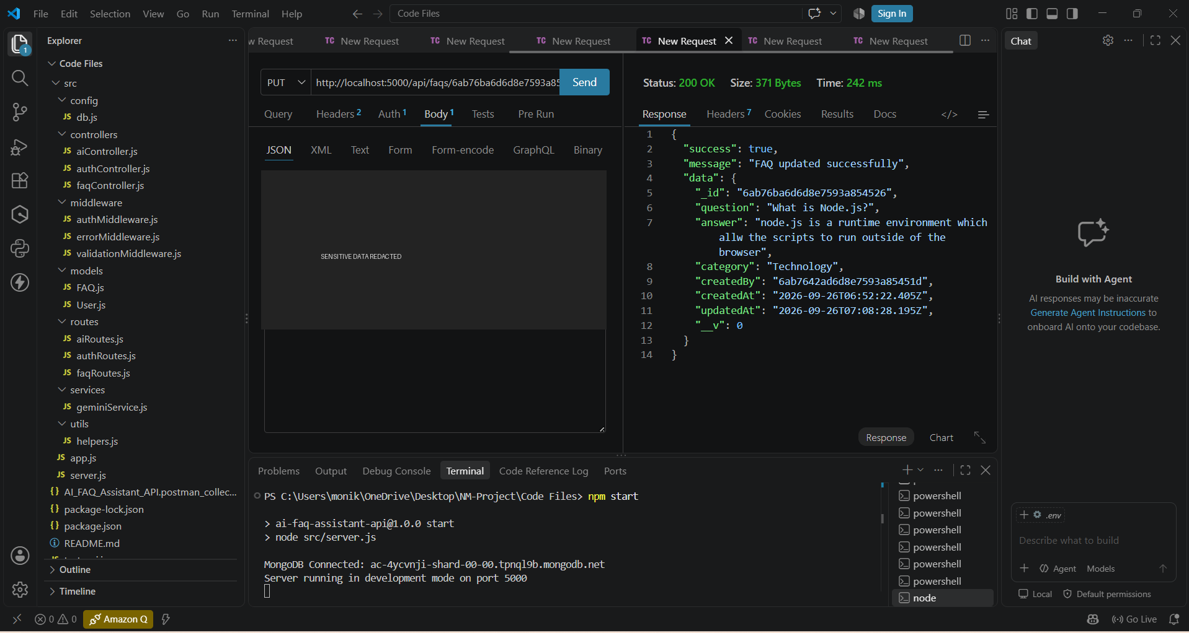
FAQ retrieval response.

Test Evidence 8
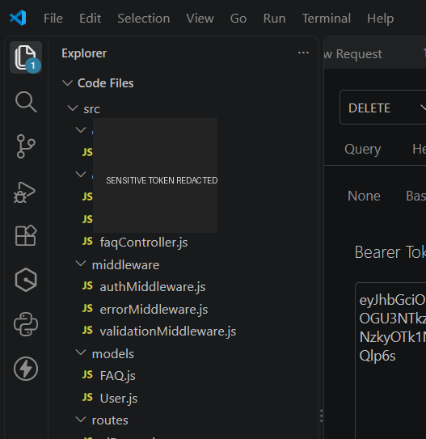
FAQ update response.

Test Evidence 9
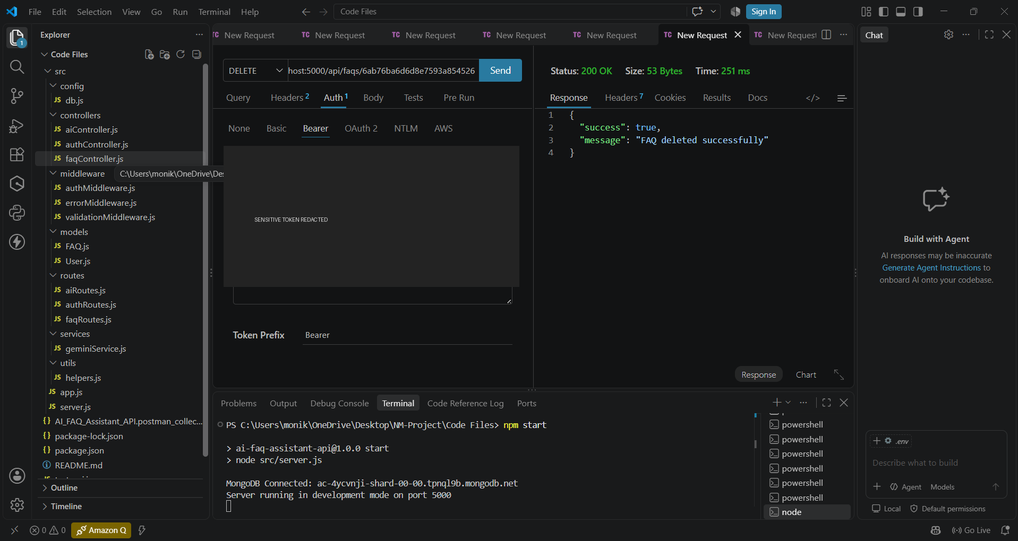
FAQ deletion response.

Test Evidence 10
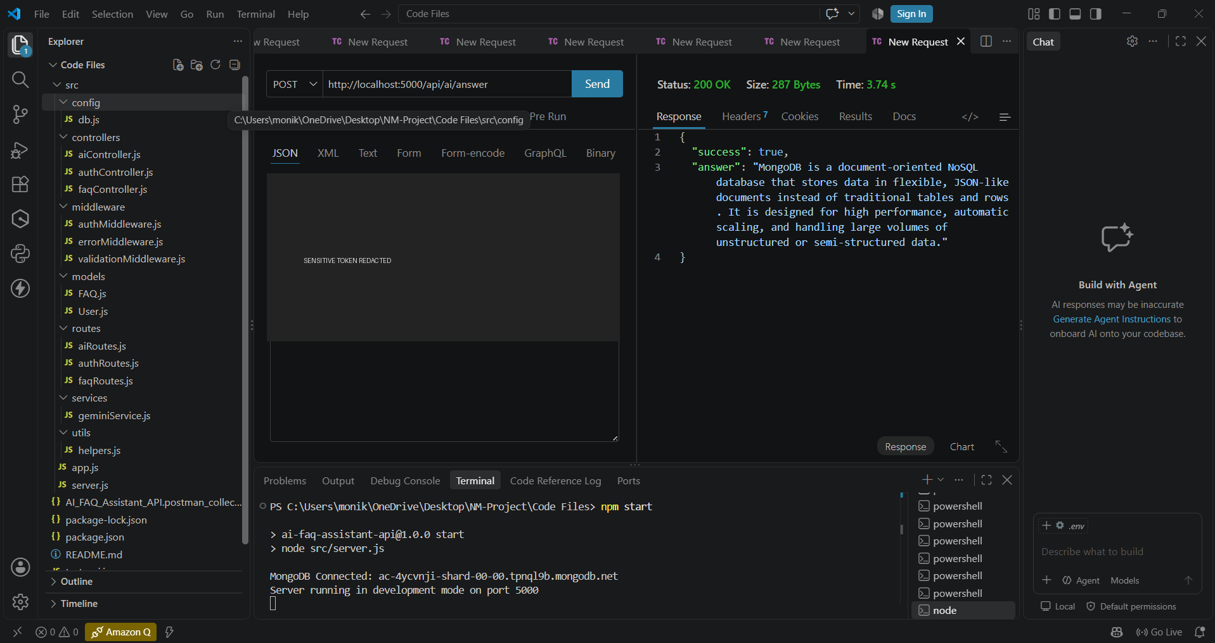
AI answer response.

Project Links
GitHub Repository: AI_FAQ_Assistant_API.git
Demo Video: Google Drive Demo Video
For the demo link to work for evaluators, Google Drive should be set to “Anyone with the link” with Viewer access. Google documents this setting under General access.

Conclusion
The AI FAQ Assistant API provides a modular backend for FAQ management, secure user authentication, and AI-assisted question answering. Its Express.js routing, MongoDB persistence, JWT protection, and Gemini service integration form a clear foundation for future additions such as richer search, administrative dashboards, analytics, and a dedicated frontend.

