PROJECT
DOCUMENTATION
AI WEATHERWISE
Backend-Based Weather & AI Recommendation System

Project Title | AI WeatherWise
Project Type | Backend-Based Weather & AI Recommendation System
Course | B.Sc. Computer Science
Academic Level | Final Year
Team Leader | Nuvera haseen .A
Email ID | 24bsccs43@cttewc.edu.in
Team Member | Deepika.J
Email ID | 24bsccs16@cttewc.edu.in
Team Member | jashvanthi.A
Email ID | 24bsccs11@cttewc.edu.in
Team Member | Rinosha Bevi.P
Email ID | 24bsccs17@cttewc.edu.in
College | Chevalier T. Thomas Elizabeth College for Women

1. Introduction
AI WeatherWise is a backend-based weather application that provides weather information for a requested location and generates AI-based recommendations according to the weather conditions. The system combines user authentication, database management, weather API integration and AI services.
The backend is developed using Node.js and Express.js, while MongoDB Atlas is used for database management. APIs are tested using Thunder Client inside Visual Studio Code.
2. Project Overview
- Register a new user.
- Login with valid credentials.
- Generate JWT authentication token.
- Retrieve weather information for a requested location.
- Generate an AI-based weather recommendation.
- Return structured JSON responses.
- Store user information using MongoDB Atlas.
- Test the backend APIs using Thunder Client.
3. Objectives
- To provide weather information through REST APIs.
- To implement secure user registration and login.
- To store user information using MongoDB Atlas.
- To use JWT-based authentication.
- To retrieve weather information from an external Weather API.
- To generate AI-based recommendations.
- To organize the backend using a modular architecture.
- To test and verify APIs using Thunder Client.
4. Architecture
The system follows a backend API architecture. A client such as Thunder Client sends HTTP requests to the Node.js and Express.js server. The server processes the request through routes and controllers and communicates with MongoDB Atlas, the Weather API, or the AI service as required.
- Backend: Node.js with Express.js
- Database: MongoDB Atlas with Mongoose
- Authentication: JSON Web Token (JWT)
- Password security: bcryptjs
- Weather integration: External Weather API
- AI integration: AI Service
- API Testing Tool: Thunder Client (VS Code Extension)
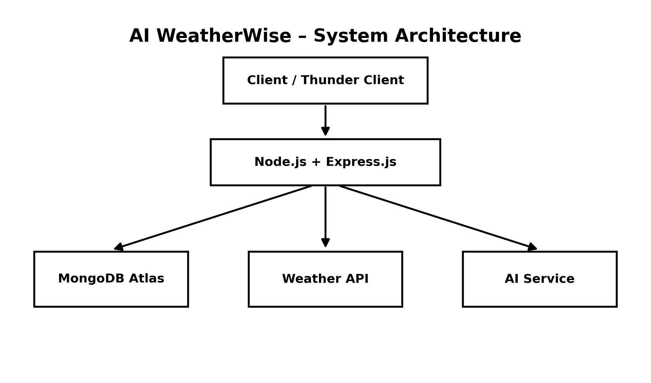
Figure 4.1 – AI WeatherWise System Architecture
5. Folder Structure
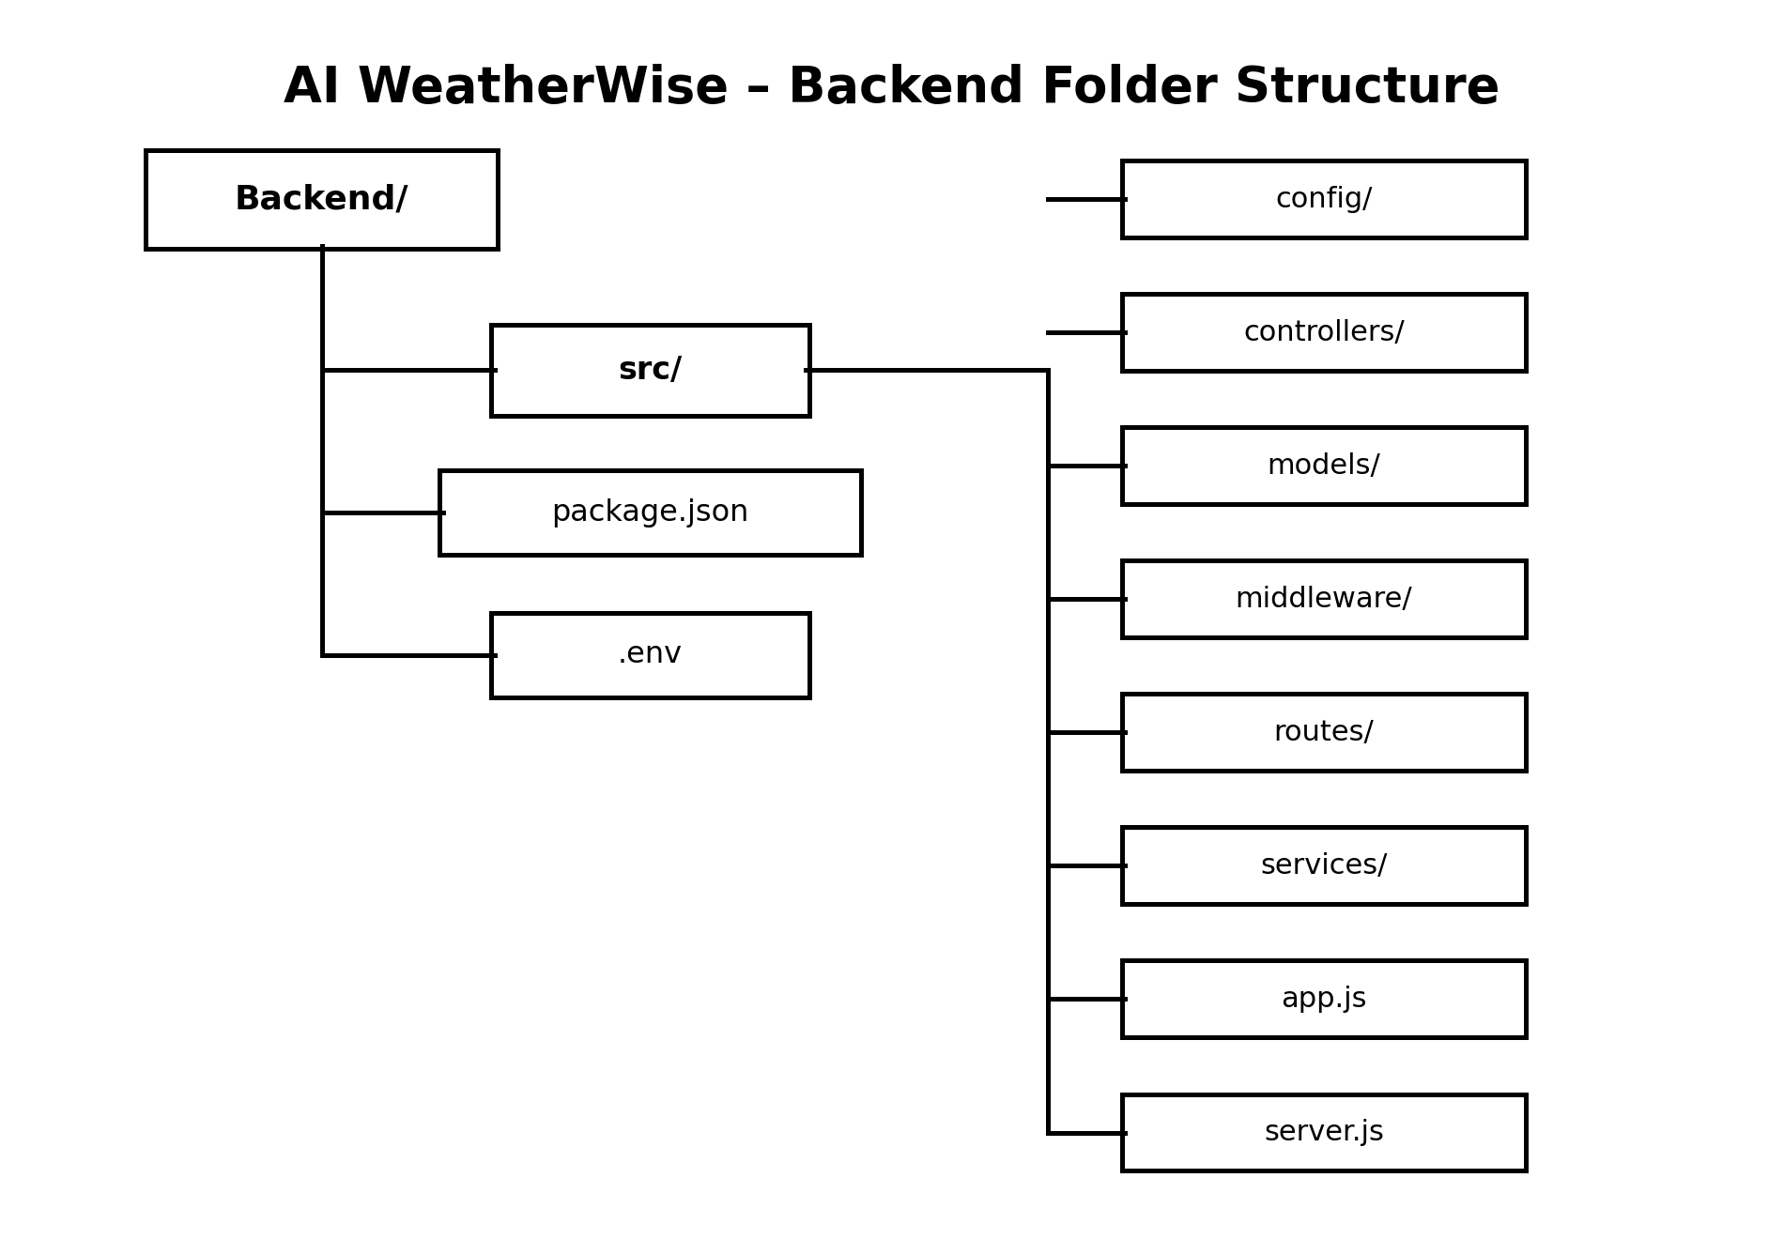
Figure 5.1 – Backend Folder Structure
The project is organized into configuration, controllers, models, middleware, routes and services so that the backend remains modular and maintainable.
6. ER Diagram
The ER diagram represents the conceptual relationship between users, weather requests and AI-generated recommendations.
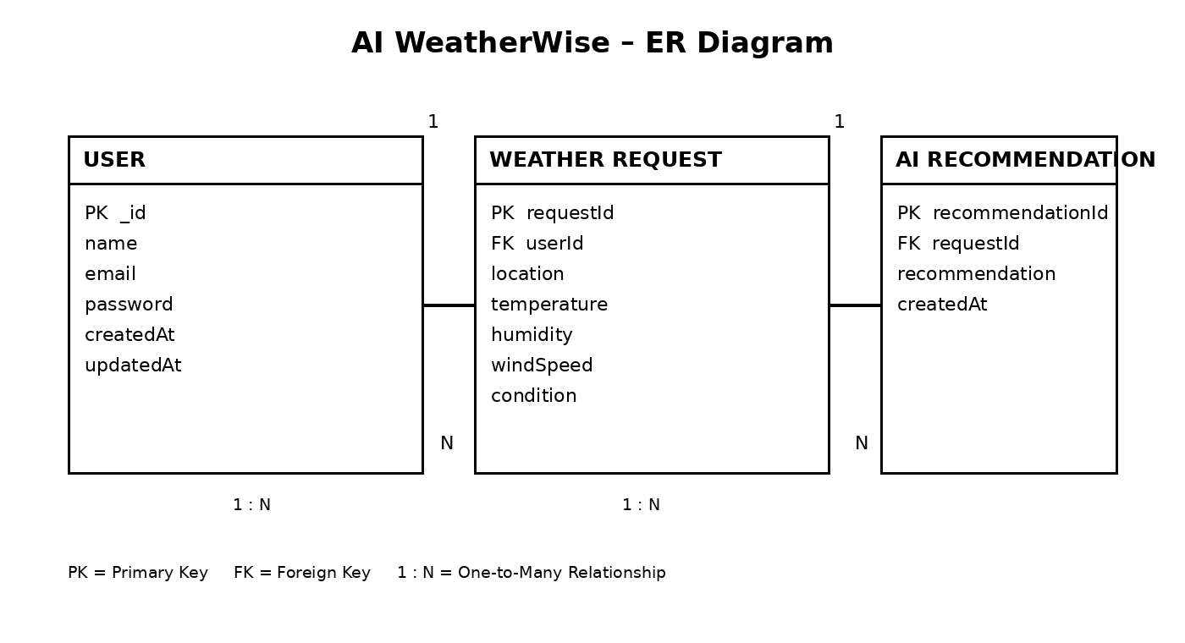
Figure 6.1 – Entity Relationship Diagram for AI WeatherWise
The USER entity stores user account information. A user can have multiple WEATHER REQUEST records. Each weather request can be associated with an AI RECOMMENDATION. Primary keys (PK) uniquely identify records and foreign keys (FK) establish the relationships.
7. Setup Instructions
- Install Node.js and npm.
- Open the AI WeatherWise project in Visual Studio Code.
- Install the required project dependencies.
- Configure the environment variables in the .env file.
- Start the backend server.
- Open Thunder Client in Visual Studio Code to test the APIs.
npm install
npm run dev
The project server runs on port 5001 in the demonstrated API environment.
8. Running the Application
npm run dev
The demonstrated backend output shows MongoDB connected and the server running on port 5001.
- MongoDB connection is established through MongoDB Atlas.
- Express starts the backend server.
- The APIs can then be tested through Thunder Client.
9. API Documentation
9.1 Register User API
The registration API creates a new user account and returns a successful response containing user data and a token.
POST http://localhost:5001/api/auth/register
{
"name": "Nuvera",
"email": "nuvera.demo2026@gmail.com",
"password": "Test@12345"
}
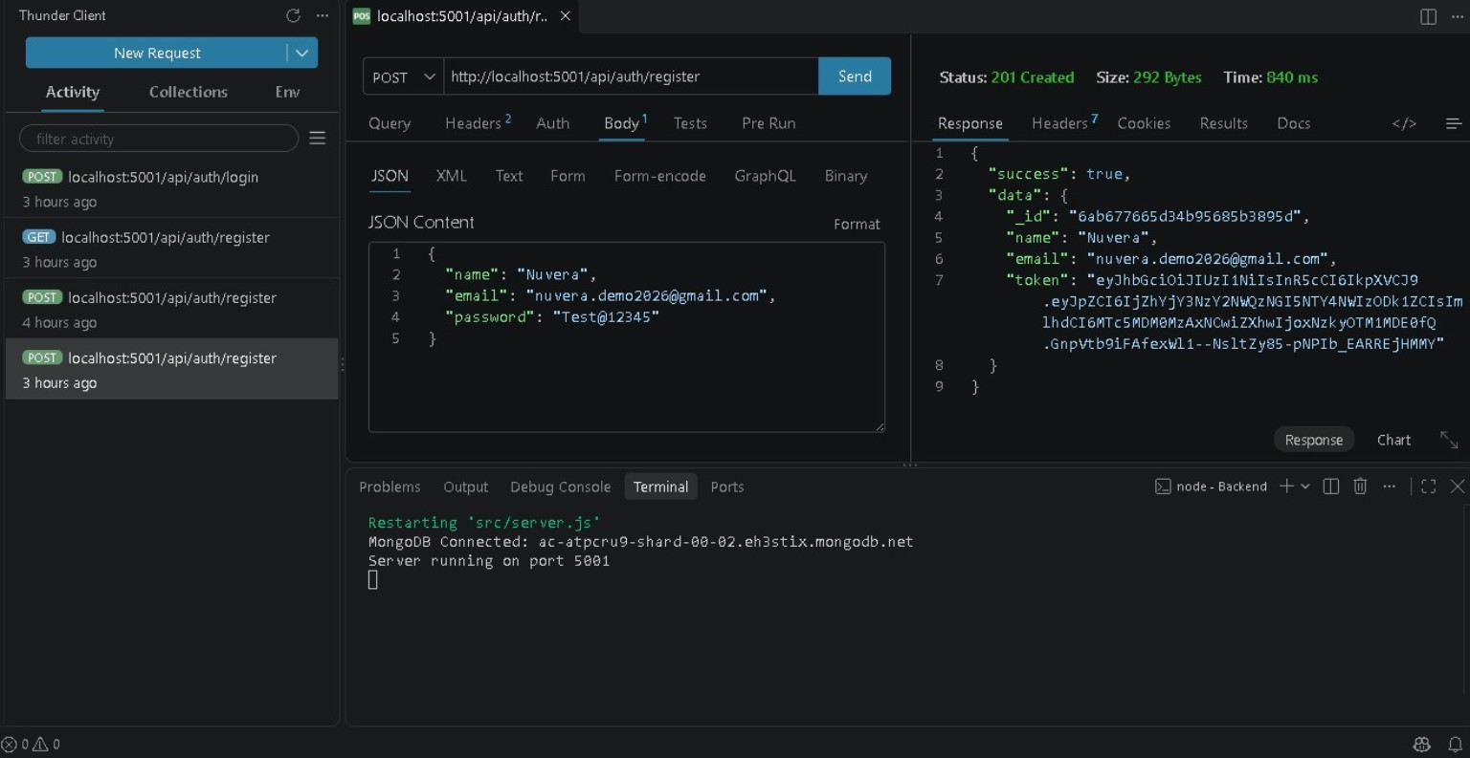
Figure 9.1 – Registration API tested using Thunder Client
9.2 Login User API
The login API verifies the user's credentials and returns a JWT token after successful authentication.
POST http://localhost:5001/api/auth/login
{
"email": "nuvera.demo@gmail.com",
"password": "Test@12345"
}
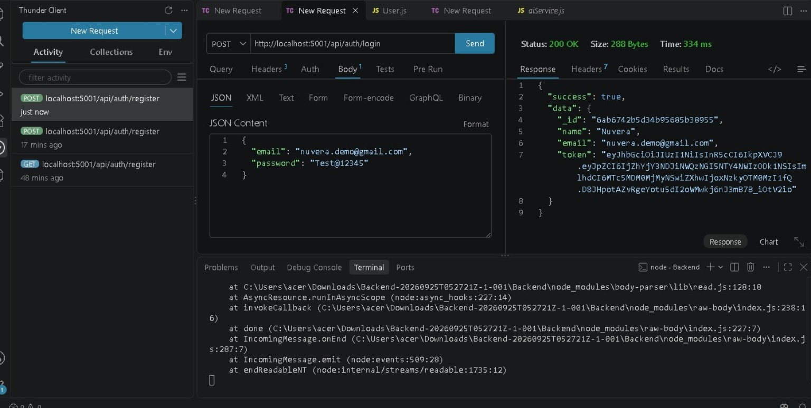
Figure 9.2 – Login API tested using Thunder Client
9.3 Weather Condition API
The weather API retrieves weather information for a requested city. The demonstrated response includes temperature, humidity, wind speed and weather condition.
GET http://localhost:5001/api/Weather/chennai
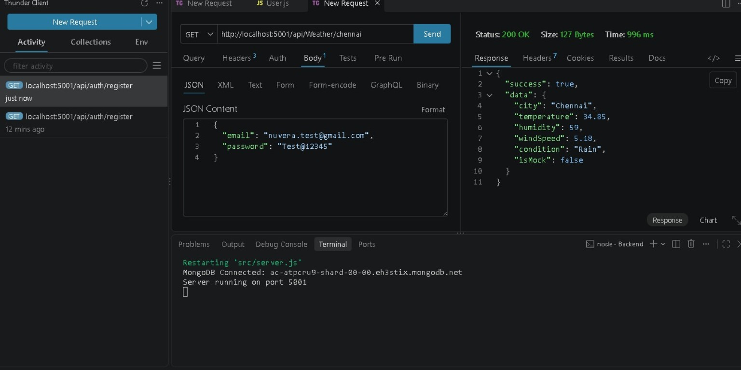
Figure 9.3 – Weather Condition API tested using Thunder Client
9.4 Weather Recommendation API
The weather recommendation API accepts weather-related information and returns an AI-generated summary or recommendation.
POST http://localhost:5001/api/ai/Weather-summary
{
"city": "Chennai",
"temperature": 29.12,
"humidity": 80,
"condition": "Rain"
}
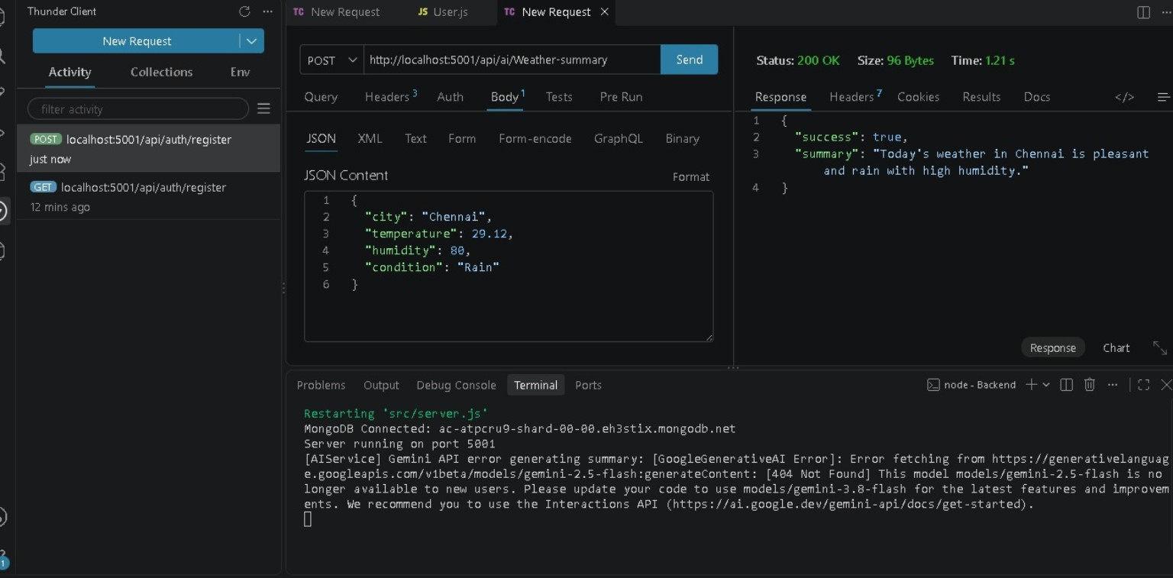
Figure 9.4 – Weather Recommendation API tested using Thunder Client
10. Authentication
JWT authentication is used in the application. During registration, the submitted user details are processed and the password is securely handled before storage. During login, the credentials are verified and a JWT token is returned after successful authentication.
Authorization: Bearer <JWT Token>
The .env file is intended for sensitive values such as the MongoDB connection string, JWT secret and external API keys. Actual secrets should not be exposed in a public project repository.
11. Main Modules
Authentication Module – Handles registration, login and authentication-related operations.
User Module – Manages user information stored in the database.
Weather Module – Retrieves weather information for a requested location.
AI Recommendation Module – Uses weather information to generate a practical recommendation or summary.
Database Module – Connects the backend with MongoDB Atlas through Mongoose.
Middleware – Provides reusable request-processing and authentication functions.
12. Testing
Testing is performed using Thunder Client. The API requests are checked for successful responses and correct JSON output.
Test Case | API / Function | Observed Result
TC01 | User Registration | Successful registration response
TC02 | User Login | Successful login response with JWT token
TC03 | Weather Condition | Weather information returned for Chennai
TC04 | Weather Recommendation | Recommendation/summary response returned
13. User Interface
This project mainly focuses on backend development. The APIs are tested through Thunder Client inside Visual Studio Code. The screenshots in this document provide evidence of the API requests and responses.
14. Known Issues
- The current project is primarily backend/API based.
- Weather information depends on the availability and accuracy of the external weather service.
- AI recommendations depend on the configured AI service.
- Internet connectivity is required for cloud database and external service integrations.
15. Future Enhancements
- Add a responsive web or mobile frontend.
- Add current-location weather detection.
- Add favourite cities.
- Add severe-weather alerts.
- Add historical weather charts.
- Add personalized recommendations.
16. Conclusion
AI WeatherWise demonstrates the integration of weather services, artificial intelligence, user authentication and cloud database technologies in a practical backend application. The project provides weather information through REST APIs and combines the obtained weather data with AI-assisted recommendations. The backend structure is modular and can be extended with additional features and a frontend interface in the future.
17. Demo & Testing Links
Demo Video Link: https://drive.google.com/file/d/1CUgInCmrWFQDMuJdvASdWmyCrieSLutg/view?usp=drivesdk
API Testing Video Link (Thunder Client): https://drive.google.com/file/d/1QmlqKUiYuRNQuDhJMR0f5ILsM37PjtMw/view?usp=drivesdk
END OF PROJECT DOCUMENTATION

