M365 for Developers Cheat Sheet

What is Microsoft 365?
Microsoft 365 is Microsoft's cloud productivity platform. It bundles together the apps and storage that a company uses every day:
- SharePoint – shared document libraries for a team or company
- OneDrive – personal file storage for one user
- Teams – chat, calls, and channels
- Outlook – email and calendar
- Word, Excel, PowerPoint, Planner, Forms, Power Automate
All of these services are connected through one single API: Microsoft Graph API. Instead of talking to SharePoint, OneDrive, and Outlook separately, an app can talk to Graph once and reach all of them.

What is Microsoft Graph API?
Microsoft Graph is Microsoft's REST API. It lets an application read and write data inside Microsoft 365 — files, emails, users, Teams messages, calendar events, and more — all through the same web address style:
- GET /me → your own profile
- GET /me/drive/root/children → your files
- GET /me/messages → your emails
- POST /search/query → search across everything (SharePoint, OneDrive, Teams, Outlook) in one go
This is exactly why it matters for our chatbot: it can ask Graph one question ("find the HR policy") instead of searching each app one by one.

Key Terms
Term | What it means
Tenant | One organization's private Microsoft 365 environment. Company A and Company B are separate tenants and can never see each other's data.
OAuth 2.0 | The login/security system Microsoft uses. A user logs in, Microsoft hands back an access token, and the app uses that token to ask Graph for data.
Access Token | A temporary digital "ID card" proving the app is allowed to ask for data. Sent with every Graph request as Authorization: Bearer <token>.
App Registration | How an app gets its own identity in Azure so Microsoft knows who is asking. Produces a Client ID, Tenant ID, and a secret/certificate.
Scope / Permission | A specific thing an app is allowed to do, e.g. Files.Read (read files) or Mail.Read (read email).
Delegated Permission | The app acts as the signed-in user and can only see that user's own data.
Application Permission | The app acts on its own, with no signed-in user, and can potentially see data across the whole organization.
Admin Consent | Approval from a Microsoft 365 administrator, required before an app can use powerful, organization-wide permissions.
Throttling | Microsoft's way of protecting its servers — if an app sends too many requests too fast, it gets a 429 Too Many Requests response and has to wait before trying again.

Common Graph API Endpoints
Term | What it means
GET /me | Returns the signed-in user's profile (name, email).
GET /me/drive/root/children | Lists the files in the user's OneDrive.
GET /me/messages | Lists the user's emails.
POST /search/query | Searches across SharePoint, OneDrive, Teams, and Outlook at once.

First Successful Graph Explorer Call
Screenshot goes here: GET /me run in Graph Explorer, showing a successful response with the signed-in user's display name and email.
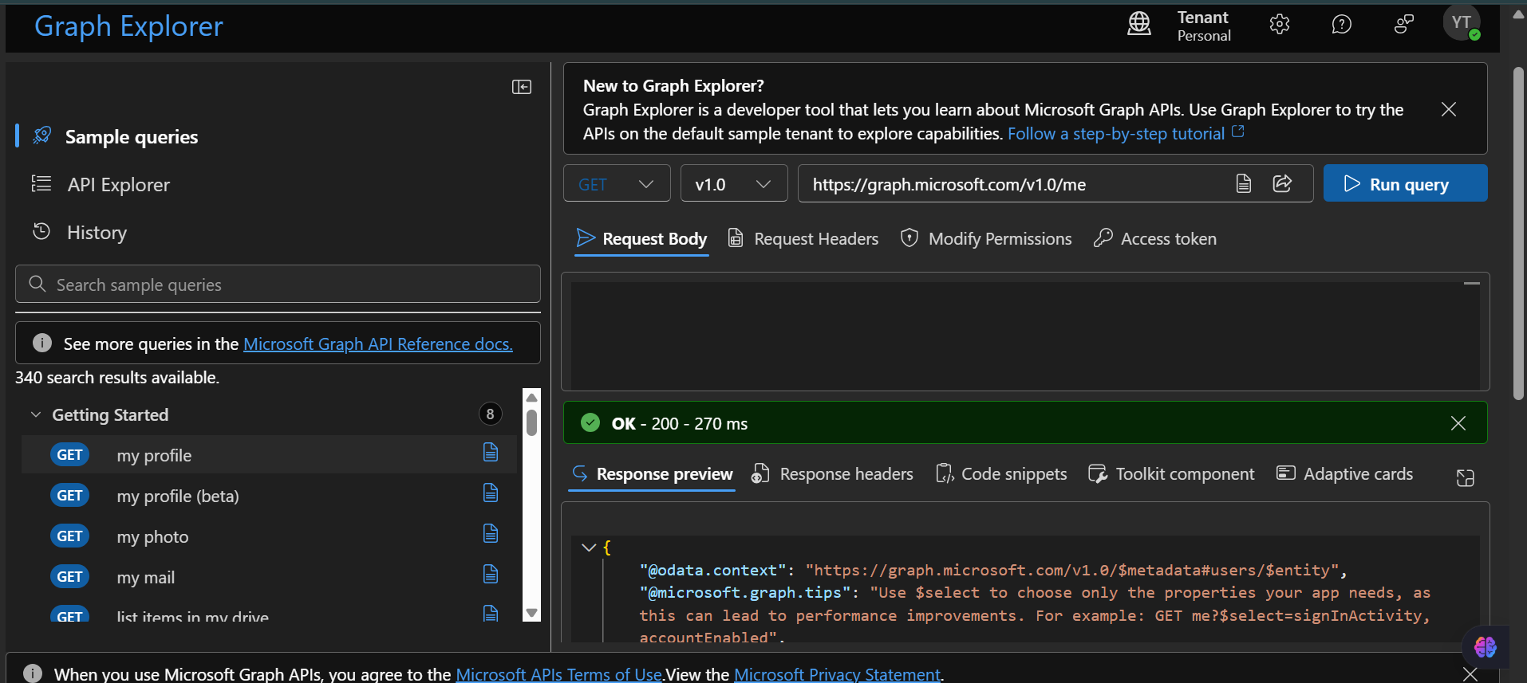

One-line summary
Microsoft 365 stores all the company's documents and messages. Microsoft Graph is the single door into all of it. OAuth and access tokens control who's allowed in. Permissions and admin consent control what they're allowed to see. Throttling controls how fast they can ask.

