**PROJECT DOCUMENTATION**

**CookBook: Your Virtual Kitchen Assistant.**

**1. Introduction**

**• Project Title**: CookBook: Your Virtual Kitchen Assistant.

**• Team ID:** NM2025TMID31296

**• Team Leader:** Abdul Rahman – 24cs3201@gmail.com

**• Team Members:**

* Adhithyan D & 24cs3202@gmail.com
* Akash A & 24cs32033@gmail.com
* Arunachalam M.J & 24cs3204@gmail.com
* Aswin V &24cs3205@gmail.com

**2. Project Overview**

* **Purpose:**

"CookBook is your ultimate virtual kitchen assistant, designed to make cooking easier and more enjoyable. With a vast recipe library, meal planning tools, and step-by-step cooking guidance, you'll be whipping up delicious meals in no time. Whether you're a seasoned chef or a kitchen newbie, CookBook is here to help you cook with confidence. Get cooking and make every meal a masterpiece!"

* **Goals:** 
  + 1. Centralized Recipe Collection – Provide a digital platform to store and access recipes easily.
    2. Easy Navigation – Use a clean UI and React Router for smooth browsing between categories and recipe details.
    3. Learning Support – Integrate YouTube tutorials for step-by-step cooking guidance.
    4. Category Organization – Group recipes by type (Beef, Chicken, Dessert, etc.) for quick discovery.
    5. User-Friendly Experience – Design an interface that is simple, responsive, and attractive.
    6. Reusable & Scalable – Build with React components so new features and recipes can be added easily.
* **Key Features:** 
  + 1. Recipe Categories – Browse recipes by popular food categories (Beef, Chicken, Dessert, etc.).
    2. Recipe Details Page – View ingredients, preparation steps, and video tutorials.
    3. YouTube Video Embedding – Watch cooking videos directly inside the app.
    4. Search & Navigation – Quickly find specific recipes using smooth navigation.
    5. Responsive Design – Works on desktop, tablet, and mobile devices.
    6. Reusable Components – Built with React components for cards, lists, forms, etc.
    7. API Integration (if added) – Fetch recipes dynamically using Axios.
    8. Modern UI – Styled with CSS and React Icons for a professional look.

**3. Architecture**

* **Component Structure** 
  + App.js — Root component, sets up routes and layout.
  + Navbar.jsx — Provides site navigation across pages (Home, Categories, Recipes).
  + Home.jsx — Homepage container, displays Hero, CategoriesHome, and NewsLetter.
  + CategoriesHome.jsx — Shows recipe categories on the homepage.
  + Category.jsx — Page that lists recipes filtered by category.
  + Recipie.jsx — Page displaying a single recipe with details.
  + About.jsx — Static page about the Cookbook application.
  + Footer.jsx — Footer with branding, copyright, and links.
* **State Management** 
  + Local State: Managed using React useState and useEffect.
  + API Integration: Axios used for fetching data from CookBook API & YouTube API.
* **Routing** 
  + Library: react-router-dom
  + Routes:
    - / Home.jsx
    - /pages/Category => food Category.jsx
    - /category/Recipie ? Recipie.jsx

**4. Setup Instructions**

**Prerequisites**

* **Node.js & npm** 
  + Node.js is required to run React applications.
  + npm (Node Package Manager) is used to install dependencies.
  + Download Node.js
* **React.js** 
  + React is the main JavaScript library used to build this project.
  + If you don’t have an existing React app, create one using:
  + npx create-react-app my-app
  + cd my-app
  + npm start
  + In SB Fitzz, the React app is already created, so you just need to install dependencies (npm install).
* **Git** 
  + Used for cloning and version control.
  + Download Git
* **Code Editor** 
  + Recommended: Visual Studio Code (VS Code)
  + Download VS Code
* **Basic Knowledge** 
  + HTML, CSS, JavaScript
  + React concepts (components, props, hooks, state, routing)
* **Installation** 
  + Get the code:
    - Download the code from the drive link given below:
      * + https://drive.google.com/drive/folders/1u8PnV_mE0mwKkH_CvuNpliZtRLJZMqrO?usp=sharing
* **Install Dependencies:** 
  + Navigate into the cloned repository directory and install libraries:
    - Navigate into the cloned repository directory and install libraries:
      * cd CODE
      * npm install
  + Start the Development Server:
    - To start the development server, execute the following command:
      * npm start
* **Access the App:** 
  + Open your web browser and navigate to http://localhost:3000.
  + You should see the application's homepage, indicating that the installation and setup were successful.
* **Environment Variables** 
  + Create a .env file with:
    - REACT_APP_API_URL=<https://exercisedb.p.rapidapi.com/exercises/equipmentList>
    - REACT_APP_YOUTUBE_API_KEY=<33cf3a7616msh4c3b1e3204f24e2p1294b3jsne16a7323d732>

**5. Folder Structure**

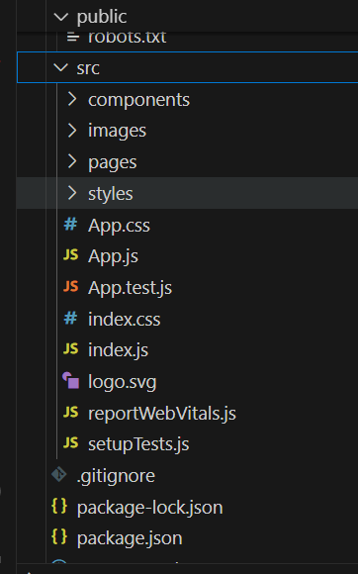

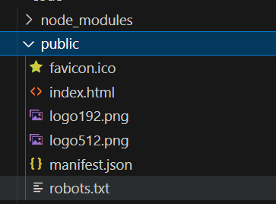

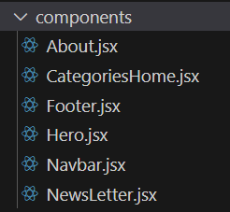

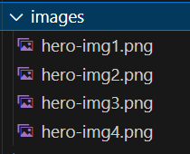

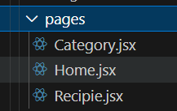

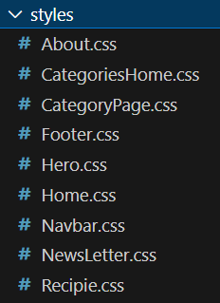



**6.Running the Application**

* Start development server:
  + npm start
* Build for production:
  + npm run build
* Run tests:
  + npm test

**7. Component Documentation**

* index.js => renders <App />
* App.js => wraps Navbar, Routes, and Footer
* Home.jsx => (uses Hero, CategoriesHome, NewsLetter)
* category => Category.jsx (may also reuse CategoriesHome)
* Recipie.jsx => (shows details of a recipe)Components import their CSS modules for styling.
* images => used in Hero, Home, and Category pages

**8. State Management**

* Local State:
  + Search queries stored in HomeSearch.
  + API data fetched and stored per-page.
* Global State:
  + Not implemented — app uses component-level state.

**9. User Interface**

* **Pages include:** 
  + **Home (Hero + Search )**

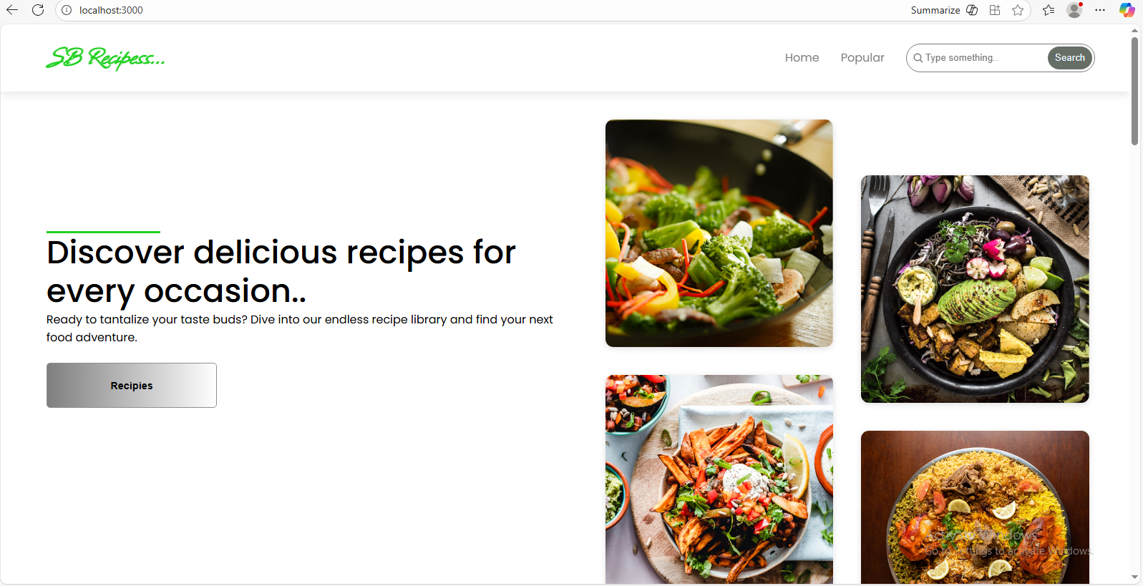

* **Popular:**

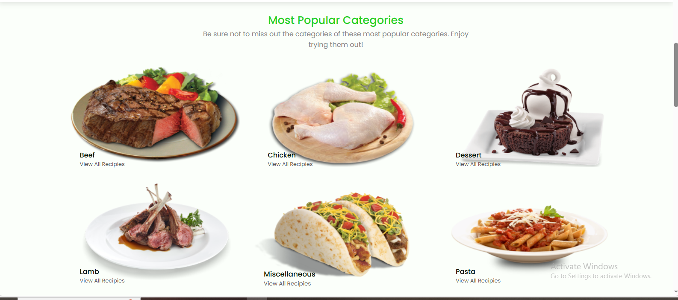

**10. Styling**

* Frameworks Used: Tailwind CSS / Bootstrap.
* Custom CSS: Stored in src/styles/.
* Each page/component has a dedicated CSS file for modularity.

**11. Testing**

* Libraries Used: Jest, React Testing Library.
* Unit Tests: Written in App.test.js.
* Setup: Configured with setupTests.js.

**12. Screenshots / Demo**

* **Demo Link:** <https://drive.google.com/file/d/1kAunaqolPHRMb4Dmw7AEV8CoBEqU1kwg/view?usp=drive_link>
* **Screenshot:**



**13. Known Issues**

* + API rate-limit may cause some exercises not to load.
  + YouTube API sometimes fails to fetch related videos.

**14. Future Enhancements**

* **User Authentication** – Allow users to sign up, log in, and save their favorite recipes.
* **Recipe Submission** – Let users add and share their own recipes with the community.
* **Search & Filters** – Advanced search by ingredients, cuisine, prep time, or dietary needs.
* **Favorites & Collections** – Users can bookmark recipes and organize them into collections.