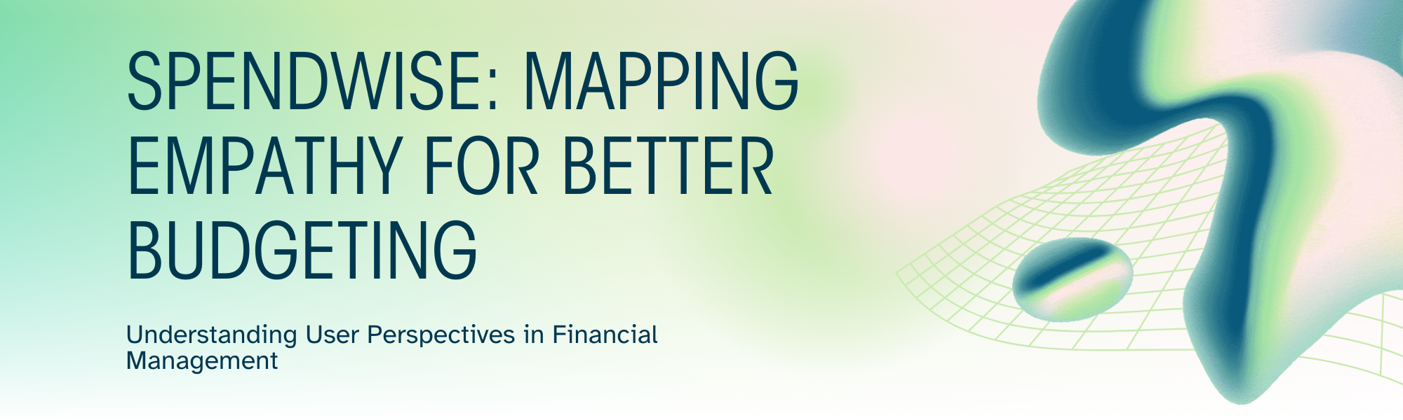
SpendWise Empathy Map Canvas
Project Overview
Date: 10 March 2026
Team ID:69a6a96fc6a66470be1bd449
Project Name: SpendWise
Team Members: 4
Maximum Marks: 4 Marks
Empathy Map Canvas
An empathy map is a simple way to understand a beginner's thoughts, feelings, and actions while learning backend development. It helps identify how beginners work with APIs, JWT authentication, and MongoDB, and what problems they face with complex code. Creating this empathy map allows the project to be viewed from the beginner's perspective, ensuring the solution stays simple, practical, and easy to understand.
Target User: Backend Development Beginners

What They THINK
- "I need to understand how APIs actually work in real applications"
- "JWT authentication seems complicated, but I know it's important for security"
- "MongoDB looks different from SQL databases I've seen before"
- "I want to build something practical that I can show to potential employers"
- "How do all these backend pieces fit together in a real project?"
- "I hope this project will help me understand the full development cycle"
What They FEEL
- Excited about building their first complete backend application
- Overwhelmed by the number of new technologies to learn simultaneously
- Curious about how professional developers structure their code
- Anxious about making mistakes or writing "bad" code
- Motivated to create something useful and portfolio-worthy
- Frustrated when documentation is too complex or assumes prior knowledge
What They SEE
- Complex tutorials that jump between different concepts
- Job postings requiring "2+ years experience" for entry-level positions
- GitHub repositories with intimidating codebases
- Fellow students struggling with similar backend concepts
- Online forums filled with advanced discussions they don't understand
- Simple frontend projects but few beginner-friendly backend examples
What They SAY & DO
Say:
- "Can someone explain this in simpler terms?"
- "I understand the theory, but how do I implement it?"
- "What's the difference between authentication and authorization?"
- "Why isn't my API endpoint working?"
- "How do I structure my project folders properly?"
Do:
- Copy-paste code from tutorials without fully understanding it
- Spend hours debugging simple syntax errors
- Search for "beginner-friendly" tutorials and examples
- Ask questions in student forums and Discord servers
- Start multiple small projects but struggle to complete them
- Compare their progress to more experienced developers

Pain Points
- Information Overload: Too many concepts introduced at once
- Lack of Context: Understanding individual pieces but not how they connect
- Complex Examples: Most tutorials use overly complicated scenarios
- Setup Difficulties: Struggling with environment configuration and dependencies
- Security Confusion: Not understanding when and why to implement certain security measures
Gains & Motivations
- Practical Skills: Want to build real-world applicable projects
- Portfolio Development: Need projects to showcase to employers
- Confidence Building: Desire to feel competent in backend development
- Career Preparation: Understanding industry-standard practices and tools
- Problem-Solving: Learning to debug and troubleshoot independently

Key Insights for SpendWise Development
Based on this empathy map, our team of 5 identified that SpendWise should:
- Start Simple: Begin with basic expense tracking before adding complex features
- Clear Documentation: Provide step-by-step explanations for each backend concept
- Modular Learning: Break down JWT, API design, and MongoDB into digestible sections
- Real-World Context: Show how each feature would be used in actual applications
- Error Handling: Include common mistakes and how to fix them
- Progressive Complexity: Build features incrementally to avoid overwhelming beginners
This empathy map guides our development approach, ensuring SpendWise remains an accessible learning project that addresses real beginner needs while teaching essential backend development skills.

