Streamlining IT Procurement: Automating Standard Laptop
Orders with Flow Designer

Phase-1 -- BRAINSTORMING & IDEATION PHASE

Date | 28.09.2026
Team Id | SWTID-2026-7568
Project Name | Streamlining IT Procurement: Automating Standard Laptop Orders with Flow Designer
Project Guide Name | Dr. K.KARPAGAM, M.Sc.,M.Phil.,Ph.D.

Team leader : Mutharasu R
Reg.No : 24CS3228

Team Members:

Name | Reg.No
Thangapandi Murugesh C | 24cs3250
Vignesh M | 24CS3255

BRAINSTORMING & IDEATION
PHASE

Project: Streamlining IT Procurement: Automating Standard Laptop Orders with Flow Designer

Project Phase: Brainstorming & Ideation. Platform: ServiceNow. Technology: Flow Designer. Process Area: IT Procurement. Main Use Case: Standard Laptop Ordering. Academic Project.

This document presents the Brainstorming & Ideation Phase for an academic project that examines how ServiceNow Flow Designer can automate the Standard Laptop procurement flow. The objective of this phase is to identify the core problems in the current procurement lifecycle, generate candidate solutions, evaluate alternatives, and propose a final automation concept suitable for detailed requirements and subsequent development phases.

Problem Definition
Manual steps in Standard Laptop requests cause delays and oversight.

Brainstorming
Generate ideas spanning manual, semi-automated, and fully automated approaches.

Evaluation
Assess alignment with ServiceNow and operational feasibility.

Selected Solution
Flow Designer automation creating Catalog Task assigned to Hardware.



Short introduction: The project addresses inefficient manual activities in the Standard Laptop ordering process by designing a Flow Designer-based automation that links Service Catalog requests, approvals, and Catalog Task creation to the Hardware assignment group.

Understanding the Existing IT Procurement Problem
The current IT procurement process for Standard Laptop orders relies on a human-operated sequence: a Service Request is submitted, approvals are obtained, and configuration tasks must be created and routed manually. When configuration task creation or assignment is omitted or delayed, downstream activities are stalled. The resulting process inefficiency increases user wait time and administrative overhead in the IT procurement and Hardware teams.

- Manual intervention
- Delayed task creation
- Configuration dependency
- Task assignment problems
- User waiting time
- Resource utilization
- Process inefficiency

Existing Challenge | Effect on Process
Manual task creation | Additional administrative effort — Configuration step may be overlooked (Proposed)
Configuration dependency | Possible delay in configuration start — To be validated
Manual assignment | Task may not reach the correct team quickly — Observation during ideation
Lack of automation | More human intervention required — Proposed solution targets this
Delayed configuration | Longer user waiting time — Expected

Laptop Request
Configuration Req
Possible Delay
Approval
Manual Activities

The diagram above visualizes how a Standard Laptop request progresses and where manual activities create risk of
delay. The analysis justifies the need for process improvement and automation design.

Identification of the Core Problem

During brainstorming, the central problem was distilled into a concise statement that frames the ideation work and evaluation criteria.

Main Problem Statement

“The current IT procurement process lacks efficiency and automation, particularly for Standard Laptop orders. Configuration activities may require manual attention, creating the possibility of oversight, delays, and additional administrative effort.”

- A user requires a Standard Laptop.
- A Service Request is created (Service Catalog).
- The request requires approval.
- Post-approval, configuration is required.
- The configuration task must be assigned to the Hardware team.
- Manual handling can introduce delays and oversight.


Inefficient Procurement
Manual Activities
Process Delays
Resource Issues
User Experience

The Problem Tree above decomposes causal factors and downstream impacts to inform solution requirements such as automatic Catalog Task creation and reliable assignment rules.

Understanding the User Need

The brainstorming phase prioritized user needs drawn from IT procurement stakeholders. These needs guided idea generation and success criteria for the automation concept.

User Need | Description / Expected Benefit
Easy laptop ordering | Standard Laptop should be requested through the catalog —  Simplified request process (Expected)
Automatic task generation | Configuration task should be created automatically — Less manual work (Proposed)
Correct assignment | Task should reach Hardware team — Better resource allocation (To be validated)
Timely configuration | Configuration should begin promptly — Reduced waiting (Expected)
Better visibility | Request and task should be traceable — Improved process understanding (Proposed)

“As an IT procurement team member, I want Standard Laptop requests to automatically generate
configuration tasks and assign them to the Hardware team after approval, so that laptop
configuration can begin promptly with less manual intervention.”


User Request
Approval
Auto Config Task
Hardware Team

Defining this user story anchors acceptance criteria: the Requested Item record must trigger automation after approval, producing a Catalog Task with assignment to Hardware and traceability in the CMDB/Requested Item context.

Objectives Defined During
Brainstorming

The brainstorming session translated stakeholder needs into measurable objectives that the proposed automation should satisfy.

- Create a seamless Standard Laptop ordering experience.
- Ensure timely laptop configuration after approval.
- Reduce manual intervention and human error.
- Improve resource utilization by correct assignment to Hardware.
- Increase procurement efficiency and productivity.
- Provide better traceability and process visibility.

Objective | Problem Addressed | Expected Direction
Seamless ordering | Complex/manual process | Simplify
Timely configuration | Configuration delays | Automate task creation
Reduce manual work | Administrative overhead | Use Flow Designer
Correct assignment | Manual routing | Assign to Hardware
Better productivity | Repetitive activities | Automate

Automation Efficiency
1
2
6
3
5
4

Productivity Accuracy

User Experience Resource Utilization

These objectives form the evaluation framework used later to compare candidate ideas.

Brainstorming of Possible Solutions

Multiple solution approaches were generated and briefly characterized. The aim was to capture low- risk to higher-automation concepts for qualitative evaluation.

- Idea 1 — Manual task creation: Continue manual creation and assignment; familiar but retains
process risk and human error.
- Idea 2 — Automated task creation: Create Catalog Task automatically from the Requested Item after approval.
- Idea 3 — Automatic assignment: Assign generated Catalog Task to Hardware group using assignment rules.
- Idea 4 — Flow-based automation: Use ServiceNow Flow Designer to connect approval outcome to Create Catalog Task and assignment actions.

Idea | Main Concept | Automation Potential
Manual task creation | Create task manually | Low
Automatic task creation | Generate task automatically | High
Automatic assignment | Route to Hardware | High
Flow Designer | Connect process steps | High
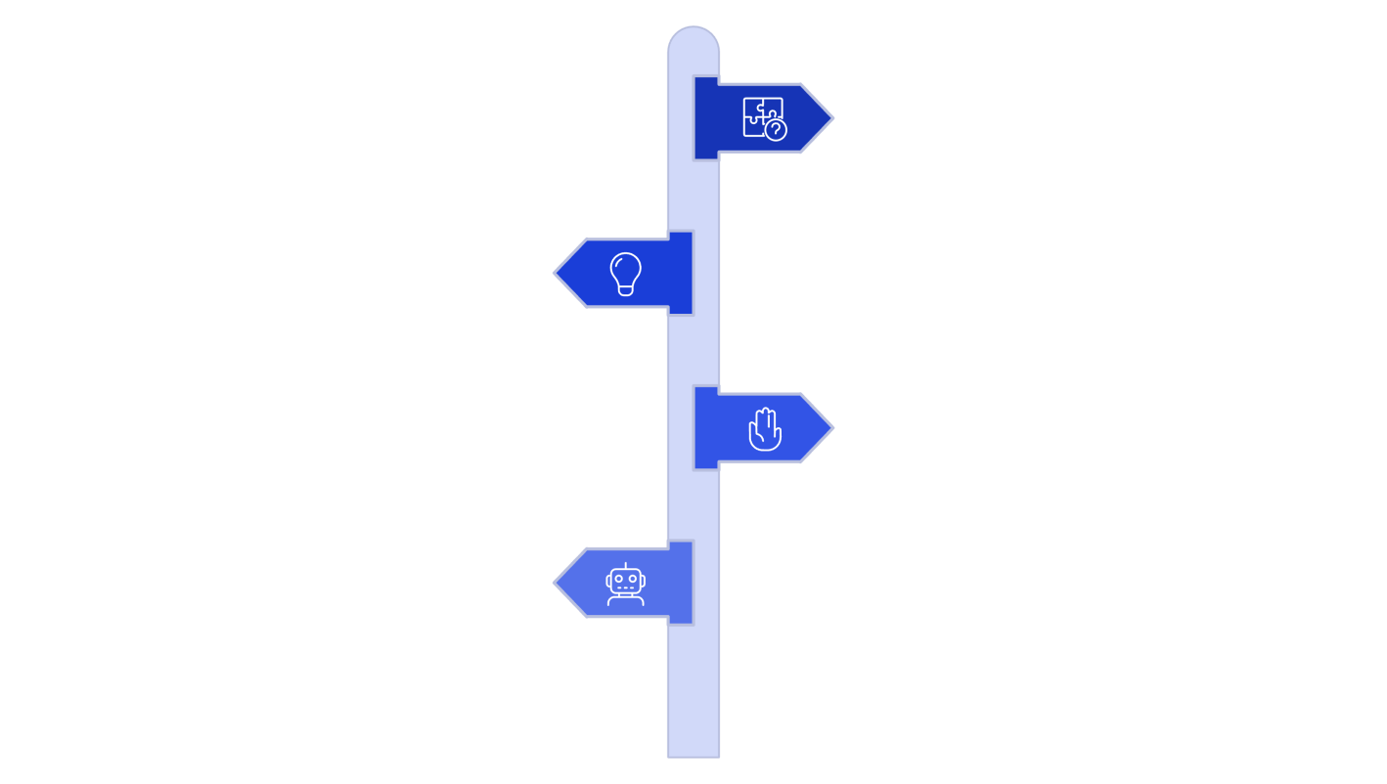
Problem
Define the core issue to solve.
Generate Ideas
Brainstorm low-risk to high-automation
options.
Manual Approach
Keep tasks created and assigned manually.
Task Automation
Automate task creation via rules or
scripts.

Each idea was captured with expected trade-offs. Flow Designer provides the most direct path to integrate Service Catalog triggers, approvals, and Catalog Task actions within ServiceNow's native workflow capabilities.

Exploring Automation Possibilities

Exploration focused on how to combine automated task creation and assignment with Service Catalog and approval logic to produce a cohesive solution.

Component | Role in Proposed Solution
Service Catalog | Provides the Standard Laptop catalog item and captures requested-item metadata.
Service Request (Requested Item) | Represents the user's order instance and stores details used by the flow.
Approval | Controls whether the request progresses to automation; approval state is a trigger guard.
Flow Designer | Automates the process: triggers on requested item state change and executes Create Catalog Task action.
Create Catalog Task action | Generates a Catalog Task record with short description and assignment.
Hardware | Assignment group that receives the configuration task for execution.
Service Catalog
Service Request
Approval
Flow Designer

This conceptual mapping clarifies data flow and integration points: the Requested Item record is the authoritative trigger; Flow Designer must read requested item fields and the approval result to populate Catalog Task fields and assignment.

Refining the Selected Concept

Refinement focused on operational details and how to convert the broad concept into actionable Flow Designer requirements and triggers.

Initial Idea | Refinement | Implementation Note
Automate task creation | Use Flow Designer Create Catalog Task action | Map Requested Item fields to Catalog Task attributes
Automate routing | Assign task to Hardware via assignment rules or flow | Use assignment group field —  To be validated
Connect request and task | Use Requested Item Record as flow trigger | Trigger on approval state transition
Track configuration | Catalog Task record for audit and traceability | Link Catalog Task to Requested Item
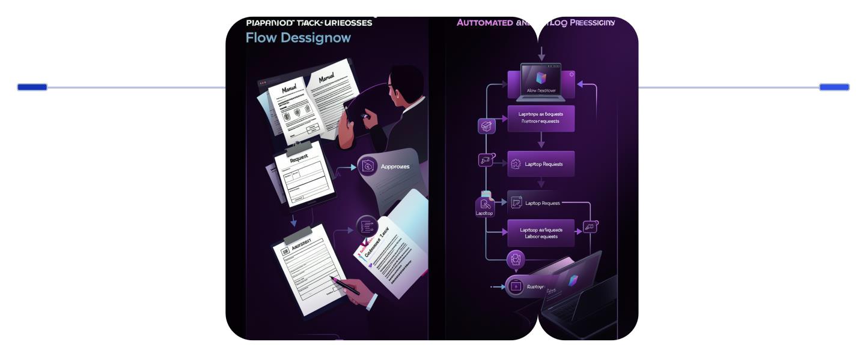
Before
Manual laptop requests and hand-configured assignments
After
Standard request with approvals and Flow Designer automation

Refinement identifies required data mappings (requested item → catalog task), trigger conditions (approval status = Approved), and assignment logic (explicit Hardware group mapping). These elements will feed the requirements specification in the next phase.

Initial Flow Designer Concept

This page specifies the proposed Flow Designer configuration at a conceptual level to support subsequent formal requirement documentation.

Configuration | Proposed Value / Notes
Flow Name | Standard Laptop Task Automation (Proposed)
Application | Global (or scoped under procurement app) — To be validated
Run As | System user (Proposed) — ensure least privileges documented
Trigger | Service Catalog Requested Item record state/approval change
Action | Create Catalog Task
Target Table | Catalog Task
Key Fields | Short Description: "Laptop need to Configured" (Proposed); Description: requested item details; Assignment Group: Hardware
Approval Condition | Approval = Approved (Flow proceeds)
Request
Trigger
Approval
Create Task

This flowchart represents the core technical sequence the Flow Designer implementation must realize. Field mappings, security context, and failure handling are identified as requirement items for the next phase.

Evaluation of Proposed Solution
Concepts

A qualitative comparison across the candidate ideas was performed using factors aligned to project objectives. No numerical scoring is assigned; descriptions provide comparative insight.

Evaluation Factor | Manual Process / Automated Task / Flow Designer Approach
Manual intervention | Manual: Required; Automated task: Reduced; Flow Designer: Reduced (Proposed)
Task creation | Manual: Manual; Automated task: Automated; Flow Designer: Automated and integrated
Assignment | Manual: Manual routing; Automated task: Can be automated; Flow Designer: Automated assignment to Hardware (Proposed)
Process consistency | Manual: Depends on user; Automated: Higher; Flow Designer: High  (Standardized)
Integration with  ServiceNow | Manual: Limited; Automated task: Possible; Flow Designer: Directly  aligned (Preferred)

Possible Ideas
Selected Concept
Compare Needs

Explanation: Flow Designer aligns directly with objectives by connecting the Service Catalog requested- item lifecycle to an automated Create Catalog Task action and explicit assignment. Therefore, it is selected as the preferred conceptual approach (Proposed Solution) pending formal requirements and validation.

