
Streamlining IT Procurement: Automating Standard Laptop
Orders with Flow Designer

Phase-7 -- PROJECT DOCUMENTATION PHASE

Date | 28.09.2026
Team Id | SWTID-2026-7568
Project Name | Streamlining IT Procurement: Automating Standard Laptop Orders with Flow Designer
Project Guide Name | Dr. K.KARPAGAM, M.Sc.,M.Phil.,Ph.D.

Team leader : Mutharasu R
Reg.No : 24CS3228

Team Members:

Name | Reg.No
Thangapandi Murugesh C | 24cs3250
Vignesh M | 24CS3255

PROJECT OVERVIEW

This project addresses a manual IT procurement process for standard laptops that produces delays, inconsistent configuration, and extended user waiting time. Manual handoffs lead to tasks being overlooked and inefficient use of hardware team resources. ServiceNow Flow Designer is employed to automate the transition from an approved catalog request to a Catalog Task assigned to the Hardware group, ensuring consistent task creation and timely configuration.
Problem
Manual and inefficient laptop procurement process causing delays and oversight.
Solution
ServiceNow Flow Designer automation to create and assign Catalog Tasks after approval.
Outcome
Faster, organized task processing with reduced manual intervention.

Project Element | Description
Problem | Manual and inefficient laptop procurement process
Proposed Solution | ServiceNow Flow Designer automation
Catalog Item | Standard Laptop
Automation | Standard Laptop Task
Main Trigger | Service Catalog
Main Action | Create Catalog Task
Assignment | Hardware
Expected Benefit | Faster and more organized task processing
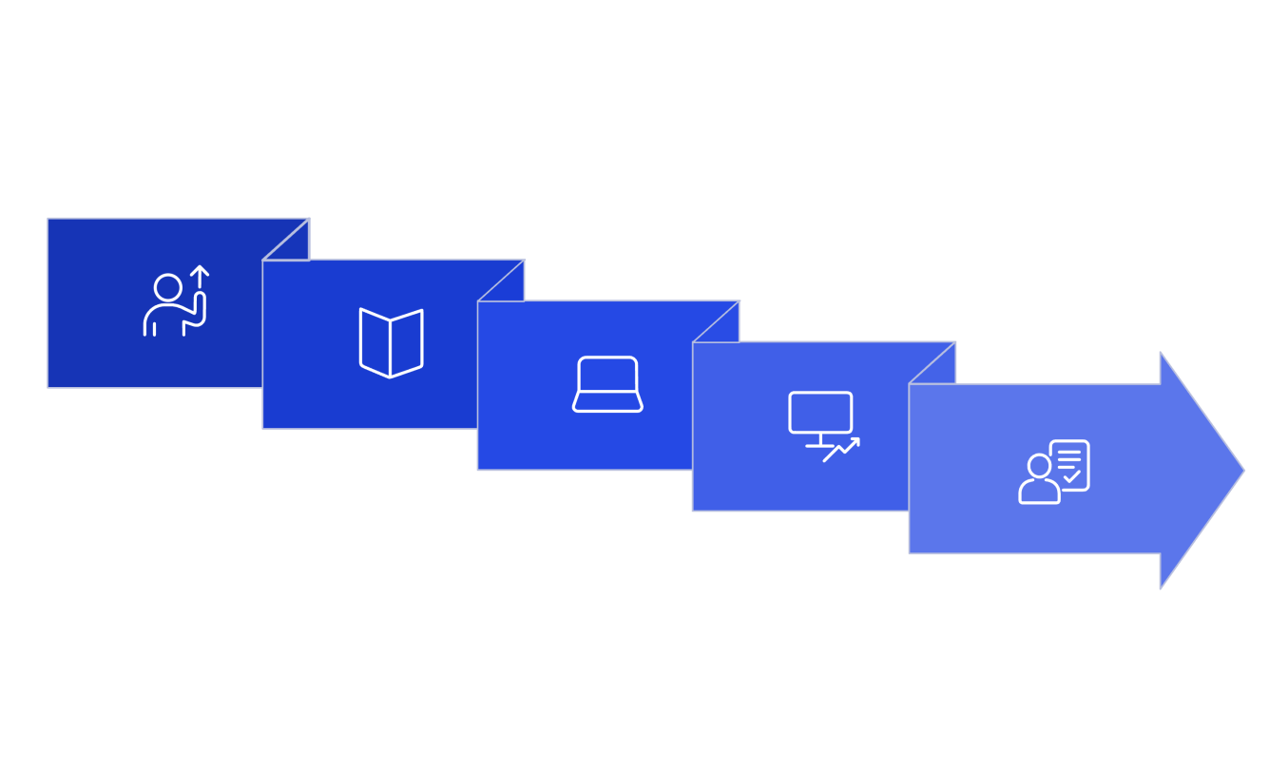
User Request
Standard Laptop
Create Task
Service Catalog
Approve &
Automate

PROBLEM STATEMENT AND
PROJECT OBJECTIVES

Problem Statement: The existing procurement workflow for standard laptops relies on manual actions and multiple human handoffs. Key failure modes include delays between request and configuration, occasional omission of configuration steps, inconsistent task creation, and overall user frustration.
Resource allocation is inefficient because work items are created ad hoc rather than through a controlled automation pipeline.

Project Objectives: This project documents a targeted automation to ensure consistent, timely laptop configuration after approval. Objectives include improving user experience, ensuring timely configuration, reducing manual interventions and errors, automating task allocation to Hardware, and improving overall operational productivity.

Objective | Documentation / Approach
Seamless experience | Service Catalog-based ordering
Timely configuration | Automated task creation via Flow Designer
Reduce manual work | Flow Designer triggers Create Catalog Task
Improve allocation | Assignment Group = Hardware
Reduce waiting | Automatic task generation after approval
Improve productivity | Structured automation and verification


Problem: Manual Workflow
Consequence: Delays & Oversight
Need: Automation Requirement
Solution: Flow Designer

PROJECT REQUIREMENTS
DOCUMENTATION

This section lists the functional requirements necessary to implement Standard Laptop procurement automation. Requirements maintain precise terminology used in the project: Platform ServiceNow; Flow Standard Laptop Task; Application Global; Run As System user; Trigger Service Catalog; Action Create Catalog Task; Request Item Required mapping to Requested Item Record; Table Catalog Task; fields Short Description and Description populated with 'Laptop need to Configured'; Assignment Group set to Hardware; Approval set to Approved.

Requireme nt ID | Requirement | Expected Behavior
FR-01 | Standard Laptop | User can request item
FR-02 | Ordering | Request is created
FR-03 | Approval | Request can be approved
FR-04 | Flow Trigger | Service Catalog starts flow
FR-05 | Task Creation | Catalog Task is generated
FR-06 | Task Description | Required text is populated
FR-07 | Assignment | Hardware receives task
FR-08 | Verification | Task can be checked
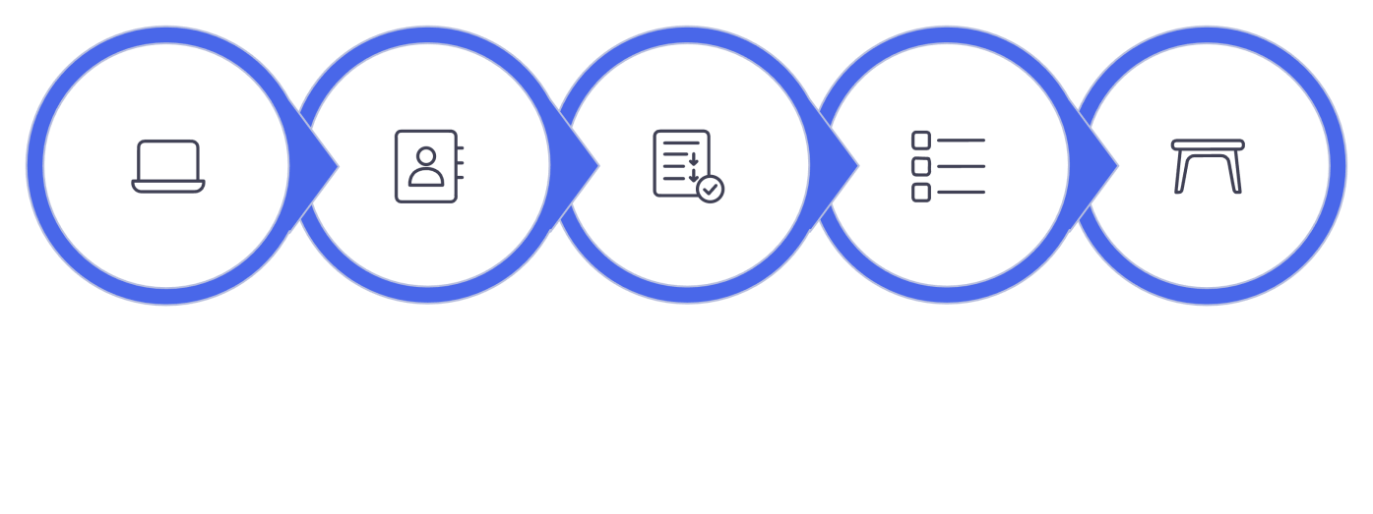
Standard
Laptop
Service
Catalog
Flow
Designer
Create
Catalog Task
Catalog Task
Table

PROJECT DESIGN
DOCUMENTATION

System design connects user interactions with ServiceNow components. A user submits a Standard Laptop request in the Service Catalog; a Requested Item record is created and subject to approval. Upon approval, Flow Designer triggers execution of the Standard Laptop Task flow (Application Global, Run As System user), which issues an action Create Catalog Task. The created Catalog Task is stored in the Catalog Task table and assigned to the Hardware assignment group for laptop configuration.

Component | Role
User | Initiates request via Service Catalog
Service Catalog | Provides ordering interface and trigger
Standard Laptop | Catalog Item representing product
Requested Item | Stores the request record
Approval | Controls approval stage
Flow Designer | Automates Create Catalog Task action
Catalog Task | Represents work in Catalog Task table
Hardware | Performs laptop configuration
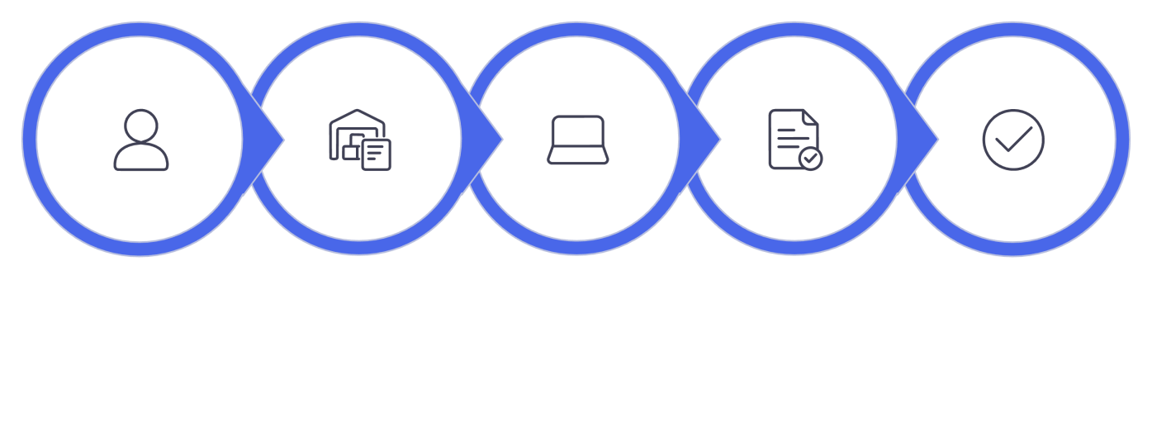
User
Service
Catalog
Standard
Laptop
Requested
Item
Approval

PROJECT PLANNING
DOCUMENTATION

Project planning covered scope definition, activity sequencing, milestone scheduling, resource allocation (roles for developer, approver, hardware technician), responsibilities, risk assessment, and testing strategy. Risks included misconfigured flow parameters and incorrect field mappings; mitigations included peer review and controlled environment testing. Testing planning specifies verification of field values and flow activation in a non-production instance prior to promotion.

Milestone | Activity / Expected Output
Milestone 1 | Flow created: Standard Laptop Task defined and saved
Milestone 2 | Flow assignment: Create Catalog Task configured with field mappings
Milestone 3 | Service Catalog integration: Standard Laptop linked to Process Engine; task verification completed


Project Plan
Create Flow
Assign Flow
Service Catalog

FLOW DESIGNER DEVELOPMENT
DOCUMENTATION

Development steps performed in ServiceNow to build the flow: Open ServiceNow, navigate to All → Flow Designer (Process Automation), create a new Flow, name it "Standard Laptop Task", set Application to Global, set Run As to System user, configure trigger and actions, and submit. The flow uses the Service Catalog trigger and a Create Catalog Task action mapping Request Item to the Requested Item Record.

Configuration | Value
Flow Name | Standard Laptop Task
Application | Global
Run As | System user
Trigger | Service Catalog
Action | Create Catalog Task
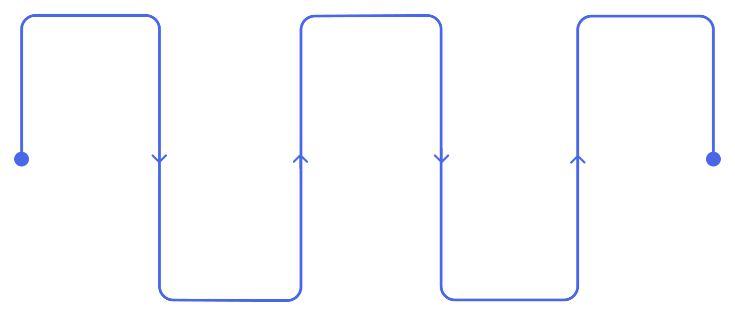
ServiceNow
Open the ServiceNow instance
New Flow
Create a new flow
Submit
Save and submit as Run As System user
Flow Designer
Navigate to All →
Flow Designer
Standard
Laptop Task
Name flow and set Application to Global

Each configuration item serves a purpose: Application=Global ensures the flow is available across the instance; Run As System user grants permissions required for creating Catalog Task records; accurate naming and consistent field mapping reduce operational errors.

SERVICE CATALOG TRIGGER AND
ACTION DOCUMENTATION

Trigger configuration: In Flow Designer, Add Trigger → Search "Service Catalog" → Select Service Catalog trigger → Configure matching catalog item or record conditions → Done. This trigger listens for Requested Item creation events related to the Standard Laptop catalog item and begins flow evaluation after approval status changes.

Action configuration: Add Action → Search "Create Catalog Task" → Select Create Catalog Task action. Configure the action to use Request Item = Requested Item Record and to write to the Catalog Task table. Populate Short Description and Description fields with 'Laptop need to Configured', set Assignment Group to Hardware, and set Approval to Approved as required by the project.

Configuration Value | Setting
Trigger | Service Catalog
Action | Create Catalog Task
Request Item | Requested Item Record
Table | Catalog Task

Service
Catalog
Catalog
Trigger
Requested
Item
Create Task
Catalog Task

CATALOG TASK CONFIGURATION
DOCUMENTATION

The Create Catalog Task action requires explicit mapping of fields to ensure the hardware team receives actionable work records. The project uses exact configured values to match source terminology and verification steps. Correct mapping prevents task creation errors and ensures consistent downstream processing for laptop configuration.

Field | Configured Value / Purpose
Short Description | Laptop need to Configured — Identifies task succinctly
Description | Laptop need to Configured — Describes required work
Assignment Group | Hardware — Sends task to Hardware
Approval | Approved — Approval condition recorded
Table | Catalog Task — Stores generated task
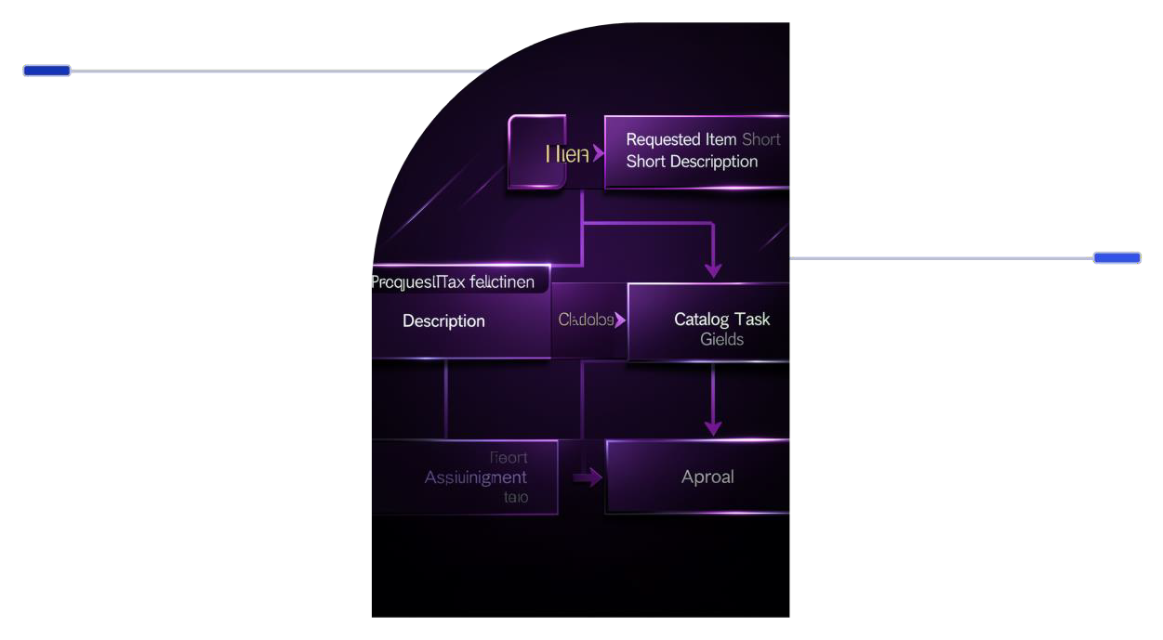
Create Catalog
Task
Map request item fields to task fields for hardware work.
Resulting
Catalog Task
Task populated with configured values for assignment and approval.

Each field mapping is essential: Request Item ensures context is retained, Short Description and Description provide task details, Assignment Group routes work to Hardware, and Approval documents that the prerequisite approval was satisfied.

PROCESS ENGINE AND CATALOG
ITEM DOCUMENTATION

Process Engine linkage attaches the developed flow to the Standard Laptop catalog item. Steps include All → Maintain Items → Search Standard Laptop → Open Standard Laptop → Open Process Engine configuration → Review existing automation → Add Standard Laptop Task flow association → Save. This ensures the catalog item invokes the configured flow when relevant triggers fire.

Step | Component / Documentation
1 | Maintain Items — Access catalog item configuration
2 | Standard Laptop — Select project catalog item
3 | Process Engine — Configure automation hook
4 | Standard Laptop Task — Add created flow to Process Engine
5 | Save — Store configuration

Maintain Items
Standard Laptop
Process Engine
Save

Linking via Process Engine guarantees that catalog item lifecycle events are observed and the Standard Laptop Task flow is invoked only for this catalog item context. This direct binding provides traceability between the item and automation.

