
Streamlining IT Procurement: Automating Standard Laptop
Orders with Flow Designer

Phase-8 --PROJECT DEMONSTRATION PHASE

Date | 28.09.2026
Team Id | SWTID-2026-7568
Project Name | Streamlining IT Procurement: Automating Standard Laptop Orders with Flow Designer
Project Guide Name | Dr. K.KARPAGAM, M.Sc.,M.Phil.,Ph.D.

Team leader : Mutharasu R
Reg.No : 24CS3228

Team Members:

Name | Reg.No
Thangapandi Murugesh C | 24cs3250
Vignesh M | 24CS3255

DEMONSTRATION OBJECTIVE AND
OVERVIEW

Objective: Validate the end-to-end connection between Service Catalog request actions and automated backend processing using Flow Designer. The demonstration must show traceability from the Service Catalog selection through request creation, approval, flow execution, Catalog Task generation, Hardware assignment, and final verification.

Demonstration Area | What Will Be Demonstrated
Catalog | Standard Laptop availability
Ordering | Order Now process
Request | Requested Item creation
Approval | Approval process
Automation | Flow Designer execution
Task Creation | Catalog Task generation
Task Details | Description and Short Description
Assignment | Hardware group
Verification | Final task details

USER
SERVICE
CATALOG
STANDARD
LAPTOP
ORDER
NOW
REQUESTE
D ITEM

DEMONSTRATION ENVIRONMENT

This page documents the technical environment and components required to perform the demonstration. It lists the ServiceNow features and project artifacts used during the live demonstration and clarifies their role in the end-to-end sequence.

Component | Demonstration Purpose
ServiceNow | Main demonstration environment
Service Catalog | Start request
Standard Laptop | Item being ordered
Requested Item | Request record
Approval | Approval stage
Flow Designer | Automation (Standard Laptop Task)
Catalog Task | Generated work task
Hardware | Task assignment

Flow Designer
Receives trigger and orchestrates actions.

Requested Item

Acts as the source record for the flow.

Hardware Assignment
Task assigned to the Hardware group.

Service Catalog
User initiates a catalog
request.

Catalog Task
Created and stored in the Catalog Task table.

Technical architecture notes: The flow is implemented in Application = Global, Run As = System user, Trigger = Service Catalog. The Create Catalog Task action writes to the Catalog Task table using fields Short Description = 'Laptop need to Configured' and Description = 'Laptop need to Configured', and sets Assignment Group = Hardware. Approval must be Approved before flow triggers.

DEMONSTRATION OF FLOW
CONFIGURATION

This section documents the Flow Designer configuration that implements the automation. It provides the step sequence to locate and verify the flow configuration prior to live execution.

- Open ServiceNow.
- Open All.
- Search Flow Designer.
- Open Flow Designer.
- Locate Standard Laptop Task.
- Open the flow.
- Verify Application = Global.
- Verify Run As = System user.
- Verify Service Catalog trigger.
- Verify Create Catalog Task action.
- Verify that the flow is active.

Configuration | Expected Value
Flow Name | Standard Laptop Task
Application | Global
Run As | System user
Trigger | Service Catalog
Action | Create Catalog Task
Status | Active

Standard
Laptop
Global App
System User
Catalog
Trigger
Create Task

SCREENSHOT PLACEHOLDER — Flow Designer showing Standard Laptop Task configuration

DEMONSTRATION OF SERVICE
CATALOG

This section documents the live steps to access and initiate a Standard Laptop request in the Service Catalog. The demonstrator should show the catalog hierarchy and the entry point used by end users.

- Open ServiceNow.
- Open Service Catalog.
- Open Hardware category.
- Locate Standard Laptop.
- Open Standard Laptop.
- Review the catalog item fields and options.
- Select Order Now.

Step | Demonstration Action | Expected Observation
1 | Open Service Catalog | Catalog is displayed
2 | Open Hardware | Hardware items shown
3 | Select Standard Laptop | Correct catalog item
4 | Review item | Standard Laptop details
5 | Select Order Now | Request process starts

Service
Catalog
Hardware
Standard
Laptop
Review Item
Order Now

SCREENSHOT PLACEHOLDER — Standard Laptop catalog item before selecting Order Now

DEMONSTRATION OF REQUEST
CREATION

After the user selects Order Now, a Requested Item record is created. This section explains how to locate the Request and the Requested Item and how to document the linkage between the user action and the backend records.

Key actions: open Order Status or Requests list, identify the Request Number, open the Requested Item record, and confirm the Requested Item references the Standard Laptop catalog item.

Demonstration Point | Expected Observation
Order Status | Request information available
Request Number | Unique request record
Requested Record | Request details available
Requested Item | Standard Laptop request
Approvers | Approval information available

Order Now
Request
Created
Order Status
Request
Number
Requested
Record

SCREENSHOT PLACEHOLDER — Request/Order Status showing the generated request

DEMONSTRATION OF APPROVAL

Approval must reach the Approved state before Flow Designer acts. This page documents the steps to review and effect approval and to verify that the Requested Item's approval field transitions to Approved.

- Open the Request (Requested Item).
- Locate the Approvers section.
- Open the relevant approval record.
- Review approval details (approver, timestamp, comments).
- Approve the request.
- Verify the approval state reads Approved on both the Approval record and Requested Item.

Demonstration Step | Expected Result
Open request | Correct request displayed
Open Approvers | Approval record available
Review approval | Correct request identified
Approve | Request becomes Approved
Verify state | Approved state displayed
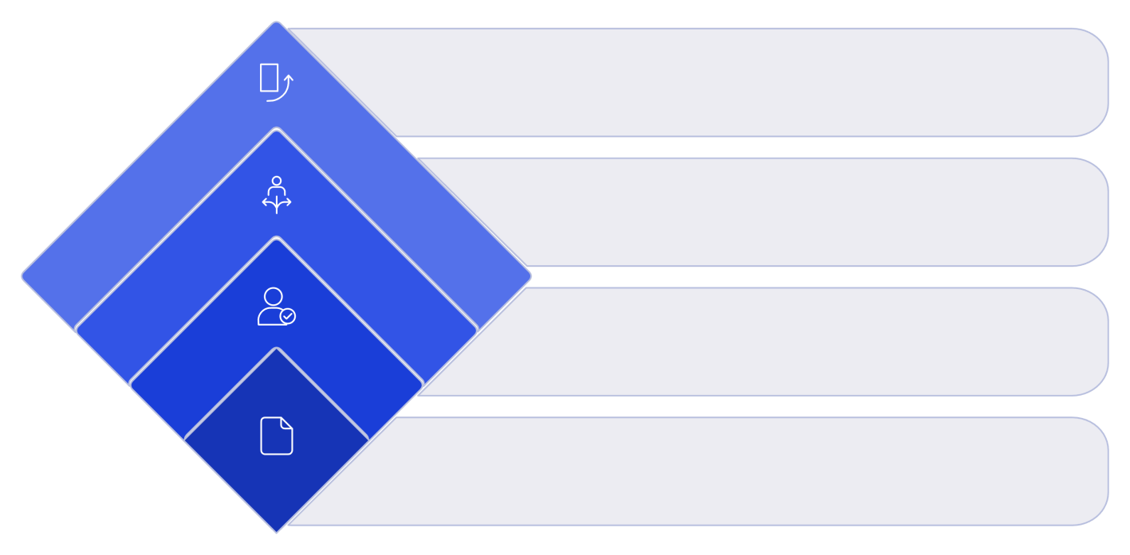
Outcome
No = pending, Yes = automate
Decision
Approved or needs action
Approvers
Review by assigned approvers
Request
Submit approval request

SCREENSHOT PLACEHOLDER — Approval record showing the approval action/state

DEMONSTRATION OF FLOW
EXECUTION

This page explains how the Approved Requested Item triggers the Flow Designer configuration. The flow should read the Requested Item record and execute the Create Catalog Task action.

Flow Stage | Demonstration Point
Trigger | Service Catalog trigger receives Approved Requested Item
Flow | Standard Laptop Task runs
Input | Requested Item Record
Action | Create Catalog Task
Output | Catalog Task record

Approved Request
Service Catalog Trigger
Standard Laptop Task
Create Catalog Task

Verification points: confirm Requested Item is the input object to the flow, confirm the Create Catalog Task action maps fields Short Description and Description to the literal value 'Laptop need to Configured', and confirm Assignment Group is set to Hardware. The flow context must indicate Application = Global and Run As = System user.

SCREENSHOT PLACEHOLDER — Flow Designer execution/configuration related to the Standard Laptop request

DEMONSTRATION OF CATALOG
TASK CREATION

The primary automation output is the Catalog Task record. This section details how the Create Catalog Task action produces a Catalog Task and how demonstrators should validate its presence and contents.

Task Creation Element | Demonstration Value
Action | Create Catalog Task
Input | Requested Item Record
Table | Catalog Task
Short Description | Laptop need to Configured
Description | Laptop need to Configured
Assignment Group | Hardware
Approval | Approved

Requested Item
Create Catalog Task
Catalog Task

SCREENSHOT PLACEHOLDER — Generated Catalog Task record

DEMONSTRATION OF CATALOG TASK
DETAILS

This page instructs the demonstrator how to validate the critical fields on the created Catalog Task. Each field must be checked for exact phrasing, table membership, and assignment.

Fields to verify precisely:

- Short Description = Laptop need to Configured
- Description = Laptop need to Configured
- Assignment Group = Hardware
- Approval = Approved
- Record table = Catalog Task

Field | Expected Value | Demonstration Check
Short Description | Laptop need to Configured | Check exact text
Description | Laptop need to Configured | Check exact text
Assignment Group | Hardware | Check assignment
Approval | Approved | Check approval
Table | Catalog Task | Confirm record type

Task Record
Description
Short Description
Assignment
Group
Approval

SCREENSHOT PLACEHOLDER — Catalog Task showing Short Description and Description

