Streamlining IT Procurement: Automating Standard Laptop
Orders with Flow Designer

Phase-6 -- PROJECT TESTING PHASE

Date | 29/09/2026
Team Id | SWTID-2026-1683
Project Name | Streamlining IT Procurement: Automating Standard Laptop Orders with Flow Designer.
Project Guide Name | Dr. K.KARPAGAM, M.Sc.,M.Phil.,Ph.D.

Team Leader : ARUNACHALAM MJ

Reg.No : 24CS3204

Team Members:

Name | Reg.No
KUMARAN K | 24CS3219
RAGHAVAN S | 24CS3235
SANTHAKUMAR G | 24CS3243

INTRODUCTION TO PROJECT
TESTING

Meaning of testing: Systematic evaluation of configured components and automated behaviors to confirm correctness and fitness for purpose. Purpose of testing: to verify that the developed automation converts an approved Standard Laptop request into a correctly populated Catalog Task assigned to the Hardware group.

Why testing is required after development: configuration errors, incorrect mappings, or inactive flows are common risks. Testing verifies configured components, detects configuration errors, validates workflow behavior, and checks that outputs match the functional specification.

Testing Area | Purpose
Catalog Testing | Verify Standard Laptop request
Request Testing | Verify Requested Item
Approval Testing | Verify approval process
Flow Testing | Verify Flow Designer execution
Action Testing | Verify Create Catalog Task
Field Testing | Verify task information
Assignment Testing | Verify Hardware assignment
Final Testing | Verify complete process
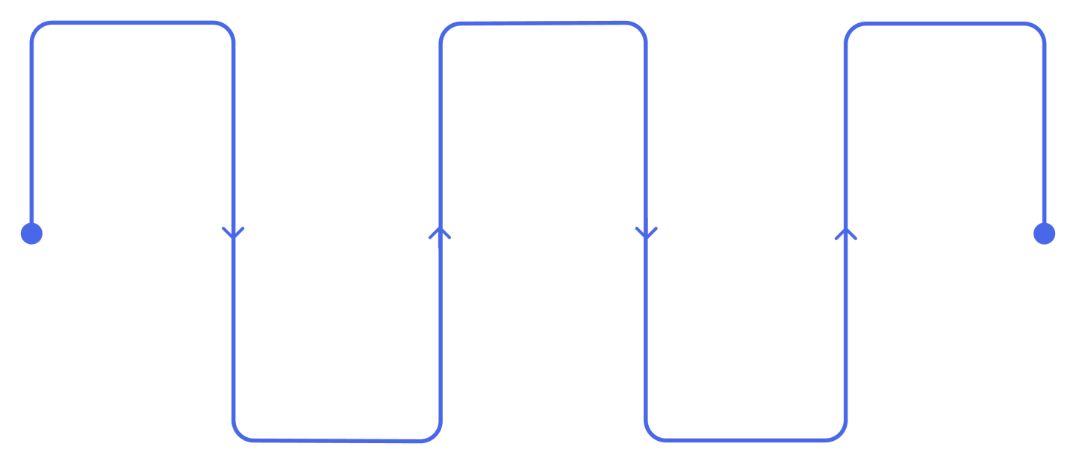
Plan Test
Define scope and cases
Verify Result
Confirm expected outcomes
Correct
Apply fixes and updates
Execute Test
Run cases against
system
Identify Issue
Log deviations
and defects

TESTING OBJECTIVES

This section enumerates precise objectives used to guide test design and acceptance criteria. Objectives emphasize traceability from user request to final Catalog Task record and ensure values conform to the exact project configuration.

- Verify that Standard Laptop can be ordered.
- Verify that the Requested Item is created.
- Verify that approval information is available.
- Verify that the approved request reaches the automation process.
- Verify that the Service Catalog trigger works.
- Verify that Create Catalog Task executes.
- Verify that Requested Item Record is correctly used.
- Verify that the Catalog Task is created.
- Verify Short Description.
- Verify Description.
- Verify Assignment Group = Hardware.
- Verify the task can be viewed from the Requested Item.
- Verify the complete workflow.

Objective ID | Testing Objective | Expected Verification
TO-01 | Standard Laptop request | Request created
TO-02 | Requested Item | Correct record exists
TO-03 | Approval | Approval state verified
TO-04 | Flow execution | Flow processes request
TO-05 | Catalog Task | Task is created
TO-06 | Task fields | Values are correct
TO-07 | Hardware assignment | Hardware group is assigned
TO-08 | Final verification | Complete process works

TESTING SCOPE

Define explicit inclusions and exclusions to constrain the testing effort. Tests are limited to the delivered ServiceNow components and behaviors described in the source project and prior phases.

In Scope

  - Standard Laptop Service Catalog item
  - Order Now process
  - Requested Item
  - Approval
  - Flow Designer
  - Service Catalog trigger
  - Create Catalog Task action
  - Requested Item Record mapping
  - Short Description and Description fields
  - Hardware assignment and Catalog Task
  - Process Engine connection
  - Final verification

Out of Scope

The project explicitly excludes interfaces and subsystems not present in the source scope.

  - External payment systems
  - External delivery systems
  - Advanced inventory systems
  - Other hardware categories
  - External third-party applications

Testing Area | In Scope | Out of Scope
Standard Laptop | ✓ | —
Service Catalog | ✓ | —
Flow Designer | ✓ | —
Catalog Task | ✓ | —
Hardware Assignment | ✓ | —
Approval | ✓ | —
External Payment | — | ✓
External Delivery | — | ✓
Other Hardware | — | ✓

TESTING ENVIRONMENT AND
COMPONENTS

This section enumerates the system components and their roles in testing. All testing occurs on the ServiceNow test instance described in the project planning phase.

  - ServiceNow — Test environment (platform for all verification).
  - Service Catalog — Mechanism to place a Standard Laptop request.
  - Standard Laptop — Catalog item under test.
  - Requested Item — Record created by the Service Catalog request.
  - Approval — Approval stage that must reach Approved.
  - Flow Designer — Automation: Flow Name = Standard Laptop Task.
  - Create Catalog Task — Action executed by the flow.
  - Catalog Task — Output record to be assigned to Hardware.
  - Hardware — Assignment group receiving the task.

Component | Testing Purpose
ServiceNow | Test environment
Service Catalog | Request testing
Standard Laptop | Catalog item testing
Requested Item | Request record verification
Approval | Approval verification
Flow Designer | Automation verification
Standard Laptop Task | Flow verification
Create Catalog Task | Task generation verification
Catalog Task | Output verification
Hardware | Assignment verification

Service Catalog
Standard Laptop
Requested Item
Approval

TEST CASE DESIGN

A test case is a discrete procedure combining inputs, execution steps, and expected results. Test cases in this project map directly to objectives and cover each stage of the workflow from catalog selection to task verification.

Test Case ID | Test Case | Input/Action | Expected Result
TC-01 | Open Standard Laptop | Open Service Catalog | Standard Laptop available
TC-02 | Select item | Select Standard Laptop | Item opens
TC-03 | Place order | Click Order Now | Request created
TC-04 | Check Requested Item | Open request | Requested Item available
TC-05 | Check approval | Open Approvers | Approval information available
TC-06 | Approve request | Approve request | Request becomes approved
TC-07 | Check flow | Review automation | Flow executes
TC-08 | Create task | Flow processes request | Catalog Task created
TC-09 | Check short description | Open Catalog Task | Correct text appears
TC-10 | Check description | Open Catalog Task | Correct text appears
TC-11 | Check assignment | Open Catalog Task | Hardware assigned
TC-12 | Final verification | Review task | Expected configuration confirmed

Each test case compares the expected result with the system's actual output. Testers must record actual results, raise defects for discrepancies, and follow the retest cycle until expected behavior is achieved.

SERVICE CATALOG TESTING

Service Catalog testing verifies that users can initiate the Standard Laptop order and that a Requested Item record is created with appropriate metadata. Tests are exploratory and procedural to ensure traceability.

Step | Action | Expected Result
1 | Open Service Catalog | Catalog available
2 | Open Hardware | Hardware catalog options shown
3 | Select Standard Laptop | Correct item opened
4 | Order Now | Request generated
5 | Open Order Status | Request status available
6 | Open Request Number | Request record opens
7 | Open Requested Record | Requested Item available
8 | Check Approvers | Approval information shown

Service Catalog
Hardware
Standard Laptop
Order Now

APPROVAL TESTING

Approval testing ensures that the requested record contains approver entries and that the approval action transitions the Requested Item to an Approved state recognized by subsequent automation triggers.

Test | Action | Expected Result
AT-01 | Open request | Request record available
AT-02 | Open Approvers | Approval record visible
AT-03 | Review approval | Correct request identified
AT-04 | Approve request | Approval becomes Approved
AT-05 | Continue process | Automation can be verified
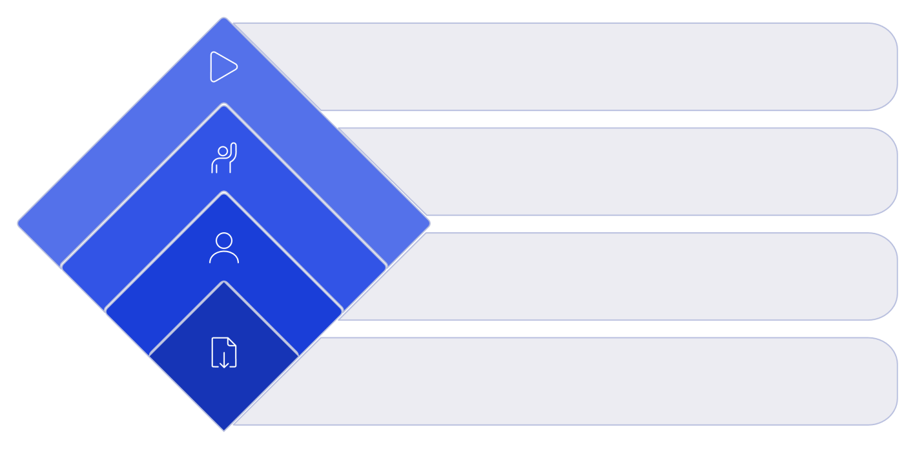
Continue Testing
Trigger automation on YES
Approved?
Decision: yes or no
Assign Approvers
Route to designated approvers
Submit Request
Initiate approval request

Rationale: Approval verification is essential because the Flow Designer trigger is dependent on the approval state. Proceeding to task creation without confirmed approval invalidates the acceptance criteria.

FLOW DESIGNER TESTING

Flow Designer testing confirms that the automation artifact is present, correctly configured, and active. Tests examine metadata and runtime behavior associated with the flow named Standard Laptop Task.

Flow Configuration | Expected Value | Verification
Flow Name | Standard Laptop Task | Checked
Application | Global | Checked
Run As | System user | Checked
Trigger | Service Catalog | Checked
Action | Create Catalog Task | Checked
Flow Status | Active | Checked
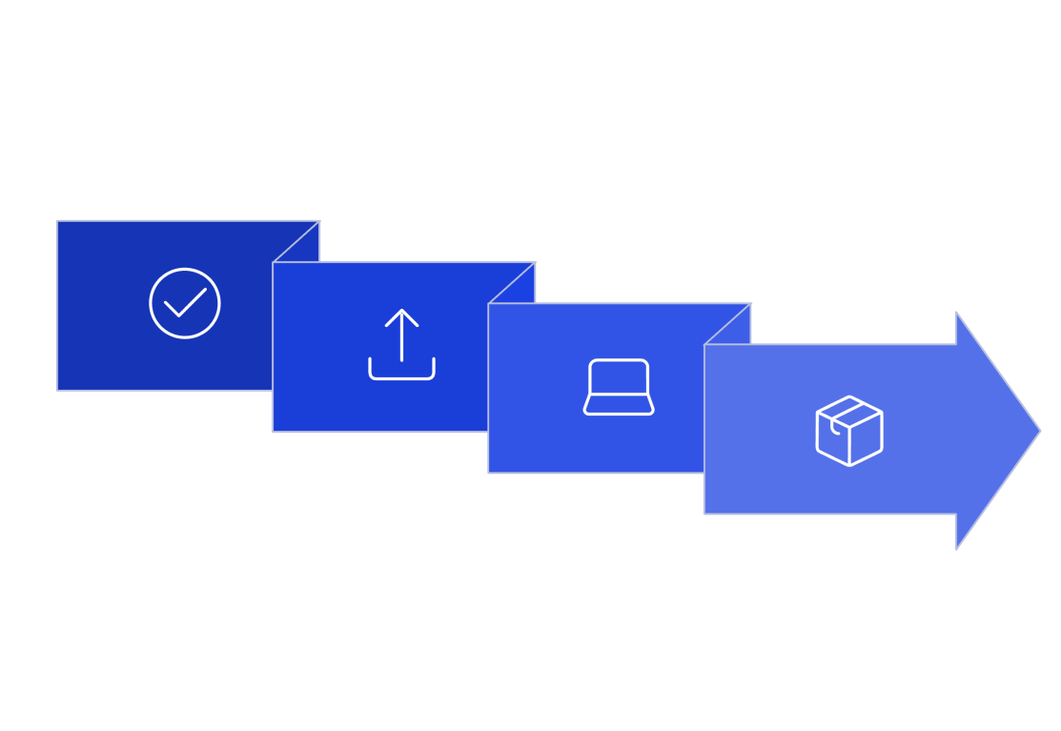
Service Catalog
Trigger
Create Catalog Task
Approved Request
Standard Laptop
Task

This test verifies the connection between the approved request and the automation; it includes a dry- run check of flow execution logs and audit entries to confirm the Create Catalog Task action is invoked.

CATALOG TASK TESTING

Catalog Task testing validates the output record created by the flow. Field-level verification ensures compliance with the project configuration and supports downstream operational processing by the Hardware group.

Field | Expected Value | Verification
Short Description | Laptop need to Configured | Pass if exact value is shown
Description | Laptop need to Configured | Pass if exact value is shown
Assignment Group | Hardware | Pass if Hardware is assigned
Approval | Approved | Pass if approved state is  shown
Table | Catalog Task | Pass if task is Catalog Task

Catalog Task
Main record that branches to specific fields for validation.
Short
Description
Validate concise summary for routing and search.
Description
Ensure detailed info supports Hardware processing.
Assignment
Group
Confirm correct group for downstream handling.

Field-level testing is necessary to ensure the automation mapping is correct and that Hardware receives actionable information. Exact-match checks are required for Short Description and Description per project configuration.

