Improving IT Procurement: Automating Standard Laptop Orders
Using Flow Designer

Phase-1 -- BRAINSTORMING & IDEATION PHASE

Date | 27-09-2026
Team Id | SWTID-2026-1982
Project Name | Streamlining IT Procurement: Automating Standard Laptop Orders with Flow Designer
Project Guide Name | Karpagam K

Team Members:

Name | Reg.No
VEERARAJA V | 24CS3252
ASWIN V | 24CS3205
AYYAPPAN G | 24CS3206
KUMARAN D | 24CS3218
NANTHAKUMAR S | 24CS3230

BRAINSTORMING & IDEATION
PHASE

Project: Improving IT Procurement: Automating Standard Laptop Orders with Flow Designer

Project Phase: Brainstorming & Ideation. Platform: ServiceNow. Technology: Flow Designer. Process Area: IT Procurement. Main Use Case: Standard Laptop Ordering. Academic Project.

This document describes the Brainstorming & Ideation Phase of an academic project focused on using ServiceNow Flow Designer to automate the Standard Laptop procurement process. The purpose of this phase is to understand the main issues in the existing procurement lifecycle, develop possible solutions, compare the alternatives, and identify an automation concept that can be taken forward into detailed requirements and later development phases.

Problem Definition
Manual handling of Standard Laptop requests can lead to delays and missed steps.

Brainstorming
Develop ideas ranging from manual methods to semi-automated and fully automated approaches.

Evaluation
Check compatibility with ServiceNow and practical operational feasibility.

Selected Solution
Use Flow Designer to create a Catalog Task and assign it to the Hardware team.



Short introduction: The project focuses on reducing inefficient manual work in Standard Laptop ordering by designing a Flow Designer automation that connects Service Catalog requests and approvals with Catalog Task creation and assignment to the Hardware group.

Understanding the Current IT Procurement Problem
The existing IT procurement process for Standard Laptop orders depends on several manual steps: a Service Request is submitted, approvals are completed, and configuration tasks are then created and routed by people. If task creation or assignment is missed or delayed, the following activities can be held up. This inefficiency can increase user waiting time and administrative work for both the IT procurement and Hardware teams.

- Manual involvement
- Late task creation
- Dependence on configuration
- Problems with task assignment
- User waiting period
- Use of resources
- Inefficient process

Existing Challenge | Effect on Process
Manual task creation  Manual task creation | More administrative work — Configuration may be missed (Proposed)
Configuration dependency | Configuration may start late — To be validated
Manual assignment | Task may not reach the right team promptly — Ideation observation
Limited automation | Greater human involvement required — Targeted by the proposed solution
Delayed configuration | Increased user waiting time — Expected

Laptop Request
Configuration Req
Possible Delay
Approval
Manual Activities

The diagram above shows how a Standard Laptop request moves through the process and where manual activities can introduce a risk of
delay. This analysis supports the need to improve the process through automation.

Identifying the Core Problem

During brainstorming, the main issue was summarized into a clear statement that guides the idea-generation process and the criteria used for evaluation.

Main Problem Statement

“The existing IT procurement process is not sufficiently efficient or automated, especially for Standard Laptop orders. Configuration work may still depend on manual attention, which can result in missed steps, delays, and extra administrative effort.”

- A user needs a Standard Laptop.
- A Service Request is submitted through the Service Catalog.
- The submitted request goes through an approval step.
- After approval, configuration work is needed.
- The configuration task needs to be assigned to the Hardware team.
- Manual processing can result in delays or missed activities.


Inefficient Procurement
Manual Activities
Process Delays
Resource Issues
User Experience

The Problem Tree above breaks the issue into causes and resulting impacts, helping define solution requirements such as automatic Catalog Task creation and dependable assignment rules.

Understanding the User Need

The brainstorming phase focused on the needs identified from IT procurement stakeholders. These needs were used to guide solution ideas and define success criteria for the proposed automation.

User Need | Description / Expected Benefit
Simple laptop ordering  Easy laptop ordering | Standard Laptop should be requested through the catalog —  Simplified request process (Expected)
Automatic task generation  Automatic task generation | Configuration task should be generated automatically — Reduced manual work (Proposed)  Configuration task should be created automatically — Less manual work (Proposed)
Correct assignment  Correct assignment | Task should be routed to Hardware — Improved resource use (To be validated)  Task should reach Hardware team — Better resource allocation (To be validated)
Timely configuration  Timely configuration | Configuration should start without unnecessary delay — Less waiting (Expected)  Configuration should begin promptly — Reduced waiting (Expected)
Improved visibility  Better visibility | Request and task should remain traceable — Better process understanding (Proposed)  Request and task should be traceable — Improved process understanding (Proposed)

“As an IT procurement team member, I want Standard Laptop requests to automatically generate
configuration tasks and assign them to the Hardware team after approval, so that laptop
configuration can begin promptly with less manual intervention.”


User Request
Approval
Auto Config Task
Hardware Team

This user story provides the basis for acceptance criteria: after approval, the Requested Item should trigger the automation, create a Catalog Task assigned to Hardware, and maintain traceability within the CMDB/Requested Item context.

Objectives Identified During
Brainstorming

The brainstorming session converted stakeholder needs into clear objectives that the proposed automation is expected to achieve.

- Provide a smooth Standard Laptop ordering experience.
- Enable laptop configuration to begin on time after approval.
- Minimize manual work and the chance of human error.
- Use resources more effectively through correct assignment to Hardware.
- Improve procurement efficiency and overall productivity.
- Improve traceability and visibility across the process.

Objective | Problem Addressed | Expected Direction
Smooth ordering | Complex/manual process | Simplify
Timely configuration | Configuration delays | Automate task creation
Reduce manual work | Administrative overhead | Use Flow Designer
Correct assignment | Manual routing | Assign to Hardware
Improved productivity | Repetitive activities | Automate

Automation Efficiency
1
2
6
3
5
4

Productivity Accuracy

User Experience Resource Utilization

These objectives provide the evaluation framework for comparing the possible solution ideas later.

Brainstorming Possible Solutions

Several possible approaches were identified and briefly described. The purpose was to consider options ranging from low automation to higher automation for qualitative comparison.

- Idea 1 — Manual task creation: Continue manual creation and assignment; familiar but retains
process risk and human error.
- Idea 2 — Automated task creation: Automatically create a Catalog Task from the Requested Item once approval is completed.
- Idea 3 — Automatic assignment: Route the generated Catalog Task to the Hardware group through assignment rules.
- Idea 4 — Flow-based automation: Use ServiceNow Flow Designer to connect the approval result with the Create Catalog Task and assignment actions.

Idea | Main Concept | Automation Potential
Manual task creation | Create task manually | Low
Automatic task creation | Generate task automatically | High
Automatic assignment | Route to Hardware | High
Flow Designer | Connect process steps | High
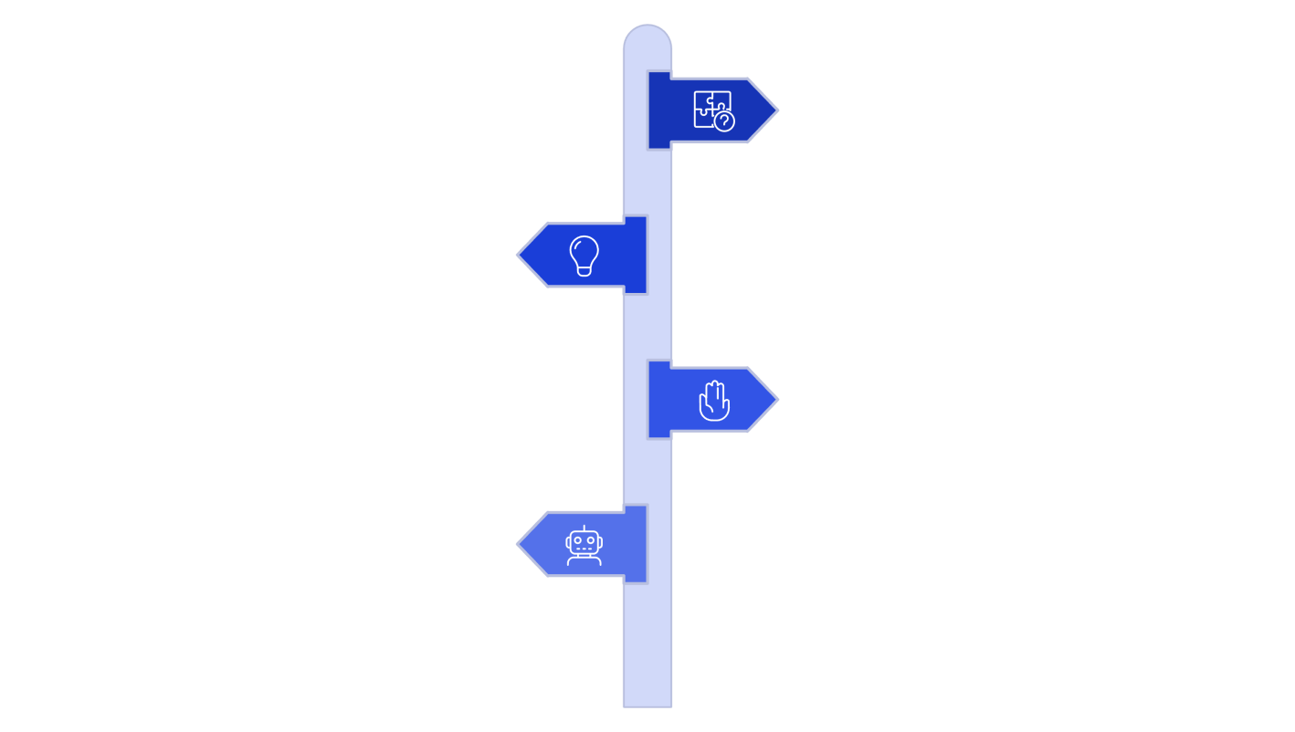
Problem
Define the core issue to solve.
Generate Ideas
Brainstorm low-risk to high-automation
options.
Manual Approach
Keep tasks created and assigned manually.
Task Automation
Automate task creation via rules or
scripts.

Each idea was recorded along with its expected trade-offs. Flow Designer offers a direct way to connect Service Catalog triggers, approval steps, and Catalog Task actions using ServiceNow's native workflow capabilities.

Exploring Automation Options

The exploration examined how automated task creation and assignment could work together with Service Catalog and approval logic to form one consistent solution.

Component | Role in Proposed Solution
Service Catalog  Service Catalog | Provides the Standard Laptop catalog item and records Requested Item information.  Provides the Standard Laptop catalog item and captures requested-item metadata.
Service Request (Requested Item)  Service Request (Requested Item) | Represents the user's order and stores the details required by the flow.  Represents the user's order instance and stores details used by the flow.
Approval  Approval | Determines whether the request can proceed to automation; approval status acts as the trigger condition.  Controls whether the request progresses to automation; approval state is a trigger guard.
Flow Designer  Flow Designer | Automates the workflow by responding to the Requested Item state change and running the Create Catalog Task action.  Automates the process: triggers on requested item state change and executes Create Catalog Task action.
Create Catalog Task action  Create Catalog Task action | Creates a Catalog Task record containing the short description and assignment details.  Generates a Catalog Task record with short description and assignment.
Hardware  Hardware | The assignment group responsible for carrying out the configuration task.  Assignment group that receives the configuration task for execution.
Service Catalog
Service Request
Approval
Flow Designer

This conceptual mapping explains the data flow and integration points: the Requested Item acts as the main trigger, while Flow Designer must use the Requested Item fields and approval result to populate the Catalog Task details and assignment.

Refining the Selected Concept

The refinement stage concentrated on operational details and on converting the overall idea into specific Flow Designer requirements and trigger conditions.

Initial Idea | Refinement | Implementation Note
Automate task creation  Automate task creation | Use the Flow Designer Create Catalog Task action  Use Flow Designer Create Catalog Task action | Map Requested Item fields to Catalog Task fields  Map Requested Item fields to Catalog Task attributes
Automate routing  Automate routing | Route the task to Hardware through assignment rules or the flow  Assign task to Hardware via assignment rules or flow | Use assignment group field —  To be validated
Connect request and task  Connect request and task | Use the Requested Item record as the flow trigger  Use Requested Item Record as flow trigger | Trigger when the approval state changes  Trigger on approval state transition
Track configuration  Track configuration | Use the Catalog Task record for audit and traceability  Catalog Task record for audit and traceability | Link the Catalog Task to the Requested Item  Link Catalog Task to Requested Item
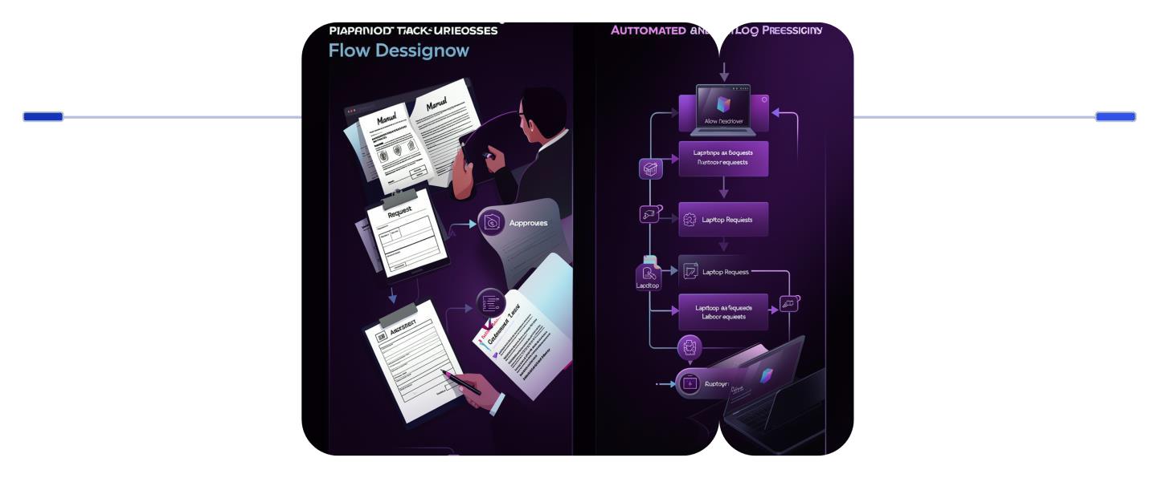
Before
Manual laptop requests and hand-configured assignments
After
Standard request with approvals and Flow Designer automation

The refinement defines the necessary data mapping from Requested Item to Catalog Task, the trigger condition of approval status = Approved, and the assignment rule that maps the task to the Hardware group. These details will support the requirements specification in the next phase.

Initial Flow Designer Concept

This section describes the proposed Flow Designer configuration at a conceptual level so it can support the formal requirements documentation that follows.

Configuration | Proposed Value / Notes
Flow Name | Standard Laptop Task Automation (Proposed)
Application  Application | Global (or scoped within the procurement app) — To be validated  Global (or scoped under procurement app) — To be validated
Run As  Run As | System user (Proposed) — document least-privilege access  System user (Proposed) — ensure least privileges documented
Trigger  Trigger | Service Catalog Requested Item state or approval change  Service Catalog Requested Item record state/approval change
Action | Create Catalog Task
Target Table | Catalog Task
Key Fields  Key Fields | Short Description: "Laptop needs to be configured" (Proposed); Description: Requested Item details; Assignment Group: Hardware  Short Description: "Laptop need to Configured" (Proposed); Description: requested item details; Assignment Group: Hardware
Approval Condition | Approval = Approved (flow continues)
Request
Trigger
Approval
Create Task

This flowchart shows the main technical sequence that the Flow Designer implementation should perform. Field mappings, security settings, and failure handling are listed as requirements to be addressed in the next phase.

Evaluation of Proposed Solution Concepts
Concepts

The candidate ideas were qualitatively compared using factors connected to the project objectives. No numerical scores were used; the descriptions are intended to show the differences between the approaches.

Evaluation Factor | Manual Process / Automated Task / Flow Designer Approach
Manual involvement  Manual intervention | Manual: Required; Automated task: Reduced; Flow Designer: Reduced (Proposed)  Manual: Required; Automated task: Reduced; Flow Designer: Reduced (Proposed)
Task creation  Task creation | Manual: Manual; Automated task: Automated; Flow Designer: Automated and integrated  Manual: Manual; Automated task: Automated; Flow Designer: Automated and integrated
Assignment  Assignment | Manual: Manual routing; Automated task: Can be automated; Flow Designer: Automated assignment to Hardware (Proposed)  Manual: Manual routing; Automated task: Can be automated; Flow Designer: Automated assignment to Hardware (Proposed)
Process consistency  Process consistency | Manual: Depends on user; Automated: Higher; Flow Designer: High (Standardized)  Manual: Depends on user; Automated: Higher; Flow Designer: High  (Standardized)
Integration with  ServiceNow  Integration with  ServiceNow | Manual: Limited; Automated task: Possible; Flow Designer: Directly aligned with ServiceNow  Manual: Limited; Automated task: Possible; Flow Designer: Directly  aligned (Preferred)

Possible Ideas
Selected Concept
Compare Needs

Explanation: Flow Designer matches the project objectives by linking the Service Catalog Requested Item lifecycle with an automated Create Catalog Task action and explicit assignment. It is therefore identified as the proposed conceptual approach, subject to formal requirements and validation.

