Agentic-AI project report

Topic:- Social Media Strategy Planner — A Multi-Agent AI System for Automated Campaign Intelligence

Group Members:-

Harshal Jhunghare (103)
Shubham Dhapodkar (104)

Github:- https://github.com/24jungharehm-dev/OE16.git

Live Demo:- https://2u78cyfgdweeqt78sqjpyb.streamlit.app/

Date:- 24/04/2026

Semester:- 4th [B.tech-A]

1. Problem Statement
PROBLEM: In today’s digital ecosystem, businesses rely heavily on social media platforms to build brand presence, engage audiences, and drive conversions. However, social media planning remains largely manual, time-consuming, and inconsistent. Marketing teams often struggle to generate trend-aligned ideas, create high-quality platform-specific content, design optimized posting schedules, and systematically review content effectiveness before publishing. This leads to inefficiencies, inconsistent messaging, and reduced campaign impact.
SOLUTION: To address this challenge, we developed a Social Media Strategy Planner, an end-to-end multi-agent AI system that automates strategy creation, content generation, scheduling, and quality evaluation in a structured workflow. An agentic approach is suitable because the problem naturally decomposes into multiple specialized tasks that can be handled by distinct agents collaborating in a pipeline.

Task Decomposition & Specifications
The Social Media Strategy Planner is designed as a multi-agent system where each agent is responsible for a specific sub-task. The workflow begins when the user provides input such as business type, target audience, niche, and preferred social media platform.
The first stage involves trend discovery. The Trend Agent analyzes the business niche and identifies trending topics, campaign angles, and relevant hashtags. Its input consists of business context and platform selection, and its output is a structured list of content ideas and trend directions.
The second stage is content generation. The Content Agent receives trend insights and generates platform-specific captions, calls-to-action (CTAs), and hashtag sets. It ensures tone consistency and relevance to the brand’s audience.
The third stage focuses on scheduling. The Scheduler Agent analyzes platform best practices and proposes an optimized weekly posting plan, including suggested posting days and time slots.
The fourth stage is evaluation. The LLM-as-Judge evaluates generated content using a predefined rubric. It scores content based on clarity, engagement potential, CTA strength, brand alignment, and readability. It then provides improvement suggestions.
Decision points exist at each stage where outputs are structured and passed forward in the pipeline. The final output presented to the user includes trending topics, generated posts, posting schedule, and evaluation feedback.

Architecture Diagram & System Design
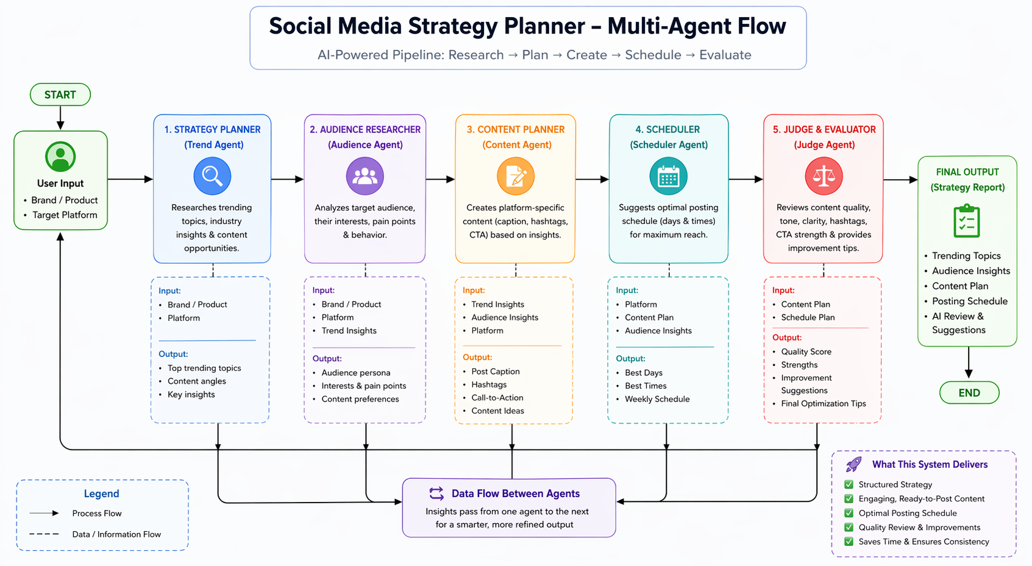

Implementation
The project is implemented using Python as the primary programming language. The frontend interface is built using Streamlit to ensure simplicity and rapid development. The application integrates with an LLM provider (Grok API or Tavily for local inference) for language reasoning and generation.
Tool integration is achieved using Tavily Search, enabling the agent to retrieve relevant web-based insights for trend analysis. The LLM-as-Judge module uses a structured rubric to evaluate generated content quality and provide constructive feedback.
The system is modular, with separate files for each agent to maintain clean architecture. Environment variables are managed using a .env file for API key security. The application runs locally using streamlit run app.py and is deployed to a public URL using streamlit for accessibility.

5. LLM-as-Judge Design
The evaluation module follows a rubric-based scoring mechanism. The rubric includes criteria such as:
- Relevance to the business niche
- Engagement potential
- Strength of call-to-action
- Clarity and readability
- Brand alignment
The LLM reviews generated content and assigns qualitative feedback along with improvement suggestions. This ensures that outputs are not only generated but also systematically assessed before presentation to the user.

6. Deployment
The completed application is deployed on a cloud platform such as Streamlit to ensure public accessibility. Deployment includes secure environment variable configuration and runtime configuration. The deployed link allows evaluators and recruiters to access and test the system in real time.

7. Challenges Faced and Solutions
During development, several challenges were encountered. Initial issues included incorrect API key configurations and model access errors. These were resolved by verifying environment variables and confirming model availability. Integration of the search tool required proper formatting of tool invocation responses to ensure compatibility with the LLM reasoning loop. Structuring the LLM-as-Judge rubric also required multiple iterations to achieve consistent evaluation outputs.
These challenges improved our understanding of API integration, debugging workflows, and agent orchestration principles.

8. Business Value and Impact
The Social Media Strategy Planner significantly reduces manual planning time by automating multiple stages of campaign creation. It ensures content consistency across strategy, writing, scheduling, and evaluation. The system provides ready-to-use, structured outputs that can directly support marketing teams, solo creators, and small businesses. By combining reasoning, tool usage, and evaluation, the solution demonstrates real-world applicability beyond a simple chatbot implementation.

9. Future Improvements
Future enhancements may include multi-platform customization modules tailored specifically for Instagram, LinkedIn, and Twitter. Additional features could include export functionality (CSV, JSON, Markdown), analytics integration to evaluate post performance, and a feedback loop that re-optimizes strategy based on engagement metrics. A human approval workflow can also be integrated to allow manual review before publishing content.

10. Conclusion
The Social Media Strategy Planner demonstrates how an agentic AI system can solve a practical business problem through task decomposition, modular architecture, tool integration, and automated evaluation. By designing a structured multi-agent workflow, we transformed a manual and fragmented process into an efficient, repeatable, and scalable system. This project reflects practical implementation of agentic AI concepts and showcases the ability to design, build, deploy, and evaluate an end-to-end AI solution.

