Practical 10
Aim: Scalable K-Means Clustering on Customer Segmentation Data using Apache Spark MLlib (Parallel K-Means)

Problem definition: You are a Data Scientist at RetailEdge Analytics. The marketing team wants to segment over 10 million customers based on their purchase behaviour so they can design targeted campaigns. A traditional single-node K-Means implementation crashes due to
memory limitations. Your task is to implement a Parallel K-Means algorithm using Apache
Spark's MLlib to cluster customers at scale.

Observation / Output:
1.Start HDFS
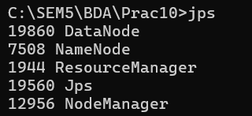
2.Make folder in HDFS
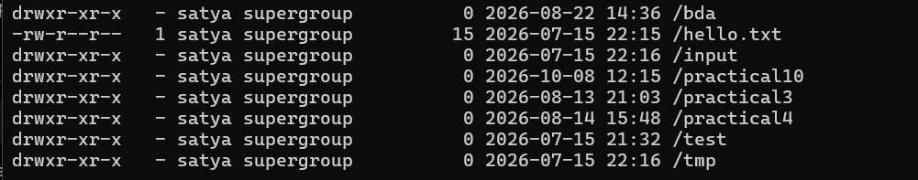
3.upload csv file in hdfs
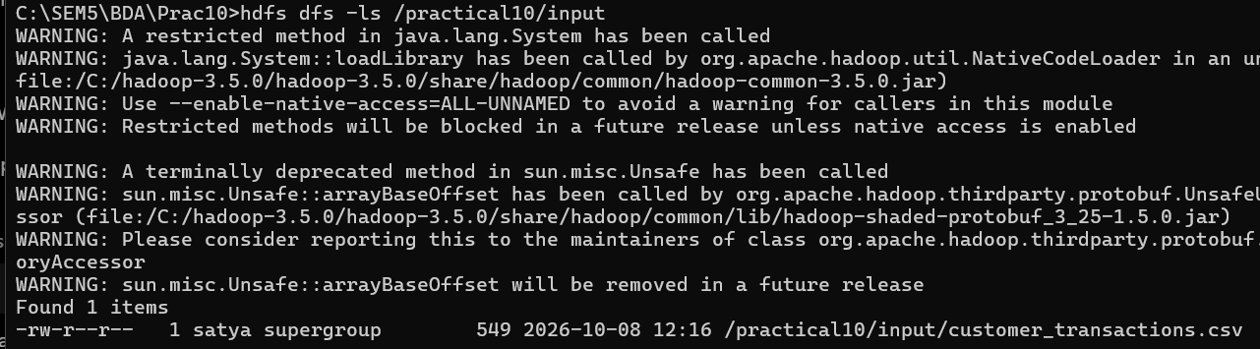

4. Load and preprocess the large-scale customer transaction dataset from HDFS.
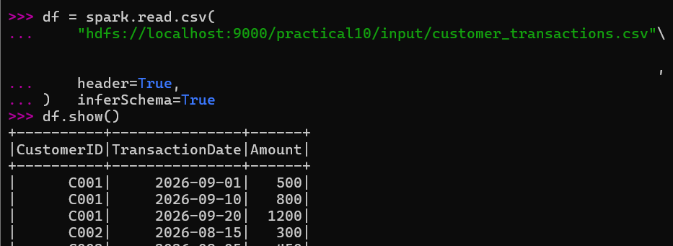

5.Extract features: total spend, purchase frequency, average basket size, and recency.
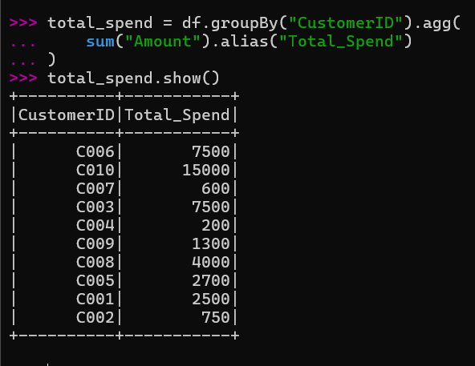
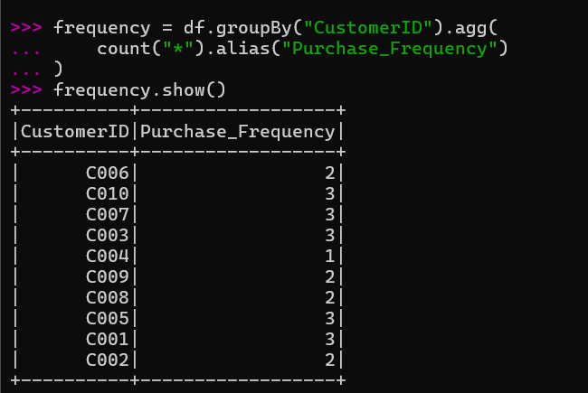
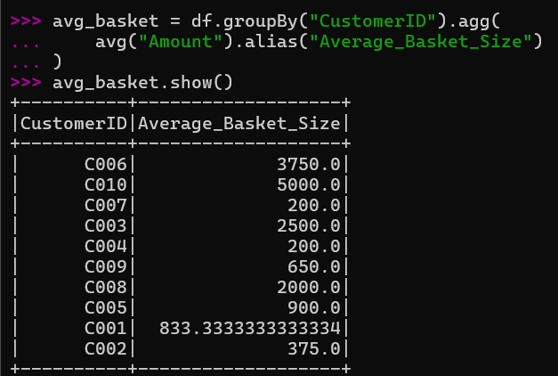
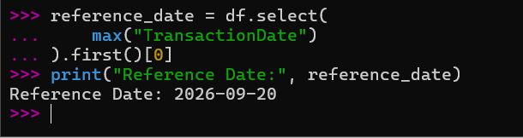
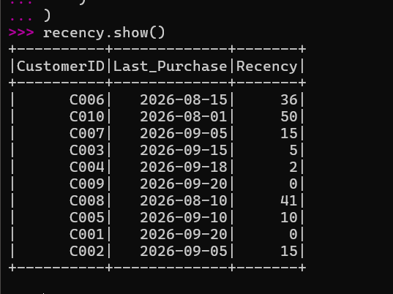

6. Apply feature scaling (StandardScaler) to normalize the features.
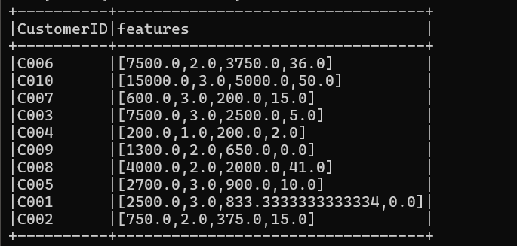
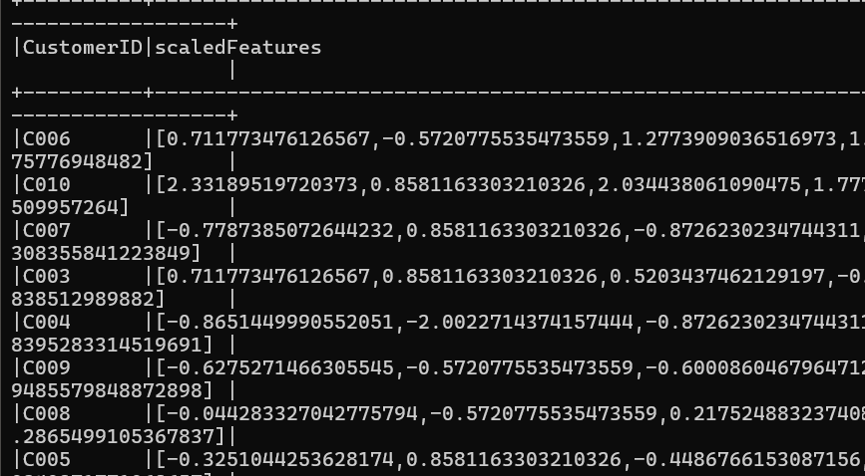

7. Implement Spark MLlib's KMeans with k=5 clusters.
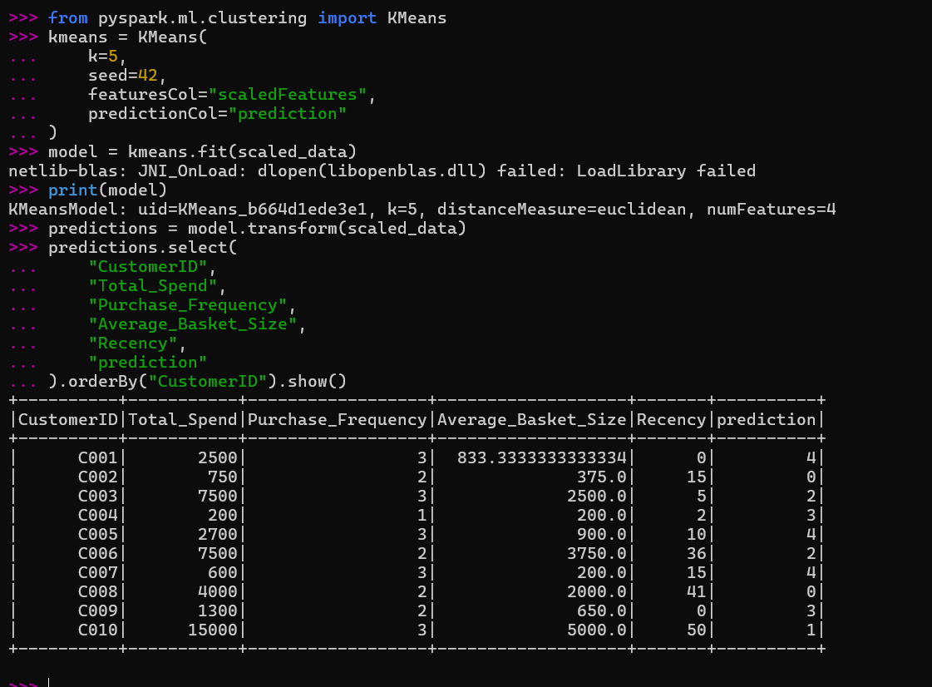

8. Evaluate clustering quality using the Within Set Sum of Squared Errors(WSSSE).
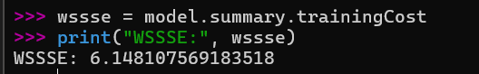

9. Visualize cluster centers and interpret the customer segments.
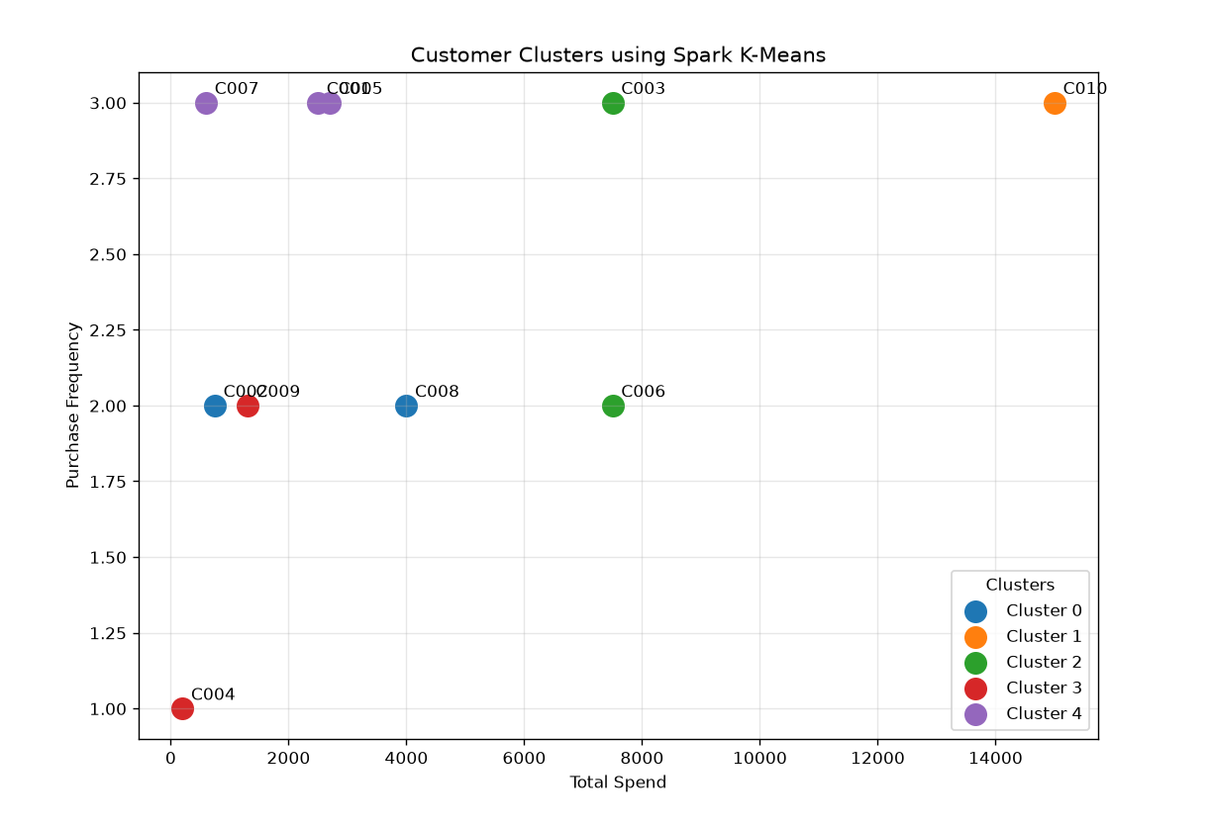

10. Compareperformance: single-node sklearn K-Means vs Spark Parallel K-Means.
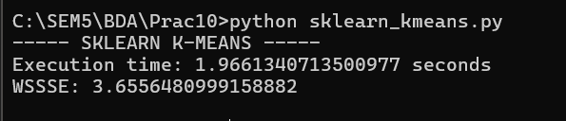

Key Questions /Analysis:

Q1. Why does traditional K-Means fail at large scale, and how does Spark's parallel K-Means overcome this?
Traditional K-Means runs mainly on a single machine, so processing a very large dataset can require high memory and computation time. It may become slow or unable to handle datasets that do not fit into memory. Spark K-Means distributes the data across multiple partitions and performs computations in parallel. This makes it more suitable for large-scale datasets and reduces processing time.

Q2. What is the significance of the WSSSE metric? How do you use the Elbow Method to select optimal k?
WSSSE (Within Set Sum of Squared Errors) measures how close the data points are to their assigned cluster centers. A lower WSSSE generally means that the clusters are more compact. In the Elbow Method, K-Means is run with different values of k, and the WSSSE is plotted against k. The point where the decrease in WSSSE starts becoming smaller is called the elbow, and that value is selected as the suitable k.
Q3. How does data partitioning in Spark affect convergence speed of K-Means?
Spark divides the dataset into partitions and processes these partitions in parallel. Properly balanced partitions allow the available resources to work efficiently and can improve the execution speed of K-Means iterations. Poorly balanced partitions can cause some tasks to take longer than others, increasing the overall execution time.

Q4. What customer behaviour pattern does each cluster represent? How can marketing strategies differ per segment?
Each cluster represents customers with similar spending and purchasing behaviour. Based on the cluster profile, segments can represent:
- High-value active customers: High spending and frequent purchases. Offer loyalty rewards and premium products.
- Occasional high-value customers: High spending but fewer purchases. Use personalized offers to increase purchase frequency.
- Frequent low-value customers: Frequent purchases with lower spending. Use bundle offers and cross-selling.
- Inactive or at-risk customers: Low activity or high recency. Use discounts and re-engagement campaigns.

Q5. How does feature scaling impact the clustering result? What happens if features are not normalized?
Feature scaling puts all features on a comparable scale before calculating distances. In this practical, Total Spend, Purchase Frequency, Average Basket Size, and Recency have different ranges. Standardization prevents a large-valued feature such as Total Spend from dominating the distance calculation. Without scaling, K-Means may give more importance to features with larger numerical values, resulting in less meaningful clusters.

.

Conclusion:
In this practical, Spark MLlib K-Means was used for scalable customer segmentation. The customer features were standardized and five clusters were generated using K-Means. The WSSSE metric was used to evaluate cluster compactness, while cluster profiles and visualization helped understand customer behaviour. Spark's partition-based parallel processing makes K-Means more suitable for large datasets than traditional single-machine K-Means. The resulting customer segments can also help businesses apply different marketing strategies to different types of customers.

