Practical 11
Aim: Large-Scale Logistic Regression for Spam Detection usingDistributed Stochastic Gradient Descent (DSGD).

Problem definition: You are a Big Data Engineer at SecureComm Inc., a telecom company that processes over 50 million SMS messages daily. The fraud prevention team wants an automated spam classifier that can scale to handle millions of new messages per hour. You will implement a Distributed Logistic Regression model using Mini-batch Gradient Descent on Apache Spark, train it on a massive SMS dataset, and deploy it for batch prediction.

Observation / Output:
- Load the large-scale SMS spam dataset from HDFS into a Spark DataFrame.
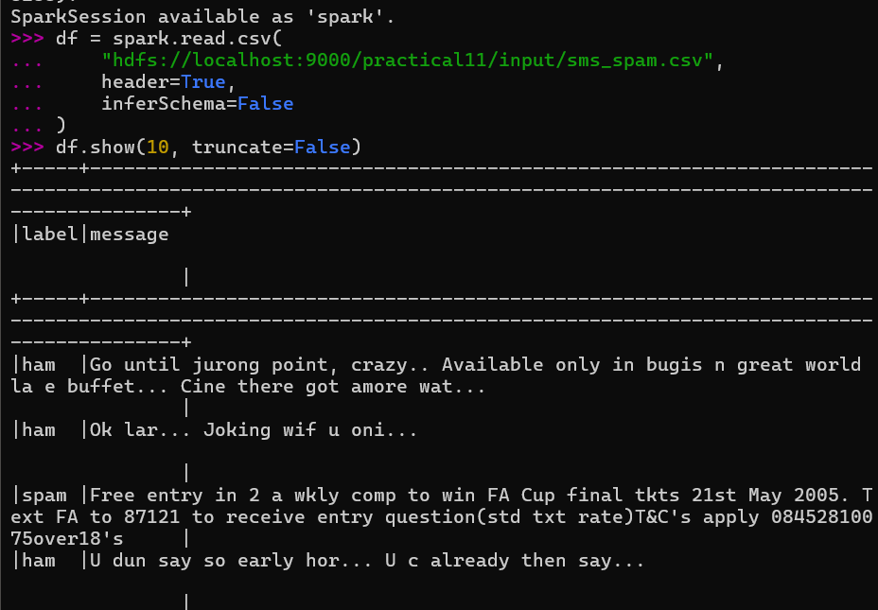

- Perform text preprocessing: tokenization, stop word removal, and TF-IDF feature extraction.
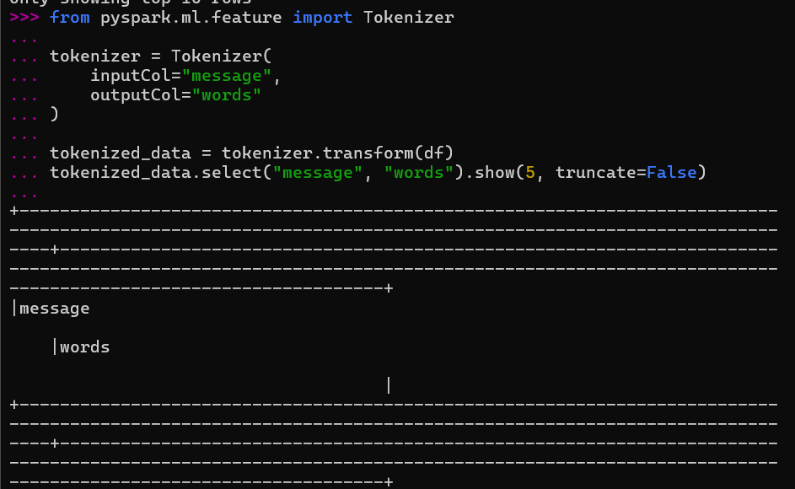
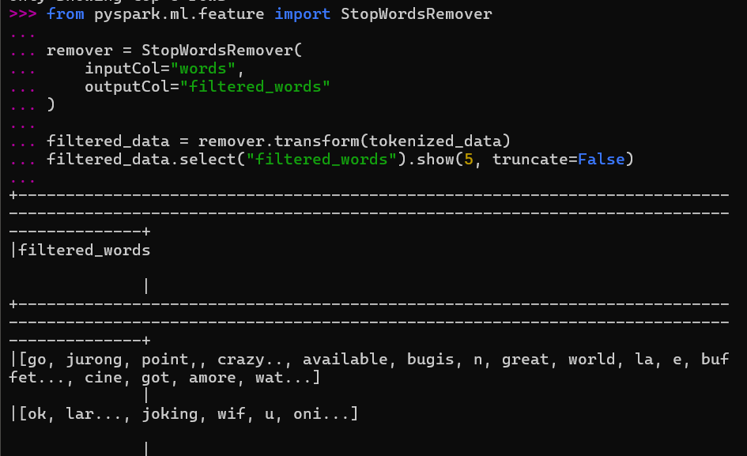
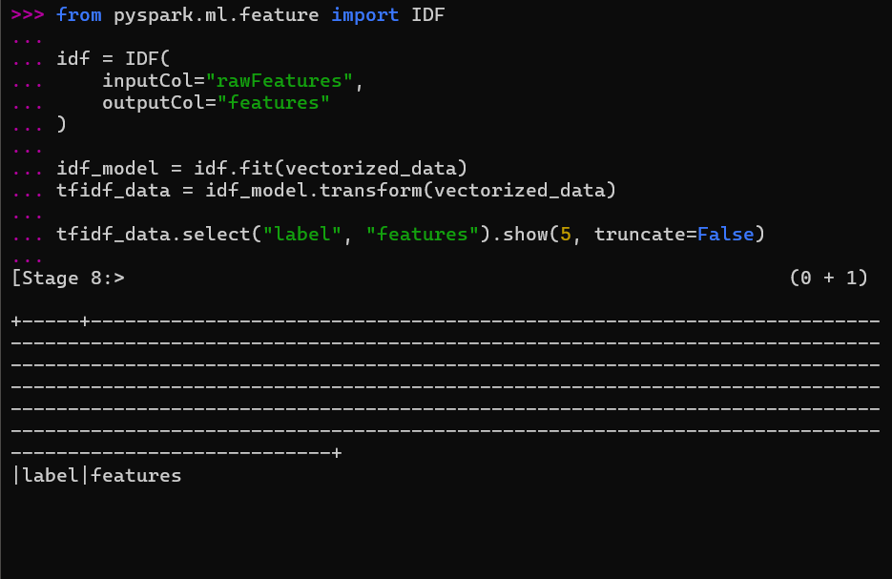

- Implement Logistic Regression using Spark MLlib with mini-batch gradient descent.
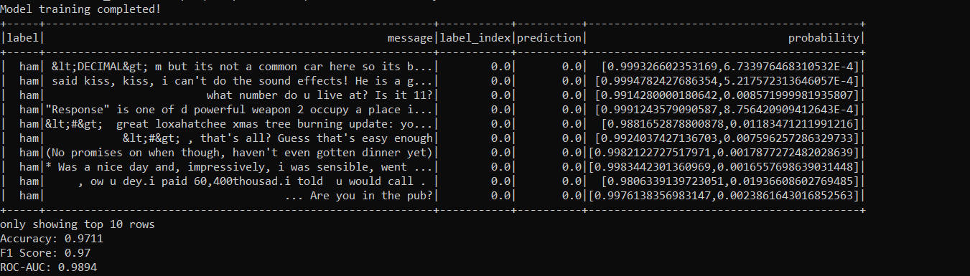

- Tune hyperparameters: regularization parameter (regParam), maxIter, and elasticNetParam.
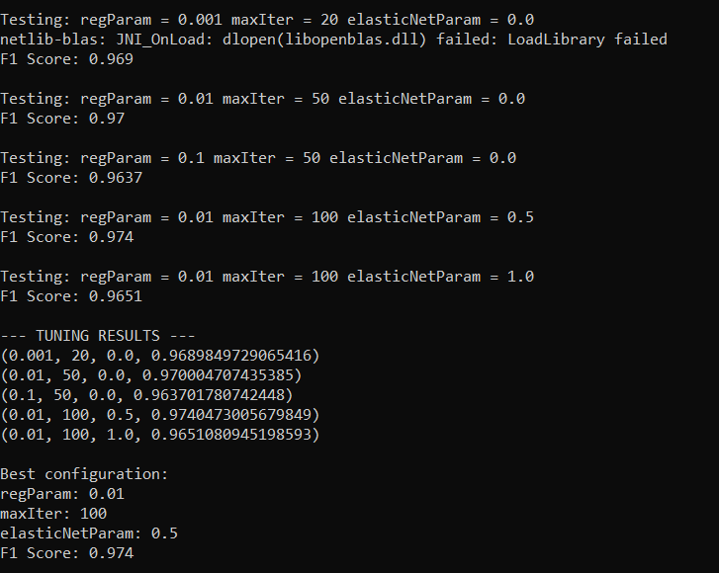

- Evaluate the model: Accuracy, Precision, Recall, F1-Score, and ROC-AUC.
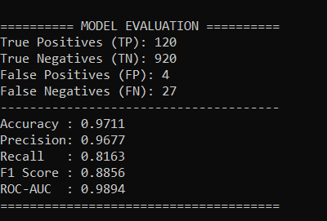

- Demonstrate howincreasing dataset size affects training time vs accuracy.
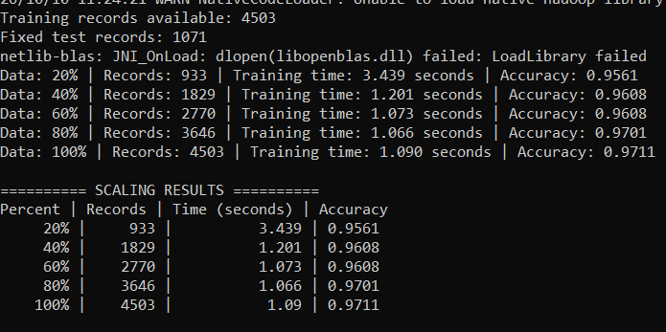

- Compare training time: full-batchgradient descent vs mini-batch gradient descent.
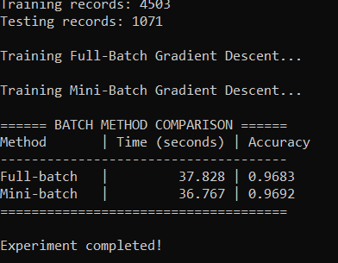

Key Questions /Analysis:
Q1. What is the difference between full-batch, mini-batch, and stochastic gradient descent? Why is mini-batch preferred in distributed settings?
Answer: Full-batch gradient descent uses the entire dataset for each update, while stochastic gradient descent (SGD) uses one record. Mini-batch gradient descent uses a small group of records for each update. Mini-batch is preferred in distributed systems because it balances computational efficiency, memory usage, and stable gradient updates.
Q2. How does the TF-IDF vectorizer handle the 'curse of dimensionality' for text classification?
Answer: TF-IDF converts text into numerical features based on word frequency and importance. Text data can create thousands of features, increasing memory and computation costs. Using techniques such as feature hashing can limit the vector size and reduce dimensionality, although some information may be lost.
Q3. What is L1 vs L2 regularization? How does the elasticNetParam blend them in Spark MLlib?
Answer: L1 regularization encourages some model weights to become zero, helping with feature selection. L2 regularization reduces large weights to help prevent overfitting. In Spark MLlib, elasticNetParam = 0 means L2, 1 means L1, and values between 0 and 1 combine both.
Q4. In a distributed environment, how do gradient updates from multiple workers get aggregated? What is the risk of stale gradients?
Answer: Multiple workers calculate gradients on different data partitions and send them to an aggregation process, which combines them to update model weights. Stale gradients occur when workers use outdated model parameters. They can slow convergence or make training less stable, especially in asynchronous systems.
Q5. If Recall is more important than Precision for spam detection, how would you adjust the classification threshold? Show with examples.
Answer: Lower the classification threshold so more messages are labelled as spam. For example, reduce it from 0.5 to 0.3; a message with a spam probability of 0.4 will then be classified as spam. This can catch more spam messages and improve recall, but may also incorrectly mark legitimate messages as spam, reducing precision.

Conclusion:
Mini-batch gradient descent supports efficient training, TF-IDF and feature hashing help process text, and regularization reduces overfitting. Distributed gradient aggregation helps workers train a common model. For spam detection, lowering the classification threshold can improve recall, but it may also increase false positives.

