Practical 12
Aim: Customer Sales Dashboard Using Interactive Analytics

Problem definition: You are working as a Data Visualization Analyst at a retail analytics company. Management wants to monitor sales performance across products, regions, and customer segments through an interactive dashboard. Static reports are insufficient for decision-making. Your task is to design an interactive dashboard that allows management to explore sales data and identify key business trends.

Observation / Output:
Import sales dataset into Tableau / Power BI.
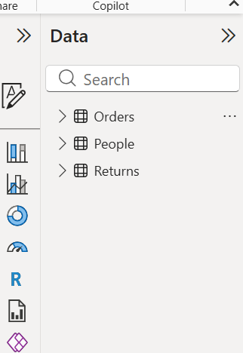

Create KPIs for Total Sales, Profit, and Orders.
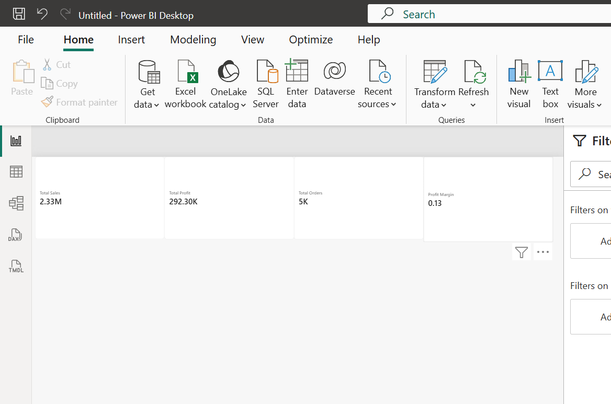

Create interactive charts for sales analysis.
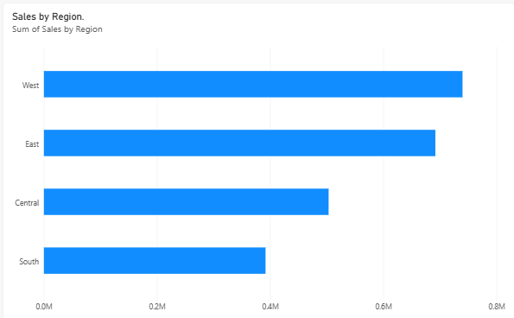
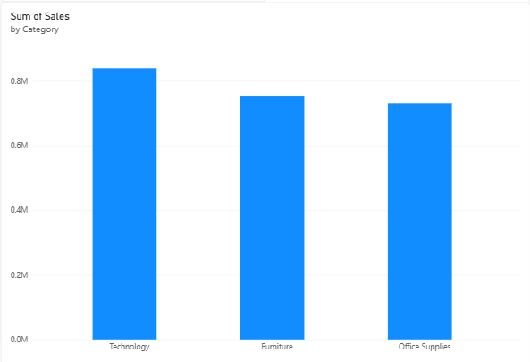
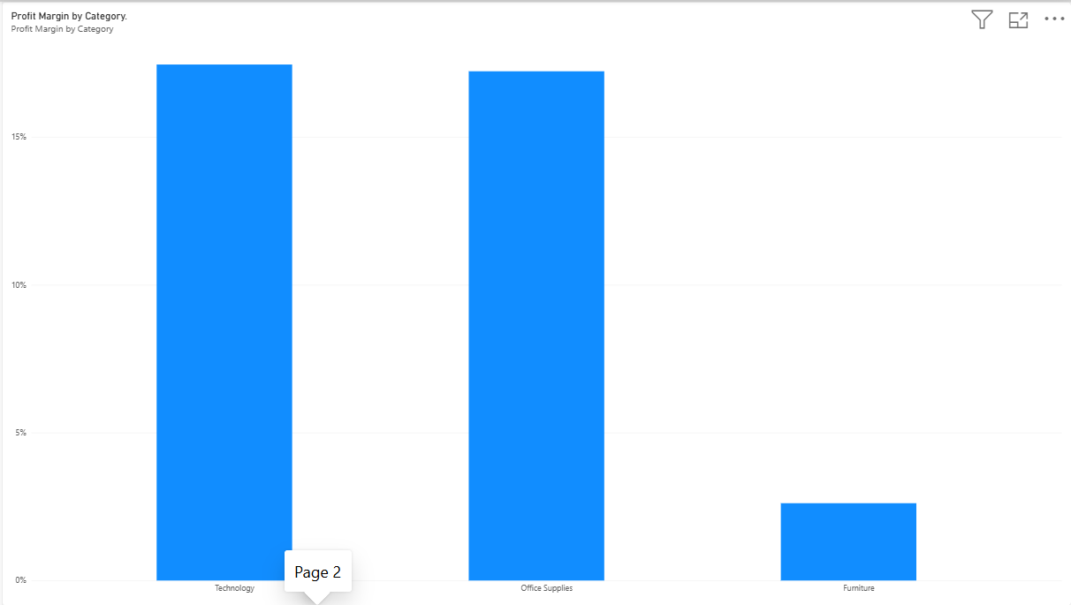

Develop drill-down functionality.
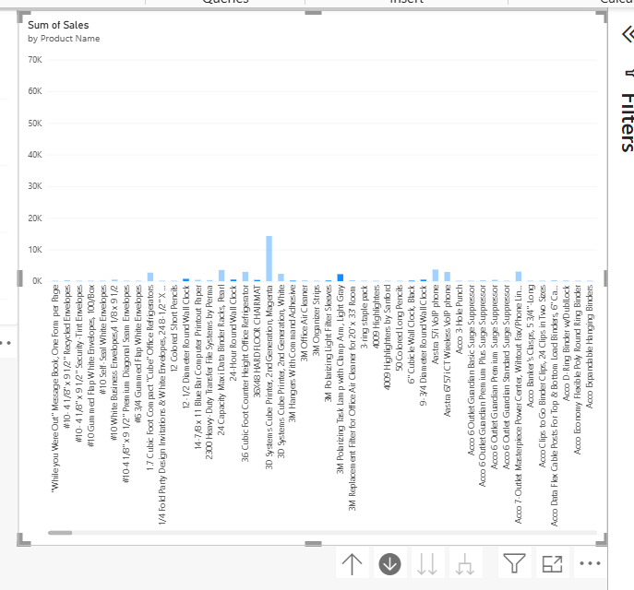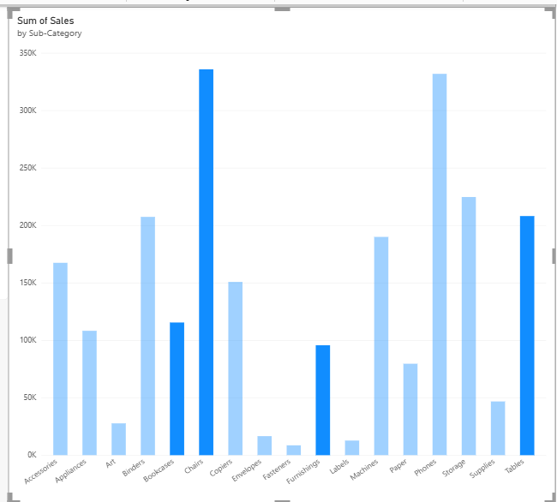
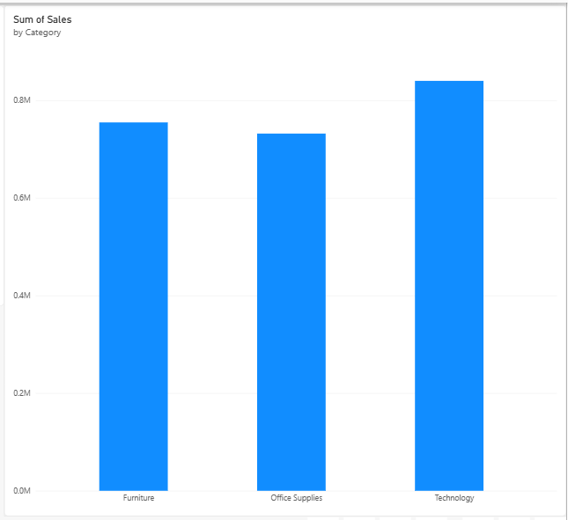

Add dashboard interactions.
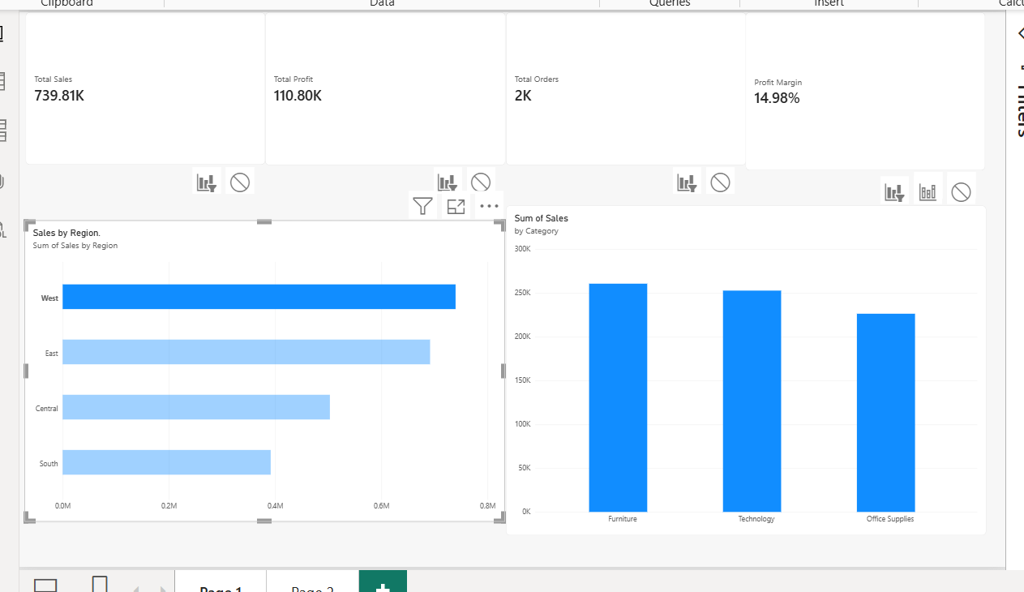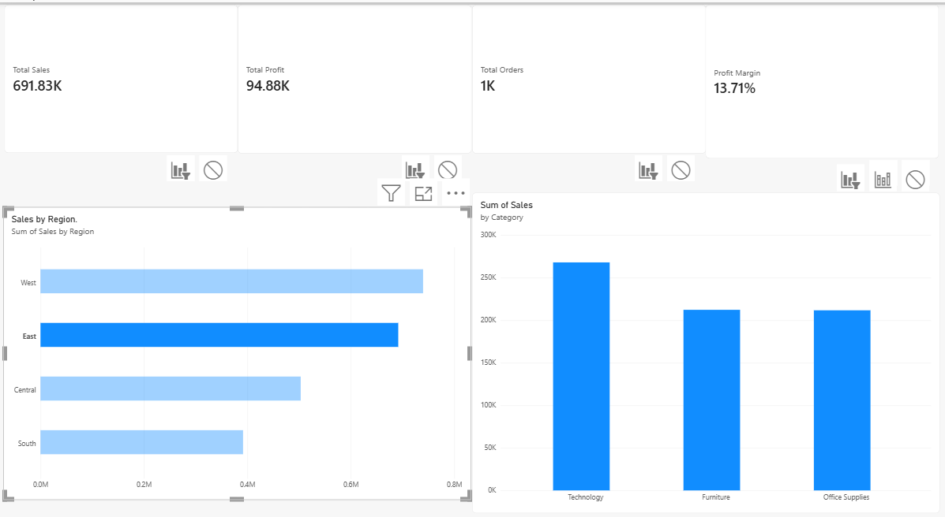

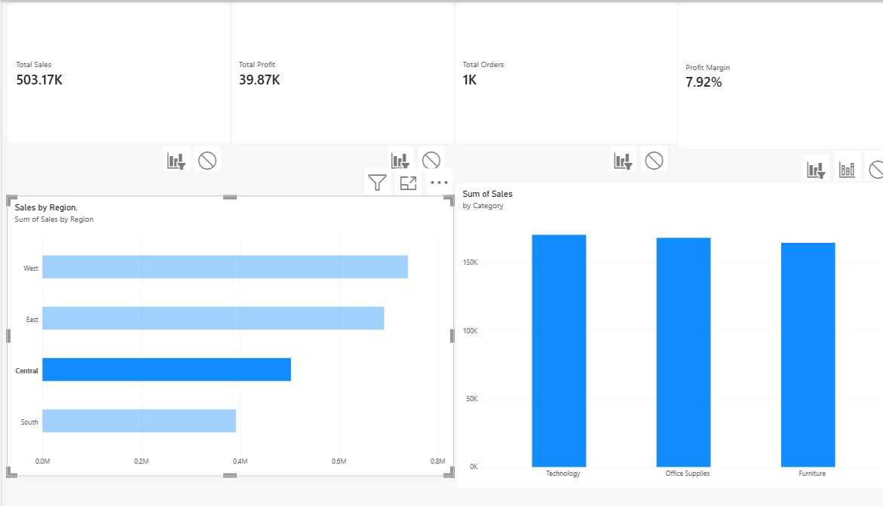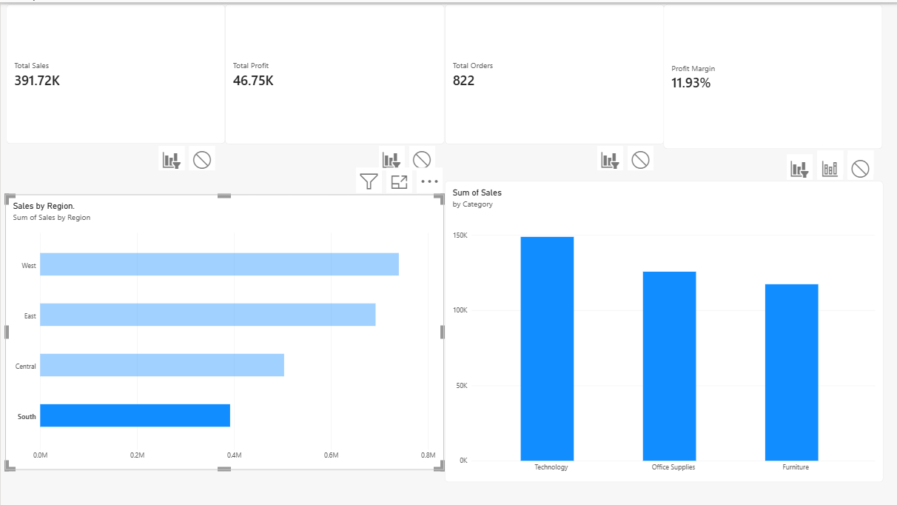

Create summary cards.
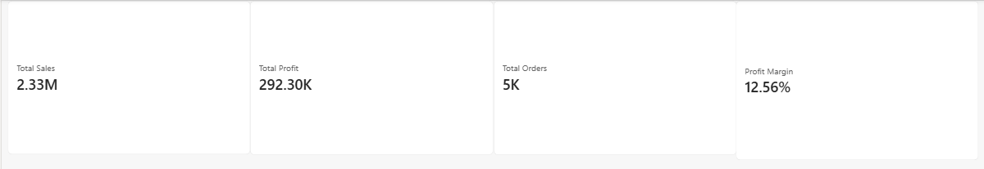

Publish dashboard.
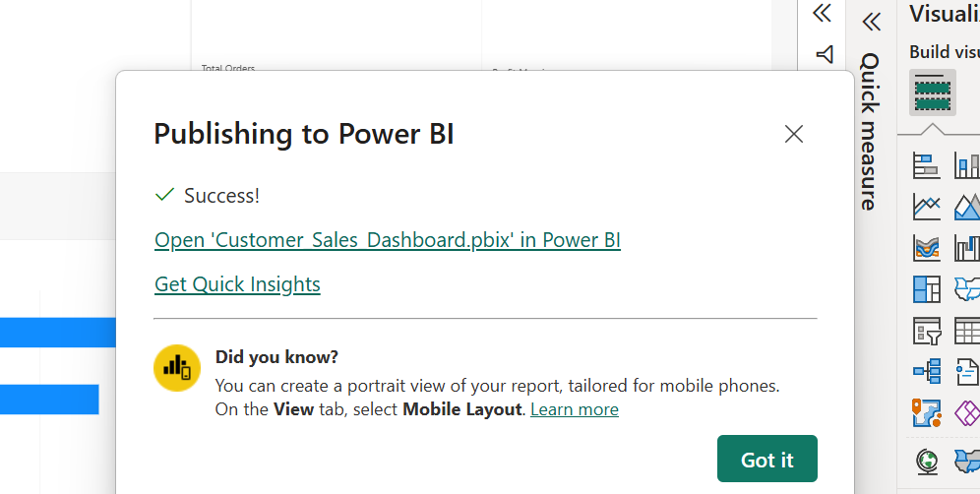

Key Questions /Analysis:
Q1. What is the role of interactive dashboards in business analytics?
Interactive dashboards present business data using charts, graphs, and KPI cards. They help users monitor performance, identify trends, and make informed decisions.

Q2. How do filters improve visual exploration?
Filters allow users to view data for specific regions, categories, or time periods. They make it easier to compare results and identify patterns in the data.

Q3. What are KPI indicators?
Key Performance Indicators (KPIs) are measurable values used to evaluate business performance. In this dashboard, Total Sales, Total Profit, Total Orders, and Profit Margin are the main KPIs.

Q4. Why are dashboards preferred over static reports?
Dashboards allow users to interact with data through filters, drill-downs, and charts. Unlike static reports, they provide flexible data exploration and make it easier to analyze changing business requirements.

Q5. How does user-driven exploration support decision-making?
User-driven exploration allows users to select specific data, compare performance, and investigate trends. It helps identify business opportunities, detect problems, and make data-based decisions.

Conclusion:
In this practical, an interactive sales dashboard was developed using Power BI. The dashboard includes KPI cards, sales charts, filters, and drill-down functionality to analyze sales performance across regions and product categories. The analysis helps identify high-performing regions, compare category-wise sales, and evaluate profitability. Thus, interactive dashboards support effective data visualization, business analysis, and informed decision-making.

