Practical 1
Aim: Linux System Administration and File Management for Marketing Analytics Team.

Problem definition:
Scenario: You have recently joined DataAnalytics Inc. as a Linux System Administrator. The company runs its analytics platform on Linux servers where project data, reports, scripts, and user accounts must be managed efficiently.
Your manager has assigned you the responsibility of setting up the project environment, managing files and directories, monitoring system resources, securing data, and creating backups for the Marketing Analytics team.

GitHub Link:
https://github.com/24dit061-Satyarajsinh/24DIT061_CSUE301_BDA

Observation / Output
Task :
- Identify the current user.
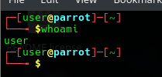

- Find the current working directory.
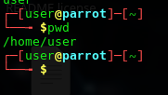

- Display system information.

- Check system uptime and date.
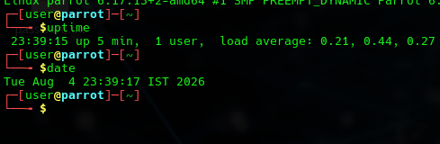

- Create a directory named MarketingAnalytics.
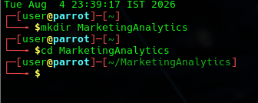

- Create subdirectories: RawData, ProcessedData, Reports.
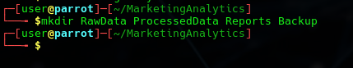

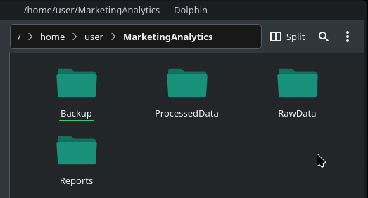

- Create data and report files.
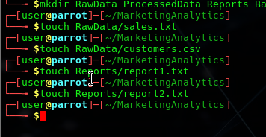

- Add sample content.
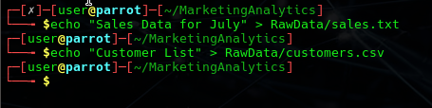
- Display file contents.
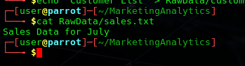

- List all files and directories.
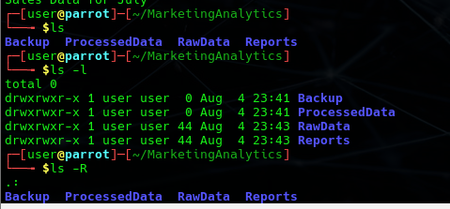

- Search for report files.
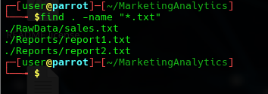

- Search specific content inside files.


- Copy report files to Backup directory.
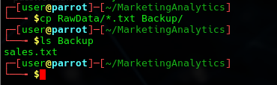

- Rename files.
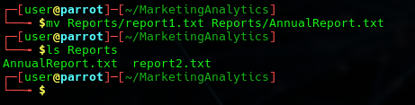
- Move files between directories.
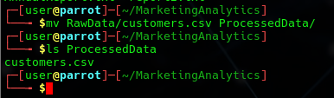

- Delete a file.
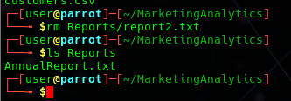

- Delete an empty directory.
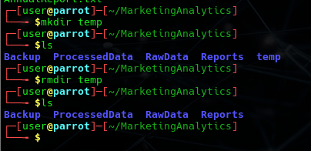

Key Questions /Analysis:
- What is the difference between absolute and relative paths?
An absolute path specifies the complete location of a file starting from the root directory.
A relative path specifies the location of a file relative to the current working directory.
Absolute: /home/kali/MarketingAnalytics/Reports/report1.txt
Relative: Reports/report1.txt

- Why are Linux permissions important for file security?
Linux permissions protect files and directories by controlling who can read, write, or execute them. This helps prevent unauthorized access, accidental modifications, and data loss.

- What is the purpose of the grep command?
The grep command searches for specific words or patterns inside files and displays the matching lines. It is commonly used to quickly locate required information from large files.

- How does Linux support efficient file management?
Linux provides commands such as mkdir, cp, mv, rm, find, and grep to efficiently organize, search, copy, move, and manage files and directories.
- Why are backups important in enterprise environments?
Backups help recover important data after accidental deletion, hardware failure, malware attacks, or system crashes, ensuring business continuity and minimizing downtime.

Conclusion:
This practical demonstrated the basic Linux system administration and file management operations such as creating directories, managing files, searching data, monitoring the system, and performing backups. These commands are essential for efficiently organizing project data and maintaining secure, reliable Linux environments used in enterprise organizations.

