Practical 2
Aim: Hadoop Installation, Configuration and HDFS Operations on Windows/Linux.

Problem definition: You have recently joined DataAnalytics Inc. as a Hadoop Administrator. The organization processes large-scale customer, sales, and marketing data using the Hadoop ecosystem. Due to increasing data volumes, the company has decided to migrate its data storage infrastructure from traditional file systems to Hadoop Distributed File System (HDFS).
As a Hadoop Administrator, your responsibility is to install and configure Hadoop in a Single-Node Cluster environment on Windows/Linux, verify the Hadoop services, manage HDFS storage, and perform data management operations.
Management wants a fully functional Hadoop environment that can store, retrieve, and process big data efficiently.
Your task is to install Hadoop, configure the Hadoop ecosystem, start Hadoop services, and perform HDFS operations using Hadoop commands.

GitHub Link:
https://github.com/24dit061-Satyarajsinh/24DIT061_CSUE301_BDA

Observation / Output:
Tasks:
Hadoop Installation &amp; Configuration
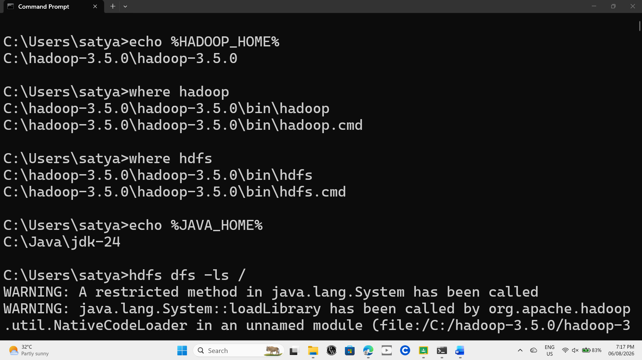

Access Hadoop Web UI.
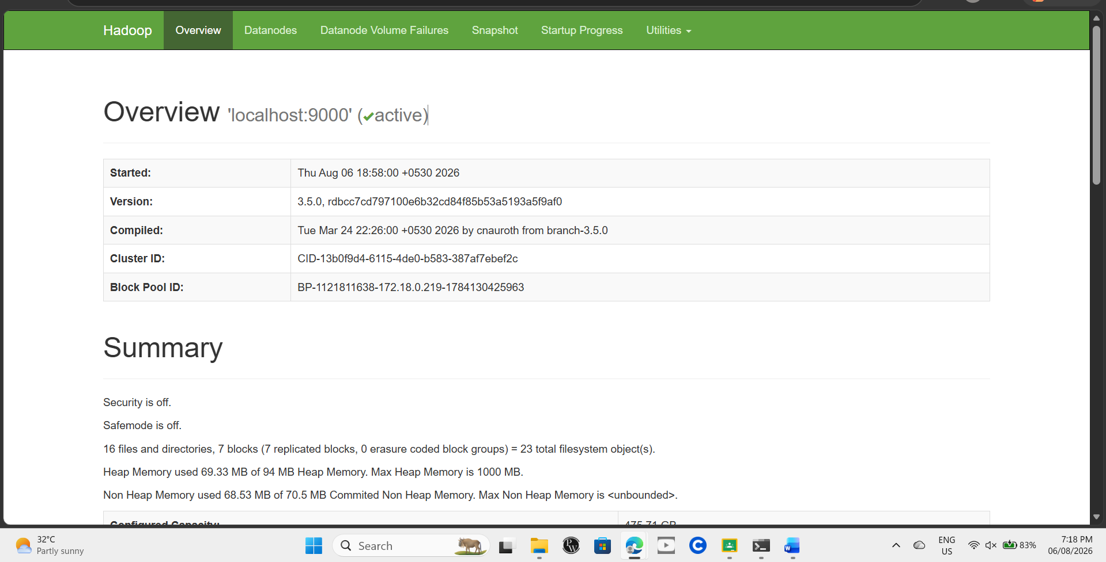

- Create directories in HDFS.
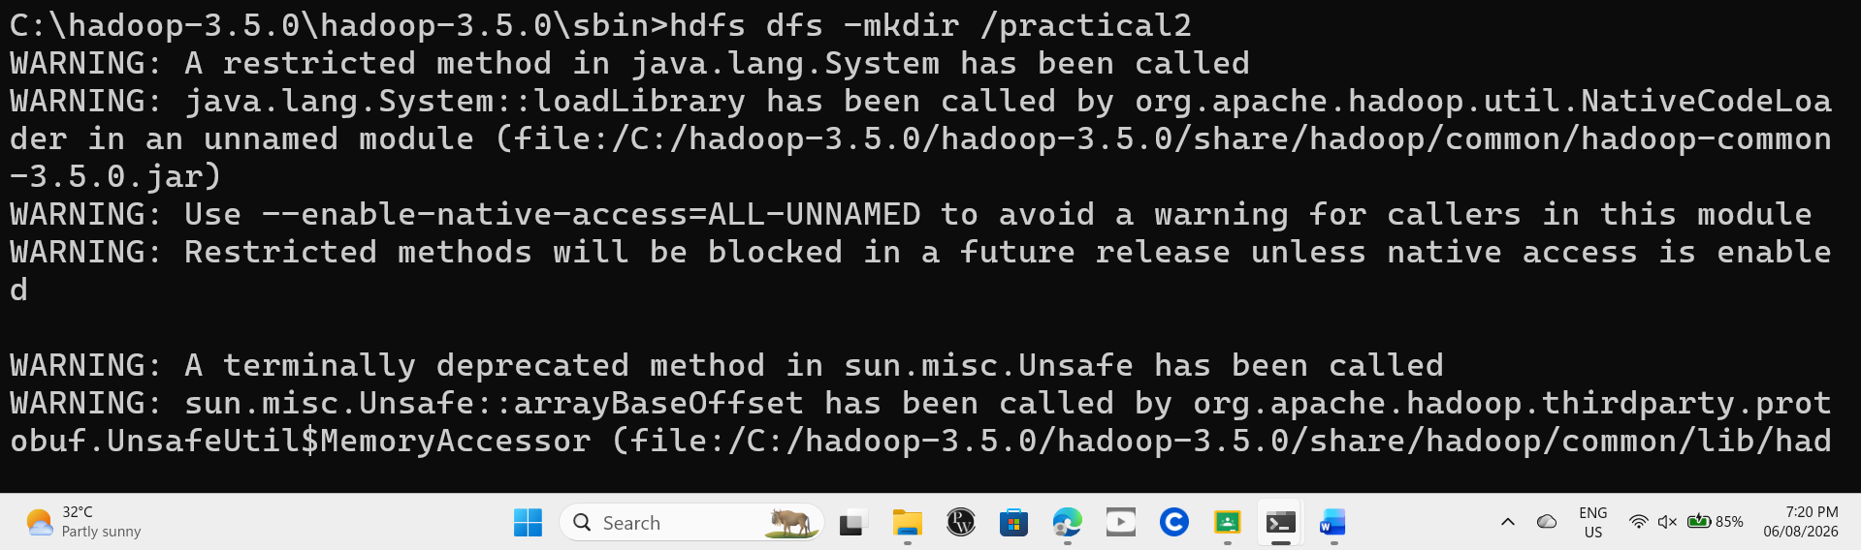
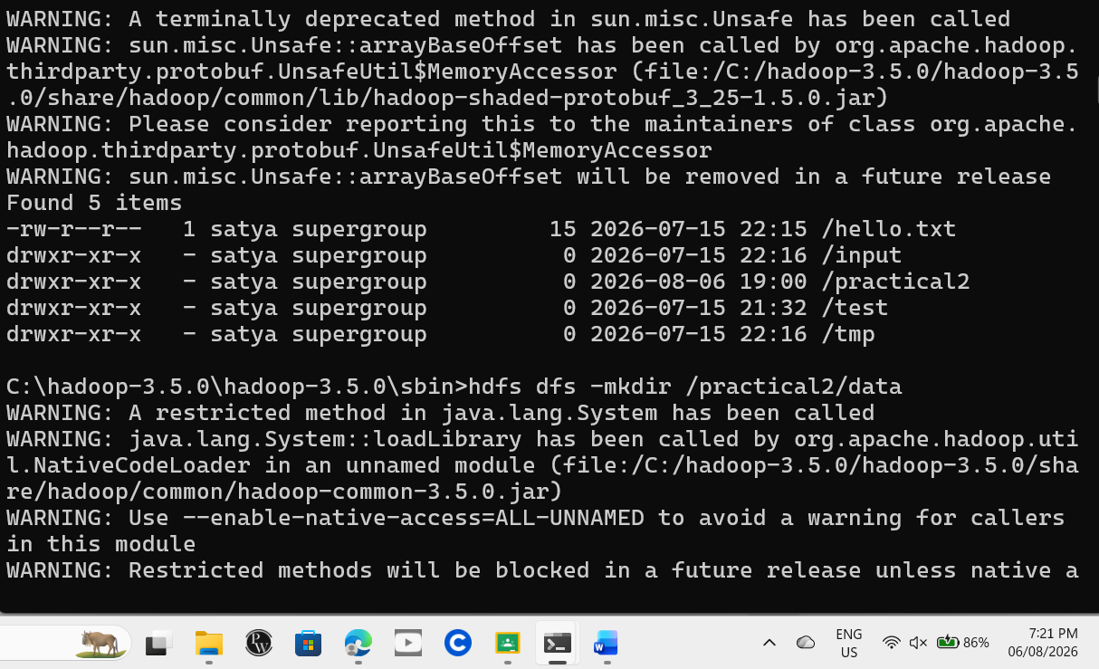

- Upload files to HDFS.
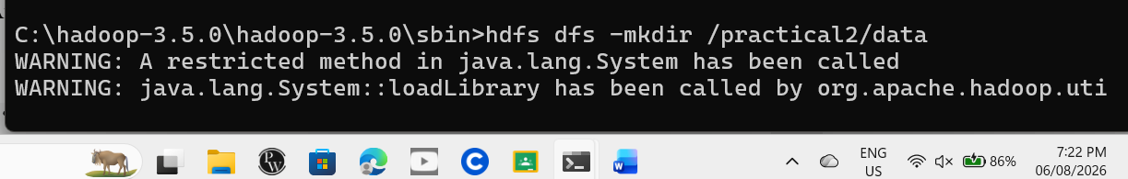
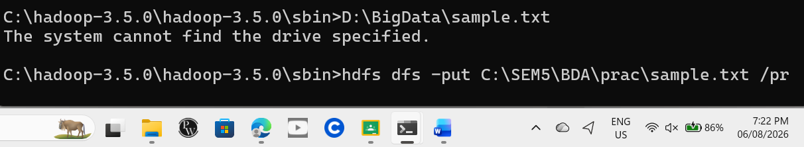

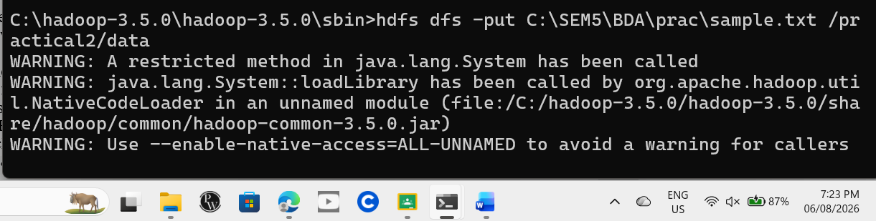

- List HDFS files and directories.
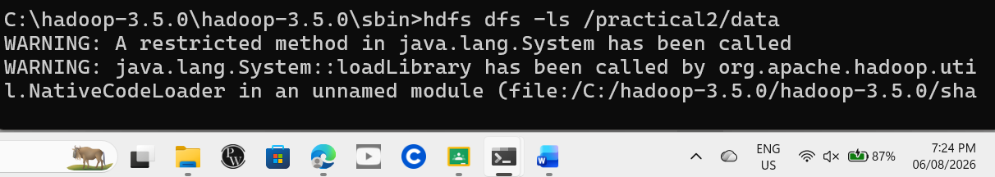
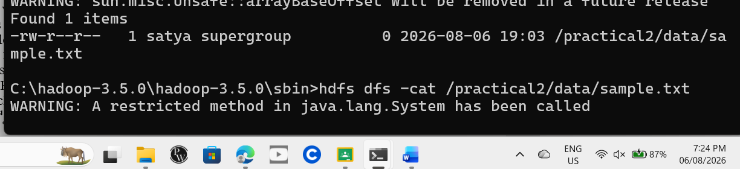

- Display file contents.
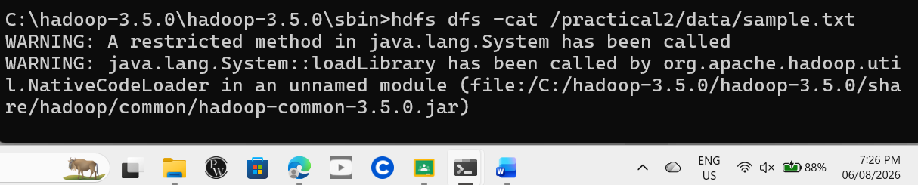

- Copy files within HDFS.
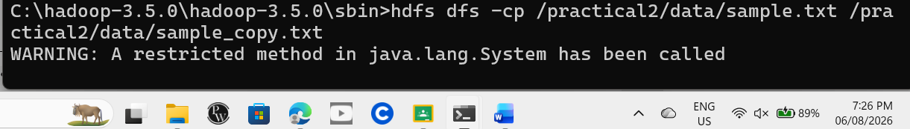

- Move files within HDFS.
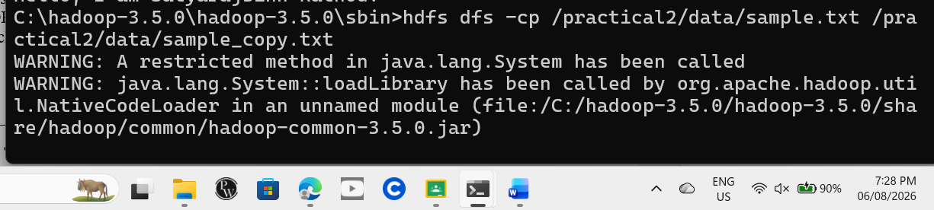
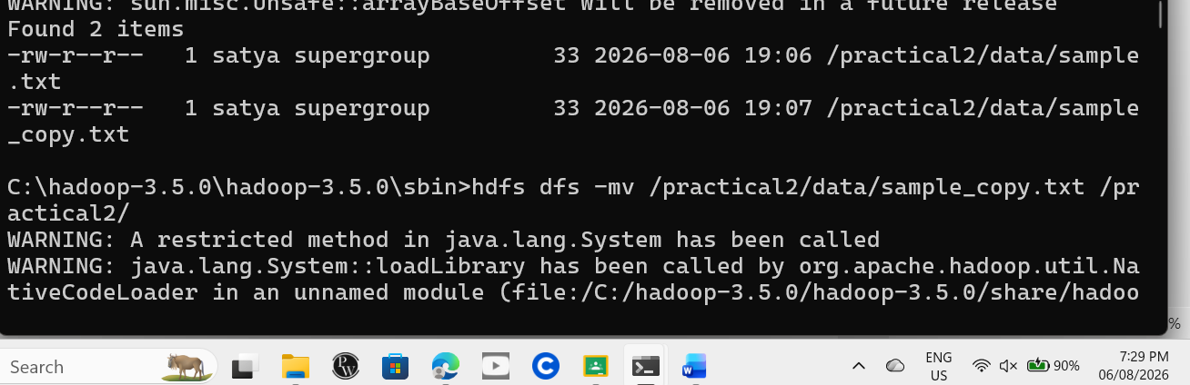

- Rename files.
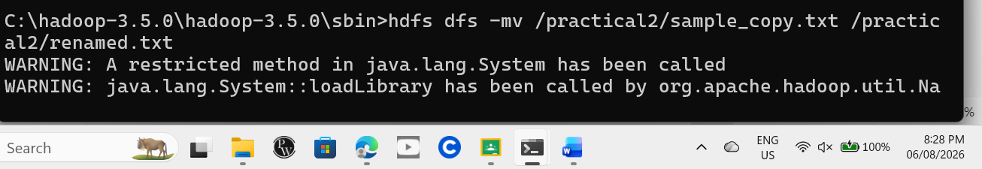
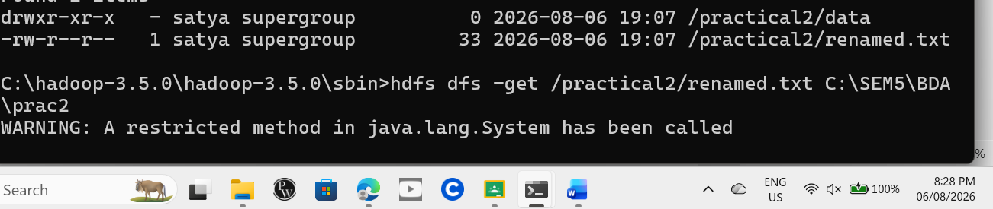

- Download files from HDFS.
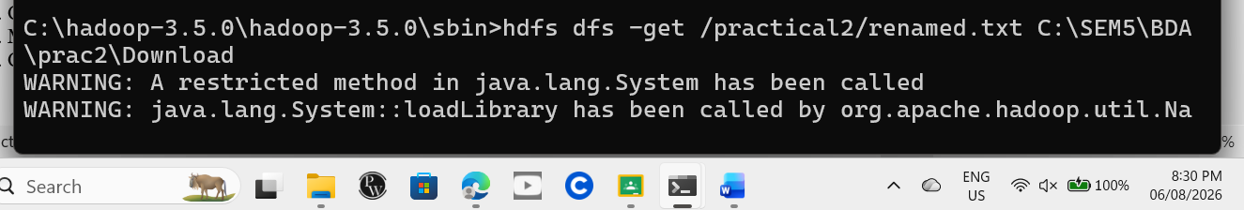
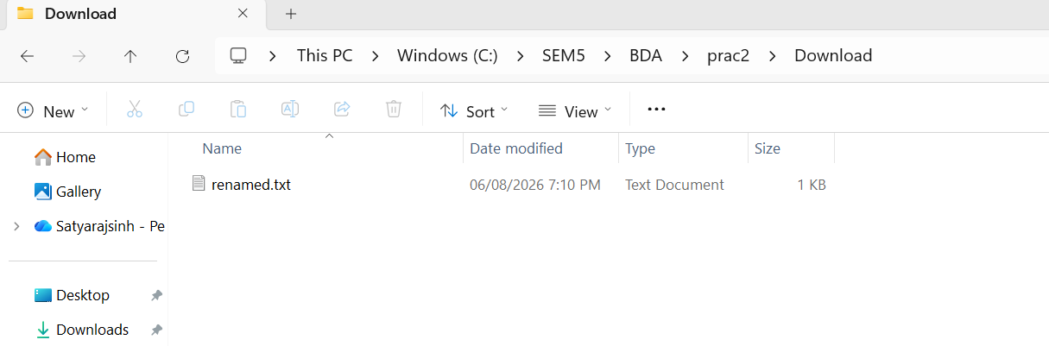

- Delete files and directories.
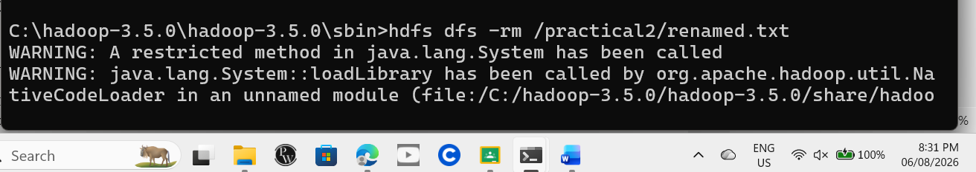
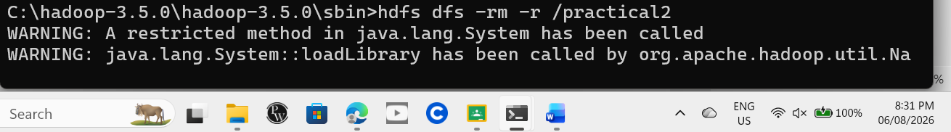

- Check HDFS report.
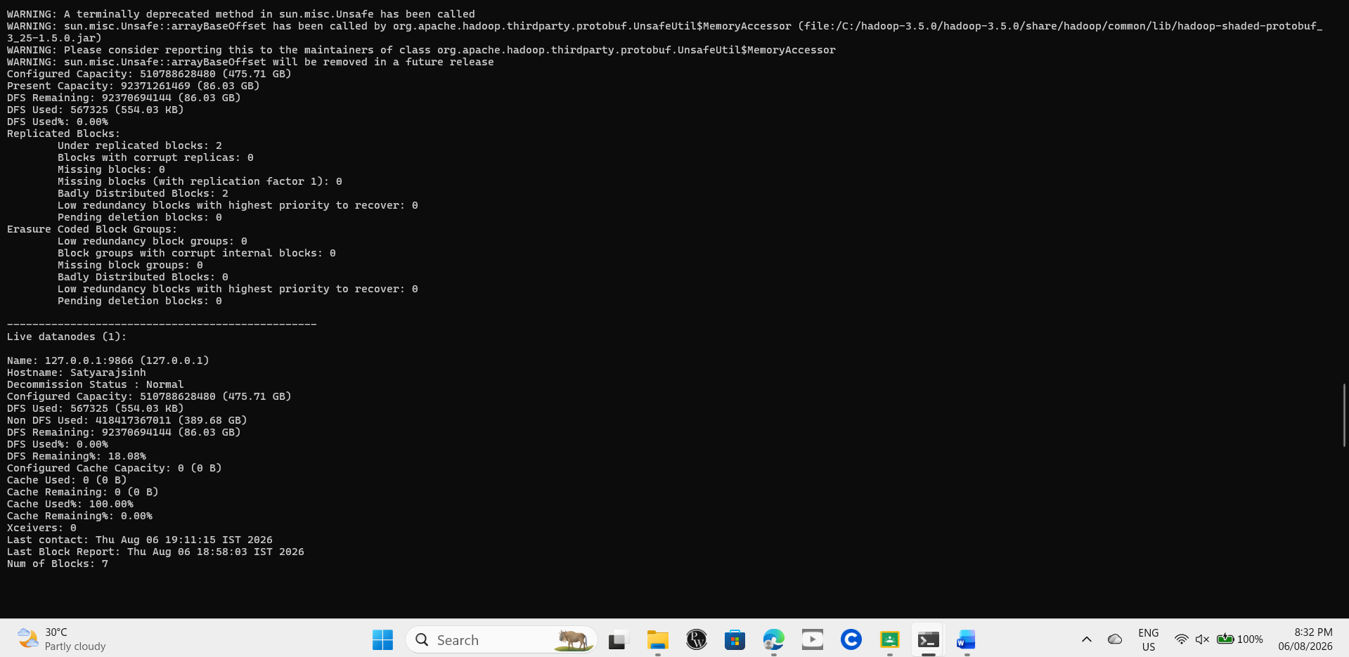

- Verify block information.
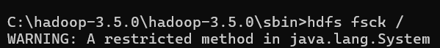
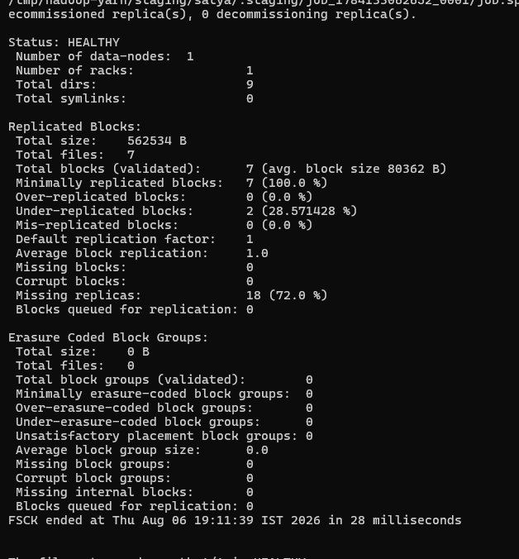

- Check Hadoop cluster health.

- Monitor Hadoop processes.
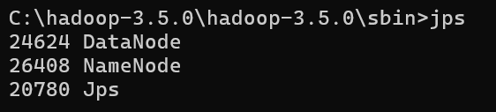

- Check storage utilization.
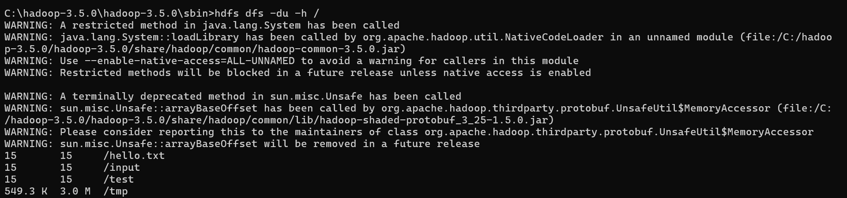

Key Questions /Analysis:
- Why is Hadoop preferred for Big Data storage?
Hadoop is widely used for Big Data because it can store huge amounts of data on multiple computers. It is easy to expand by adding more machines, protects data by keeping copies, and provides an economical solution for handling large datasets.

- What is the role of NameNode and DataNode in HDFS?
The NameNode manages the HDFS system by keeping information about files, folders, and the location of data blocks. The DataNode stores the actual data blocks and sends them to users or applications whenever requested.

- What is the difference between HDFS and traditional file systems?
HDFS | Traditional File System
Stores data across many computers | Stores data on one computer or disk
Suitable for very large datasets | Suitable for regular-sized files
Keeps multiple copies of data for safety | Usually stores only one copy unless backed up
Can grow by adding more machines | Expansion is limited by the machine's capacity
Built for distributed data processing | Built for everyday file storage

- What are the advantages of distributed storage?
Distributed storage allows data to be shared across multiple computers, making it easier to manage very large files. It increases reliability because data is copied to different machines, improves performance by processing data in parallel, and allows storage capacity to be increased without replacing existing hardware.

Conclusion:
The Hadoop single-node environment was successfully installed and configured on Windows. HDFS operations such as creating directories, uploading, managing, retrieving, and deleting files were performed successfully. The Hadoop cluster health, storage usage, and block information were also verified, demonstrating that HDFS can efficiently manage and store large-scale data.

