Practical 4
Aim: Find the Maximum Temperature Recorded for Each Year of NCDC Data using MapReduce

Problem definition: A meteorological research organization maintains historical weather records collected from various weather stations worldwide. The organization uses Hadoop to analyze large climate datasets and study long-term temperature trends. As a Data Analytics Engineer, you are required to process the National Climatic Data Center (NCDC) dataset and identify the maximum temperature recorded for each year using MapReduce.

GitHub Link:
https://github.com/24dit061-Satyarajsinh/24DIT061_CSUE301_BDA

Observation / Output:
Task 1: Upload the NCDC weather dataset to HDFS and examine the structure of the weather records.
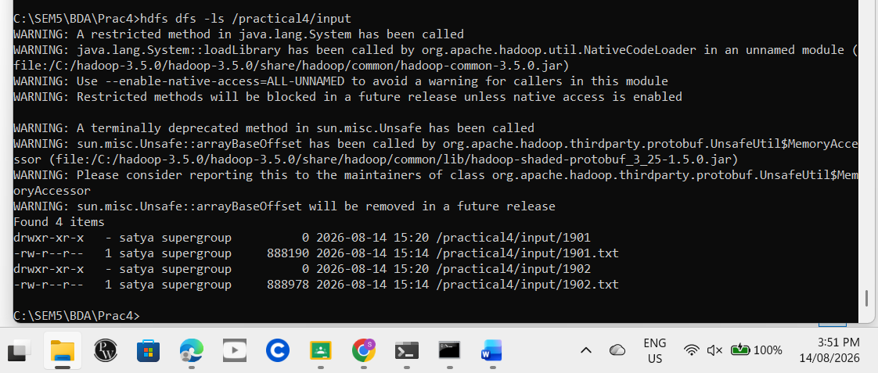

Task 2: Develop and implement the Mapper program to extract the year and temperature values from each record and generate intermediate key-value pairs.
Mapper.py
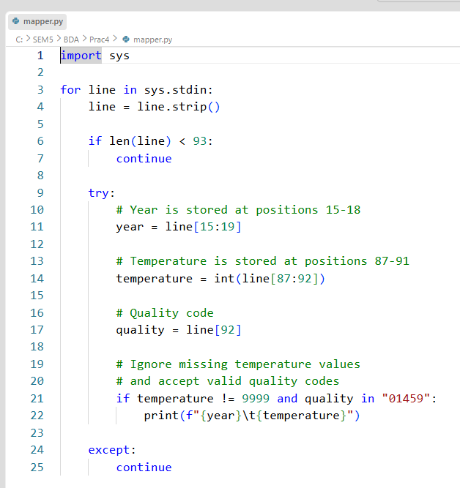

Task 3:Develop and implement the Reducer program to determine the maximum temperature recorded for each year.
Reducer.py
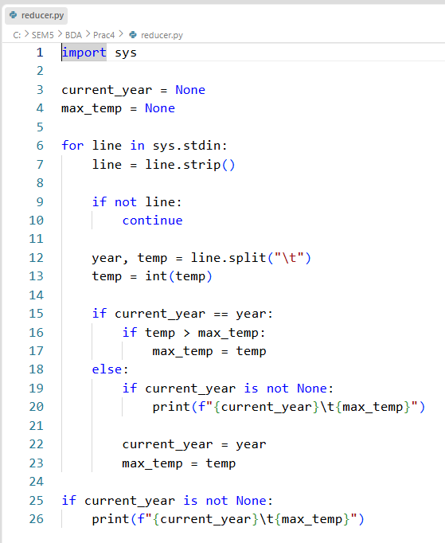

Task 4: Execute the MapReduce job on Hadoop and store the results in HDFS. Verify the correctness of the output generated.
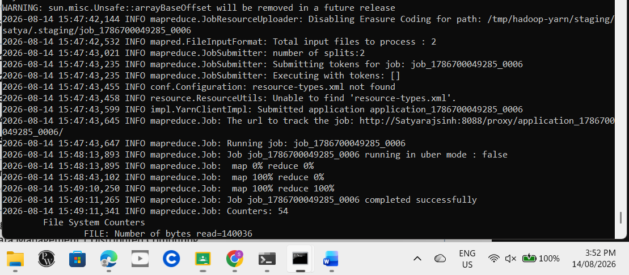

Task 5: Analyze the yearly maximum temperature trends and identify the hottest year in the dataset. Discuss the advantages of using MapReduce for large-scale climate data analysis.
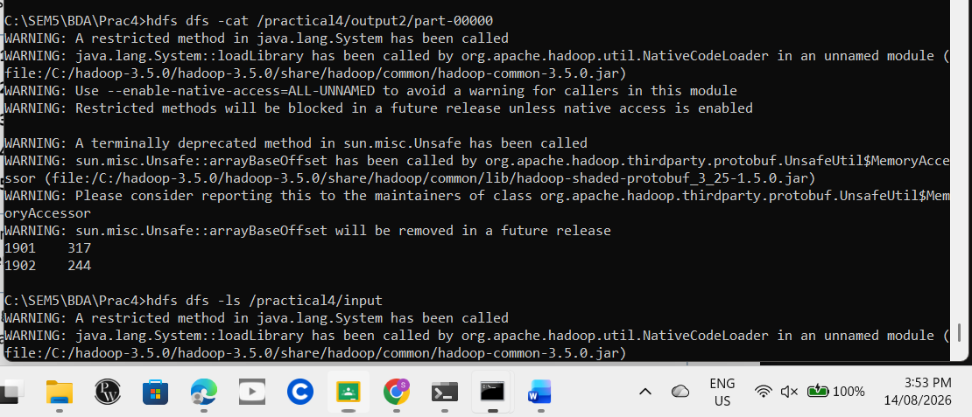

Key Questions /Analysis:
- How is weather data parsed and processed using MapReduce?
The weather data is stored in HDFS and read by the Mapper. The Mapper takes the required information from each record, mainly the year and temperature. Hadoop then groups the data according to the year, and the Reducer finds the highest temperature for each year.

- What key-value pairs are generated by the Mapper?
The Mapper generates the year as the key and temperature as the value.
1901 -194
1901 -156
1901 -150
So, the key is year and the value is temperature.

- How does the reducer identify the maximum temperature for a given year?
The Reducer receives all temperature values for the same year and compares them. It keeps the largest value and gives that value as the maximum temperature for that year.
For example:
1901 -194
1901 -156
1901 317
The result will be:
1901 317

- What challenges arise when processing large climate datasets?
Large climate datasets contain a very large number of records. Some records may also contain missing or incorrect values. Processing such data requires proper data handling, storage, and efficient processing of the records.

- How does Hadoop improve scalability and performance for weather data analytics?
Hadoop divides large datasets into smaller parts and processes them in parallel. HDFS provides distributed storage, while MapReduce performs distributed processing. Therefore, Hadoop can handle large weather datasets more efficiently than processing everything on a single machine.

Conclusion:
In this practical, the NCDC weather data was successfully processed using Hadoop MapReduce. The Mapper extracted the year and temperature from the records, and the Reducer calculated the maximum temperature for each year. The final results were stored in HDFS and verified successfully. This practical helped demonstrate how Hadoop can be used to process large weather datasets using distributed processing.

