Practical : 5
AIM:
To perform CRUD operations and aggregation operations in MongoDB using MongoDB Compass and MongoDB Shell.
PROBLEM DEFINITION:
Scenario: Perform Create, Read, Update, and Delete (CRUD) operations using MongoDB. Students will work with a NoSQL document database to understand how unstructured and semi-structured data is managed at scale in Big Data environments.

Tasks:
1. Install and configure MongoDB.
2. Create a database and collection.
3. Insert documents (single and multiple).
4. Read/Query documents using various filters.
5. Update existing documents.
6. Delete documents and collections.
7. Use MongoDB aggregation pipeline for data analysis.

OUTPUT :
Task 1 — Start MongoDB
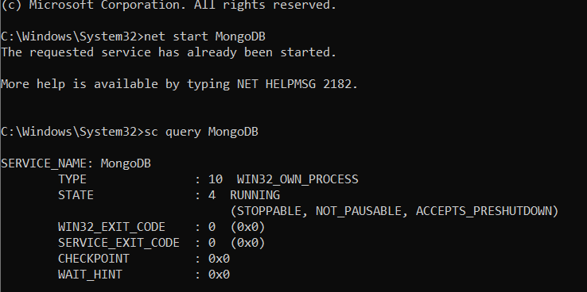
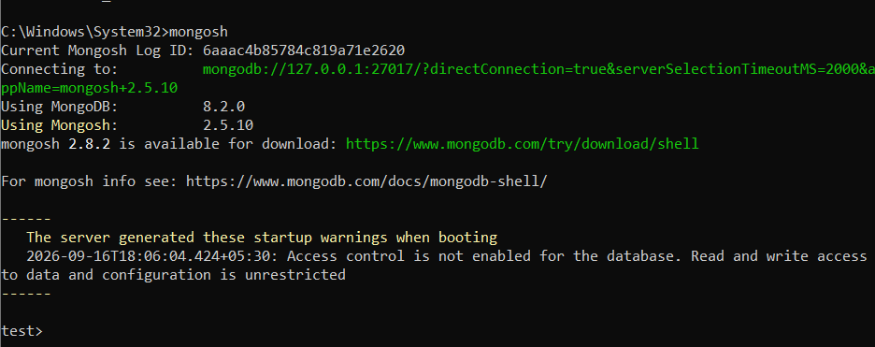

Task 2 — Create Database and Collection

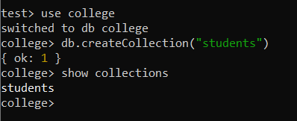

Task 3 — Insert Documents
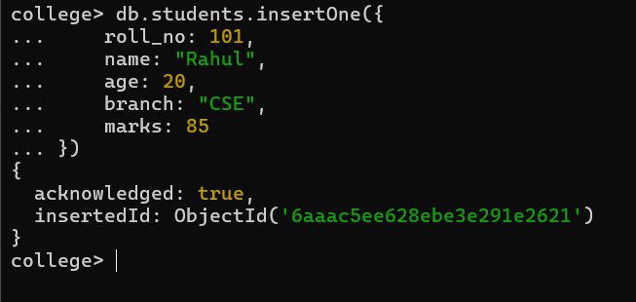
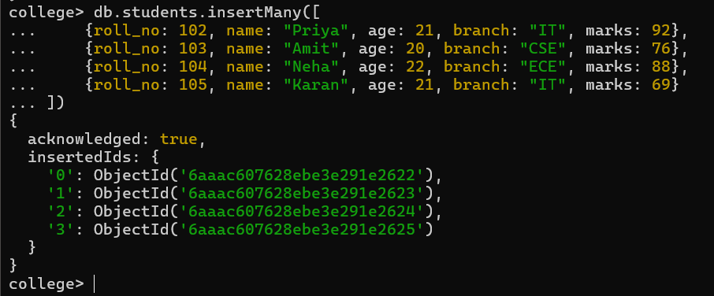

Task 4 — Read / Query Documents
First display everything
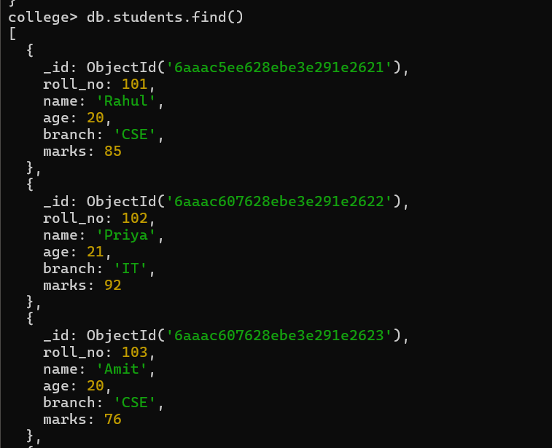

Find one student
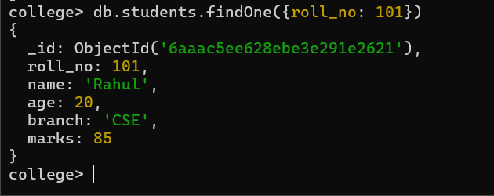
Students having marks greater than 80
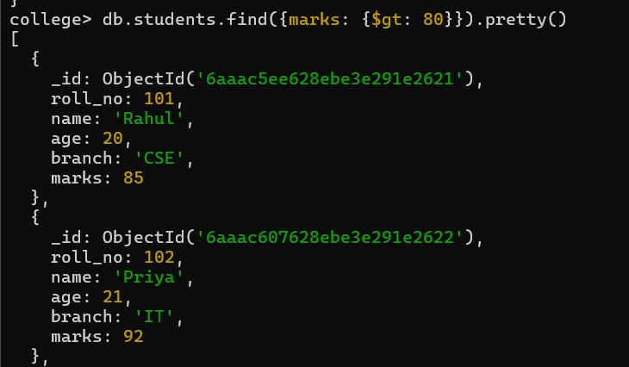
Marks between 70 and 90
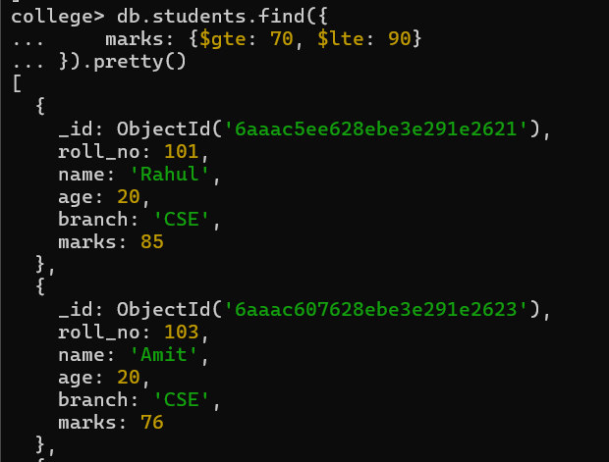

Task 5 — Update Documents
5.1 Update one student
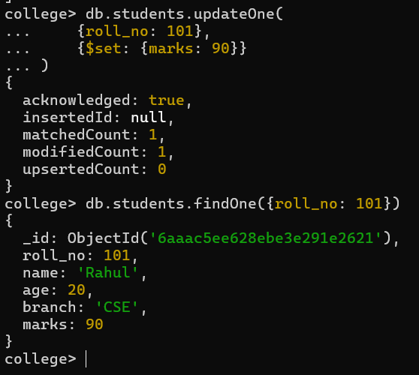
Old mark as below
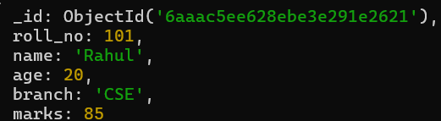
5.2 Update multiple documents
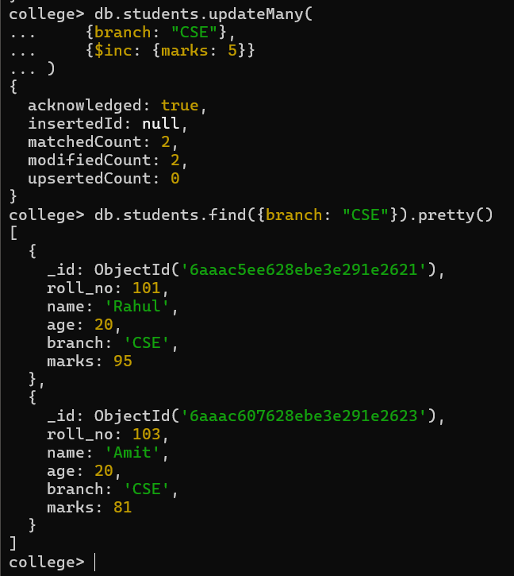

Task 6 — Delete Documents
Delete student with roll number 105:
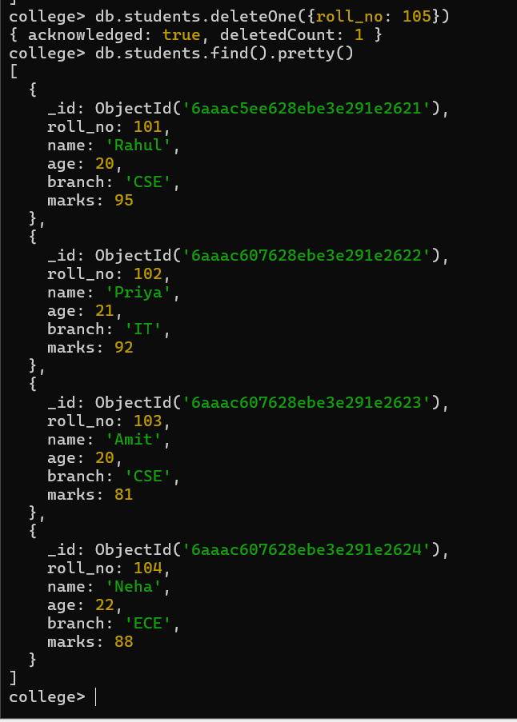
6.2 Delete based on condition


Task 7 — MongoDB Aggregation Pipeline
7.1 Find average marks for each branch
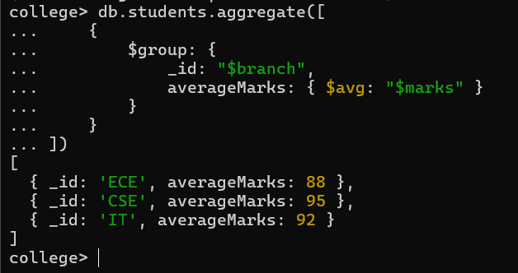

7.2 Find maximum marks in each branch
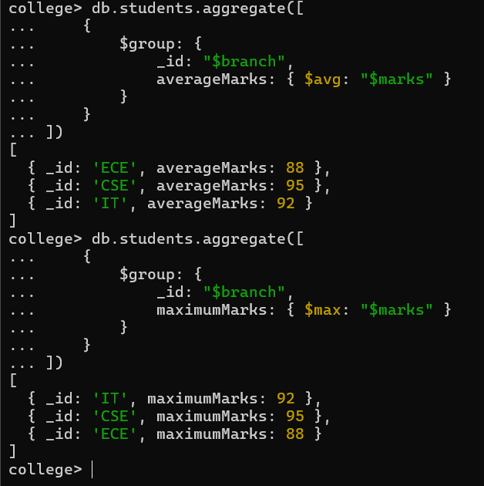
7.3 Count students in each branch
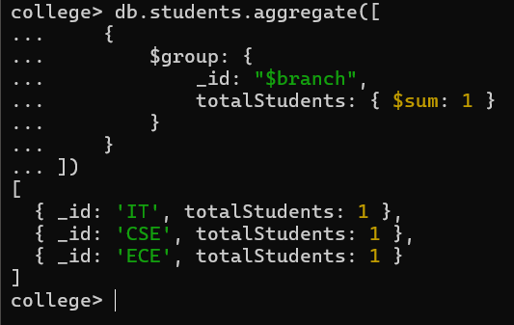
7.4 Filter + Aggregation
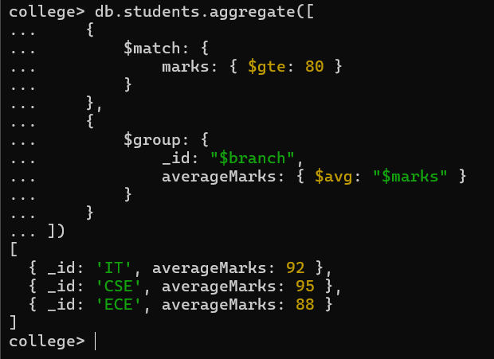
Task 7.5 — Create an Index
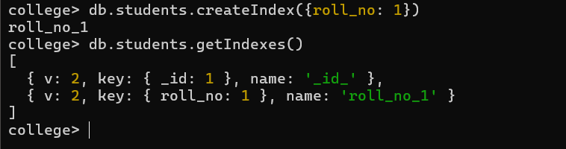

KEY QUESTIONS :

Q1. What is MongoDB and how does it differ from relational databases?
MongoDB is a NoSQL document database that stores data in flexible documents instead of tables. Unlike relational databases, MongoDB does not require a fixed schema and is suitable for handling large and changing datasets.

Q2. What are CRUD operations and why are they fundamental to database management?
CRUD stands for Create, Read, Update, and Delete. These operations are fundamental because they allow users to insert, view, modify, and remove data from the database.

Q3. How does MongoDB store data (BSON format)?
MongoDB stores data in BSON (Binary JSON) format. BSON stores data as key-value pairs and supports different data types such as strings, numbers, arrays, dates, and embedded documents.

Q4. What is the aggregation pipeline in MongoDB?
The aggregation pipeline is a sequence of stages used to process and analyze documents. It can filter, group, sort, and calculate data using stages such as $match, $group, $sort, and $project.

Q5. When should NoSQL databases be preferred over SQL databases?
NoSQL databases should be preferred when data is unstructured or changes frequently, and when large amounts of data need to be distributed and scaled easily. They are commonly used in Big Data and real-time applications.

CONCLUSION :
Thus, CRUD operations were successfully performed using MongoDB. Documents were inserted, retrieved, updated and deleted using MongoDB Shell. MongoDB Compass was used to visualize the database and documents. The aggregation pipeline was also used to analyze student data by calculating average, maximum, minimum and count values.

