Practical 6
Aim: E-Commerce Sales Analysis Using Spark DataFrames

Problem definition: You are a Data Analyst at ShopSmart Analytics Pvt. Ltd. The company operates a large-scale e-commerce platform that processes thousands of transactions every day.
Management wants to identify high-performing product categories, top-selling products, and
revenue contribution by city. Traditional spreadsheet tools are unable to efficiently process the growing volume of transaction data. Therefore, the company has adopted Apache Spark for scalable analytics. Your task is to design a Spark-based analytical solution to process sales data and generate business insights.

Observation / Output:
Tasks-1: Load sales data into a Spark DataFrame.
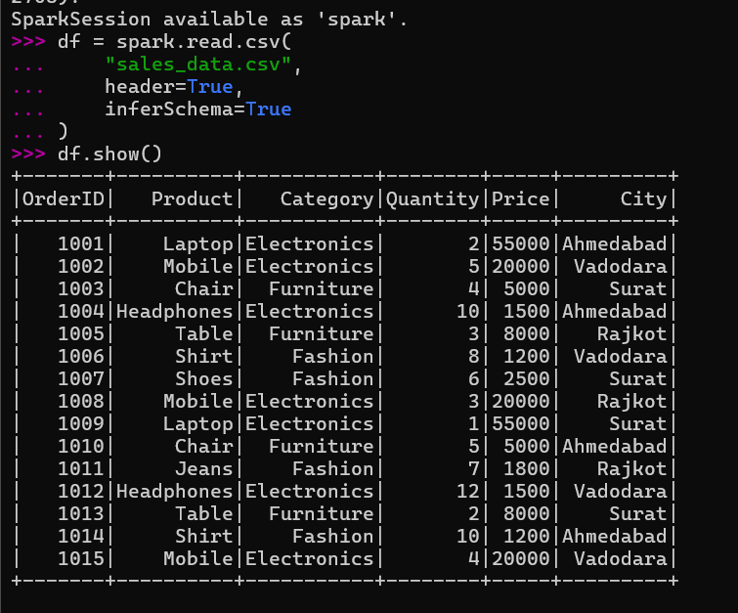

Tasks-2: Display the schema of the dataset.
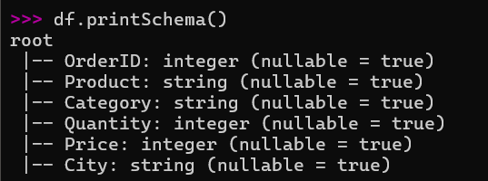

Tasks-3: Validate data types of all columns.
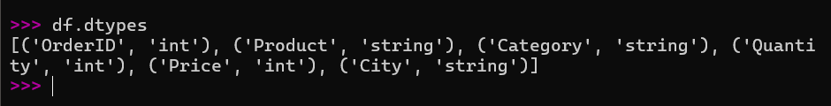

Tasks-4: Create a new Revenue column using Quantity x Price.
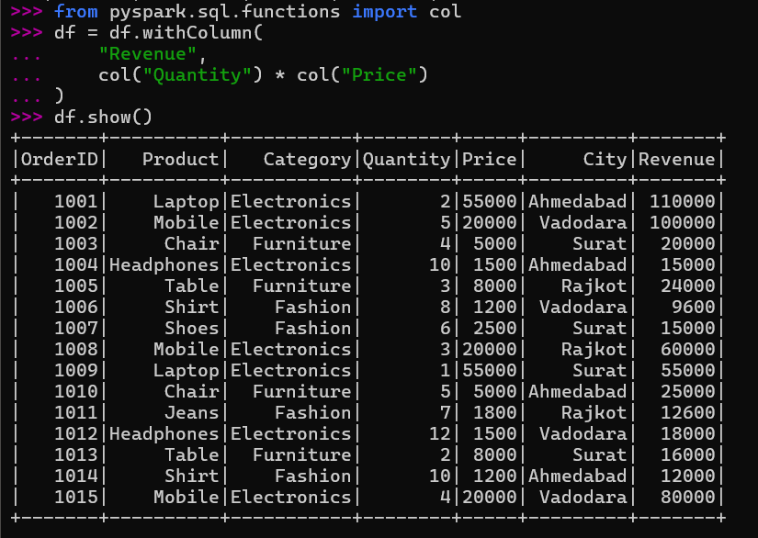

Tasks-5: Calculate category-wise revenue.
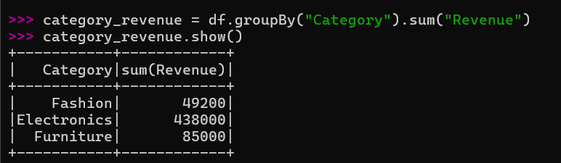

Tasks-6: Identify top-selling products based on quantity sold.
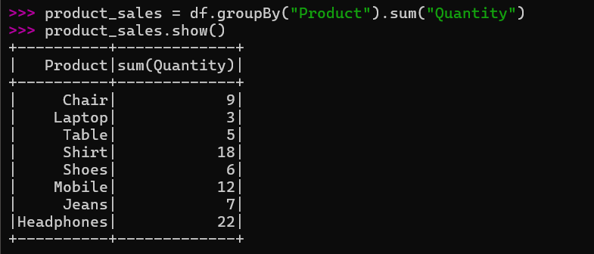

Tasks-7: Calculate city-wise revenue.
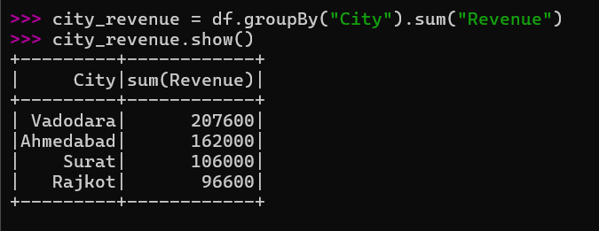

Tasks-8: Sort categories based on revenue generated.
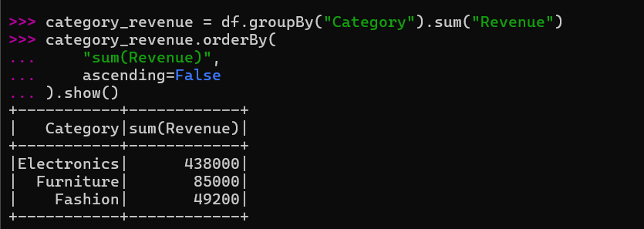

Key Questions /Analysis:

Q1. Why are Spark DataFrames preferred over traditional spreadsheets for large-scale analytics?
Spark DataFrames are preferred because they can process large amounts of data quickly using distributed computing. Unlike spreadsheets, Spark can handle millions of records and perform complex analytics efficiently.

Q2. What is the role of the groupBy() operation in data aggregation?
The groupBy() operation groups records based on a specific column. It is used with functions such as sum(), count(), and avg() to calculate aggregated results, such as category-wise revenue.

Q3. Explain the difference between transformations and actions in Spark.
Transformations create a new DataFrame from existing data without immediately executing the operation, such as filter(), select(), and groupBy(). Actions execute the computation and return a result, such as show(), count(), and collect().

Q4. How does Spark improve scalability for e-commerce analytics?
Spark improves scalability by distributing data processing across multiple computers or processing cores. This allows large volumes of e-commerce transactions to be processed faster and efficiently.

Q5. Which category contributes the highest revenue and what business action can be taken?
The category with the highest total revenue in the Spark analysis contributes the most to sales. The company can maintain sufficient stock, promote its products, and focus marketing efforts on this high-revenue category.

Conclusion:
Apache Spark was successfully used to analyze e-commerce sales data and identify categorywise revenue, top-selling products, and city-wise revenue. The analysis helps the business understand sales performance and make better data-driven decisions.

