Practical 9
Aim: Social Media Trend Detection Using PySpark

Problem definition: You are a Big Data Analyst at TrendPulse Social Media Analytics, a company that monitors social media activity across multiple platforms such as Twitter, Instagram, Facebook, and LinkedIn. Every day, millions of users post content containing hashtags related to current events, technology, sports, entertainment, politics, and business. The marketing team wants to identify: most trending hashtags, popular discussion topics, user interests, and emerging market trends. Traditional analytics tools cannot efficiently process the massive volume of social media data generated every day.

Observation / Output:
- Create Spark Session.
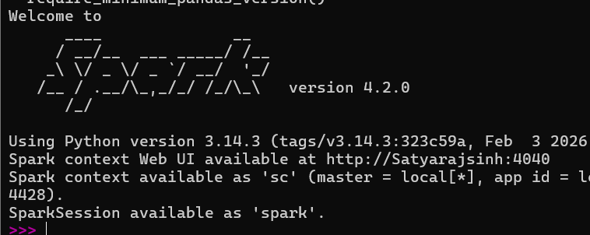

- Load social media hashtag dataset.
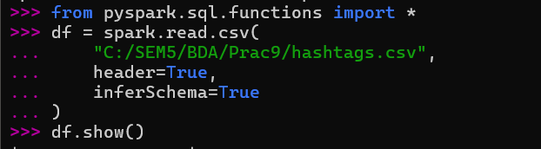

- Display hashtag records.
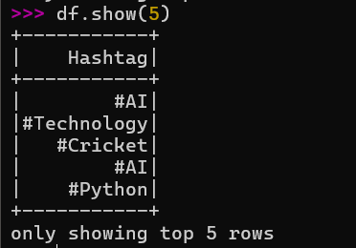
- Validate dataset structure.
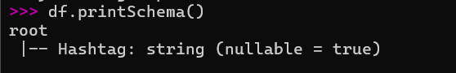

- Group identical hashtags.
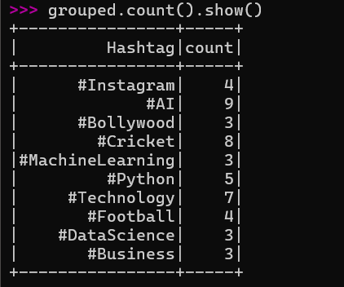

- Count hashtag occurrences.
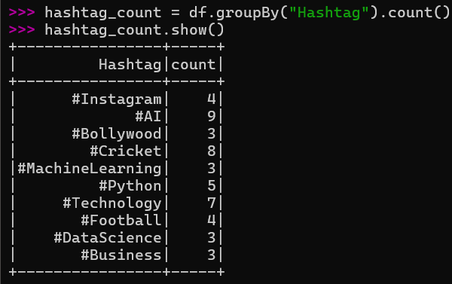

- Sort hashtags based on popularity.
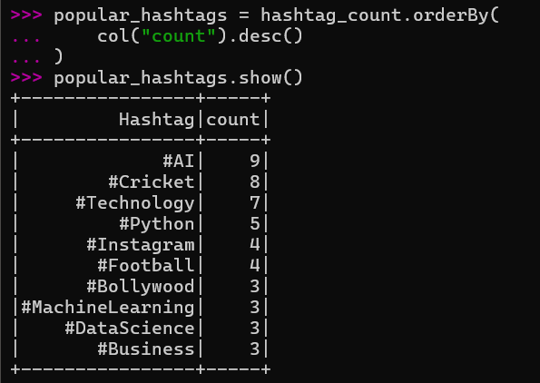

- Identify top trending hashtags.
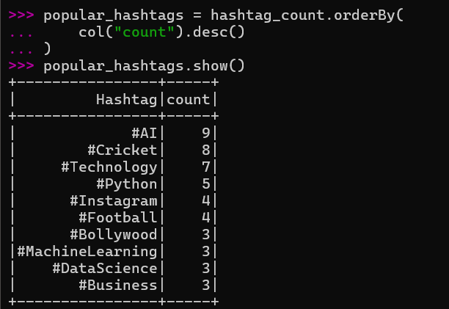
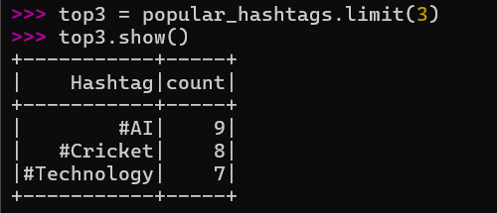

- Generate trend analysis report.
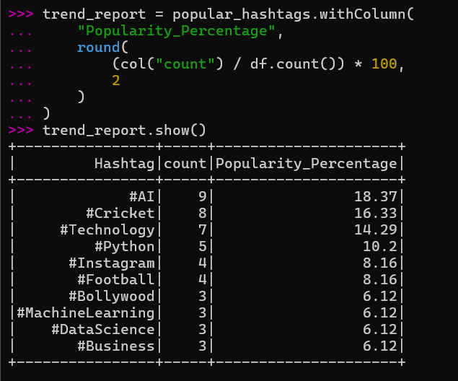

- Interpret user interests.
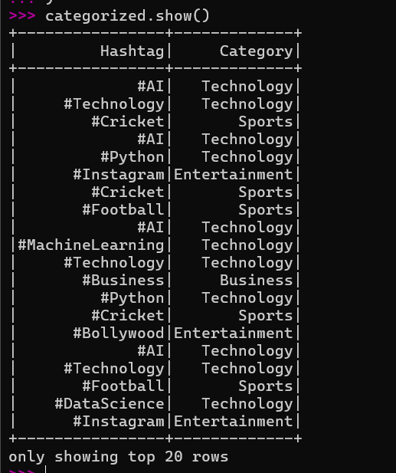

Key Questions /Analysis:

- Why is Apache Spark suitable for social media analytics?
Apache Spark is suitable because social media platforms generate very large volumes of data. Spark can process this data in parallel and provides DataFrame and aggregation operations that make it efficient to analyse hashtags, posts and trends.

- What is the significance of hashtag frequency?
Hashtag frequency shows how often a particular hashtag appears in the dataset. A higher frequency indicates greater activity or interest around that topic during the analysed period.

- How can trend analysis support digital marketing campaigns?
Trend analysis helps marketers understand topics that are receiving attention from users. This information can be used to create relevant content, select suitable hashtags and plan campaigns around current interests.

- Why do businesses monitor social media trends?
Businesses monitor social media trends to understand customer interests, observe discussions about products or topics and identify changes in audience behaviour. This information can support content planning and marketing decisions.

- How can real-time analytics improve decision making?
Real-time analytics allows new social media data to be processed as it arrives. Businesses can detect rapidly changing trends earlier and respond to them with timely content or campaigns.

Conclusion:
In this practical, PySpark was used to analyse social media hashtag data and detect popular trends. The dataset was loaded into a Spark DataFrame, its structure was validated and identical hashtags were grouped and counted. The hashtags were then sorted according to their frequency to identify the most popular topics. Category-based analysis was also performed to understand broad user interests. This practical demonstrated how Spark can process social media data efficiently and provide useful information for trend analysis and business decision-making.

