PRACTICAL-2
Problem Defination:
- Extend the portfolio application from Practical 1 by adding ReactRouter.
- Implement a navigation bar with at least 3 routes: Home, Projects, andContact.
- Each route must render a distinct component without a full page reload.
- Add at least 2 useState variables used meaningfully one for toggling UIvisibility and one for managing a form input on the Contact page.
- The Contact page must include a controlled input that captures and
- displays user input in real time.

OUTPUT:

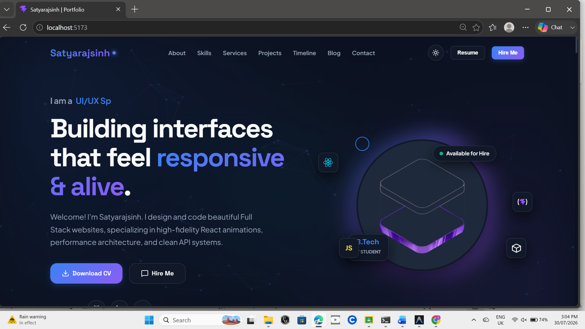

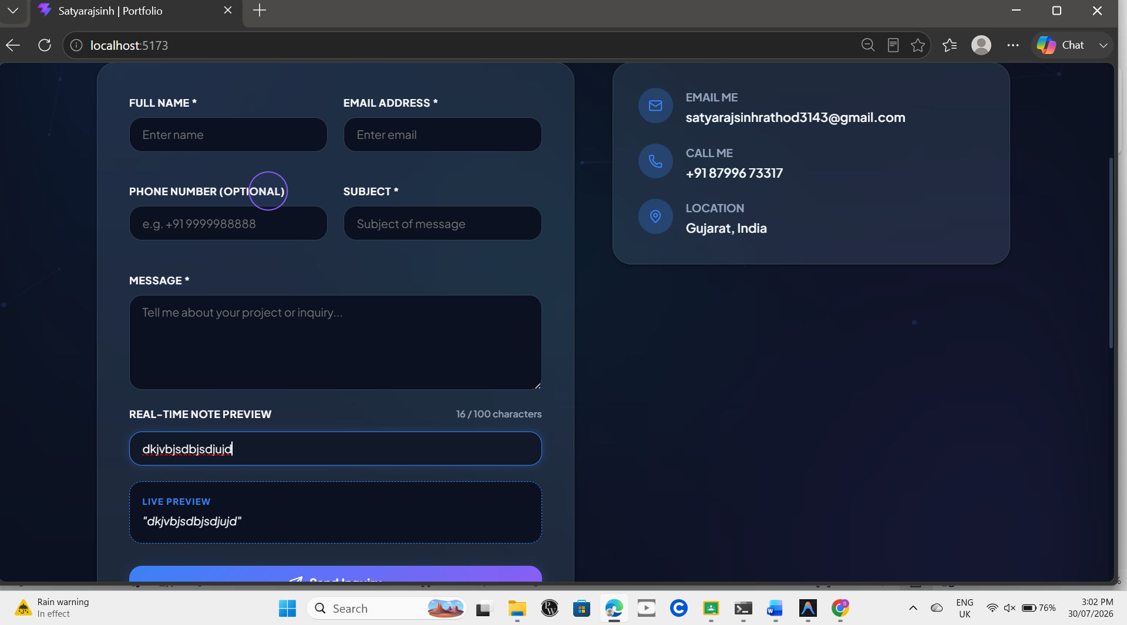

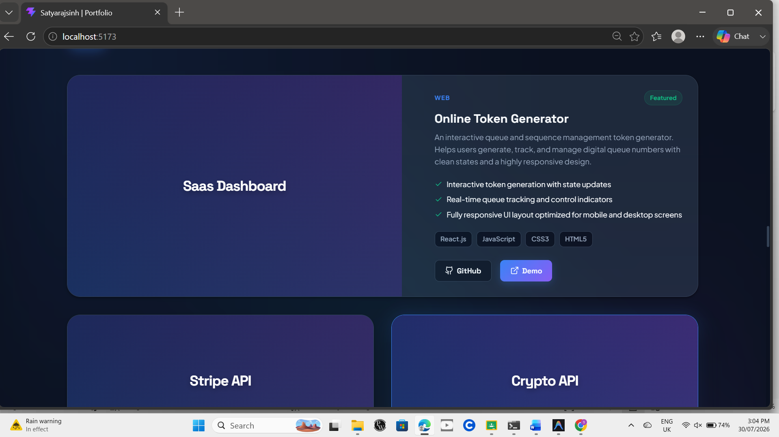

Key Questions:-
- What is the role of each component in the overall UI structure?
- Each component represents a separate part of the user interface and performs a specific task. Components combine to create the complete UI in an organized and structured way.
- How does React re-render when props change?
- When props change, React re-renders the affected component and updates only the necessary parts of the UI.
- Why is component reusability important in large-scale applications?
- Component reusability is important because it reduces duplicate code, makes development faster, improves consistency, and makes large applications easier to maintain.

Conclusion:
This practical demonstrated the use of React Router to create a single-page application with multiple routes without reloading the page. It also showed how useState can be used to manage UI visibility and handle controlled form inputs. Overall, the portfolio application became more interactive, user-friendly, and well-structured using React components, routing, and state management.

